Activity 14 – Before-and-After Comparison Report
Objective
The objective of this activity was to compare the dataset before and after the data cleaning and preprocessing phase. This comparison demonstrates the improvements made to the dataset by handling missing values, correcting data types, validating customer ages, and treating outliers. It helps evaluate the effectiveness of the preprocessing workflow and ensures that the dataset is ready for Exploratory Data Analysis (EDA) and Machine Learning.

Before-and-After Comparison Table
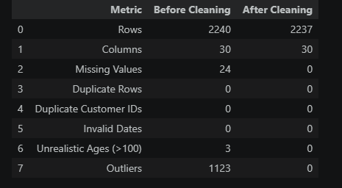
Improvements Made
The preprocessing phase significantly improved the overall quality of the dataset. Initially, the dataset contained 24 missing values in the Income column, which were successfully handled using median imputation. This ensured that no information was lost while maintaining the distribution of income values.
The dataset originally contained three unrealistic customer ages (greater than 100 years). These records were identified during the age validation process and removed from the dataset, reducing the total number of records from 2240 to 2237.
Outlier detection using the Interquartile Range (IQR) method identified 1,123 outlier values across the selected numerical variables. These outliers were handled using the Winsorization (capping) technique, which reduced the influence of extreme values while preserving all valid customer records.
The dataset contained no duplicate rows, duplicate customer IDs, or invalid dates, indicating that these aspects of the data were already consistent.
Summary
After preprocessing, the dataset became cleaner, more consistent, and more reliable for further analysis. Missing values were removed, unrealistic records were eliminated, and extreme numerical values were treated appropriately. These improvements ensure that the dataset is suitable for Exploratory Data Analysis (EDA), visualization, feature engineering, and machine learning model development.
Conclusion
The comparison between the original and cleaned datasets confirms that the preprocessing workflow was successful. All major data quality issues were addressed, resulting in a high-quality dataset that is ready for the next stages of the project. The preprocessing process has improved the accuracy, consistency, and reliability of the data while preserving valuable business information.

