Customer Personality Analysis Dataset
1. Objective
The objective of this analysis is to understand customer spending behavior across different product categories. The analysis examines total customer spending, average spending, spending by product category, and the spending behavior of the highest-spending customers.
The following six product categories were analyzed:
- Wine
- Fruits
- Meat Products
- Fish Products
- Sweet Products
- Gold Products

2. Total Customer Spending
A new variable named Total_Spending was calculated by combining the spending values across all six product categories for each customer.
Statistical Summary
Statistic | Value
Number of Customers | 2,237
Average Spending | 568.16
Standard Deviation | 546.63
Minimum Spending | 5.00
25th Percentile | 69.00
Median Spending | 395.00
75th Percentile | 990.00
Maximum Spending | 2,098.50
Interpretation
The average customer spends approximately 568.16 across all product categories.
The median spending is 395.00, which is considerably lower than the mean. This indicates that spending is not evenly distributed among customers. A smaller group of customers spends considerably more than the typical customer.
Customer spending ranges from only 5.00 to 2,098.50, showing substantial variation in purchasing behavior.

3. Total Spending by Product Category
The total spending for each product category was calculated.
Product Category | Total Spending
Wine | 675,920.00
Meat Products | 337,387.00
Gold Products | 88,299.00
Fish Products | 71,821.50
Sweet Products | 49,073.00
Fruits | 48,474.00
Interpretation
Wine is the highest-spending product category, generating a total spending value of 675,920.00.
Meat Products are the second-highest category, with total spending of 337,387.00.
Gold Products generate 88,299.00, followed by Fish Products at 71,821.50.
Sweet Products and Fruits have the lowest total spending, with 49,073.00 and 48,474.00, respectively.
Therefore, Wine and Meat Products are the dominant product categories in terms of customer spending.

4. Average Spending by Product Category
The average spending per customer was also calculated.
Product Category | Average Spending
Wine | 302.15
Meat Products | 150.82
Gold Products | 39.47
Fish Products | 32.11
Sweet Products | 21.94
Fruits | 21.67
Interpretation
Wine has the highest average customer spending at approximately 302.15.
Meat Products have the second-highest average spending at approximately 150.82.
Gold Products have an average spending of 39.47, while Fish Products have an average of 32.11.
Sweet Products and Fruits have the lowest average spending, at approximately 21.94 and 21.67, respectively.
The results show that Wine and Meat Products are particularly important categories for the business.

5. Top 10 Highest-Spending Customers
The ten customers with the highest total spending were identified.
Rank | Customer ID | Total Spending
1 | 4580 | 2,098.50
2 | 1763 | 2,072.00
3 | 5735 | 2,064.00
4 | 5350 | 2,064.00
5 | 10133 | 2,063.00
6 | 4475 | 2,049.00
7 | 3403 | 2,046.50
8 | 5453 | 2,029.50
9 | 1173 | 2,005.50
10 | 5386 | 1,983.00
Interpretation
Customer ID 4580 is the highest-spending customer, with total spending of 2,098.50.
The other top customers also have spending values above 1,980, indicating a group of particularly high-value customers.
These customers may be important targets for loyalty programs, personalized offers, premium product recommendations, and customer retention campaigns.

6. Visualizations
The following visualizations were created during this analysis:
6.1 Total Spending by Product Category
The bar chart compares the total amount spent across the six product categories.
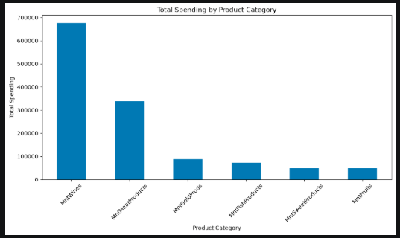
Observation: Wine has the highest total spending, followed by Meat Products.

6.2 Average Spending by Product Category
The average spending bar chart shows the average amount spent by customers in each category.
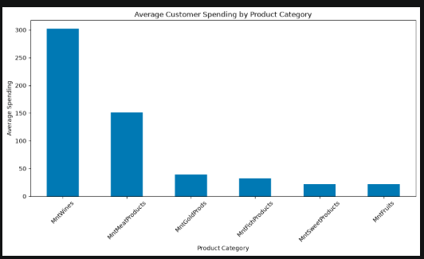
Observation: Wine has the highest average spending, followed by Meat Products.

6.3 Distribution of Total Customer Spending
The histogram shows the distribution of total spending among customers.
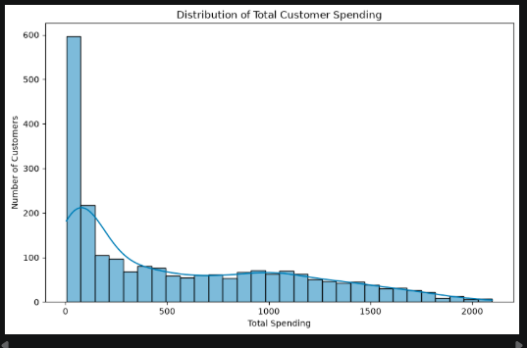
Observation: Customer spending varies considerably, with many customers spending relatively low amounts and a smaller number of customers showing much higher spending.

6.4 Total Spending Box Plot
The box plot provides a visual representation of the spread of total customer spending and helps identify customers with unusually high spending.
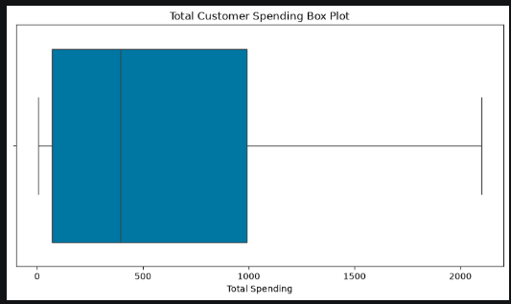
6.5 Top 10 Highest-Spending Customers
The bar chart displays the ten customers with the highest total spending.
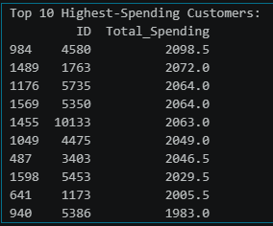
6.6 Product Category Spending of Top 10 Customers
The stacked bar chart compares how the top-spending customers distribute their spending across the different product categories.
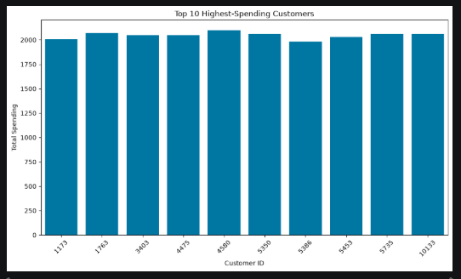
7. Business Insights
The analysis provides several important business insights:
- Wine is the most important product category. It has the highest total and average spending.
- Meat Products are the second strongest category, making them another important source of revenue.
- Wine and Meat Products together dominate customer spending, suggesting that marketing strategies should continue to focus on these categories.
- Customer spending varies significantly. The mean spending is 568.16, while the median is only 395.00, indicating that high-spending customers have a significant influence on the overall average.
- The highest-spending customer, ID 4580, spent 2,098.50, which is substantially higher than the typical customer.
- The top-spending customers could be considered high-value customers and may deserve targeted loyalty and retention strategies.
- Fruits and Sweet Products have relatively low spending compared with Wine and Meat Products, which could indicate opportunities for cross-selling and promotional campaigns.

8. Recommendations
Based on the spending analysis, the following recommendations can be made:
- Develop personalized marketing campaigns for high-value customers.
- Use loyalty programs to retain customers with high total spending.
- Continue promoting Wine and Meat Products because they generate the highest spending.
- Use cross-selling strategies to encourage Wine and Meat customers to purchase Fruits, Sweets, Fish, and Gold Products.
- Analyze why some customers have very low spending and develop targeted offers to increase their engagement.
- Provide personalized product recommendations based on individual purchasing history.
- Further analyze whether customer income, age, education, and household composition influence spending.

9. Conclusion
The Customer Spending Analysis shows substantial variation in customer purchasing behavior. The average total customer spending is 568.16, while the median is 395.00.
Among all product categories, Wine has the highest total spending (675,920.00) and the highest average spending (302.15). Meat Products are the second most important category.
The identification of high-spending customers also provides valuable information for customer segmentation and marketing strategy. These customers can be targeted with loyalty programs, personalized promotions, and premium offers.
Overall, the analysis provides a strong foundation for understanding customer purchasing behavior and will support further analysis of purchasing channels, website engagement, and marketing campaign effectiveness.

