# Instructions for installing windows10

Follow these steps to create installation media (USB flash drive or DVD) you can use to perform a clean installation of Windows 10. Before you download the tool make sure you have:

* An internet connection (internet service provider fees may apply).
* Sufficient data storage available on a computer, USB or external drive for the download.
* A blank​ USB flash drive with at least 8GB of space or blank DVD (and DVD burner) to create media. We recommend using a blank USB or blank DVD, because any content on it will be deleted.

## Check a few things on the PC where you want to install Windows 10:

* 64-bit or 32-bit processor (CPU).​ You’ll create either a 64-bit or 32-bit version of Windows 10. To check this on your PC, go to PC info​ in PC settings or System​ in Control Panel, and look for System type.​
* System requirements.​ Make sure the PC meets the system requirements for Windows 10. We also recommend going to the PC manufacturer's website for additional info about updated drivers and hardware compatibility.

Using the tool to create installation media:

1. Click on the link provided in our email. Select Download tool now​, and run it. You

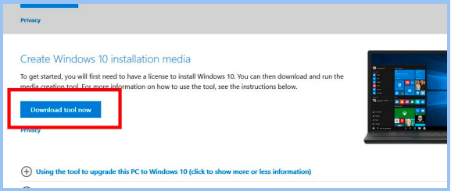Need to be an administrator to run this tool.

1. If you agree to the license terms, select Accept​.
2. 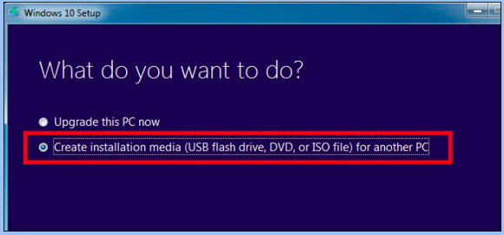On the What do you want to do?​ page, select Create installation media for another PC​, and then select Next​. Windows 10 installation guide.
3. 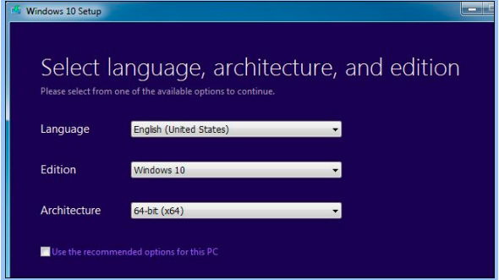Select the language, edition, and architecture (64-bit or 32-bit) for Windows 10.
4. Select which media you want to use

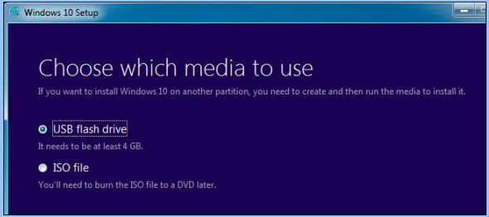

* USB flash drive.​ Attach a blank USB flash drive with at least 8GB of space. Any content on the flash drive will be deleted.
* ISO file.​ Save an ISO file to your PC, which you can use to create a usb. After the file is downloaded, you can go to location where the file is saved.

Installing the system from the media you created:

1. After the installation media is created, follow the steps below to use it.

1.1. Attach the USB flash drive or insert the DVD on the PC where you want to install Windows 10.

1.2. Restart your PC, and then press any key to boot from the USB flash drive or the DVD.

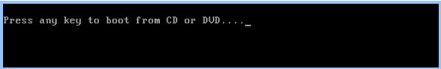

2. On the Install Windows​ page, select your language, time, and keyboard preferences, and then select N​ext​.

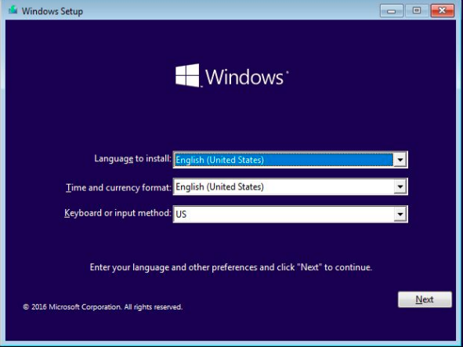

3. Click on ‘Install now’



4. When you reach the “Which type of installation do you want?” screen, click “Custom” to perform a clean installation and remove everything on your PC.

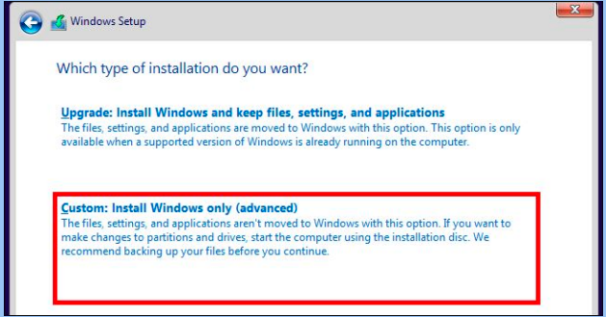

1. On the next screen, select the hard drive you want to install Windows on and erase it. If you have multiple partitions on that drive, you may want to erase those as well.

Warning: When you delete a partition, you’re also deleting all the files on that partition. Be sure you have backups of any important files before doing this!

When you’re done erasing partitions, you should have a big block of “Unallocated Space”. Select that, click “New”, and once it’s formatted your drive, click Next.

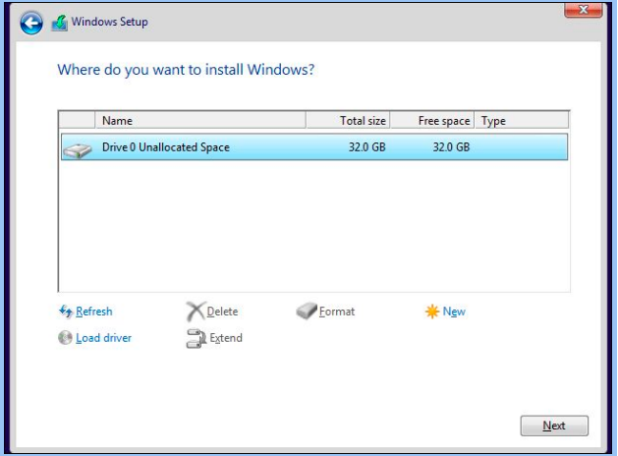

1. Windows 10 will install itself, and may restart a few times during this process. When it’s done, you’ll see the normal setup interface you see when setting up Windows 10 on any new PC, where you can add user accounts and adjust various settings.

