
Taibah University
College of Computer Science and Engineering
Department of Information Systems

Detection of AI-Generated Arabic Text: A Data Mining Approach

Author: Areej Abdulaziz Alshamani
Institution: Taibah University
MSIS-822 Advanced Data Analytic Techniques
Instructor:Mohammed alsarem

Abstract
The rapid development of text generation technologies has led to difficulties in distinguishing between human-generated and AI-generated content. This challenge is particularly pronounced in Arabic due to its complex grammatical and morphological richness. This project aims to develop and evaluate multiple models for detecting AI-generated Arabic texts using a combination of linguistic feature engineering. These features are carefully extracted, including numeral-to-letter ratios, punctuation variations, adjective and grammatical construction frequency, and the Gini coefficient for word frequency distribution. The goal is to understand stylistic differences, and these models are used to train and evaluate various classifiers, including traditional machine learning models such as logistic regression, random forest, and XGBoost, as well as the AraBert deep learning model. The results showed that the modified AraBert model outperformed the others, achieving significantly higher accuracy and an F1 score by extracting patterns more deeply. This highlights the importance of understanding the contextual language for detecting AI-generated texts.

- Introduction:
The widespread adoption of large language models has revolutionized content creation, enabling the generation of seamless texts and their use in academic writing, journalism, and all social media platforms. This raises concerns about academic integrity, the spread of misinformation, content credibility, and plagiarism. Given the limited research and linguistic resources for Arabic compared to English, this presents a significant research challenge.
The motivation behind this project is to develop a comprehensive, efficient, and reliable project for detecting AI-generated Arabic texts using a wide range of engineering features and advanced machine learning techniques. The underlying goal is to bridge this gap by improving an Arabic language model based on the accurate identification of patterns that distinguish content written by humans or AI.
The main objectives of this project are to design a structured pipeline encompassing data processing, feature extraction, data segmentation, model evaluation, and the identification of the most effective model. The project aims to provide insights and representations that support the effectiveness of linguistic features in training large language models.
- Related Work
Previous research in AI-generated text detection has focused on identifying linguistic and statistical differences to differentiate between human-generated and AI-generated content. Based on current studies, these approaches can be categorized as feature-based and transformational models that support deep learning (Gehrmann et al., 2019; Ippolito et al., 2020).
The current trend is towards deep learning due to the emergence of powerful transformal models like BERT. These models have contributed to significant improvements in text classification because of their ability to grasp contextual semantics to detect differences by identifying subtle patterns (Ippolito et al., 2020; Mitchell et al., 2023). While they achieve high accuracy, they require substantial computational resources. In the field of Arabic, a transformal model like AraBert has been developed that considers its unique linguistic characteristics and is designed to handle linguistic complexity (Antoun et al., 2020). It has demonstrated strong performance in natural language processing, but it needs precise tuning to achieve its objectives.
In general, many current studies indicate that transformal-based models outperform traditional feature-based methods in text detection (Gehrmann et al., 2019; Mitchell et al., 2023). However, traditional models still retain their value due to their ease of interpretation and lower computational cost. In this context, this report demonstrates the effectiveness of the results by comparing traditional machine learning models (Random Forest, XGBoost) with the deep learning model (AraBert).
- Dataset Description
- Source:
The dataset used in this study is the https://huggingface.co/datasets/KFUPM-JRCAI/arabic-generated-abstracts , obtained from the HuggingFace repository. It contains Arabic academic abstracts written by humans and AI-generated versions produced by multiple large language models.
- Size:
The dataset consists of 8,388 samples collected from three generation methods: by_polishing, from_title, and from_title_and_content.
- Class Distribution:
Explicit labels are not provided in the original dataset. Therefore, class labels were constructed during preprocessing, where human-written abstracts were labelled as 0 and AI-generated abstracts were labelled as 1. The final dataset provides a balanced comparison between the two classes.
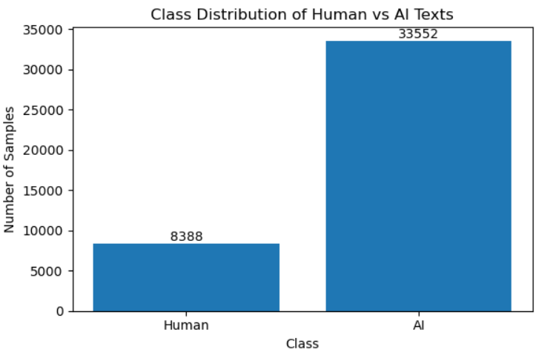
Figure 1: Class distribution of human-written and AI
- Sample Samples:
To illustrate the dataset content, random samples were inspected. Human-written abstracts exhibit formal academic structure and coherent argumentation, while AI-generated abstracts closely resemble human writing in structure and length, making manual distinction challenging.
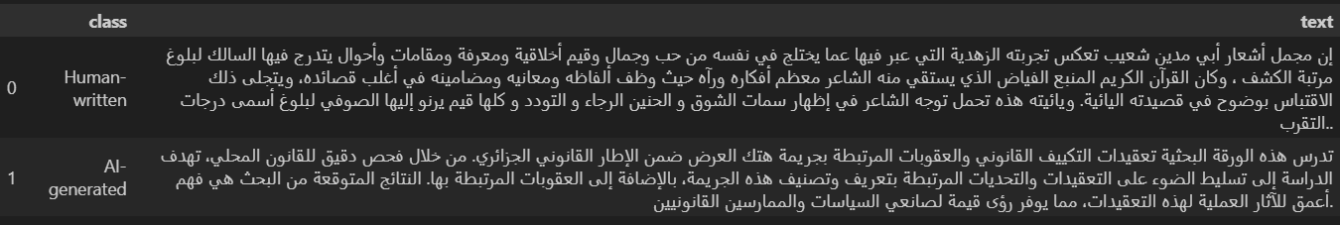
Figure2: shows example samples from both human-written and AI-generated abstracts.
- Methodology Overview
The project follows a systematic pipeline starting with collecting human-written and AI-generated Arabic texts. The data is pre-processed through cleaning, normalization, and tokenization, followed by extracting linguistic and statistical features. Traditional machine learning models and a fine-tuned AraBERT model are then trained and evaluated using standard classification metrics. Based on performance and error analysis, AraBERT is selected as the best-performing model.
In the feature engineering phase, a set of linguistic and statistical features was extracted to capture stylistic differences between human-written text and AI-generated text. These features include:
- Number of digits / C
- Number of different punctuation marks / C
- Number of adjectives
- Number of genitives
- Gini Coefficient of Word Frequencies: Measures inequality in word frequency distribution.
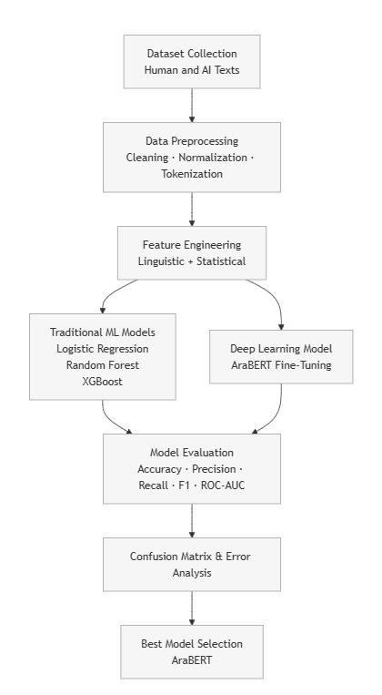
Figure 3: Methodology
5- Results & Analysis
- 5.1 Model Performance Comparison (Metrics Table)
Four different models were tested to evaluate their effectiveness in detecting AI-generated Arabic text. Four models were trained and evaluated on the test set: logistic regression, random forest, XGBoost, and modified AraBERT.
The results in (Figure 4) show clear differences in performance between the models. Logistic regression achieved high recall, but its ROC-AUC was very low compared to the others, indicating its limited ability to differentiate between texts.
The XGBoost model performed better than the first, showing a slight improvement in performance, but the random forest model outperformed it, achieving high performance across all metrics. This confirms that feature-based methods remain effective.
The last model, modified AraBERT, performed better than all the other models across all metrics, achieving the highest F1 score of 0.995 and a very high ROC-AUC, surpassing all traditional models.
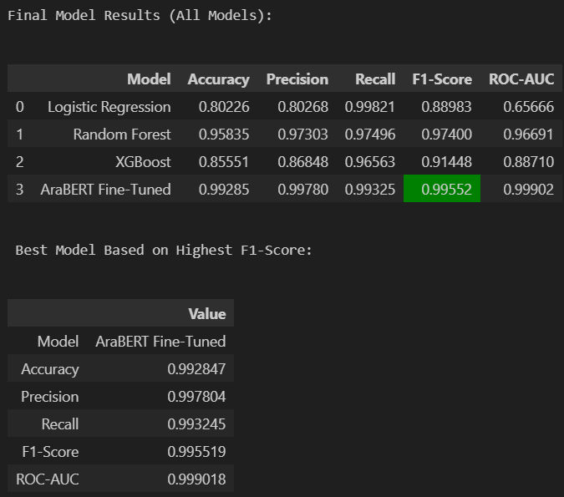
Figure 4: summarizes the performance of all models
- 5.2 Confusion Matrix Comparison
Logistic Regression exhibits many false positives, where human-written texts are incorrectly classified as AI-generated. XGBoost reduces these errors but still shows noticeable misclassifications. Random Forest achieves a more balanced confusion matrix, with fewer false positives and false negatives.
AraBERT fine-tuned demonstrates the cleanest confusion matrix among all models, with minimal misclassified samples in both classes. This confirms its superior generalization ability compared to feature-based approaches.
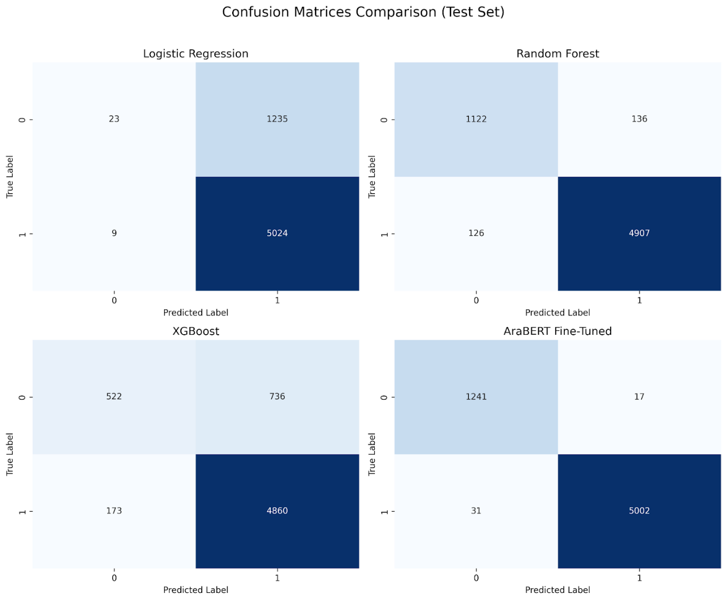
Figure 5: confusion matrices of all four models.

- 5.3 Feature importance charts
A feature important analysis was conducted on traditional models to identify the features influencing the model's classification decision. The results show that the F24_uniue_punct_ratio is the most influential feature in both the Random Forest and XGBoost models. Figures 6 and 7 illustrate the most influential features. These features indicate that AI-generated Arabic texts tend to exhibit consistent stylistic patterns, higher lexical uniformity, and more structured grammatical usage. In contrast, human-written texts show greater variation in their use it.
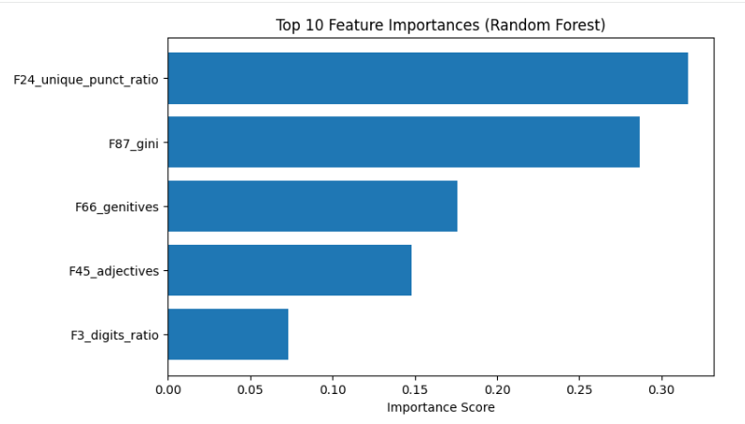
Figure 6: Top Features important (Random Forest)
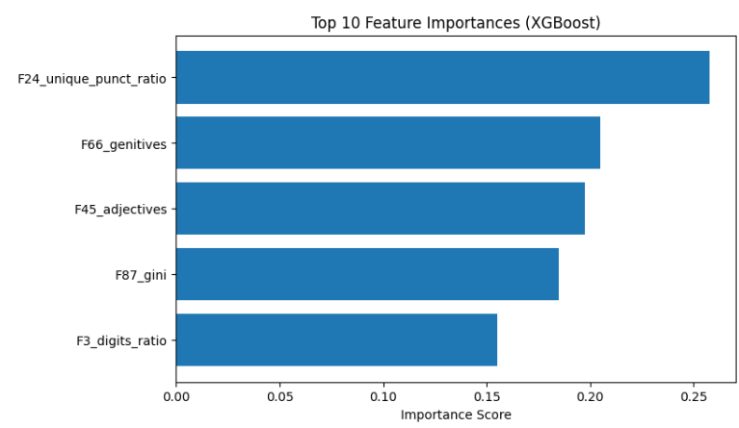
Figure 7: Top Features important (XGBoost)
- 5.4 Error Distribution and Analysis
- Error Distribution (AraBERT)
To further analyze AraBERT’s remaining errors, the distribution of false positives and false negatives was examined. Although the AraBERT model achieved high overall performance, a detailed error analysis was conducted to understand the instances of misclassification.
Figure 8 shows the distribution of errors made by the AraBERT model. False negative errors ( AI-generated texts that were misclassified as being written by a human) occur more frequently than false positive errors ( texts written by humans that were misclassified as being AI-generated).
The conclusion is that instances where the AraBERT model misclassified texts due to stylistic similarities present a significant challenge and can be improved in the future with new models. For example, some academic or linguistically modified human texts were misclassified as AI-generated due to their formal style and structured writing. The model also faces challenges with short texts due to their lack of distinctive linguistic patterns. Finally, some AI-generated texts were misclassified as human-generated due to rewording and linguistic refinement.
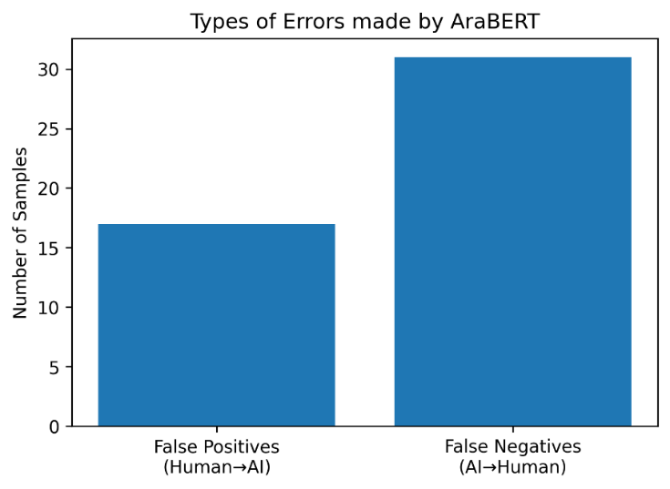
Figure 8: Type of errors (AraBert)
- Error Analysis (Feature-Based Models)
To better understand the limitations of feature-based models, an error analysis was conducted on the Random Forest predictions. Misclassified samples were isolated and analyzed based on their linguistic and statistical feature values.
The analysis revealed that many misclassified instances exhibited feature values close to class boundaries, particularly for digit ratio, punctuation diversity, and lexical dispersion (Gini coefficient). This suggests that handcrafted features may struggle to distinguish highly polished AI-generated texts from human-written texts.
These findings highlight the limitations of surface-level features and motivate the use of contextual deep learning models, such as AraBERT, which demonstrated significantly fewer misclassifications.
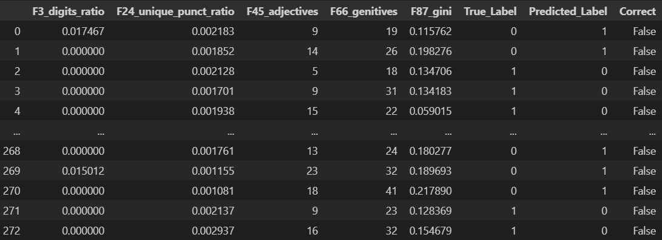
Figure 9: Feature important analysis
- Conclusion & Future Work
This project demonstrates that while traditional models can detect AI-generated Arabic texts using manually designed features, the results show that deep models like AraBERT significantly outperform them. The optimized AraBERT model achieves near-perfect performance indicators, highlighting the importance of semantic and contextual representations for this task.
Limitations:
- Limited dataset size and scope coverage.
- High computational requirements for tuning transformer models.
- Despite the positive results, interpreting deep models remains a challenge.
Future Work:
- Expanding datasets to include a wider range of dialects and domains.
- Expanding detection to include different languages.
- Exploring efficient, lightweight transformer models.
References
Antoun, W., Baly, F., & Hajj, H. (2020). AraBERT: Transformer-based model for Arabic language understanding. arXiv preprint arXiv:2003.00104.
https://arxiv.org/abs/2003.00104

Gehrmann, S., Strobelt, H., & Rush, A. M. (2019). GLTR: Statistical detection and visualization of generated text. arXiv preprint arXiv:1906.04043.
https://arxiv.org/abs/1906.04043

Ippolito, D., Duckworth, D., Callison-Burch, C., & Eck, D. (2020). Automatic detection of generated text is easiest when humans are fooled. arXiv preprint arXiv:2005.00778.
https://arxiv.org/abs/2005.00778

Mitchell, E., Lee, Y., Khazatsky, A., Manning, C. D., & Finn, C. (2023). DetectGPT: Zero-shot machine-generated text detection using probability curvature. arXiv preprint arXiv:2303.11387.
https://arxiv.org/abs/2303.11387

