
Taibah University
College of Computer Science and Engineering
Department of Information Systems

Detection of AI-Generated Arabic Text: A Data Mining Approach
Dataset: KFUPM-JRCAI/arabic-generated-abstracts

Author: Areej Abdulaziz Alshamani
Institution: Taibah University
MSIS-822 Advanced Data Analytic Techniques
Instructor:Mohammed alsarem
Date: 14 Dec 2025

Abstract
The rapid development of text generation technologies has led to difficulties in distinguishing between human-generated and AI-generated content. This challenge is particularly pronounced in Arabic due to its complex grammatical and morphological richness. This project aims to develop and evaluate multiple models for detecting AI-generated Arabic texts using a combination of linguistic feature engineering. These features are carefully extracted, including numeral-to-letter ratios, punctuation variations, adjective and grammatical construction frequency, and the Gini coefficient for word frequency distribution. The goal is to understand stylistic differences, and these models are used to train and evaluate various classifiers, including traditional machine learning models such as logistic regression, random forest, and XGBoost, as well as the AraBert deep learning model. The results showed that the modified AraBert model outperformed the others, achieving significantly higher accuracy and an F1 score by extracting patterns more deeply. This highlights the importance of understanding the contextual language for detecting AI-generated texts.

- Introduction:
The widespread adoption of large language models has revolutionized content creation, enabling the generation of seamless texts and their use in academic writing, journalism, and all social media platforms. This raises concerns about academic integrity, the spread of misinformation, content credibility, and plagiarism. Given the limited research and linguistic resources for Arabic compared to English, this presents a significant research challenge.
The motivation behind this project is to develop a comprehensive, efficient, and reliable project for detecting AI-generated Arabic texts using a wide range of engineering features and advanced machine learning techniques. The underlying goal is to bridge this gap by improving an Arabic language model based on the accurate identification of patterns that distinguish content written by humans or AI.
The main objectives of this project are to design a structured pipeline encompassing data processing, feature extraction, data segmentation, model evaluation, and the identification of the most effective model. The project aims to provide insights and representations that support the effectiveness of linguistic features in training large language models.

- Related Work
Previous research in AI-generated text detection has focused on identifying linguistic and statistical differences to differentiate between human-generated and AI-generated content. Based on current studies, these approaches can be categorized as feature-based and transformational models that support deep learning (Gehrmann et al., 2019; Ippolito et al., 2020).
The current trend is towards deep learning due to the emergence of powerful transformal models like BERT. These models have contributed to significant improvements in text classification because of their ability to grasp contextual semantics to detect differences by identifying subtle patterns (Ippolito et al., 2020; Mitchell et al., 2023). While they achieve high accuracy, they require substantial computational resources. In the field of Arabic, a transformal model like AraBert has been developed that considers its unique linguistic characteristics and is designed to handle linguistic complexity (Antoun et al., 2020). It has demonstrated strong performance in natural language processing, but it needs precise tuning to achieve its objectives.
In general, many current studies indicate that transformal-based models outperform traditional feature-based methods in text detection (Gehrmann et al., 2019; Mitchell et al., 2023). However, traditional models still retain their value due to their ease of interpretation and lower computational cost. In this context, this report demonstrates the effectiveness of the results by comparing traditional machine learning models (Random Forest, XGBoost) with the deep learning model (AraBert).
- Dataset Description
- Source:
The dataset used in this study is the KFUPM-JRCAI Arabic Generated Abstracts dataset, obtained from the HuggingFace repository. It contains Arabic academic abstracts written by humans and AI-generated versions produced by multiple large language models.
- Size:
The dataset consists of 8,388 samples collected from three generation methods: by_polishing, from_title, and from_title_and_content.
- Class Distribution:
Explicit labels are not provided in the original dataset. Therefore, class labels were constructed during preprocessing, where human-written abstracts were labelled as 0 and AI-generated abstracts were labelled as 1. The final dataset provides a balanced comparison between the two classes.
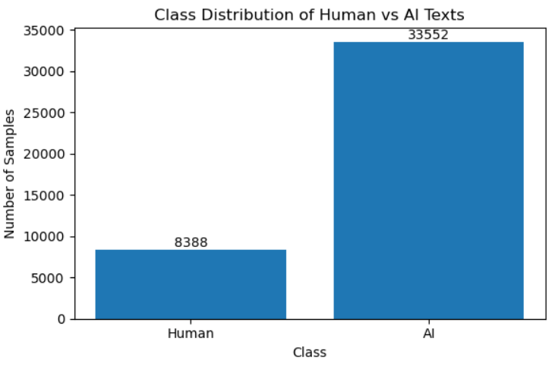
Figure 1: Class distribution of human-written and AI
- Sample Samples:
To illustrate the dataset content, random samples were inspected. Human-written abstracts exhibit formal academic structure and coherent argumentation, while AI-generated abstracts closely resemble human writing in structure and length, making manual distinction challenging.
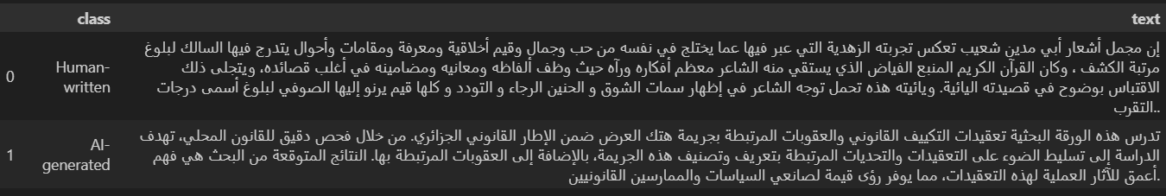
Figure2: shows example samples from both human-written and AI-generated abstracts.
- Methodology Overview
The project follows a systematic pipeline starting with collecting human-written and AI-generated Arabic texts. The data is pre-processed through cleaning, normalization, and tokenization, followed by extracting linguistic and statistical features. Traditional machine learning models and a fine-tuned AraBERT model are then trained and evaluated using standard classification metrics. Based on performance and error analysis, AraBERT is selected as the best-performing model.
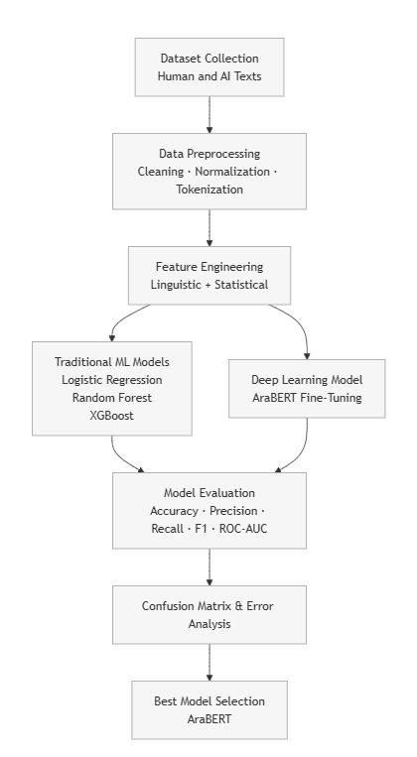
Figure 3: Methodology
5- Results & Analysis
5.1 Model Performance Comparison (Metrics Table)
To evaluate the effectiveness of different approaches for AI-generated Arabic text detection, four models were trained and evaluated on the test set: Logistic Regression, Random Forest, XGBoost, and AraBERT fine-tuned.

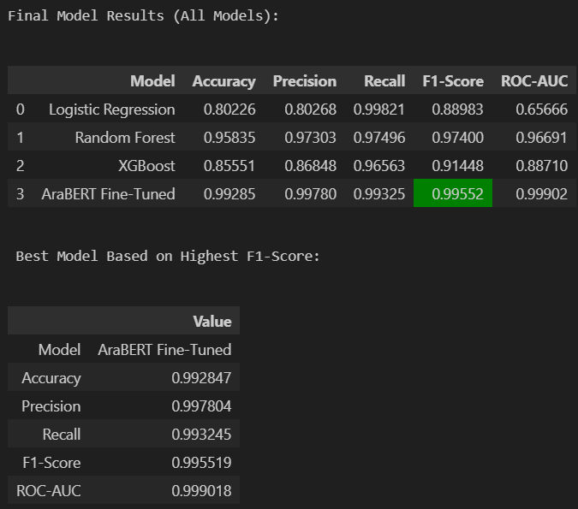

Table 4: summarizes the performance of all models using Accuracy, Precision, Recall, F1-Score, and ROC-AUC.

The results reveal clear performance differences between traditional machine learning models and the deep learning approach. Logistic Regression achieved high recall but relatively low ROC-AUC, indicating weak discriminative capability. XGBoost improved overall performance compared to Logistic Regression but remained inferior to Random Forest. Random Forest demonstrated strong and balanced performance across all metrics, confirming the effectiveness of feature-based ensemble methods.

AraBERT fine-tuned achieved the highest performance across all evaluation metrics, with an F1-score of 0.9955 and a ROC-AUC of 0.9990, significantly outperforming all traditional models. This highlights the advantage of contextual deep learning representations for capturing subtle linguistic patterns in Arabic text.

5.2 Confusion Matrix Comparison
Logistic Regression exhibits many false positives, where human-written texts are incorrectly classified as AI-generated. XGBoost reduces these errors but still shows noticeable misclassifications. Random Forest achieves a more balanced confusion matrix, with fewer false positives and false negatives.

AraBERT fine-tuned demonstrates the cleanest confusion matrix among all models, with minimal misclassified samples in both classes. This confirms its robustness and superior generalization ability compared to feature-based approaches.

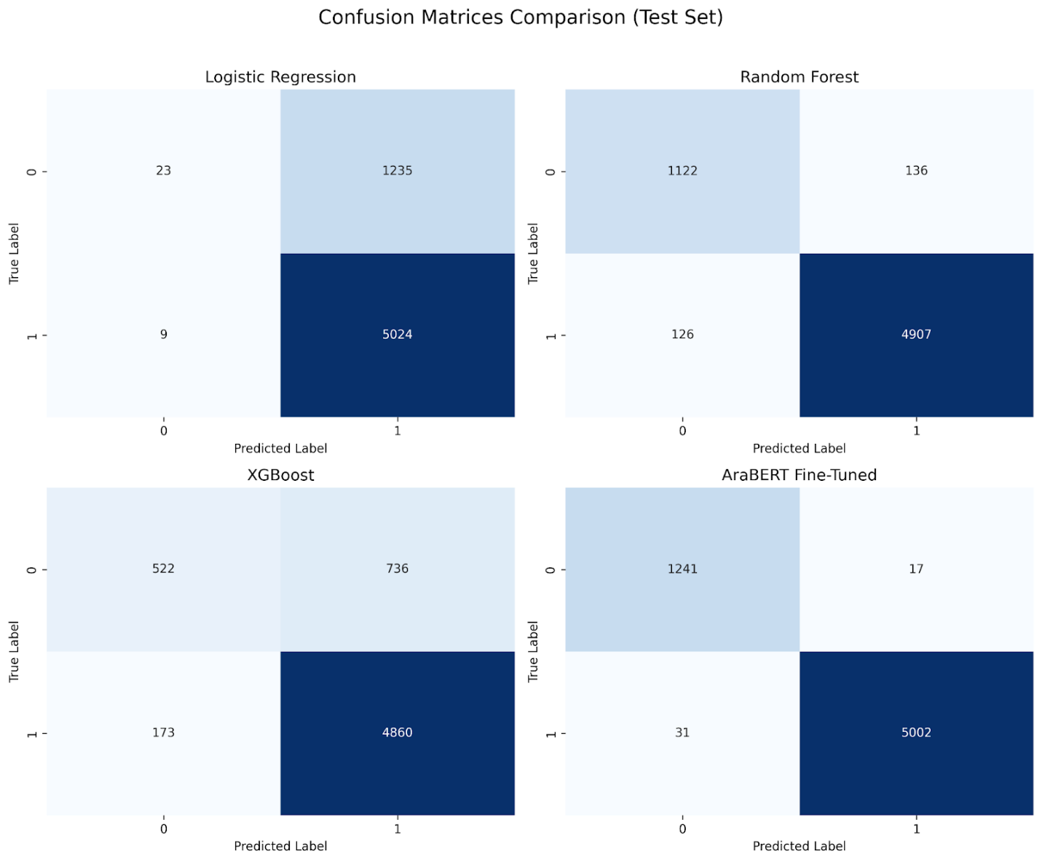
Figure 5: presents the confusion matrices of all four models on the test set.

5.3 Error Distribution and Analysis (AraBERT)
To further analyze AraBERT’s remaining errors, the distribution of false positives and false negatives was examined.
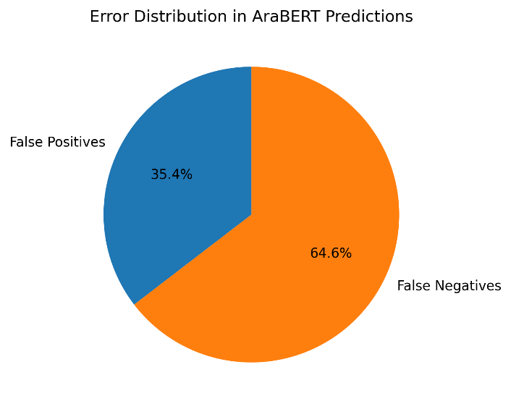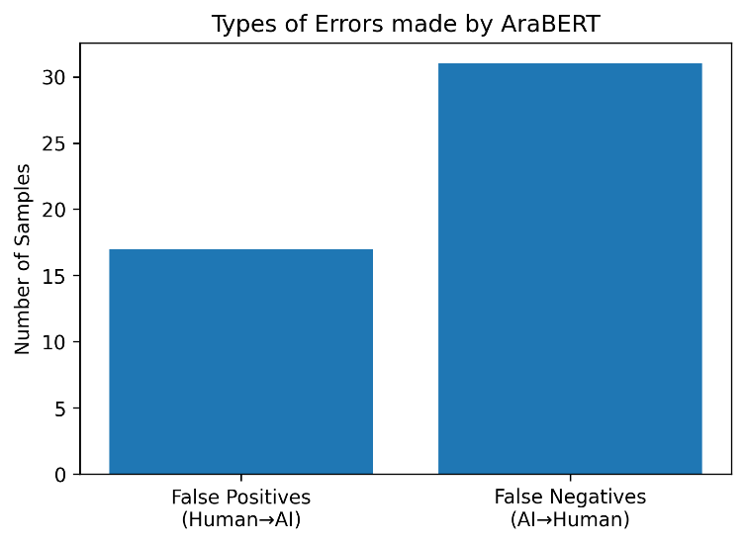
Figure 6: (pie chart) shows that approximately 64.6% of the errors are false negatives (AI-generated texts predicted as human-written), while 35.4% are false positives. Figure 7 (bar chart) further confirms this imbalance.
This behavior indicates that AraBERT is relatively conservative when labeling text as AI-generated, occasionally failing to detect highly fluent AI-generated abstracts. While this reduces false accusations, it highlights a potential risk of undetected AI-generated content. Overall, the results suggest that AraBERT effectively captures deep contextual and semantic cues, but extremely human-like AI text remains a challenge.

- Conclusion & Future Work
This project demonstrates that while traditional machine learning models can effectively detect AI-generated Arabic text using handcrafted features, deep contextual models such as AraBERT significantly outperform them. The fine-tuned AraBERT model achieves near-perfect performance, highlighting the importance of semantic and contextual representations for this task.
- Limitations
Dataset size and domain coverage are limited.
Computational requirements for fine-tuning transformer models are high.
Explainability of deep models remains challenging.
- Future Work
Future research may focus on:
Expanding the dataset to include more domains and dialects.
Exploring lightweight transformer models for efficiency.
Integrating explainable AI techniques.
Extending the approach to multilingual or cross-lingual detection.

References

Antoun, W., Baly, F., & Hajj, H. (2020). AraBERT: Transformer-based model for Arabic language understanding. arXiv preprint arXiv:2003.00104.
https://arxiv.org/abs/2003.00104

Gehrmann, S., Strobelt, H., & Rush, A. M. (2019). GLTR: Statistical detection and visualization of generated text. arXiv preprint arXiv:1906.04043.
https://arxiv.org/abs/1906.04043

Ippolito, D., Duckworth, D., Callison-Burch, C., & Eck, D. (2020). Automatic detection of generated text is easiest when humans are fooled. arXiv preprint arXiv:2005.00778.
https://arxiv.org/abs/2005.00778

Mitchell, E., Lee, Y., Khazatsky, A., Manning, C. D., & Finn, C. (2023). DetectGPT: Zero-shot machine-generated text detection using probability curvature. arXiv preprint arXiv:2303.11387.
https://arxiv.org/abs/2303.11387

