How to use our moodle

* Frist you have download moodle from this link :
* [https://download.moodle.org/windows/](https://l.facebook.com/l.php?u=https%3A%2F%2Fdownload.moodle.org%2Fwindows%2F&h=ATM3M07TmzWxqt0fHST0J32yeEqDgbKIEfrZVFV3hd_PTOvQ5uNZwOzcpK1w0at0MFahsak8Jmsv0rqZHNf9XtsCPGU6Z0mIM8kSxHvUQqKef33EjdG-Fg) our version (Moodle 3.5dev)
* Try to open the moodle from start App
* 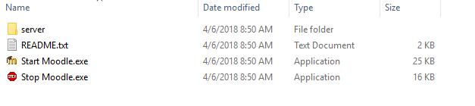open your browser on this URL (<http://127.0.01>)
* And follow the instructions
* Make sure all of the properties
* 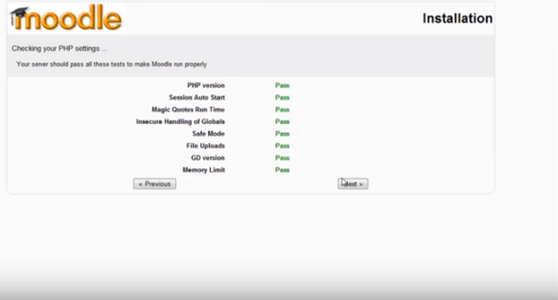
* You must complete your information account
* 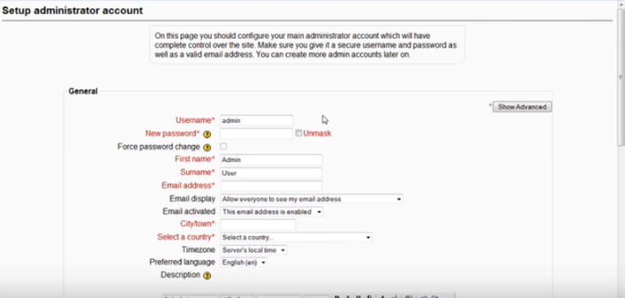
* Congratulations you have access in moodle and account on it 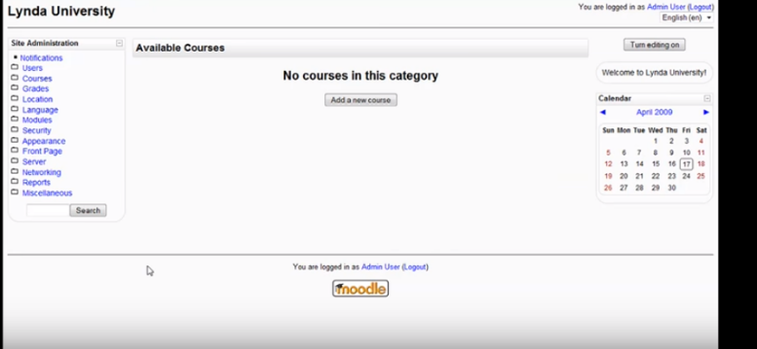
* Now you login as admin and have capabilities to add(courses ,students, teacher ) 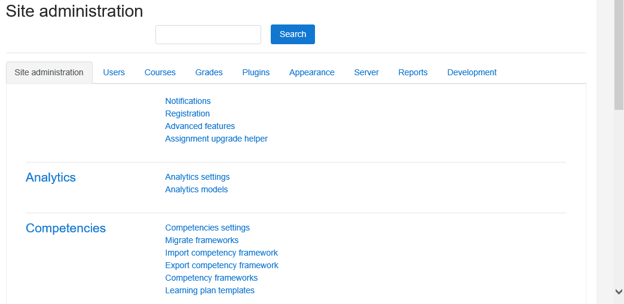
* Choose what you want be add and press in their tab
* You can manage and control all of this.
* If you want any help please check moodle documentation link (<https://docs.moodle.org/34/en/Main_page>)

How to install plugin

* First download the plugin from this link
* Then upload the zip file here

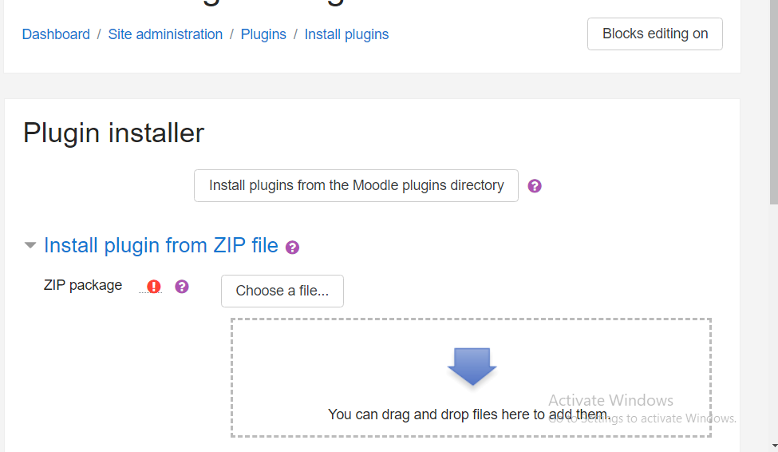

* Then follow the steps

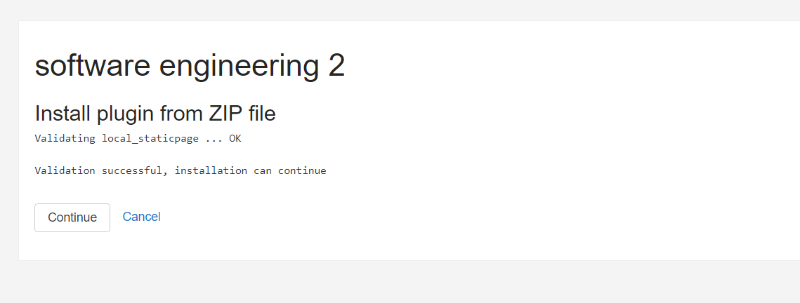

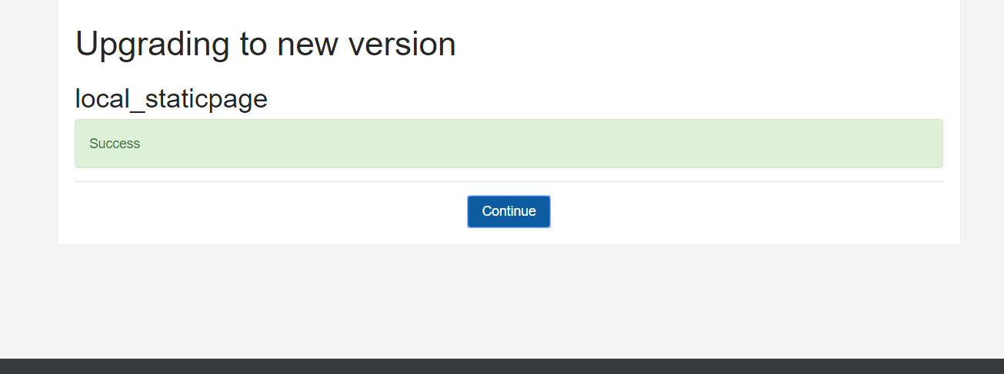

How to add user and assign it’s role

* Go to sit administration->add new user
* Fill his information

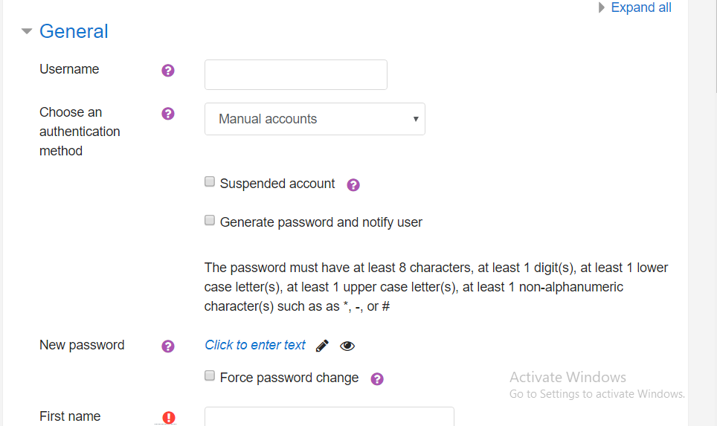

Follow steps and assign it’s role

How to create courses

* Go to sit administration->add new user->manage courses and categories
* Fill his information
  + How to use plugin

1. Go to dashboard
2. From Courses Tab choose the course you want to add a schedule to it
3. Click the settings icon on the Course_Name Header
4. Choose Turn Editing On
5. Click on Add an activity or resource
6. Click on "Scheduler" icon then Add button
7. Enter details of Schedule
8. Click On add slots From Actions Header
9. Choose "add repeated slots"or"add a single slot and set the details then click save changes
10. From the settings icon at each slot you can choose which student to set an appointment with
11. Or you can click on "send invitation" to students to choose a timeslot
12. After the student Chooses one of the slots , The Student Column of the choosen slot will be updated with the student’s name .and this Student will be removed from “Schedule by Student”
13. The teacher can revoke any Appointment And the student will be notified that the Appointment is canceld
14. After finishing the meeting you should mark them as”Seen” after clicking the checkbox near to their pictures in the slots schedule

How to use plugin as student

1-First you must receive an invitation from the teacher so that the timeslots appear in your schedule

2-Go to Dashboard

3-From Courses Tab choose the course related to the teacher who sent you the invitation

4-Click the schedule icon

5-Book one of the slots by clicking on”Book Slot” button on the desired slot

6-Confirm Booking

7-Now your choosen time slot appears in Upcoming Appointments

8-You can Cancel appointment if you want to

9-You will receive a message in case of cancelation from the teacher

(Report) **Total Hours spent by the teacher**

Download the plugin from this link <https://github.com/Microsoft/moodle-block_skypeweb.git>

1. **Click add block**
2. **Choose configurable report**
3. **Manage report**
4. **Click add report**
5. **Choose type of SQL report**
6. **Type the name of the report**
7. **Click add**
8. **Write the SQL query**
9. **Click save changes**
10. **Click on view report**

# Online / offline meeting

Download the plugin from this link <https://github.com/Microsoft/moodle-block_skypeweb.git>

1. **Turn editing into on (behind the course name ).**
2. **Click on add activity .**
3. **Choose skype .**
4. **Then choose the student to make online / offline meeting .**

Finally

* + - You can stop moodle from this app 

Good luck