Genetic Algorithm Report

1. Exploring how population size effects number of generations:

|  |  |  |
| --- | --- | --- |
| Population Size | Length of Chromosome | No. of Generations  (1st is initial iteration) |
| 4 | 8-bit | **5** |
| 5 | 8-bit | **6** |
| 6 | 8-bit | **2** |
| 7 | 8-bit | **5** |
| 8 | 8-bit | **1** |
| 9 | 8-bit | **4** |
| 10 | 8-bit | **6** |

Population Size = 5 and No. of generations = 6

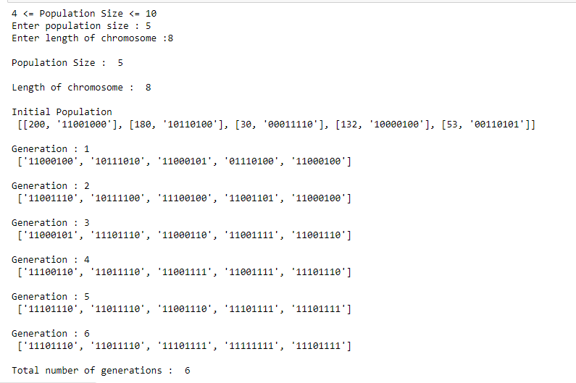

Population Size = 6 and No. of generations = 2

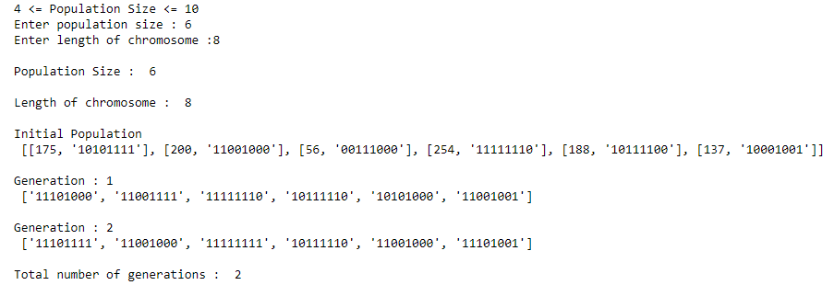

Population Size = 7 and No. of generations = 5

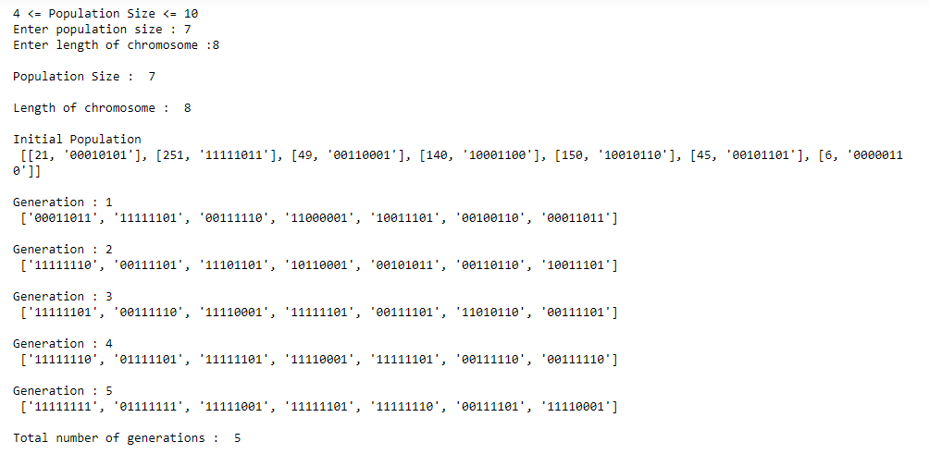

Population Size = 8 and No. of generations = 1

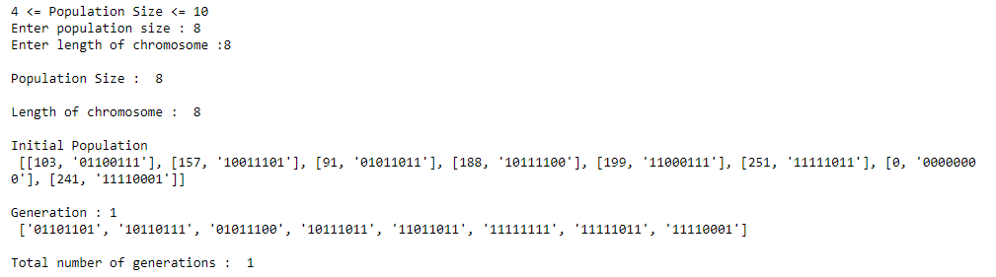

1. Exploring how length of chromosome effects number of generations:

|  |  |  |
| --- | --- | --- |
| Length of Chromosome | Population Size | No. of Generations  (1st is initial iteration) |
| 8-bit | 4 | **6** |
| 9-bit | 4 | **3** |
| 10-bit | 4 | **6** |
| 11-bit | 4 | **10** |
| 12-bit | 4 | **5** |

Length of chromosome = 8 and no. of generations = 6

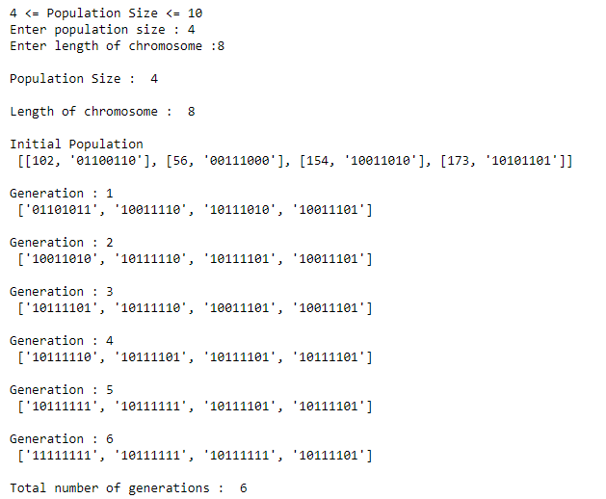

Length of chromosome = 9 and no. of generations = 3

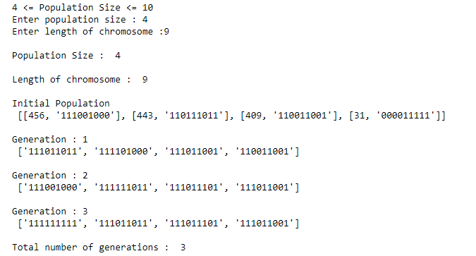

Length of chromosome = 10 and no. of generations = 6

