Results

1. Cohort Assembly and Metadata Overview
Using the iReceptor Statistics API (v0.3.0), we queried seven immune repertoire datasets spanning COVID-19 disease severities and healthy controls. The initial query returned metadata for all repertoires across these studies. After applying quality filters—removing non-biological controls (covid_vaccine_new-Fb, covid_vaccine_new-Water), subjects with insufficient data (lp16_Igblast-D159, lp16_Igblast-D154, lp16_Igblast-Hu-1), and restricting to peripheral blood samples only—we assembled a final cohort of 103 subjects across 6 datasets.
An important cohort design decision involved the healthy control group. The covid19 dataset (CD3) contained three subjects labeled as "healthy" (H3, H4, H8); however, these individuals were recruited within the context of a COVID-19 study and may have been exposed to the virus, introducing potential confounding. We therefore excluded these three subjects from the healthy control group and instead used the dedicated healthy cohort from the lp16_Igblast dataset (HC1), which comprises six pre-pandemic healthy donors with no known COVID-19 exposure, providing a cleaner baseline for comparison.
The 13 raw disease labels across datasets were harmonized into six standardized categories: Severe (n=27), Mild (n=41), Moderate (n=9), Recovered (n=12), COVID Naive (n=8), and Healthy (n=6). This harmonization mapped labels such as "Early phase hypoxaemia" to Severe, "non-severe" to Mild, and "Early phase-Stable/Improving" to Moderate, enabling cross-dataset comparisons despite heterogeneous annotation practices.
Figure 1 shows the number of subjects contributed by each dataset. Figures 2–3 illustrate the raw disease stage distribution and the harmonized disease spectrum across the assembled cohort, including the contribution from the HC1 healthy controls.
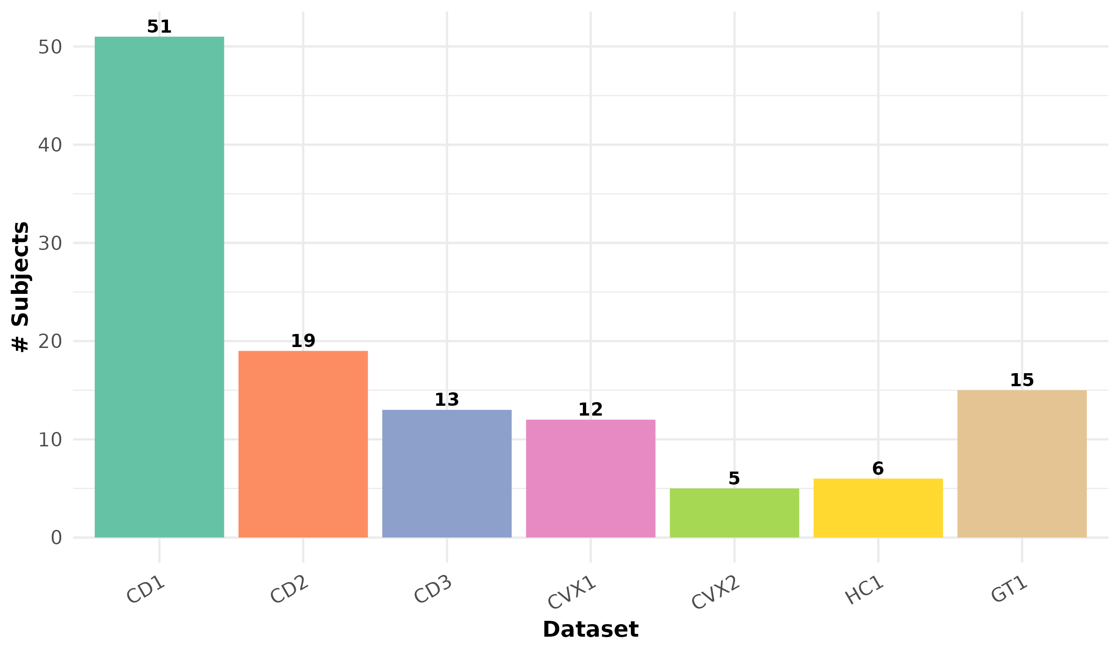
Figure 1. Number of subjects per dataset after quality filtering.
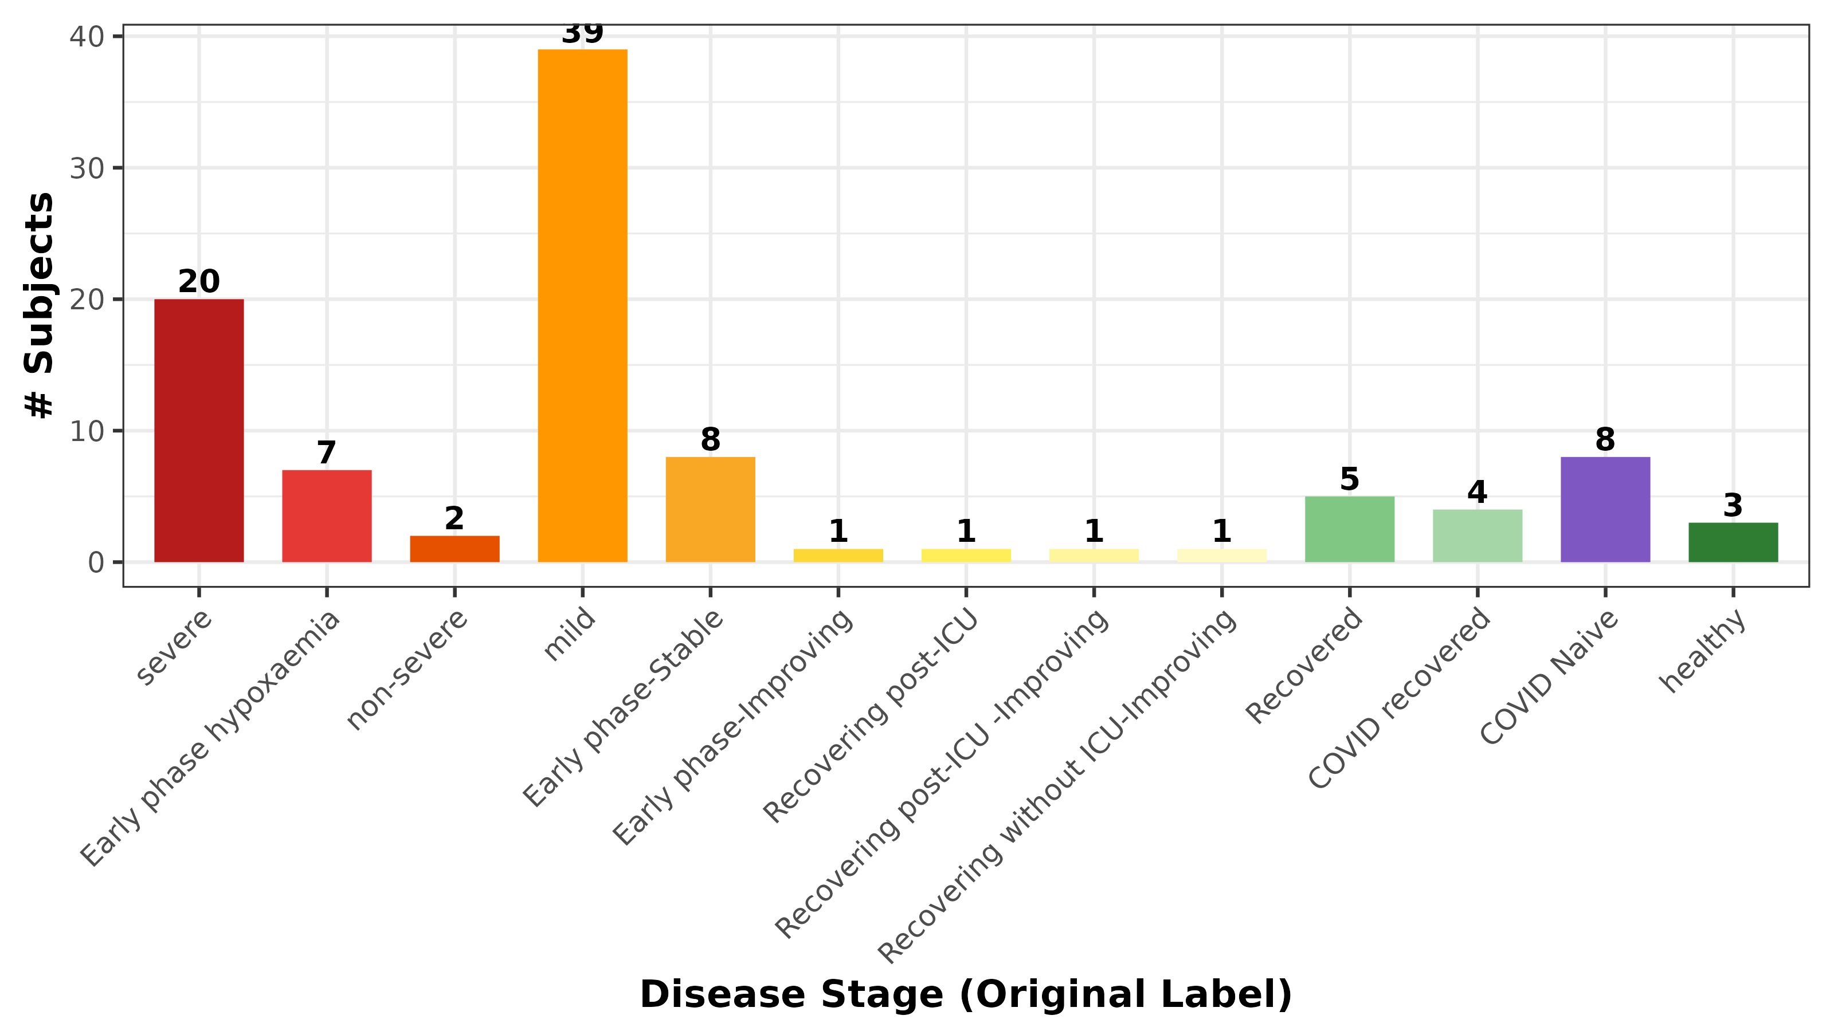
Figure 2. Distribution of raw disease stage labels across all datasets, colored by severity gradient.
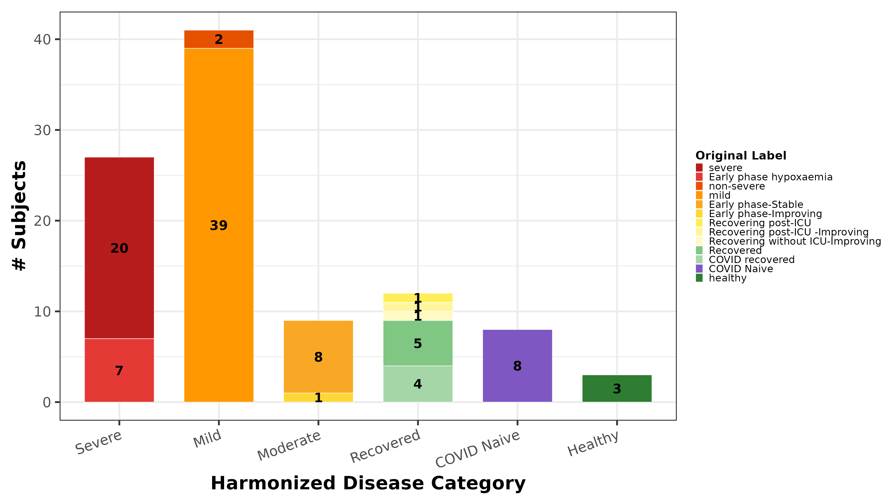
Figure 3. Harmonized disease categories with mapping from original labels.
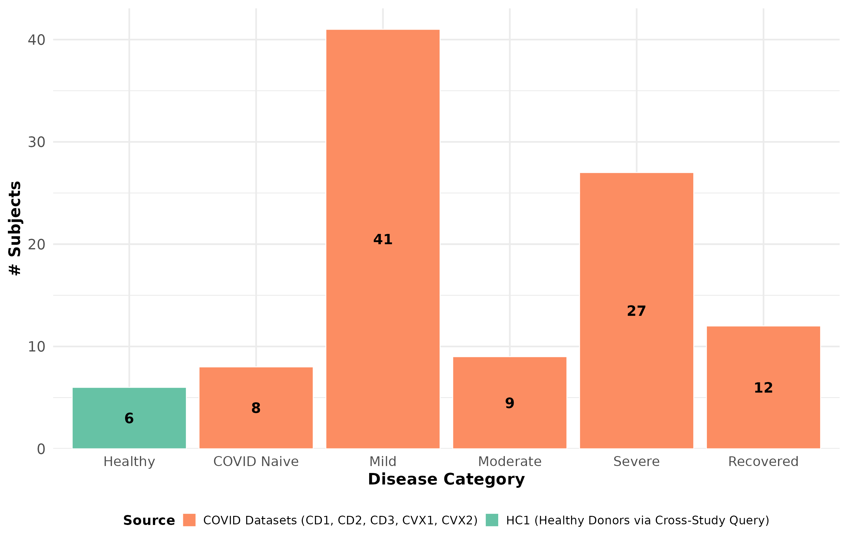
Figure 4. Disease spectrum coverage showing COVID dataset and HC1 healthy control contributions.

1.1 Demographic Characteristics
Demographic metadata availability varied across studies. Figure 5 summarizes the sex and age group distributions where reported. Figure 6 shows the cross-tabulation of disease categories by sex, while Figure 7 presents the age distribution by disease category.
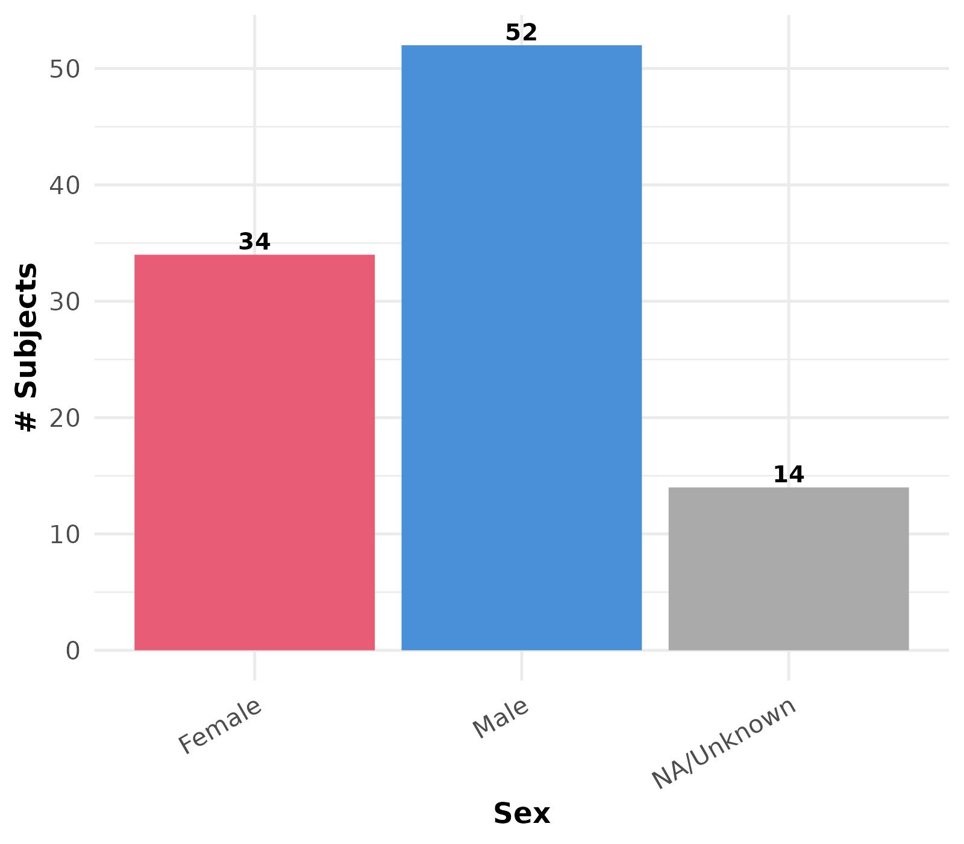
Figure 5. Distribution of subjects by sex across the cohort.
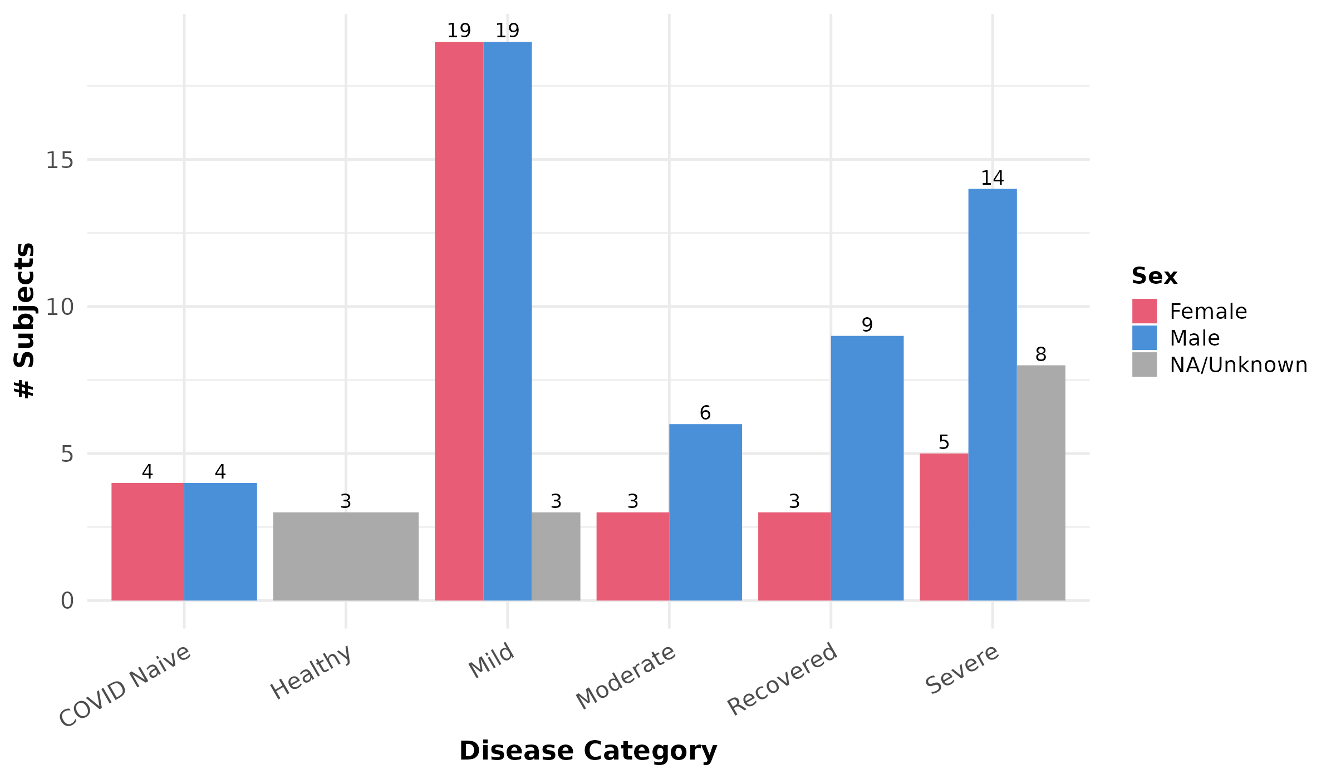
Figure 6. Disease category breakdown by sex.
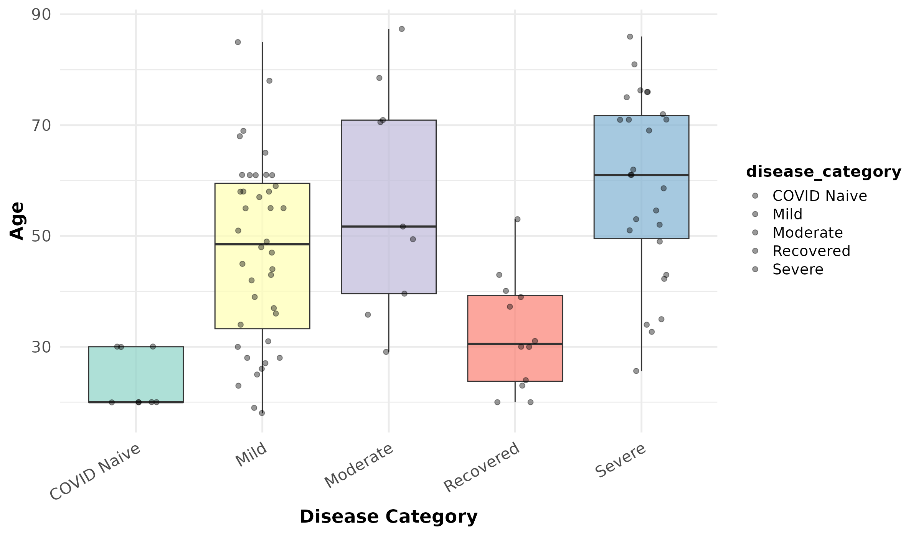
Figure 7. Age distribution across disease categories.

2. Clonal Analysis by Disease Severity
All clonal analysis endpoints were computed via the iReceptor Statistics API using metadata fingerprint grouping, which enables disease-stratified analysis across federated datasets. Unless otherwise noted, all analyses include 103 subjects across six disease categories. Clone size analysis is based on 96 subjects (seven CD1 subjects—Cov14, Cov39, Cov45, Cov49, Cov60, Cov66, and Cov70—were not returned by the API for this endpoint). All boxplots display the median (horizontal line), interquartile range (box), and mean ± standard deviation (red diamond with error bars).

2.1 Clonal Diversity (Clone Count)
Clone count, representing the number of unique clonal lineages per subject, serves as a measure of B-cell repertoire diversity. As shown in Figure 8, Recovered subjects exhibited the highest median clone count (21,527), followed by COVID Naive (16,682), suggesting that prior SARS-CoV-2 exposure drives clonal diversification. In contrast, Mild subjects showed the lowest median clone count (2,478), consistent with a less pronounced immune response. Severe and Moderate groups displayed intermediate diversity (median 5,089 and 5,085, respectively), with substantial inter-subject variability.
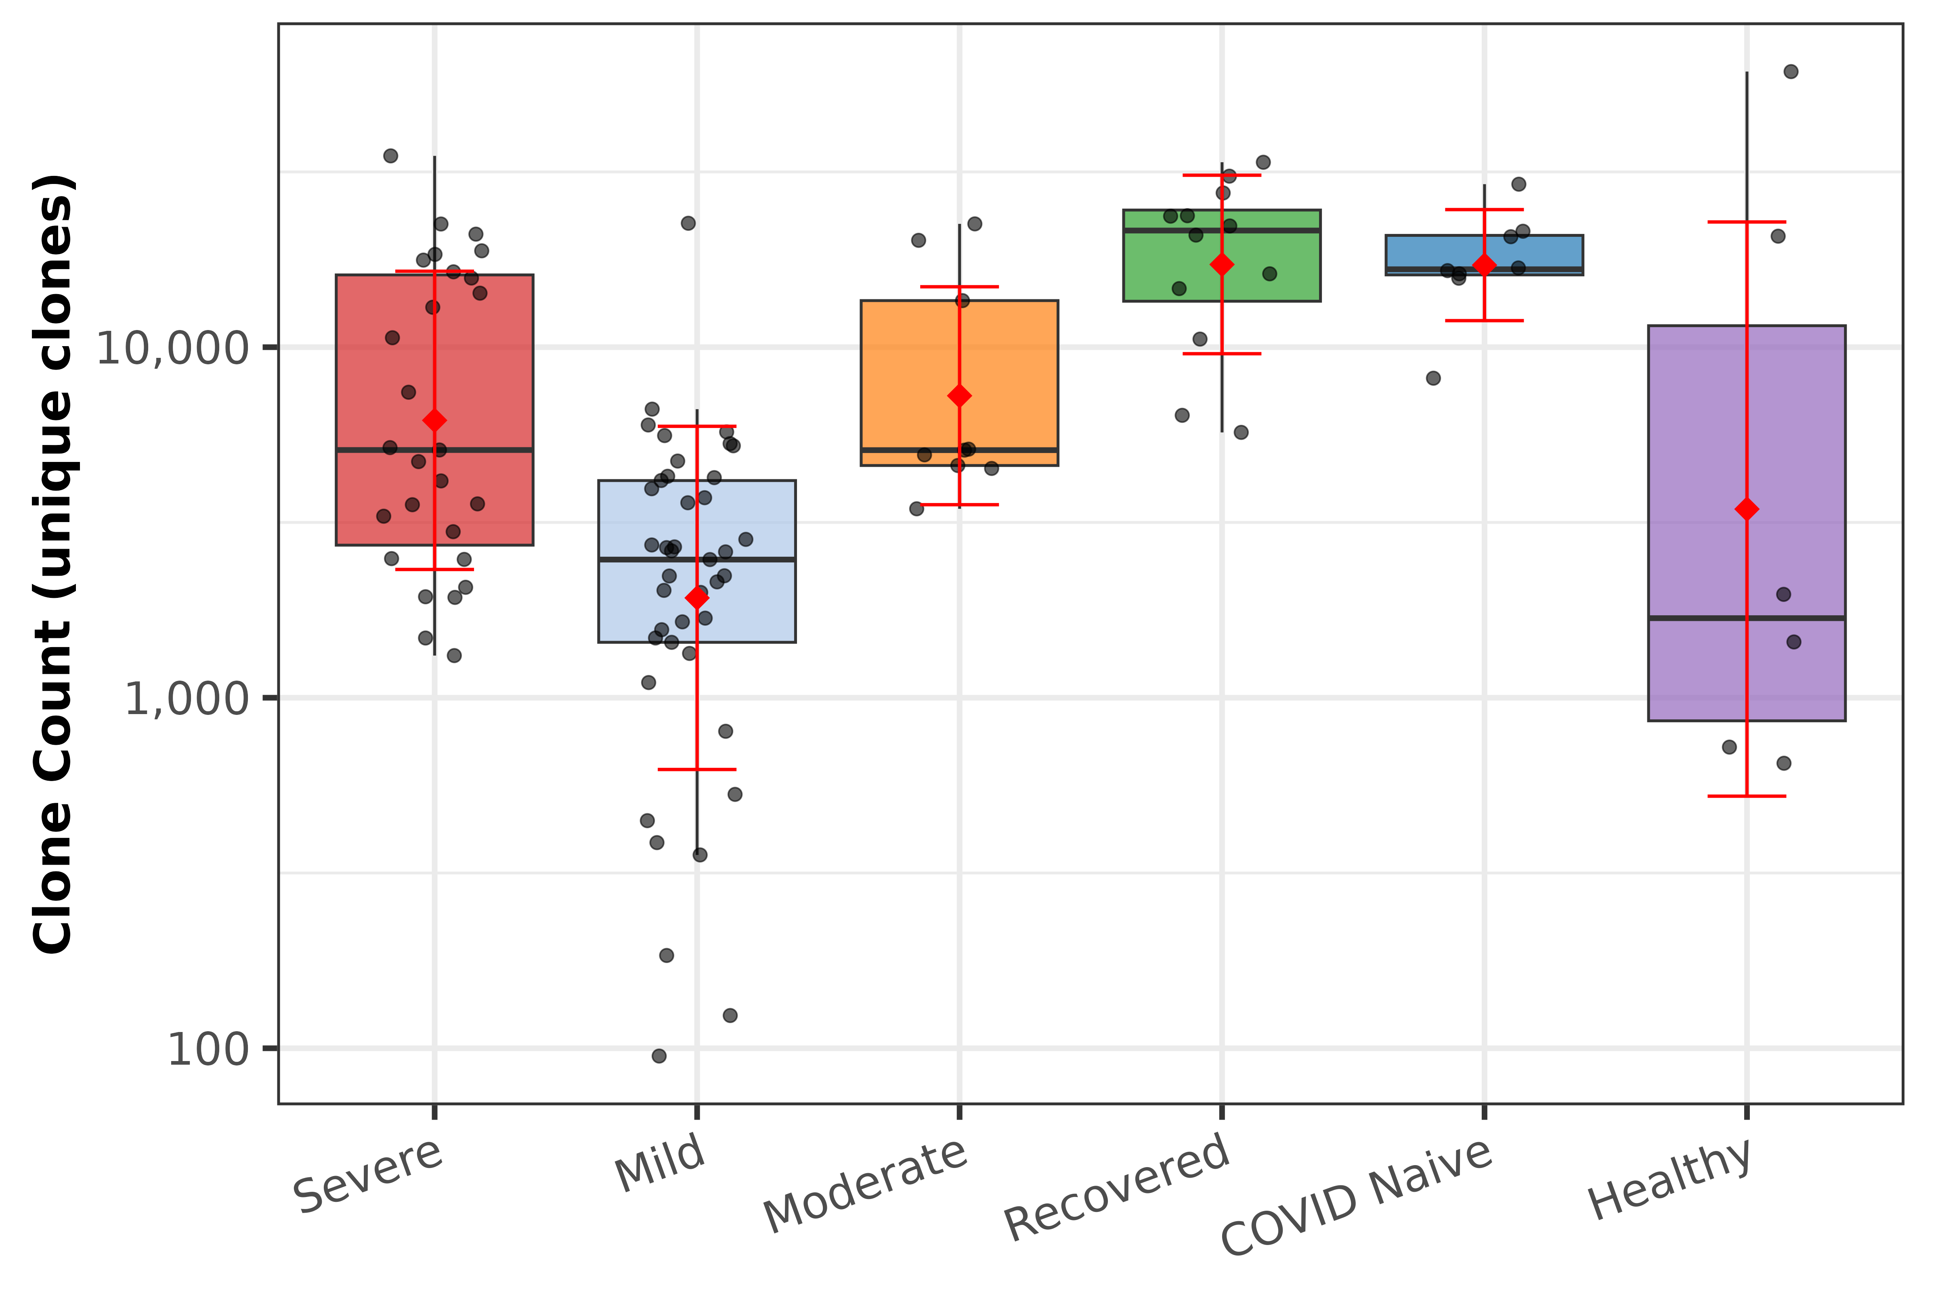
Figure 8. Unique clone count (clonal diversity) by disease category. Y-axis on log10 scale.

2.2 Clonal Dominance (Top-X Proportions)
To assess clonal dominance, we quantified the proportion of total immunoglobulin copies accounted for by the top 10, top 100, and top 1,000 most expanded clones per subject. Figure 9 presents the stacked composition for each subject, grouped by disease category.
Healthy controls showed the most oligoclonal repertoires, with the top 1,000 clones accounting for a median 99.3% of total copies. The Moderate group exhibited the highest median top-10 dominance (23.1%), indicating concentrated clonal expansion. Mild subjects displayed the lowest top-10 proportion (10.6%), consistent with more polyclonal repertoires. Recovered subjects showed relatively low top-1,000 dominance (62.0%), indicating the most evenly distributed repertoires among the disease groups.
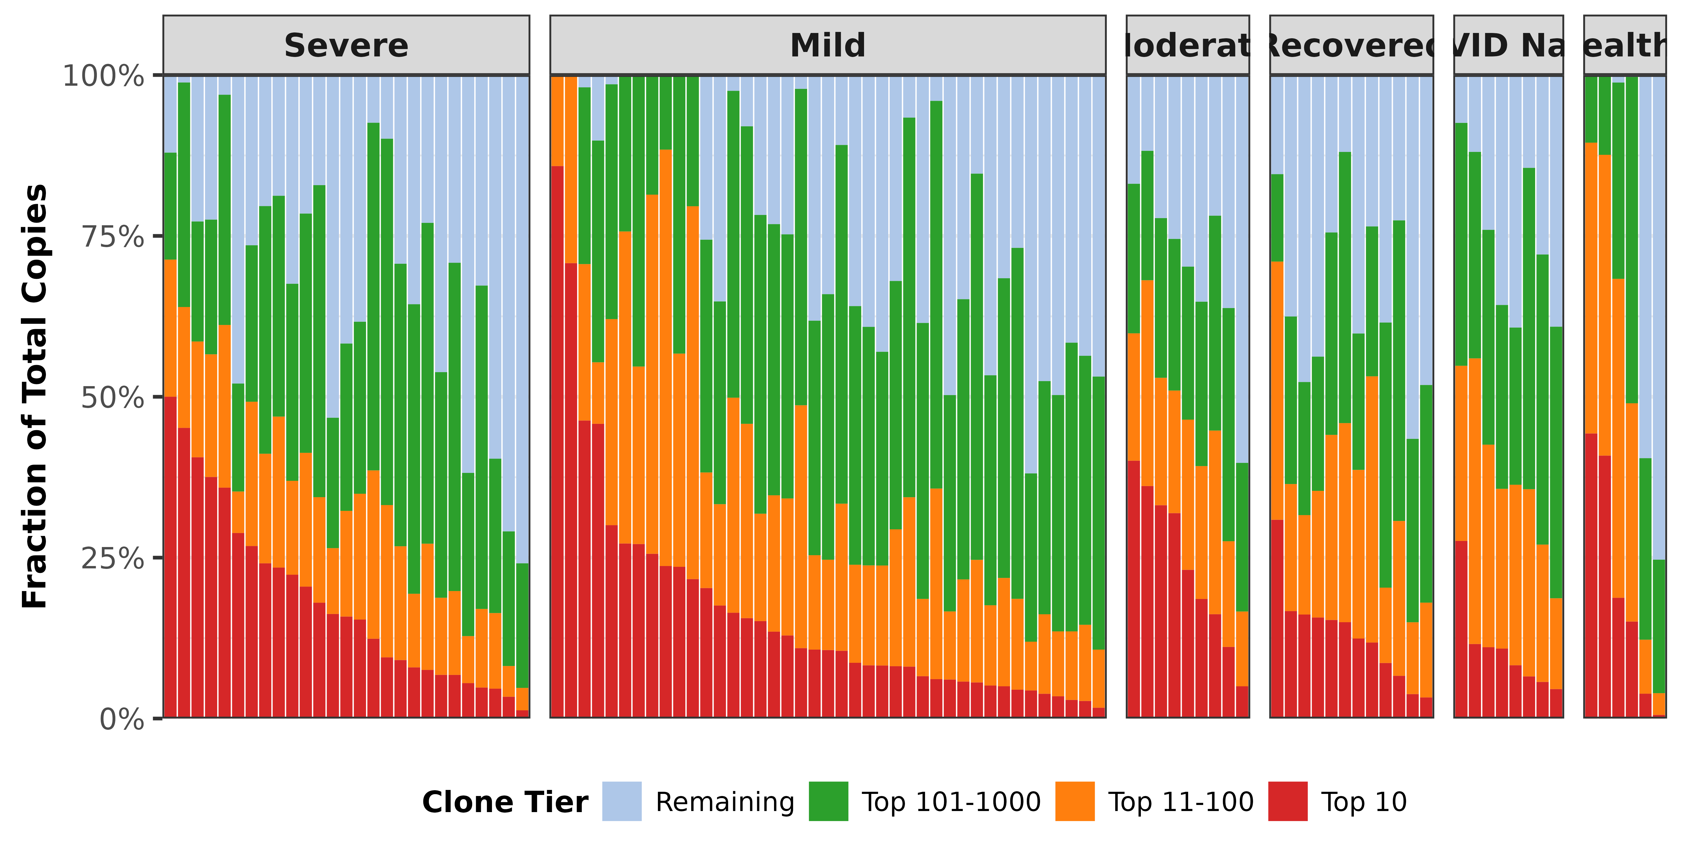
Figure 9. Stacked bar representation of clonal dominance showing the fraction of total copies from the top 10, 11–100, 101–1000, and remaining clones per subject, grouped by disease category.

2.3 CDR3 Length Analysis
CDR3 region length is a key determinant of antigen-binding specificity. We examined the average CDR3 amino acid length across the top 10, top 100, and top 1,000 most expanded clones per subject. As shown in Figure 10, CDR3 lengths were generally consistent across clone tiers and disease categories, ranging from approximately 14–18 amino acids.
Notably, Severe subjects exhibited the longest median CDR3 in their top-10 clones (17.7 AA), compared to Healthy controls (13.8 AA). This pattern was less pronounced in less expanded tiers (top 100 and top 1,000), where CDR3 lengths converged across disease groups. The CDR3 length difference between top-10 and top-1,000 clones (Figure 11) reveals that Severe subjects had a positive median difference (+1.2 AA), indicating that the most expanded clones tend to have longer CDR3 regions, while Healthy controls showed a negative difference (−2.1 AA), suggesting their most expanded clones have shorter CDR3 sequences.
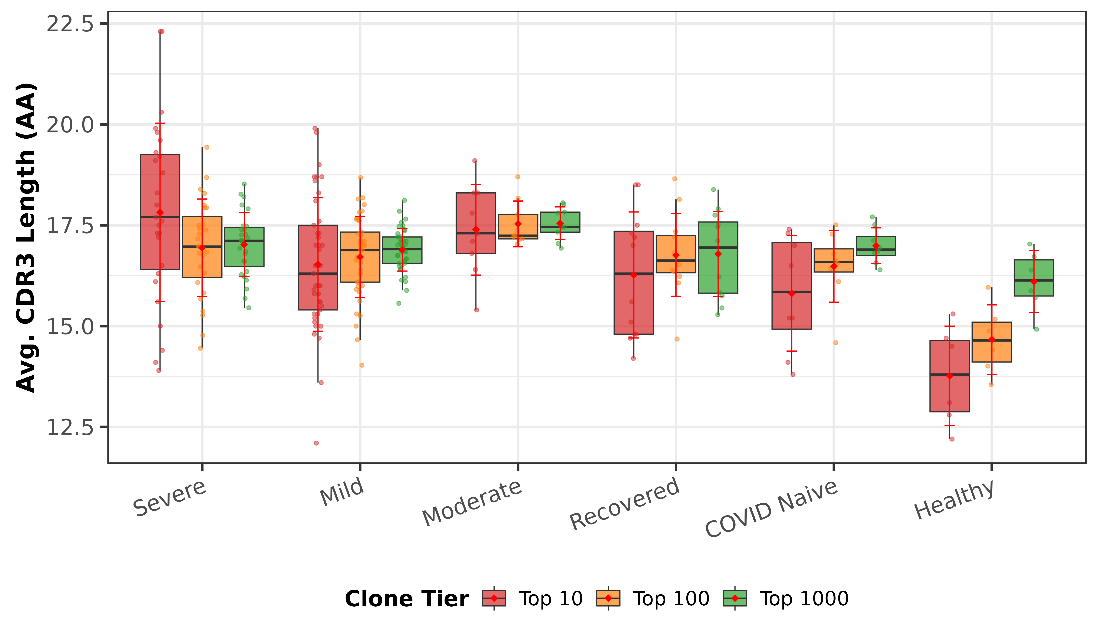
Figure 10. Average CDR3 amino acid length by clone tier (Top 10, Top 100, Top 1000) across disease categories.
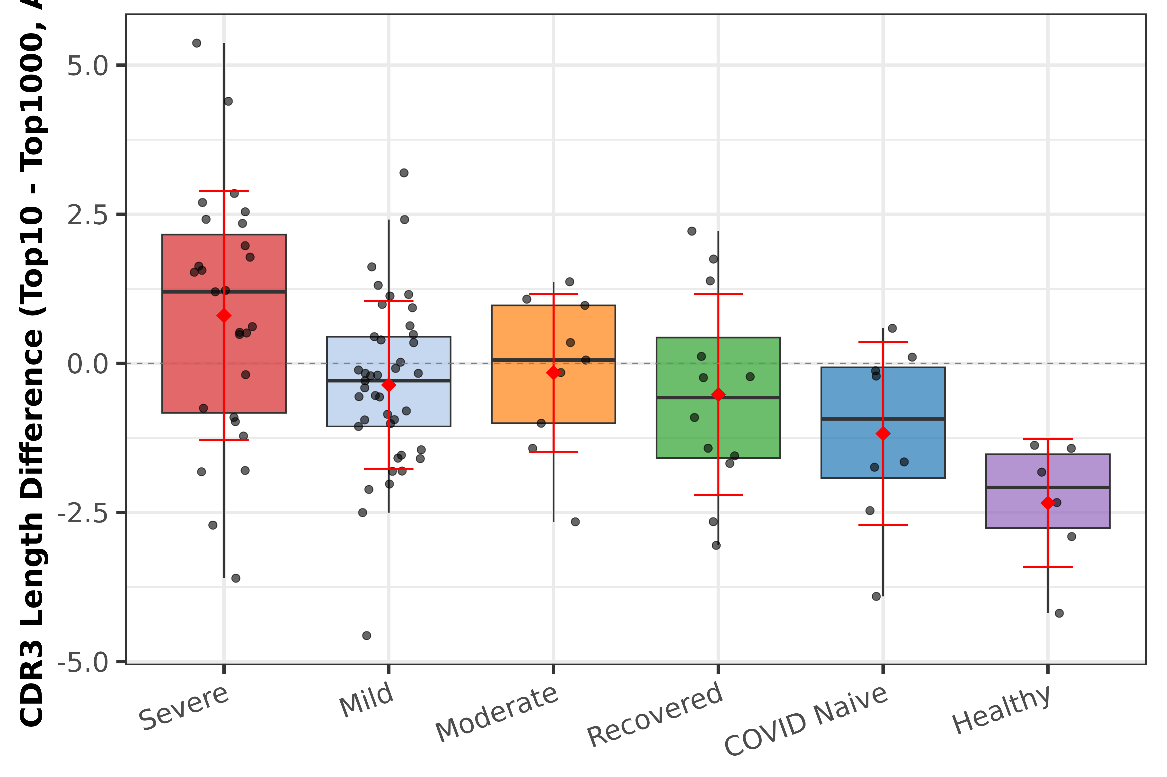
Figure 11. CDR3 length difference between the top 10 and top 1000 clones per subject, reflecting selective pressure on CDR3 length in the most expanded clones. Dashed line indicates zero difference.

2.4 Somatic Hypermutation
Somatic hypermutation (SHM) levels reflect the degree of affinity maturation in B-cell clones. Figure 12 presents the average mutation count across clone tiers by disease category. COVID Naive subjects showed the highest median mutation levels across all tiers (top 10: 119.0, top 100: 92.9, top 1000: 27.3), consistent with extensive affinity maturation from prior immune challenges. Recovered subjects also exhibited elevated mutation (top 10: 107.0), suggesting ongoing or recent germinal center activity.
The mutation gradient (Figure 13)—defined as the difference in average mutation count between the top 10 and top 1,000 clones—was positive across all disease categories, indicating that more expanded clones consistently carry more mutations. COVID Naive subjects showed the steepest gradient (median 92.2), while Mild subjects had the shallowest (median 33.2), suggesting a more uniform mutation profile in mild disease.
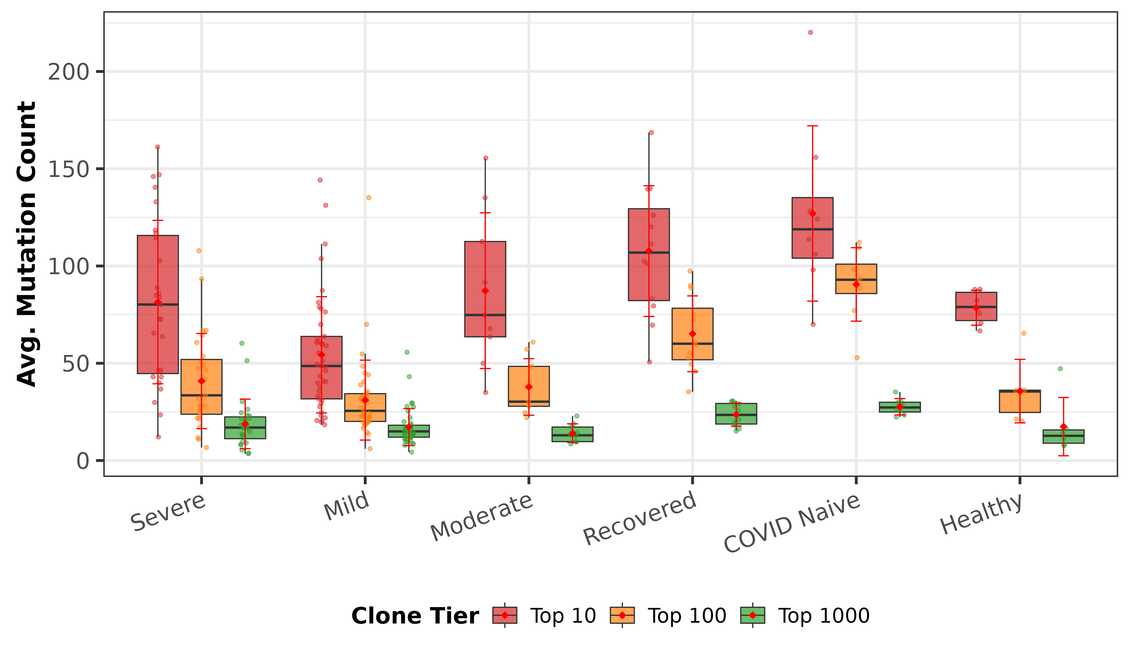
Figure 12. Average somatic hypermutation count by clone tier across disease categories.
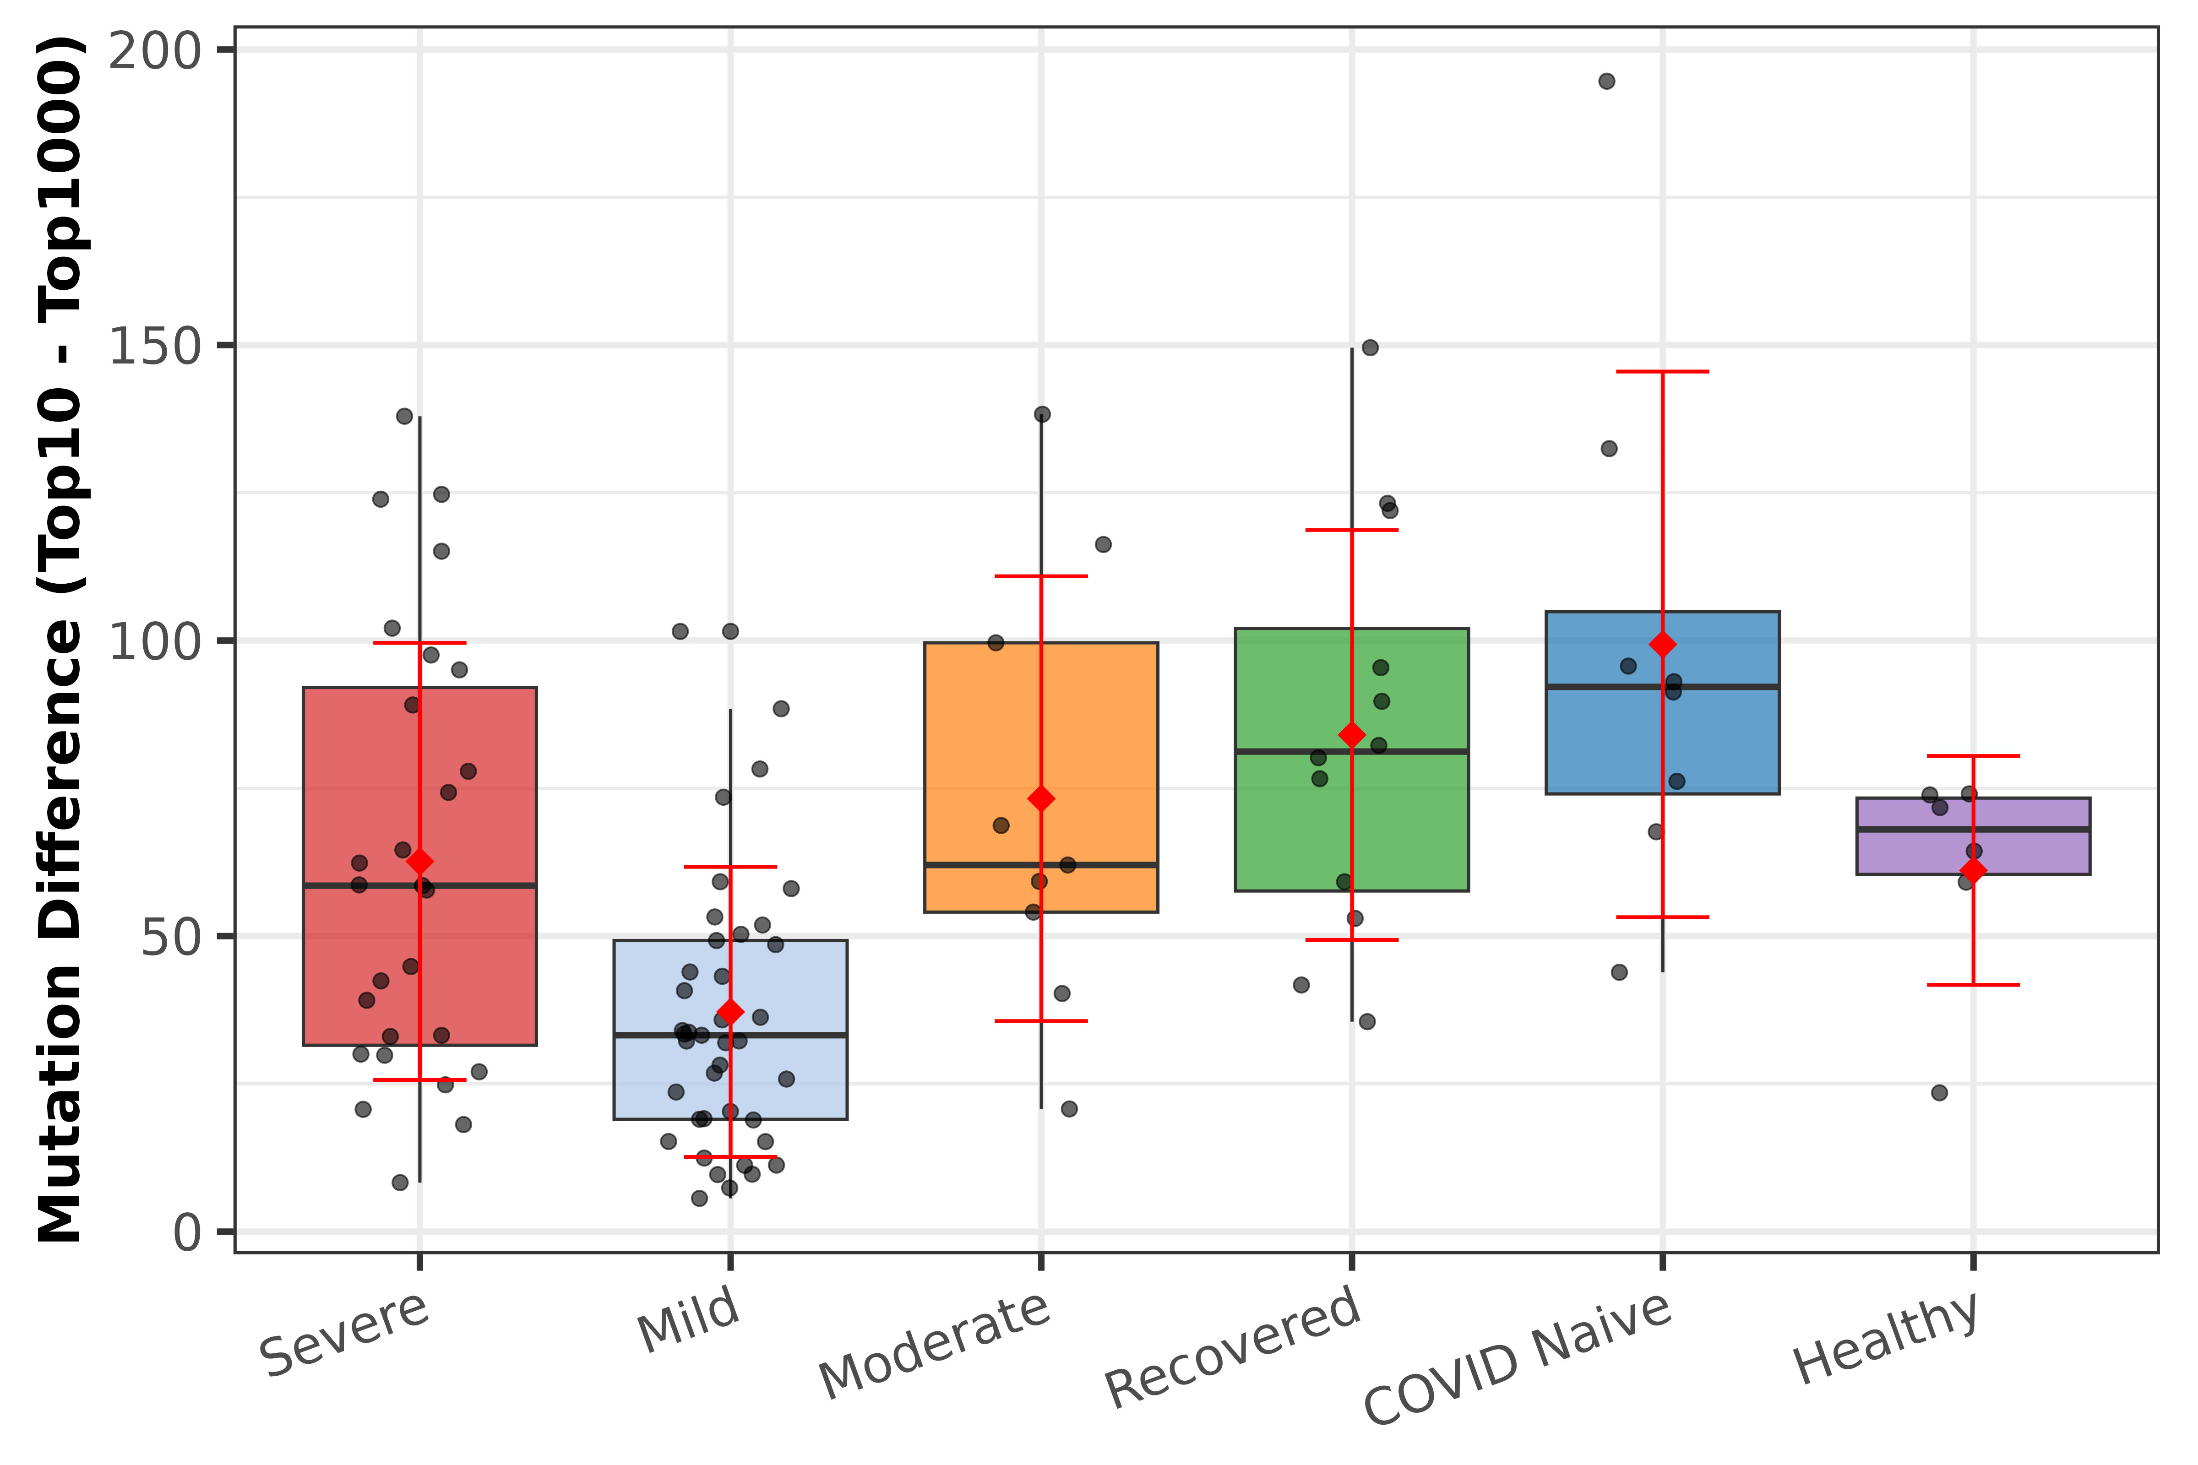
Figure 13. Mutation gradient (Top 10 minus Top 1000 mutation count) by disease category, reflecting selective enrichment of mutated clones.

2.5 Region-Specific Mutation (CDR vs. FW)
To distinguish between antigen-driven selection (reflected in CDR mutations) and background mutation accumulation (reflected in framework mutations), we analyzed mutation rates separately for CDR and FW regions. As shown in Figures 14–15, FW regions consistently carried more mutations than CDR regions across all disease categories, consistent with the longer total length of framework regions.
Mild subjects exhibited the highest median CDR mutation rate (5.11 mutations per clone), followed by Severe (4.39) and Healthy (4.23). Framework mutations were highest in Mild (11.3) and Severe (9.11) groups. The CDR-to-FW mutation ratio was lowest in Moderate subjects (0.209), suggesting a relatively higher proportion of background over antigen-driven mutations, while Recovered subjects showed the highest ratio (0.600), indicative of stronger antigen-driven selection.
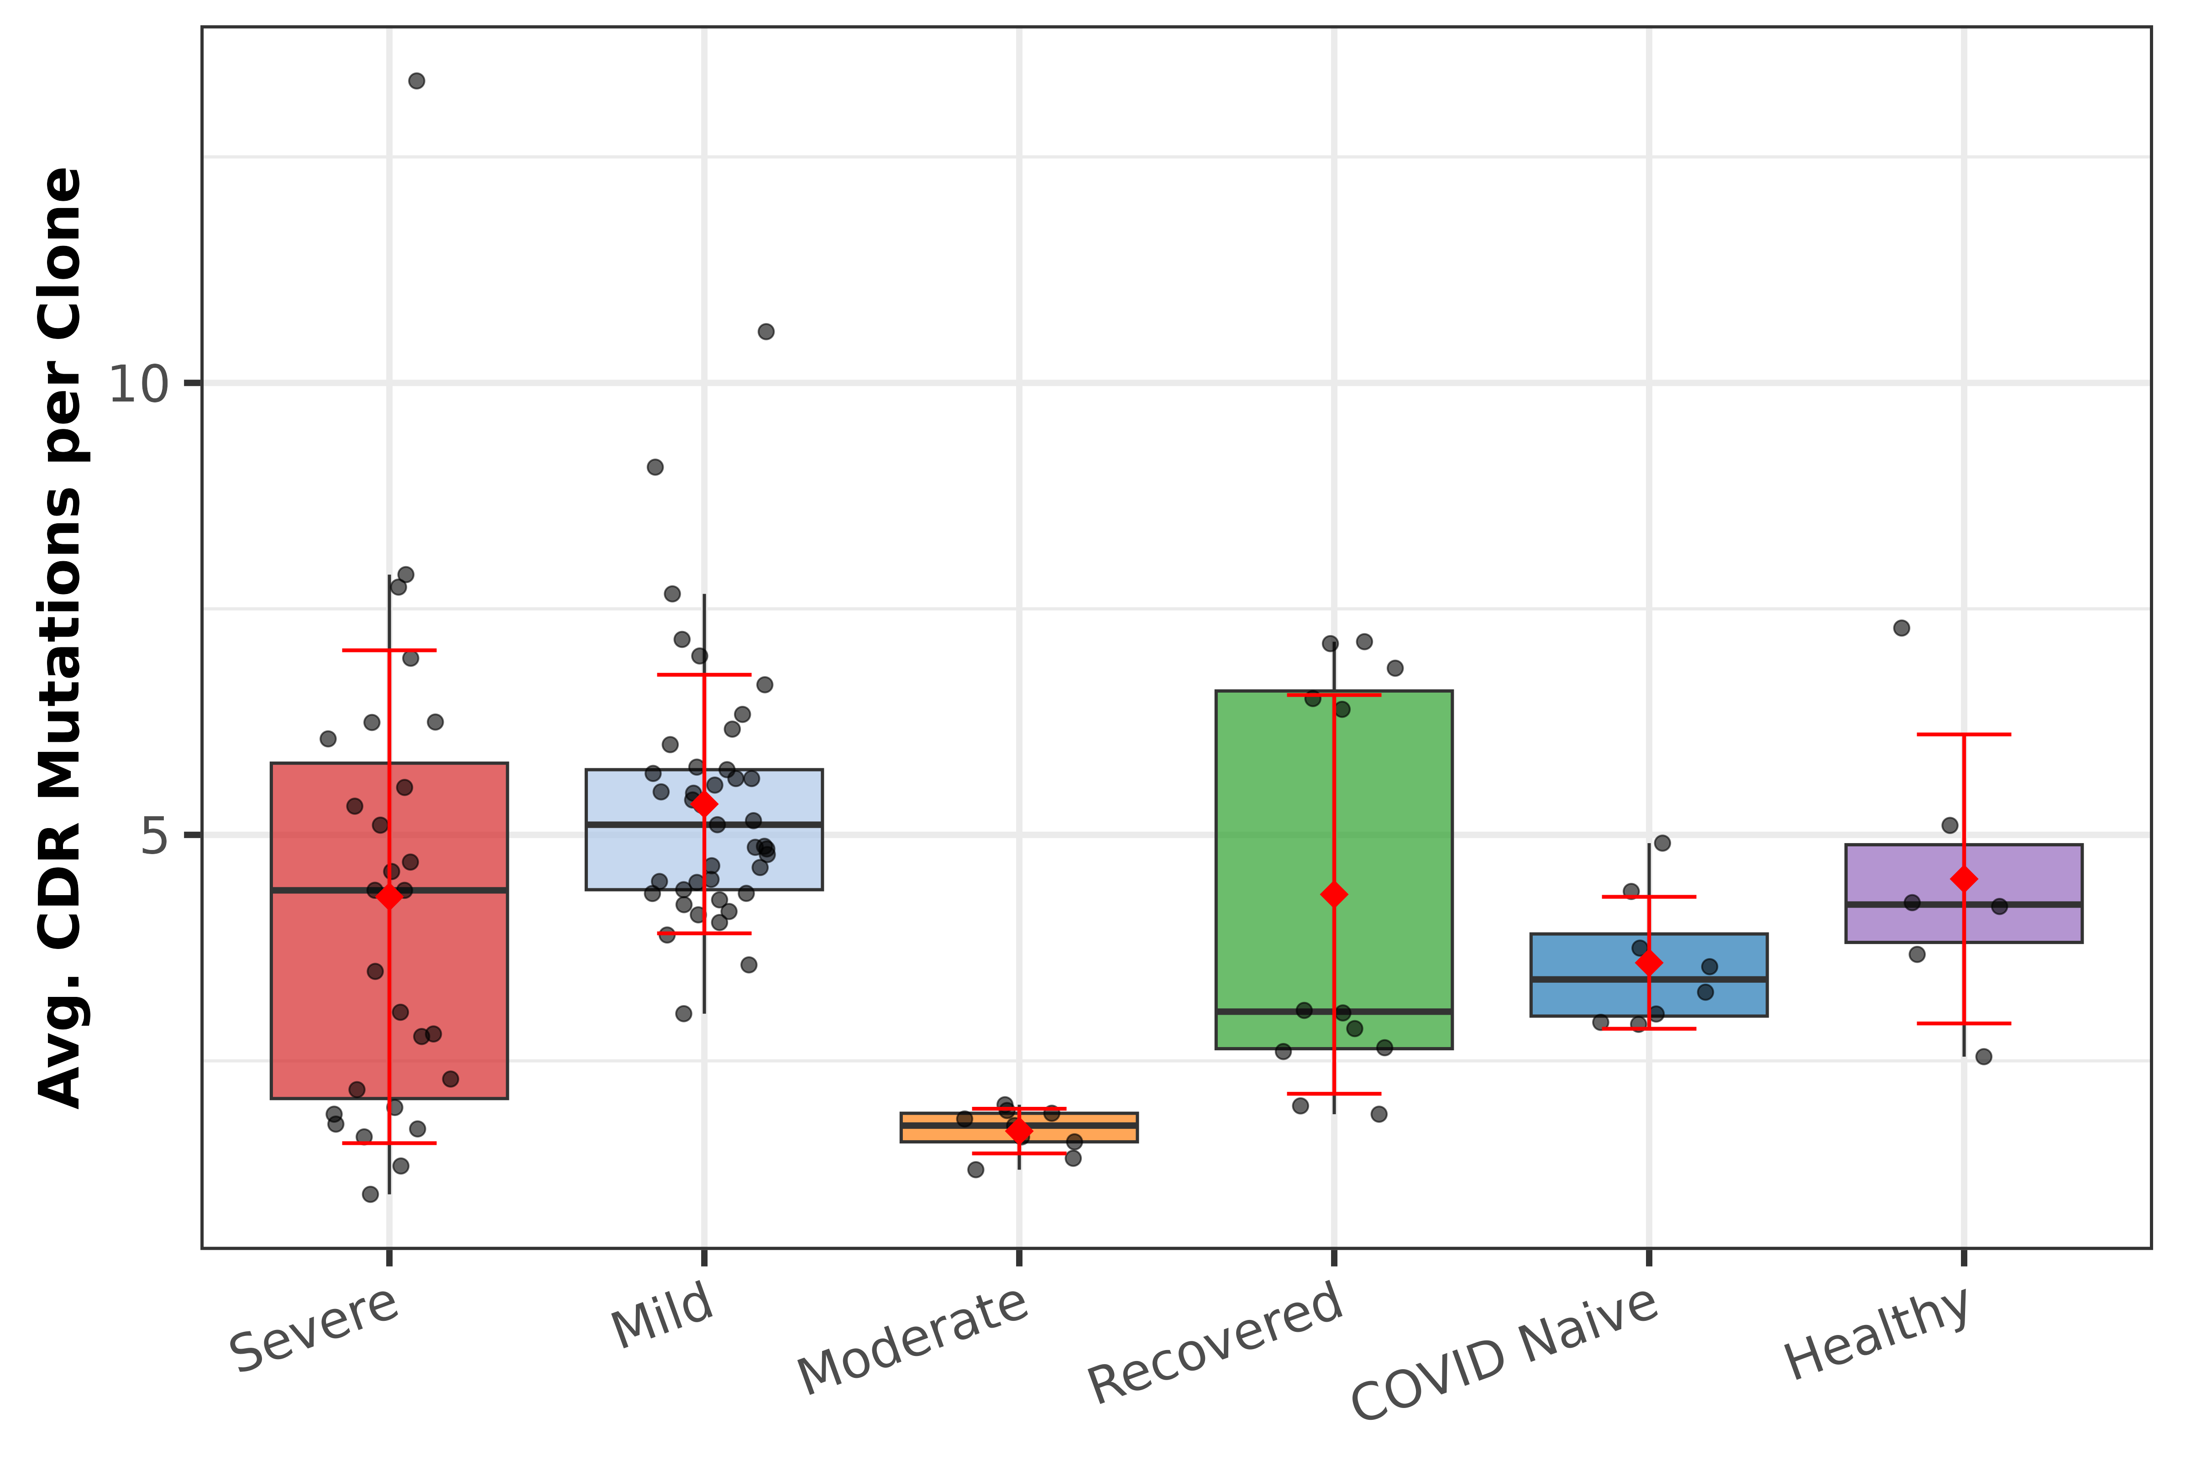
Figure 14. Average CDR region mutations per clone by disease category.
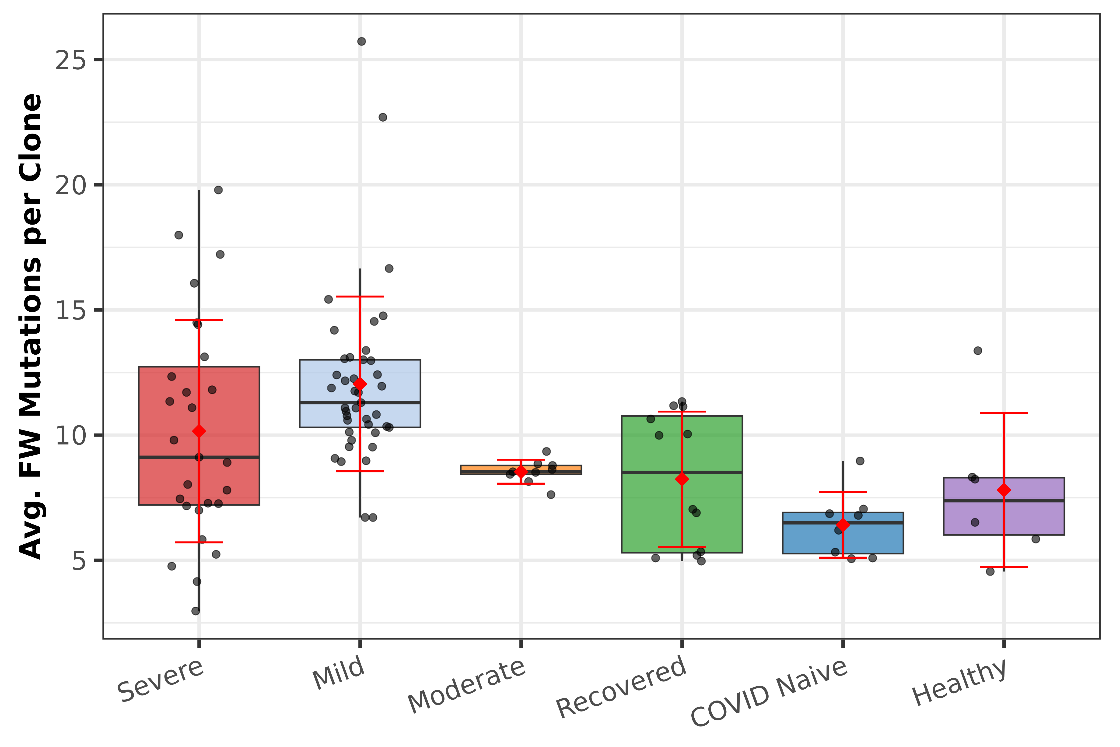
Figure 15. Average framework (FW) region mutations per clone by disease category.

2.6 Replacement-to-Synonymous (R/S) Mutation Ratio
The R/S ratio quantifies the balance between replacement (non-synonymous) and synonymous mutations, serving as a proxy for positive selection pressure. An R/S ratio significantly above 1 suggests antigen-driven selection. As shown in Figure 16, CDR regions exhibited markedly higher R/S ratios than framework regions across all disease categories, consistent with CDR regions being the primary target of antigen-driven selection.
The median CDR R/S ratio ranged from 1.98 (Moderate) to 3.18 (Mild), all well above 1.0, confirming strong positive selection in CDR regions. Framework R/S ratios were more constrained (range: 1.51–1.72), consistent with structural conservation pressures. The dashed line in Figure 16 indicates an R/S ratio of 1.0 (neutral selection). Notably, Moderate subjects showed the lowest CDR R/S ratio (1.98), which, combined with their low CDR-to-FW mutation ratio (Section 2.5), suggests reduced antigen-driven selection relative to other disease groups.
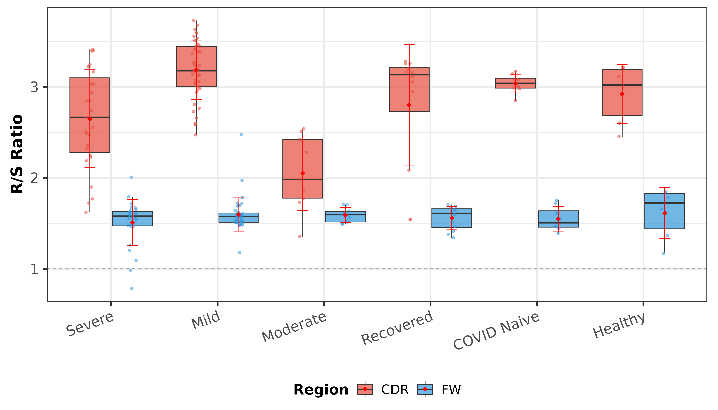
Figure 16. Replacement-to-synonymous (R/S) mutation ratio in CDR and FW regions by disease category. Dashed line at R/S = 1.0 indicates neutral selection.

2.7 Clone Size Distribution
Clone size analysis was performed on 96 of 103 subjects (seven CD1 Severe subjects were not returned by the API for the clone_size endpoint). Clone size represents the number of copies (sequences) per clonal lineage, with all clones in this dataset having a minimum size of 21 copies. We defined "highly expanded" clones as those with more than 100 copies.
Figure 17 presents the median clone size per subject across disease categories. COVID Naive subjects exhibited the highest median clone size (103 copies), followed by Recovered (73.5) and Moderate (69.5) groups. Mild subjects had the lowest median clone size (37 copies), consistent with their lower clonal dominance observed in the Top-X analysis.
The number of highly expanded clones (>100 copies) varied dramatically across disease categories (Figure 18). COVID Naive subjects had the most expanded clones (median 157), while Mild subjects had a median of 0 expanded clones, indicating that most Mild subjects lack clones exceeding the 100-copy threshold. Among subjects with expanded clones, Figure 19 shows the mean size of those expanded clones, with similar distributions across disease categories.
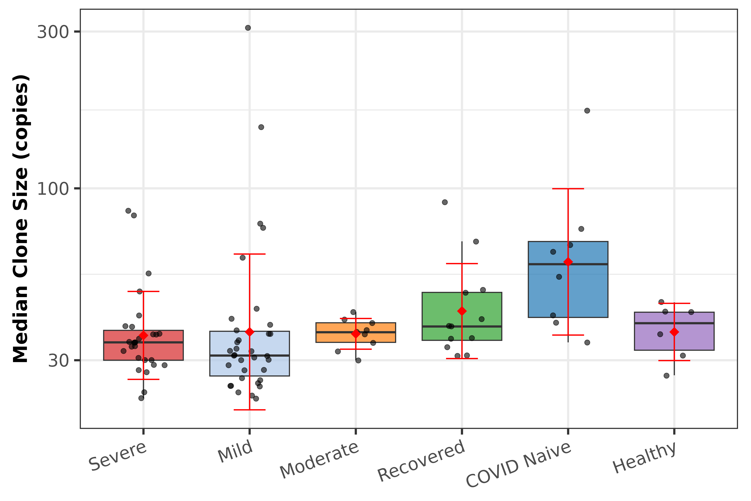
Figure 17. Median clone size (copies per clone) by disease category. Y-axis on log10 scale.
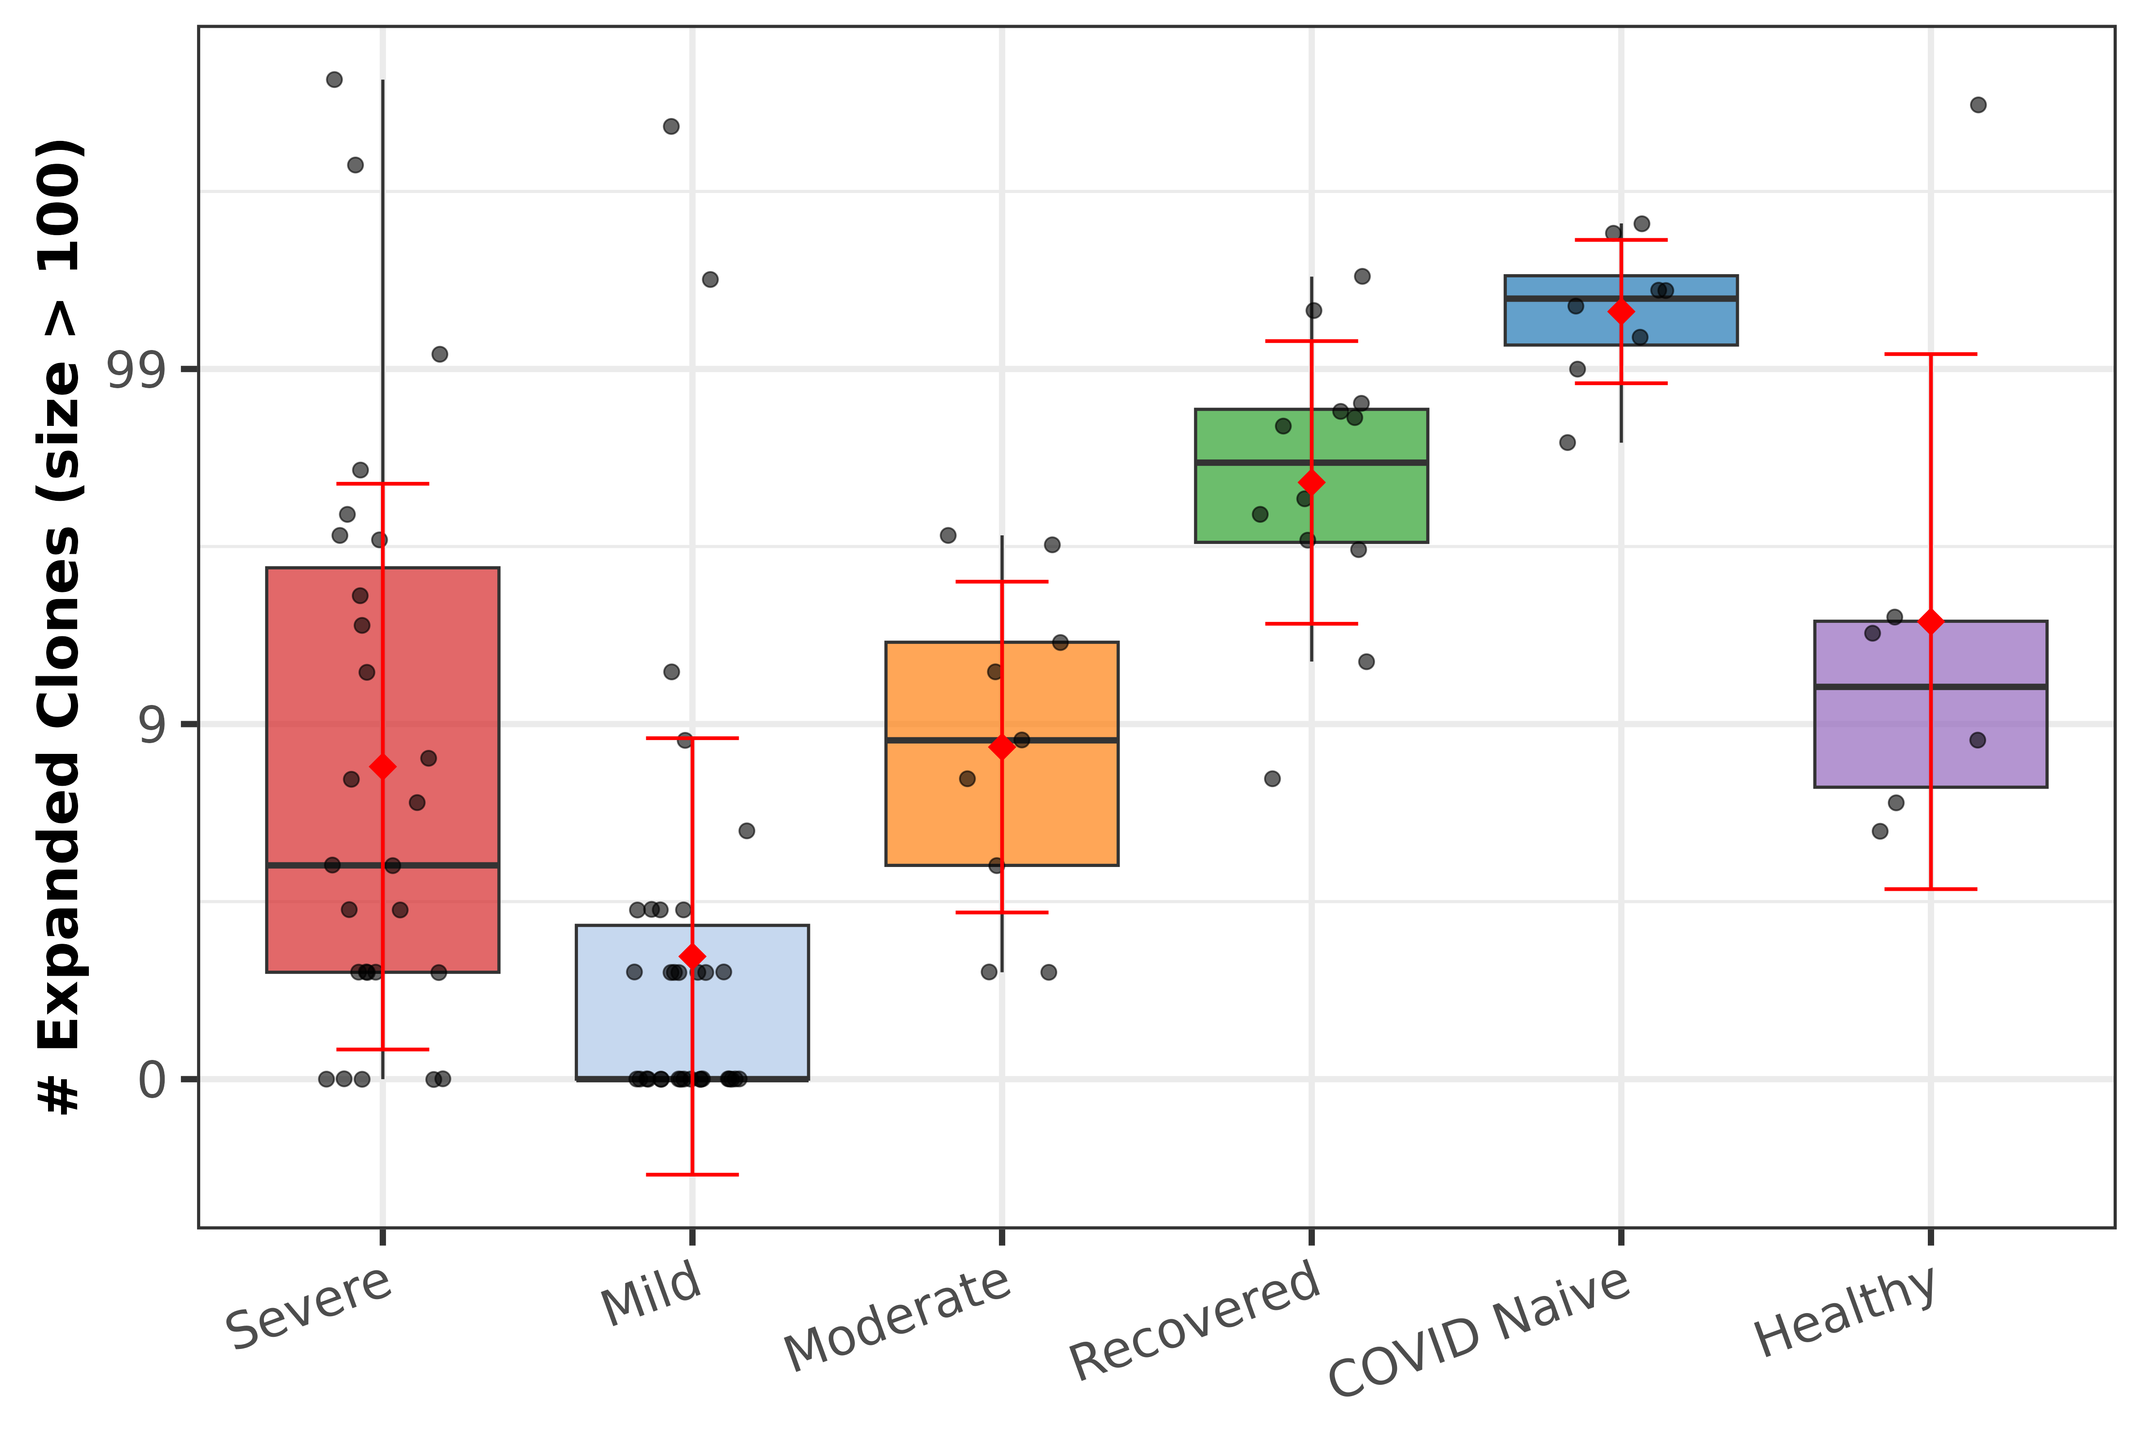
Figure 18. Number of highly expanded clones (>100 copies) per subject by disease category. Y-axis on log10 scale (+1 offset).
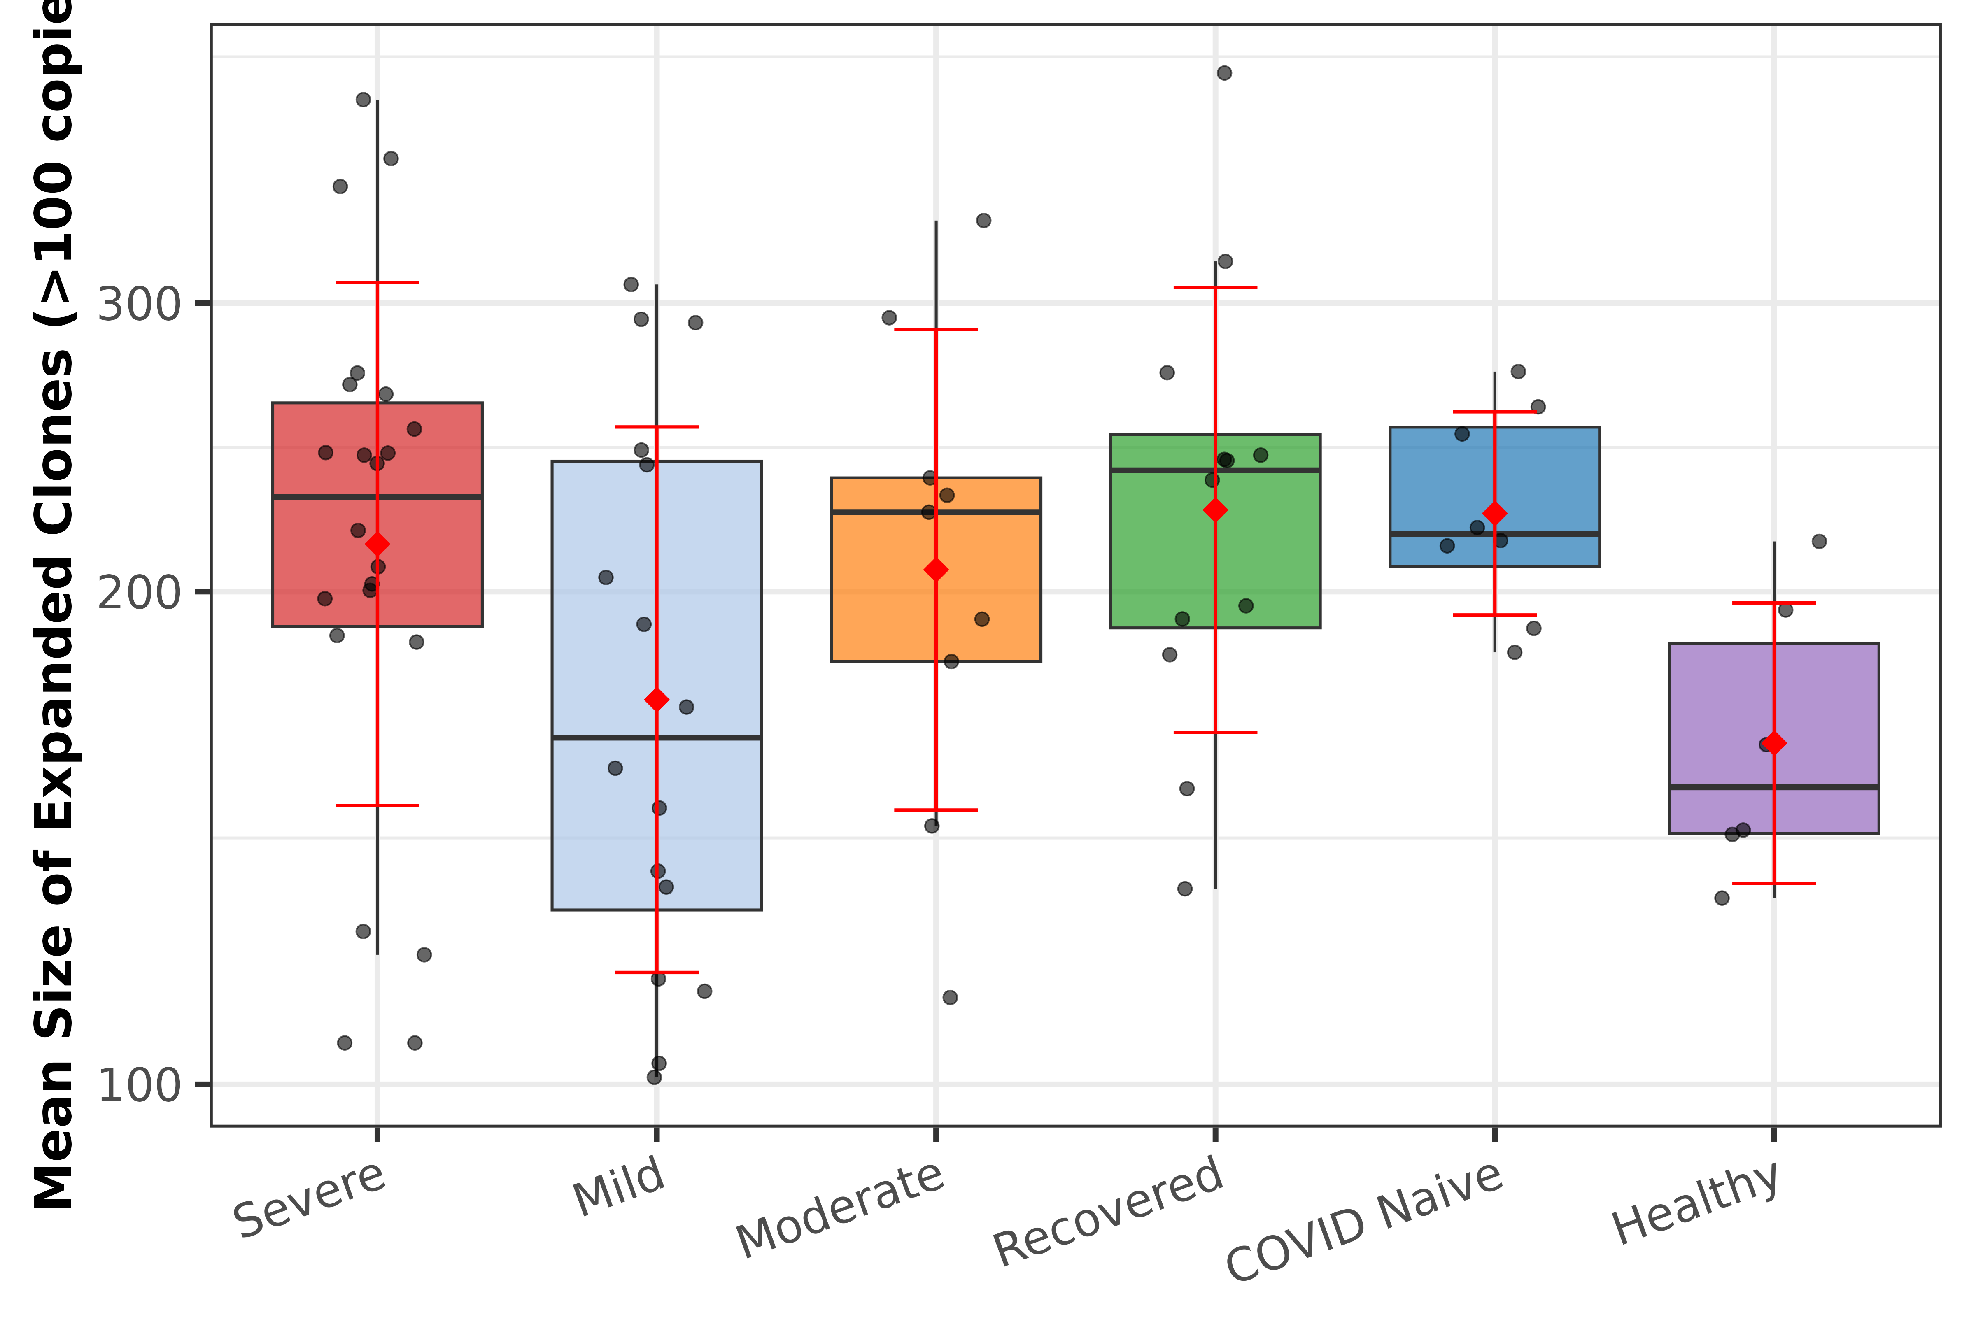
Figure 19. Mean clone size of highly expanded clones (>100 copies) only, by disease category. Y-axis on log10 scale.

3. Summary of Key Findings
This study demonstrates the utility of the iReceptor Statistics API for federated immune repertoire analysis across seven heterogeneous datasets. Key findings by disease category:
Severe (n=27): High clone count variability with intermediate diversity (median 5,089 clones). Longest CDR3 in top-10 clones (17.7 AA) with positive CDR3 length gradient, suggesting selection for longer binding loops. Moderate mutation levels and R/S ratios.
Mild (n=41): Lowest clonal diversity (median 2,478), lowest clone size (median 37 copies), and fewest expanded clones (median 0), consistent with a limited immune response. Shallowest mutation gradient but highest CDR R/S ratio (3.18), suggesting efficient but narrow selection.
Moderate (n=9): Highest top-10 dominance (23.1%), indicating concentrated clonal expansion. Lowest CDR R/S ratio (1.98) and CDR-to-FW mutation ratio (0.209), suggesting relatively less antigen-driven selection compared to other groups.
Recovered (n=12): Highest clonal diversity (median 21,527 clones) with the most evenly distributed repertoires (lowest top-1000 dominance at 62.0%). High mutation levels and highest CDR-to-FW ratio (0.600), indicating sustained affinity maturation following infection.
COVID Naive (n=8): Highest mutation levels across all tiers, steepest mutation gradient (92.2), and most expanded clones (median 157), reflecting a repertoire shaped by prior immune challenges unrelated to COVID-19.
Healthy (n=6): Drawn from the HC1 pre-pandemic cohort to avoid confounding. Most oligoclonal repertoires (top-1000 at 99.3%) with shortest CDR3 in top clones (13.8 AA) and negative CDR3 length gradient (−2.1 AA).
Across all analyses, clone size data was available for 96 of 103 subjects, with seven CD1 Severe subjects absent from the API response for that endpoint. All other endpoints (clone count, CDR3 length, Top-X proportions, somatic hypermutation, regional mutation, and R/S ratio) were available for the full 103-subject cohort.

