Results
Clonal analysis was performed on immune repertoire data from 103 subjects across 7 studies (CD1, CD2, CD3, CVX1, CVX2, HC1, GT1), using peripheral blood samples only. Subjects were categorized into six disease groups: Severe (n=27), Mild (n=41), Moderate (n=9), Recovered (n=12), COVID Naive (n=8), and Healthy (n=6). Disease labels from individual studies were harmonized into these categories. Statistics were computed using the iReceptor Statistics API (v0.3.0) with a metadata fingerprint grouping approach that correctly aggregates per-tissue data across samples.

1. Clone Size Analysis
Clone size, defined as the number of sequence copies per clone, reflects the degree of clonal expansion in each subject's repertoire. We analyzed both the number of expanded clones (clones with size > 20) and the median clone size per subject.

1.1 Number of Expanded Clones by Disease Category
Figure 1 shows the number of expanded clones (size > 20) across disease categories. COVID Naive and Healthy subjects showed higher counts of expanded clones compared to acute disease groups, suggesting pre-existing clonal expansions unrelated to SARS-CoV-2 infection.
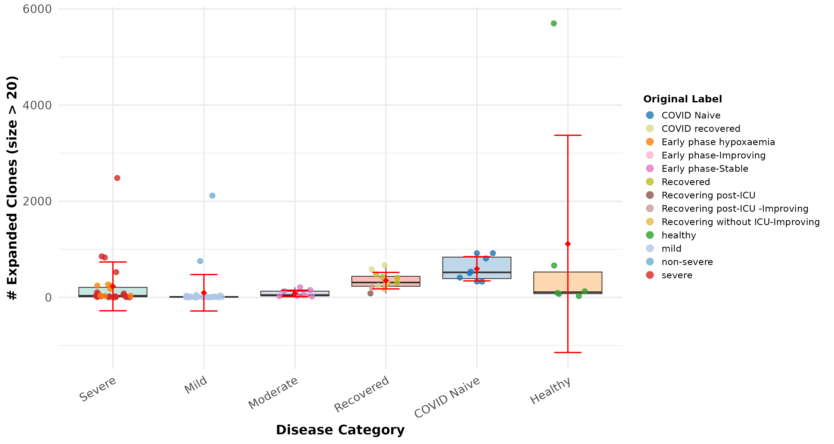
Figure 1. Number of expanded clones (size > 20) by disease category. Box plots show median and IQR; red diamond indicates mean with SD error bars. Points are colored by original disease label.

1.2 Median Clone Size by Disease Category
Figure 2 presents the median clone size per subject across disease categories. The median clone size was relatively uniform across groups, with COVID Naive subjects showing slightly elevated values.
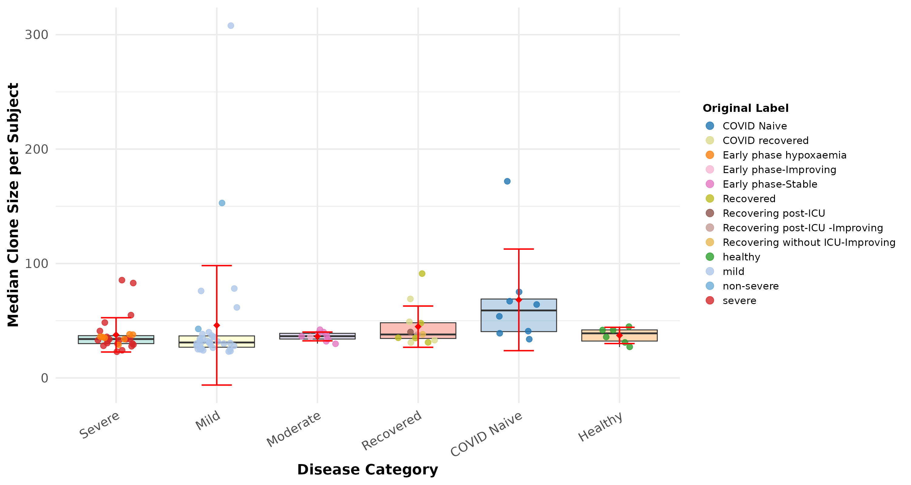
Figure 2. Median clone size per subject by disease category.

1.3 Clone Size by Age and Disease
Figures 3 and 4 examine the number of expanded clones and median clone size stratified by age group within each disease category.
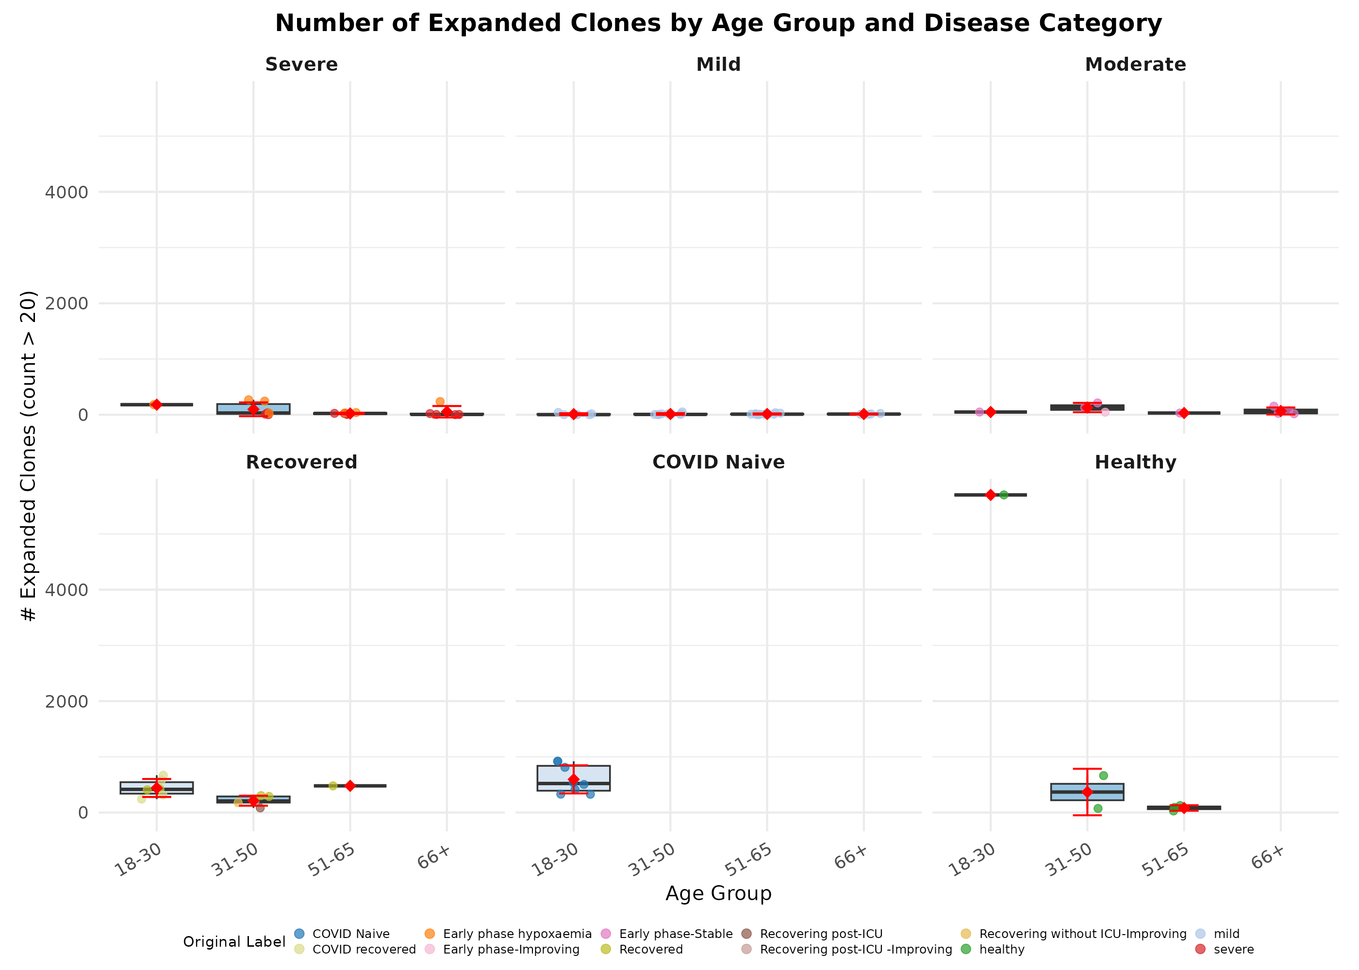
Figure 3. Number of expanded clones by age group, faceted by disease category.

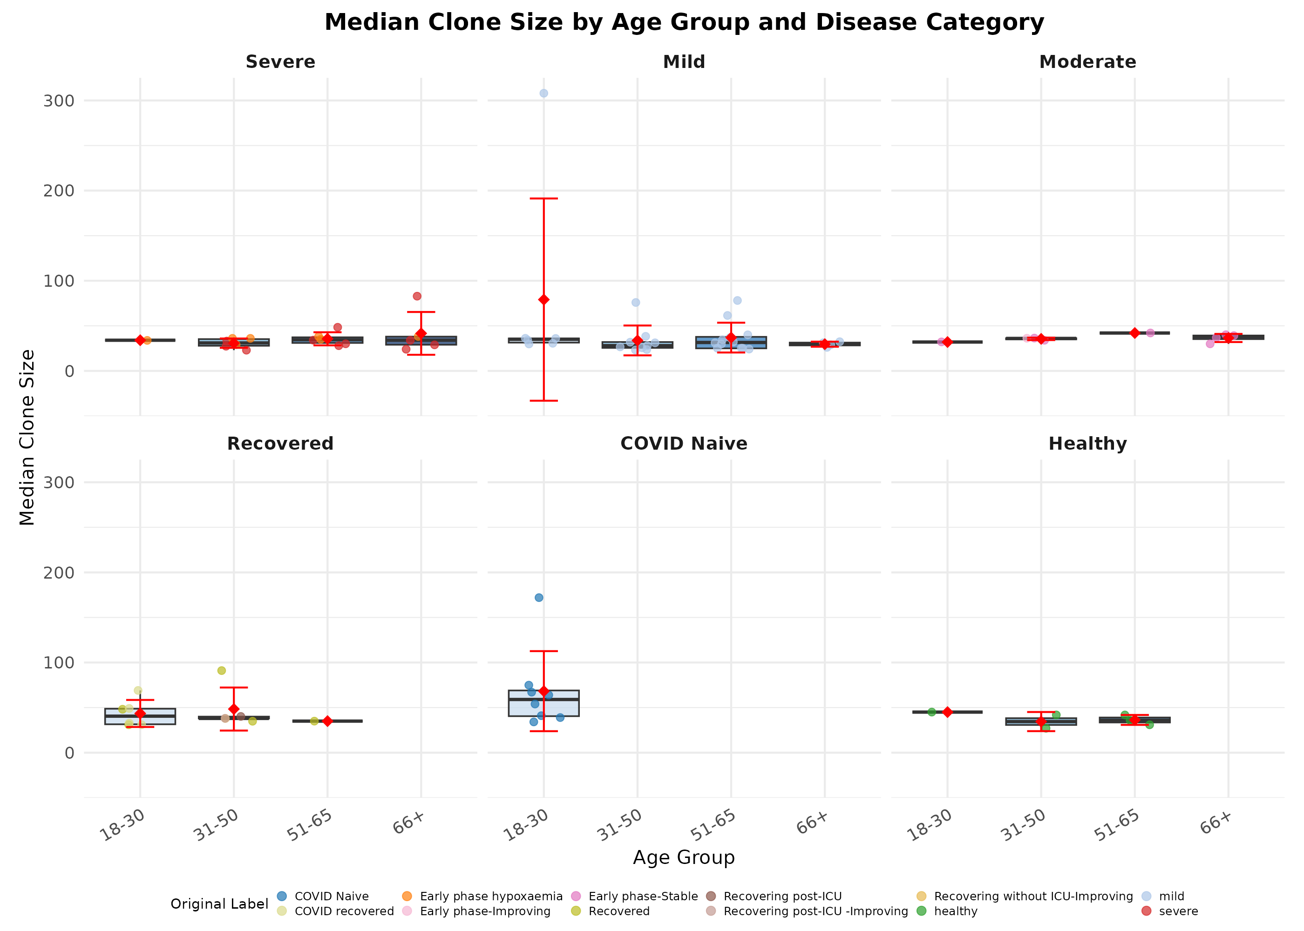
Figure 4. Median clone size by age group, faceted by disease category.

1.4 Clone Size by Sex and Disease
Figures 5 and 6 examine sex-based differences in clonal expansion within each disease category.
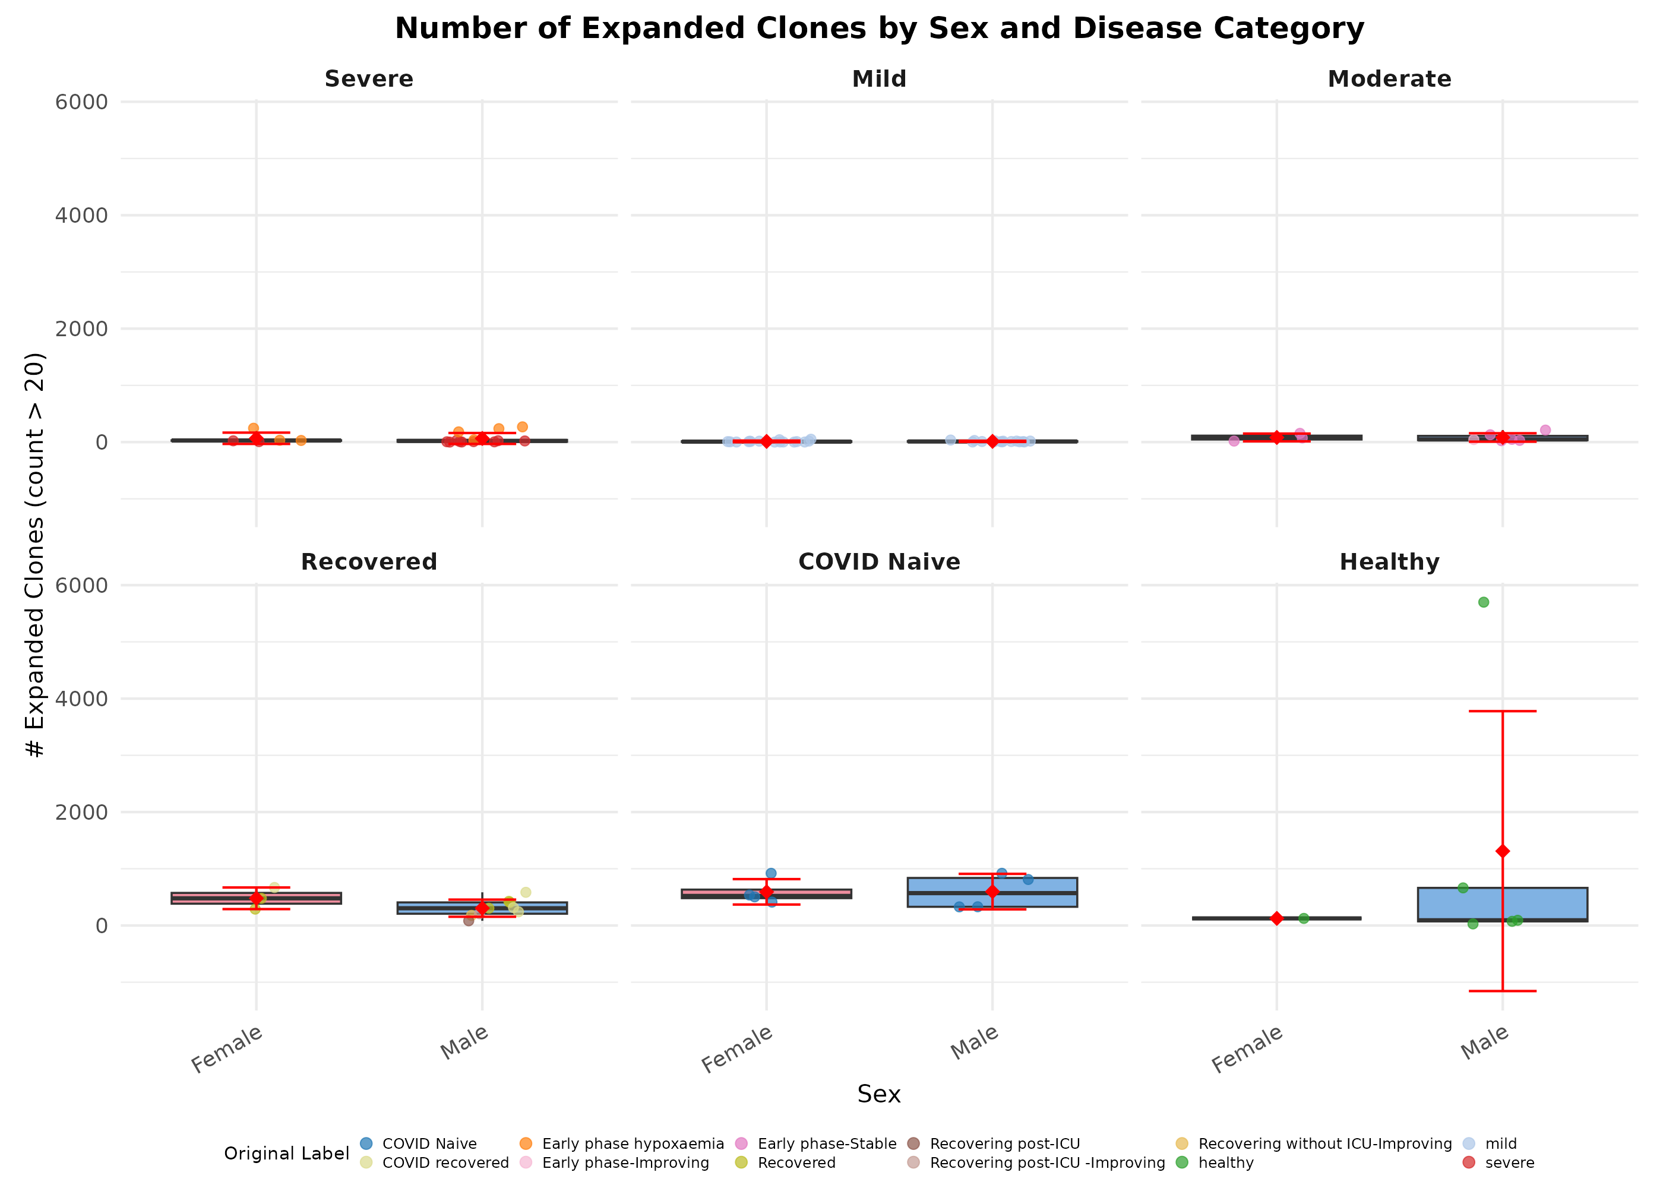
Figure 5. Number of expanded clones by sex, faceted by disease category.

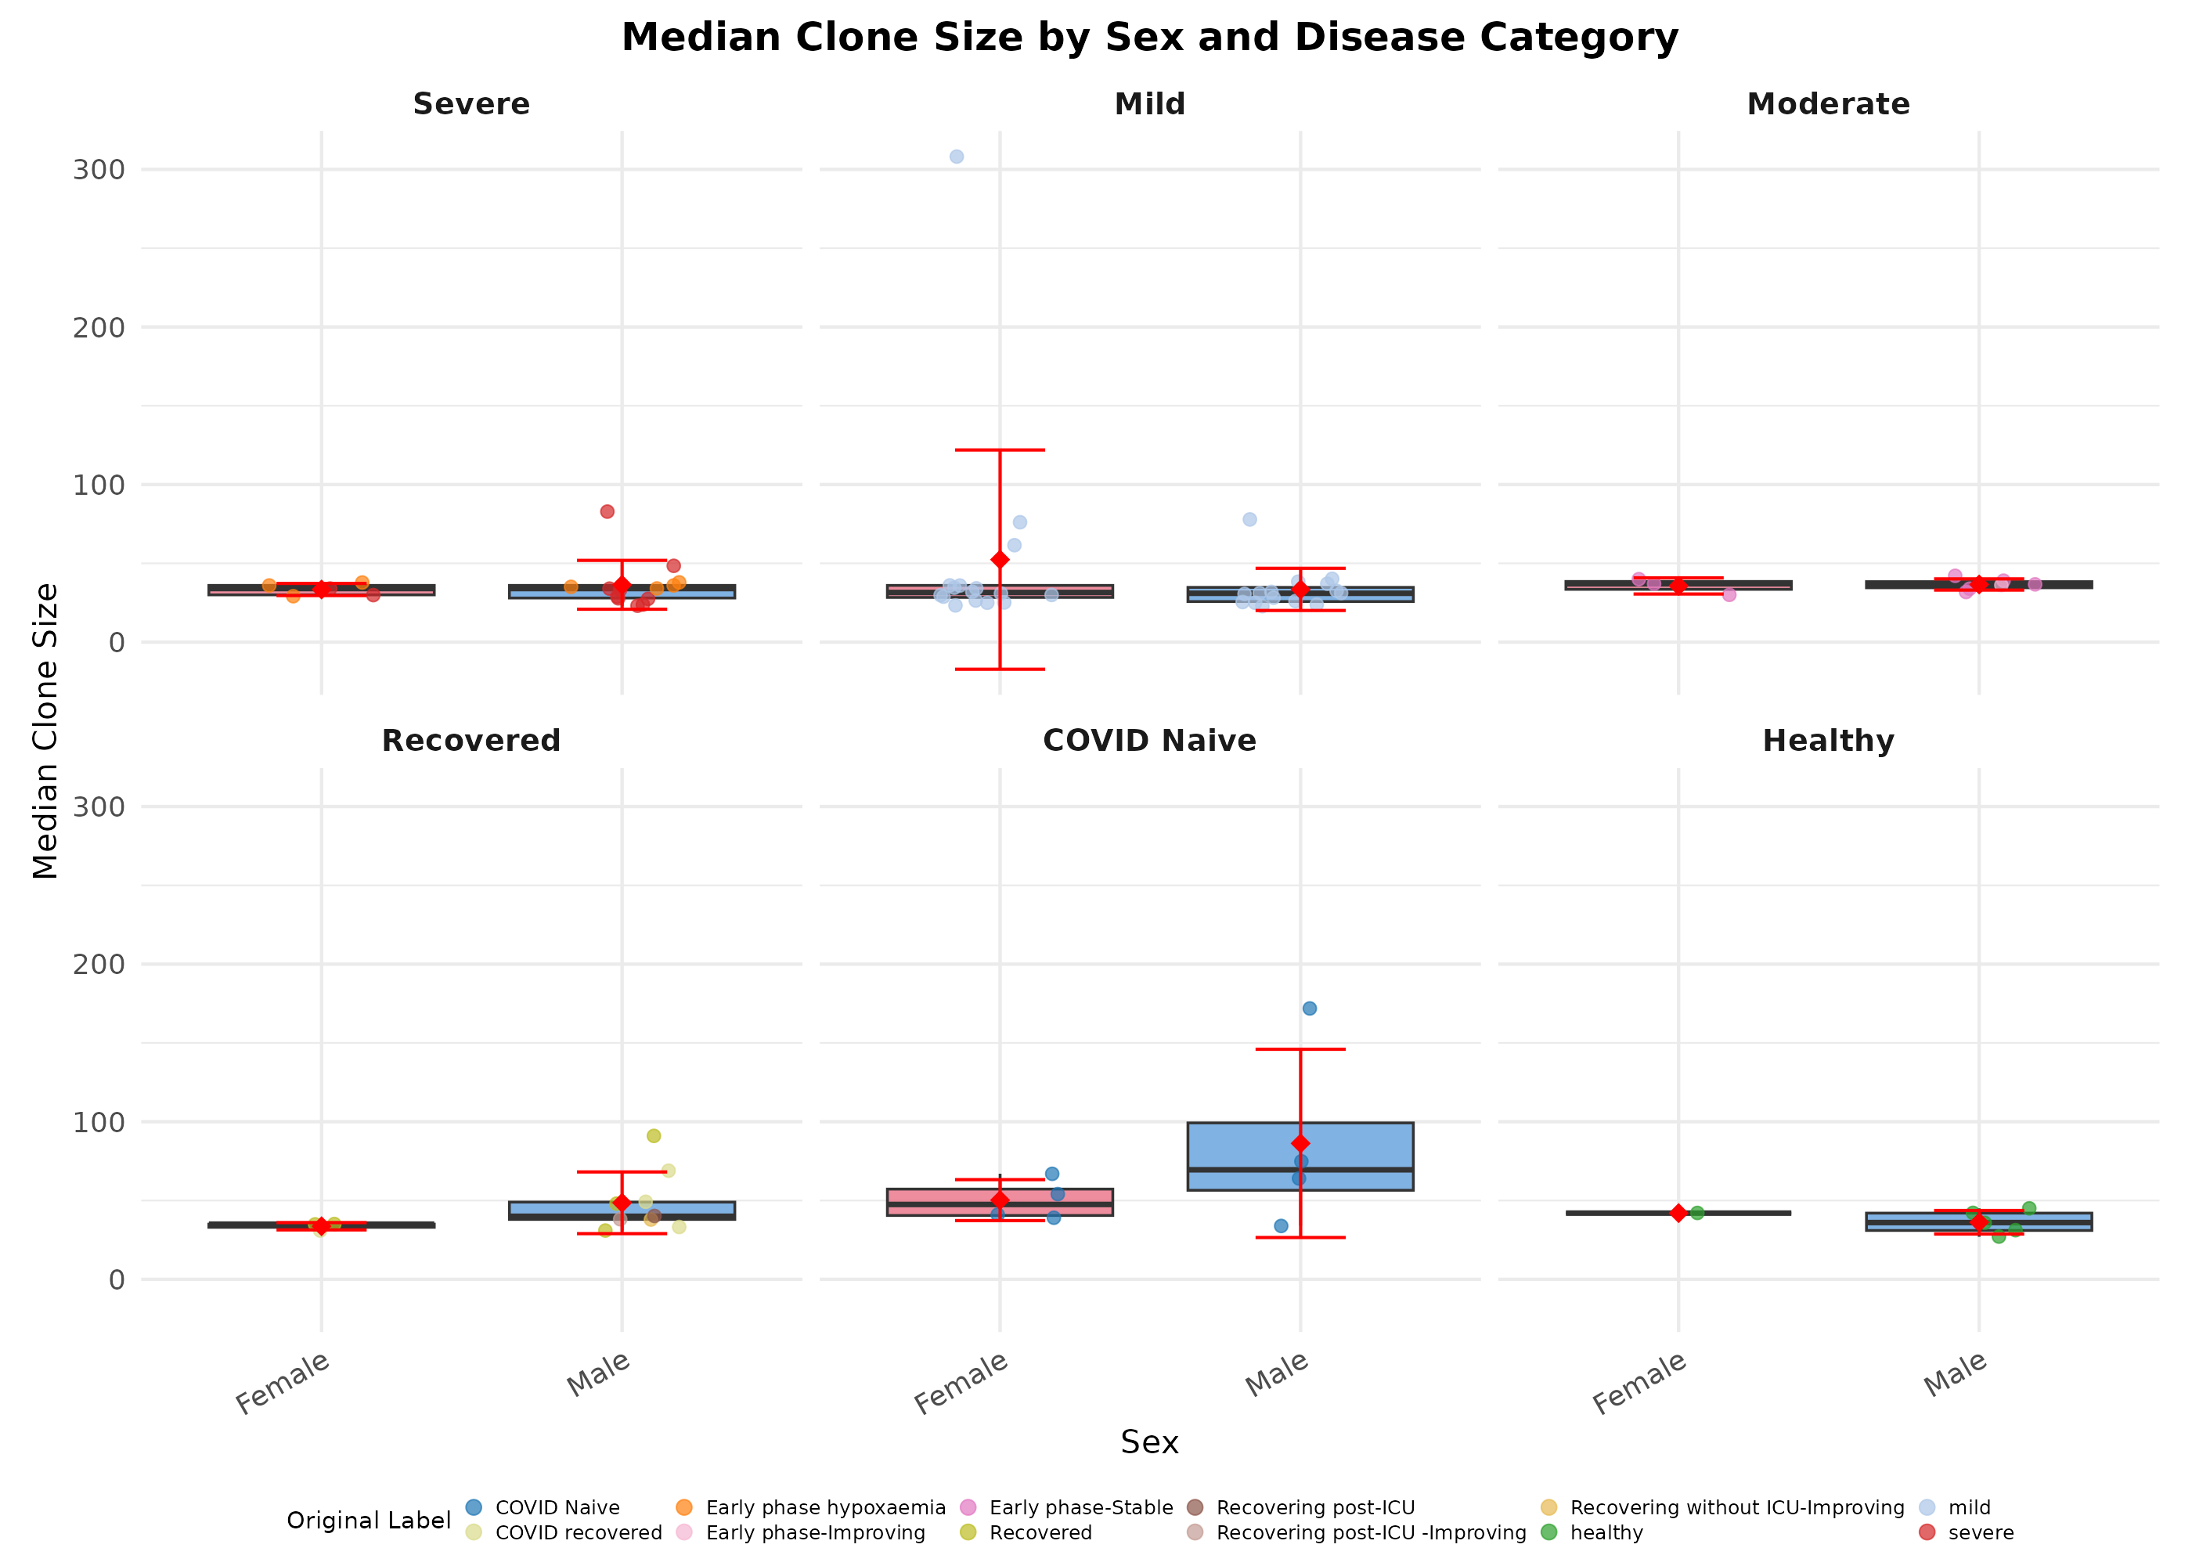
Figure 6. Median clone size by sex, faceted by disease category.

2. Clonal Diversity (Clone Count)
Clone count, representing the number of unique clones per subject, serves as a measure of clonal diversity. Higher clone counts indicate greater repertoire diversity.

2.1 Clone Count by Disease Category
Figure 7 shows the distribution of unique clone counts across disease categories. Recovered and COVID Naive subjects exhibited markedly higher clone counts (median 21,526 and 16,682, respectively) compared to Mild (2,478) and Severe (5,089) groups, suggesting repertoire expansion following infection or vaccination. The Healthy group showed high variability (range 650-61,136).
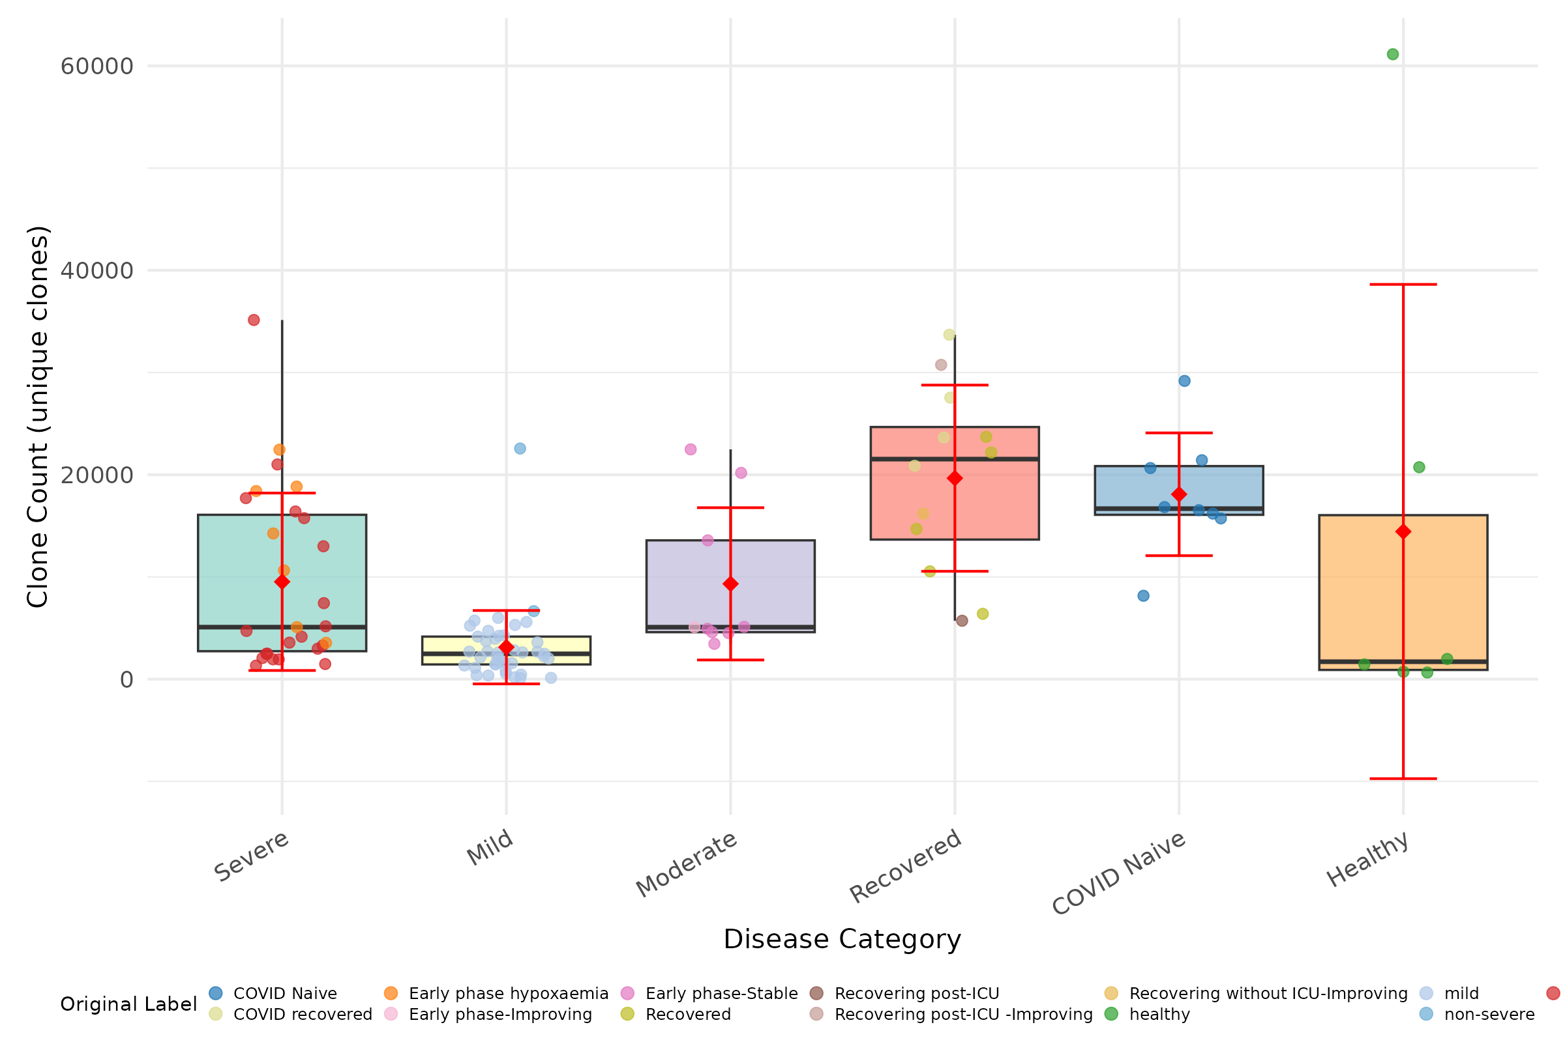
Figure 7. Clone count (number of unique clones) by disease category. Box plots show median and IQR; red diamond indicates mean with SD error bars.

Table 1. Clone count summary statistics by disease category.
Disease Category | n | Median | Mean | Min | Max
Severe | 27 | 5,089 | 9,529 | 1,319 | 35,137
Mild | 41 | 2,478 | 3,127 | 95 | 22,565
Moderate | 9 | 5,085 | 9,327 | 3,459 | 22,480
Recovered | 12 | 21,526 | 19,661 | 5,713 | 33,699
COVID Naive | 8 | 16,682 | 18,086 | 8,156 | 29,178
Healthy | 6 | 1,707 | 14,443 | 650 | 61,136

2.2 Clone Count by Age Group and Disease
Figure 8 displays clone count distributions stratified by age group within each disease category.
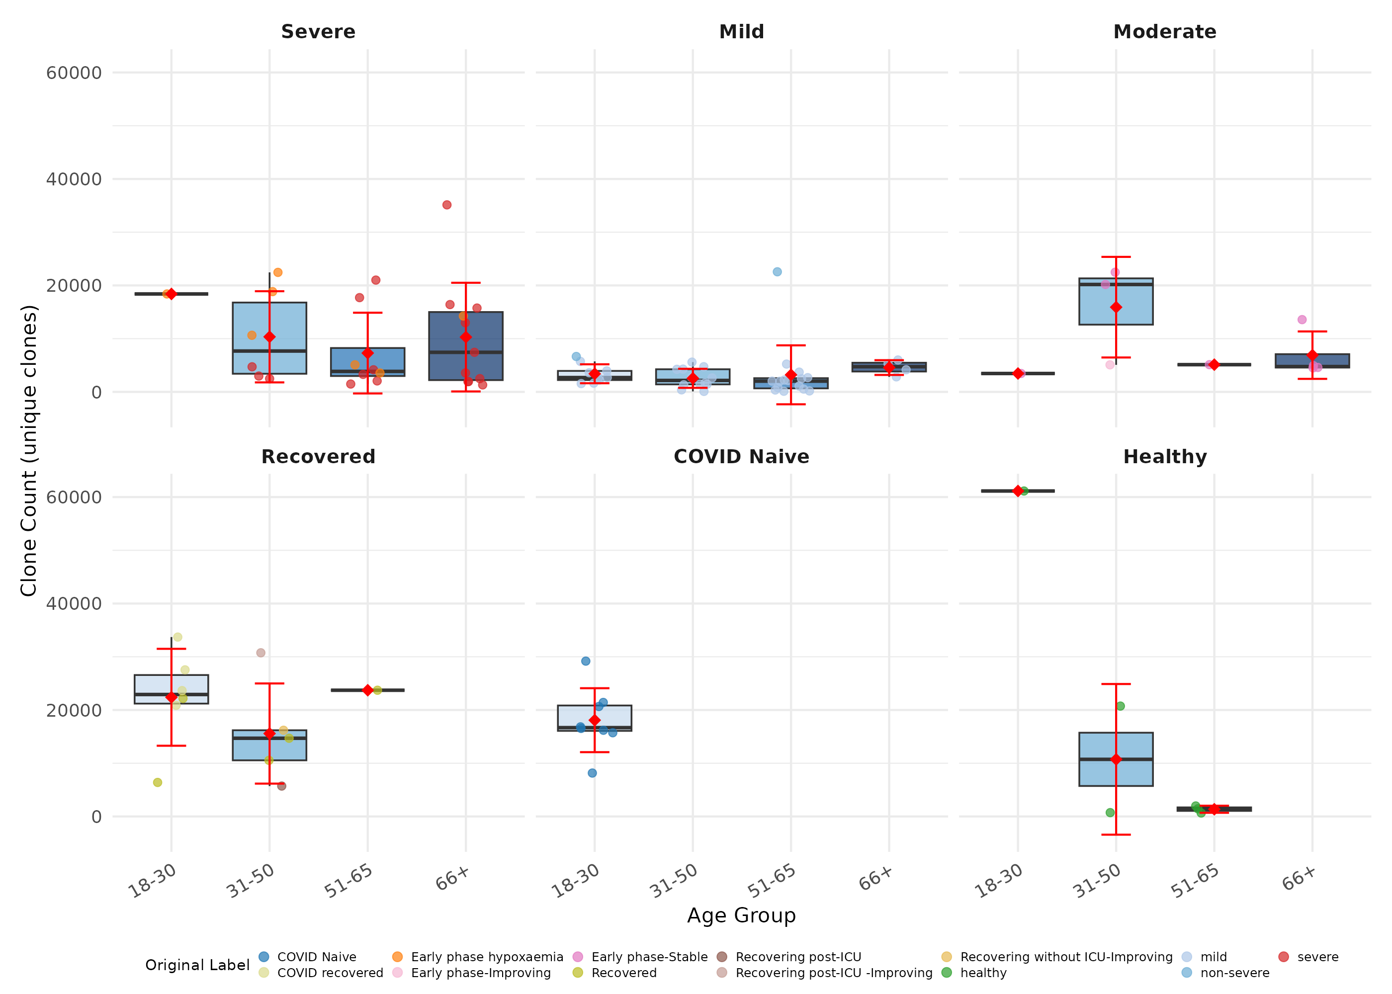
Figure 8. Clone count by age group, faceted by disease category.

2.3 Clone Count by Sex and Disease
Figure 9 shows clone count distributions by sex within each disease category. No substantial sex-based differences were observed across disease groups.
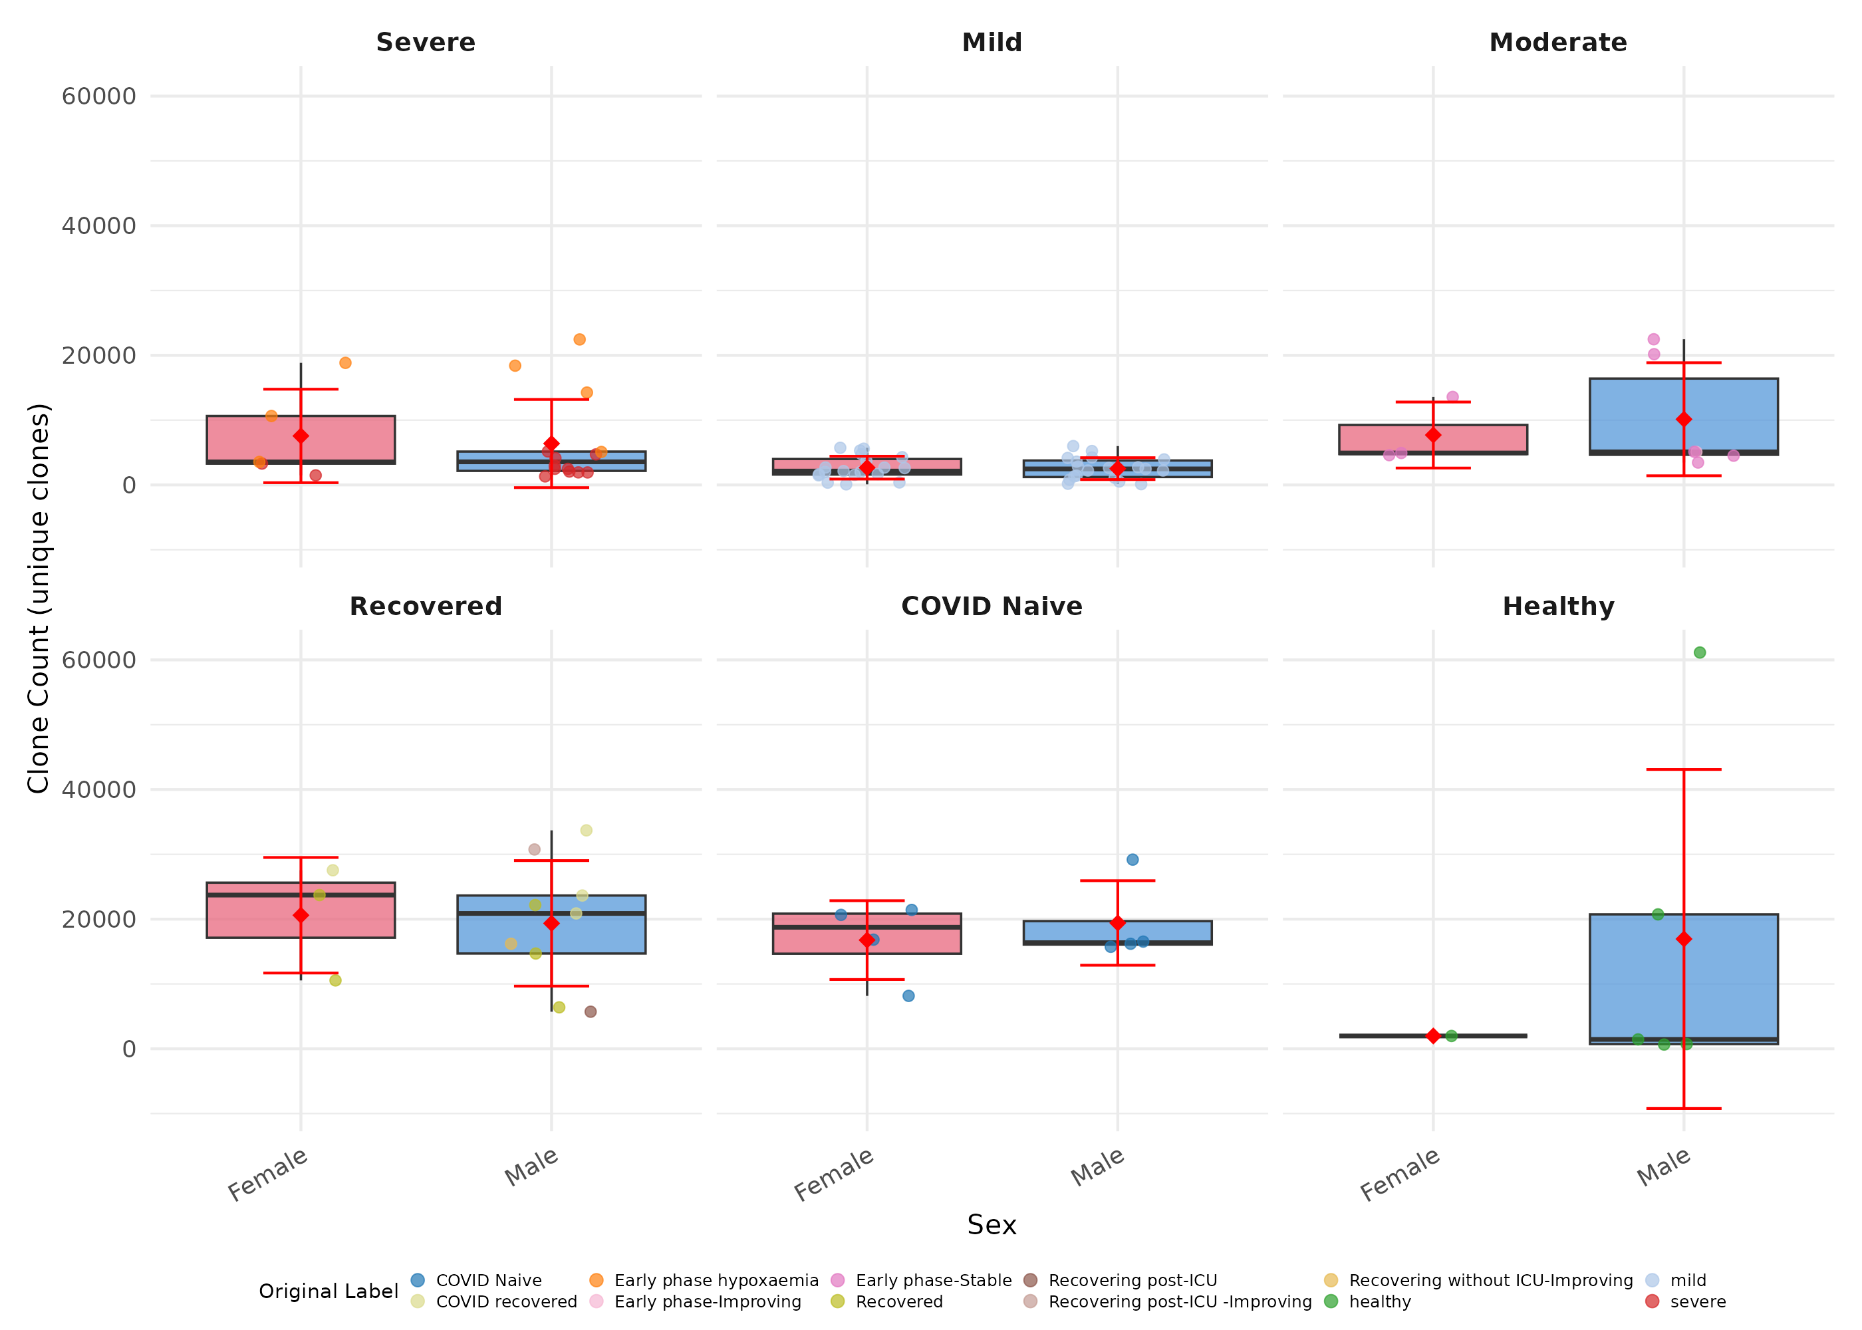
Figure 9. Clone count by sex, faceted by disease category.

Table 2. Clone count by disease category and sex.
Disease Category | Sex | n | Median Clone Count
Severe | Female | 5 | 3,552
Severe | Male | 14 | 3,567
Mild | Female | 19 | 2,140
Mild | Male | 19 | 2,478
Moderate | Female | 3 | 4,930
Moderate | Male | 6 | 5,102
Recovered | Female | 3 | 23,711
Recovered | Male | 9 | 20,876
COVID Naive | Female | 4 | 18,745
COVID Naive | Male | 4 | 16,364
Healthy | Female | 1 | 1,972
Healthy | Male | 5 | 1,442

3. Top-X Clone Proportion Analysis
The proportion of total repertoire copies held by the top expanded clones (Top 10, Top 100, and Top 1000) provides a measure of clonal dominance. Higher proportions indicate that a small number of clones dominate the repertoire.

3.1 Top-X Proportion by Disease Category
Figure 10 shows the proportion of total copies captured by the top 10, 100, and 1000 clones across disease categories. Healthy subjects showed notably high Top 1000 concentration (median 99.3%), indicating that nearly all copies belong to the top 1000 clones, consistent with a repertoire dominated by relatively few expanded clones. Moderate disease subjects showed the highest Top 10 dominance (median 23.1%).
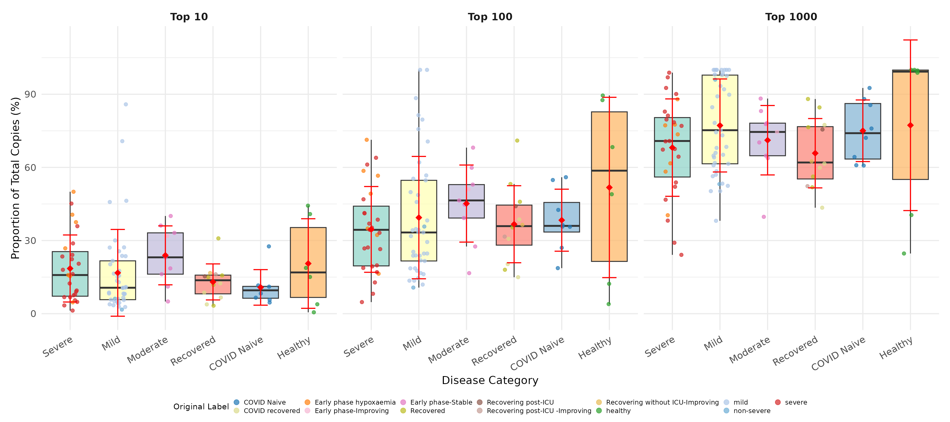
Figure 10. Proportion of total copies held by Top 10, Top 100, and Top 1000 clones, by disease category.

Table 3. Median proportion of total copies held by top-X clones.
Disease Category | n | Top 10 (%) | Top 100 (%) | Top 1000 (%)
Severe | 27 | 15.8 | 34.4 | 70.8
Mild | 41 | 10.6 | 33.3 | 75.2
Moderate | 9 | 23.1 | 46.4 | 74.5
Recovered | 12 | 13.7 | 35.9 | 62.0
COVID Naive | 8 | 9.6 | 36.0 | 74.0
Healthy | 6 | 16.9 | 58.7 | 99.3

3.2 Top-X Proportion by Age and Disease
Figure 11 presents the top-X clone proportions stratified by age group within each disease category.
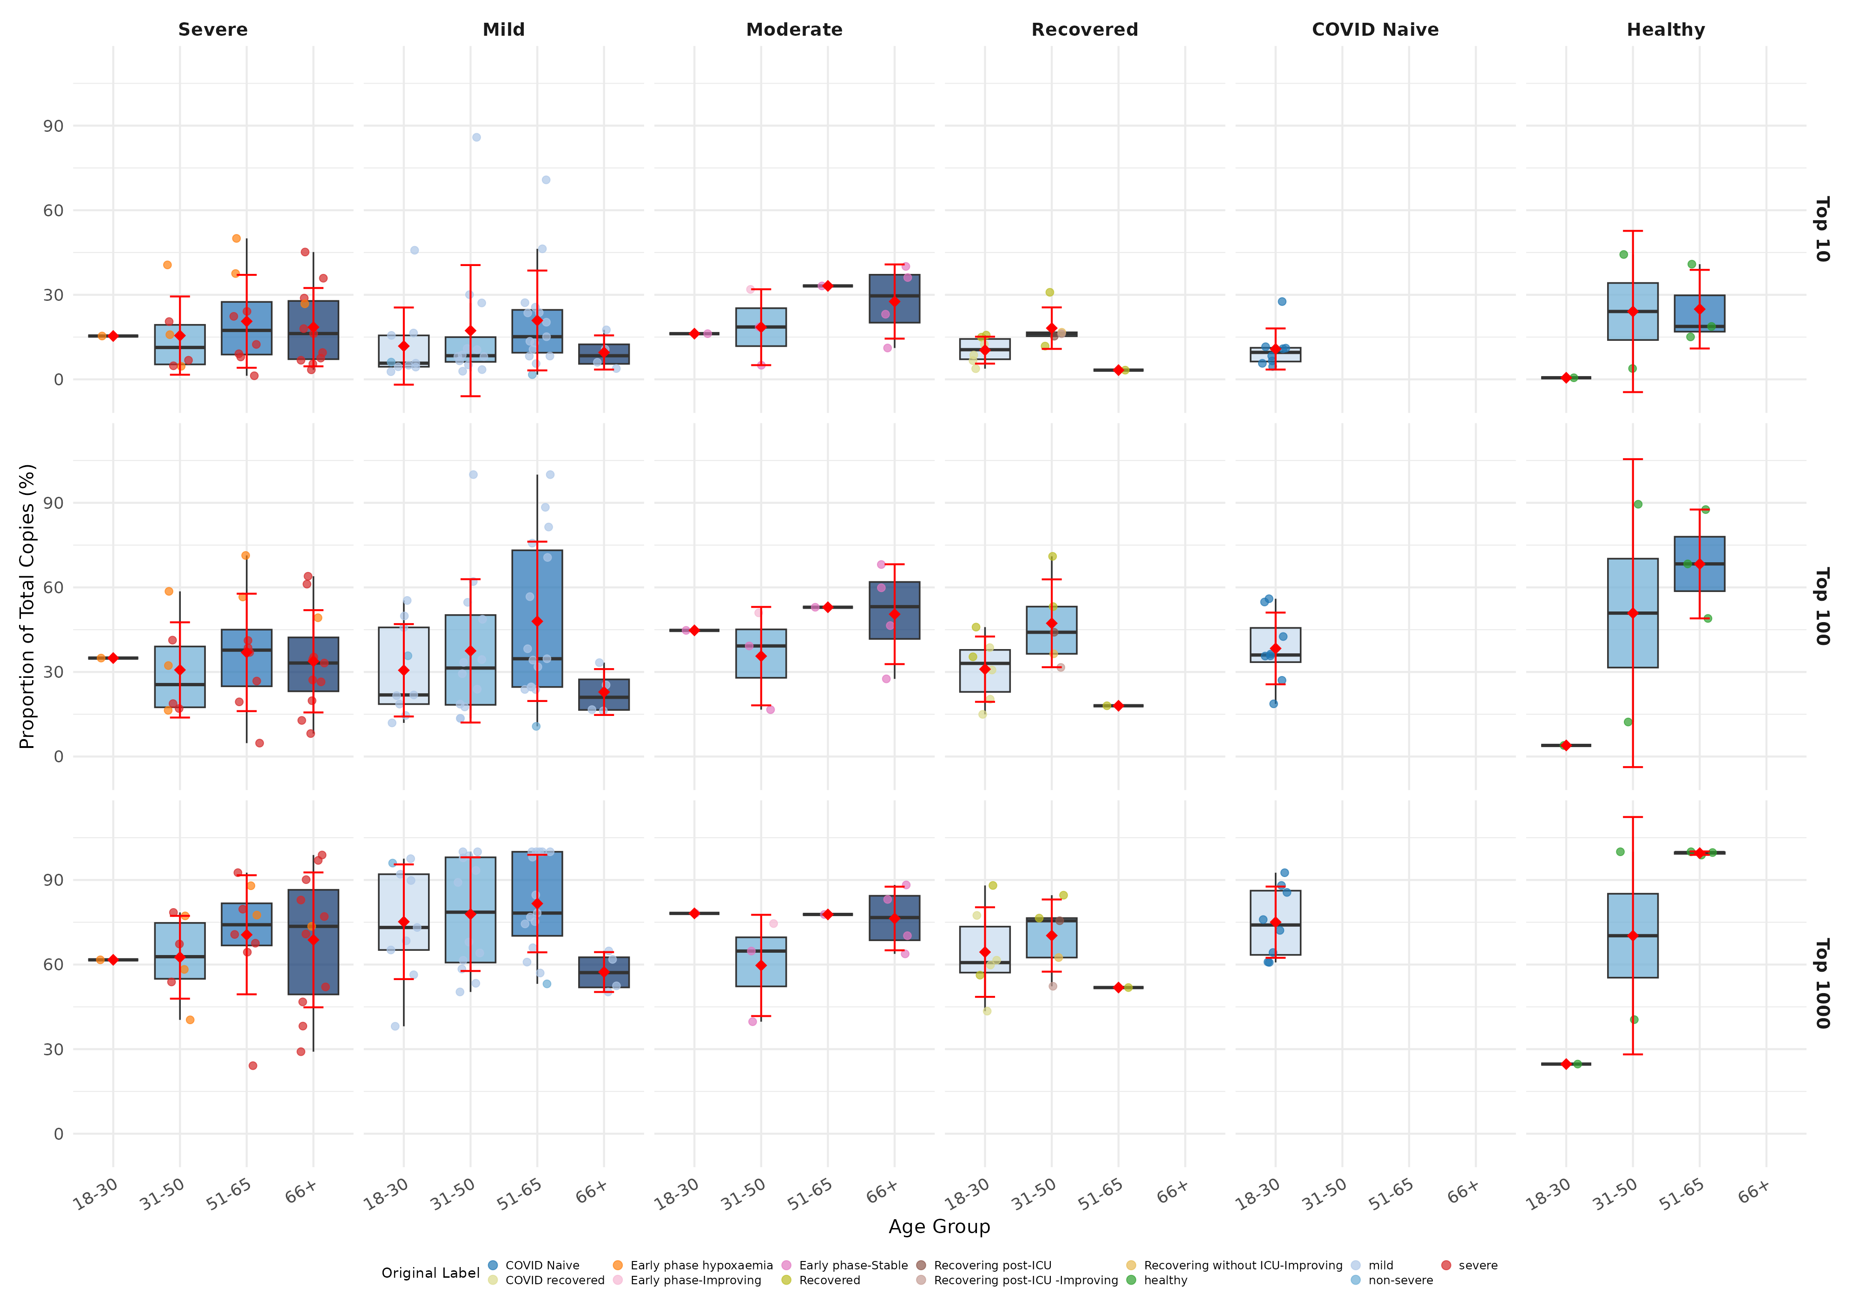
Figure 11. Top-X clone proportion by age group, faceted by disease category.

3.3 Top-X Proportion by Sex and Disease
Figure 12 shows top-X clone proportions by sex within each disease category.
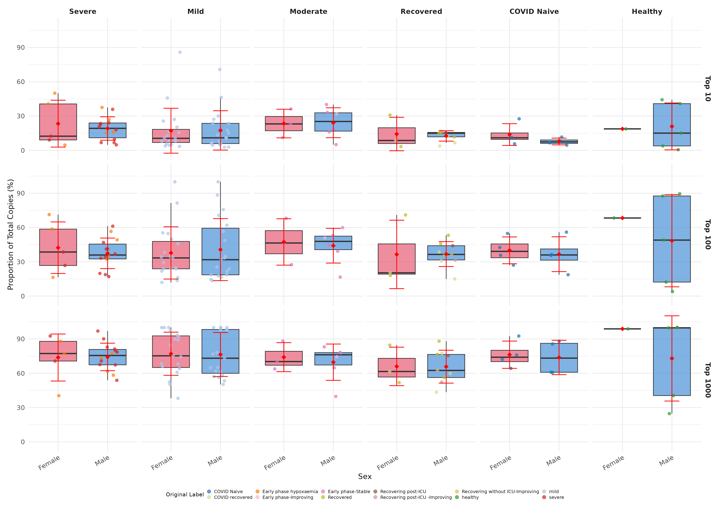
Figure 12. Top-X clone proportion by sex, faceted by disease category.

Table 4. Median top-X clone proportions by disease category and sex.
Disease Category | Sex | n | Top 10 (%) | Top 100 (%)
Severe | Female | 5 | 12.4 | 38.6
Severe | Male | 14 | 19.2 | 35.9
Mild | Female | 19 | 10.5 | 33.4
Mild | Male | 19 | 10.9 | 31.8
Moderate | Female | 3 | 23.1 | 46.4
Moderate | Male | 6 | 25.2 | 47.9
Recovered | Female | 3 | 8.6 | 20.3
Recovered | Male | 9 | 15.0 | 36.4
COVID Naive | Female | 4 | 11.0 | 39.1
COVID Naive | Male | 4 | 7.4 | 36.0
Healthy | Female | 1 | 18.8 | 68.3
Healthy | Male | 5 | 15.1 | 49.0

4. CDR3 Amino Acid Length Analysis
The CDR3 (Complementarity-Determining Region 3) amino acid length is a key structural feature of antibodies that influences antigen binding specificity. We analyzed the average CDR3 AA length of the top expanded clones (Top 10, Top 100, and Top 1000) to examine whether disease severity is associated with differences in CDR3 length of dominant clones.

4.1 CDR3 Length by Disease Category
Figure 13 shows the average CDR3 AA length of the top expanded clones across disease categories. Severe cases exhibited the longest CDR3 lengths in Top 10 clones (median 17.7 AA), while Healthy subjects showed the shortest (median 13.8 AA). This difference was most pronounced in the Top 10 tier and diminished progressively with larger clone sets (Top 100, Top 1000), suggesting that the most expanded clones in severe disease tend to use longer CDR3 regions.
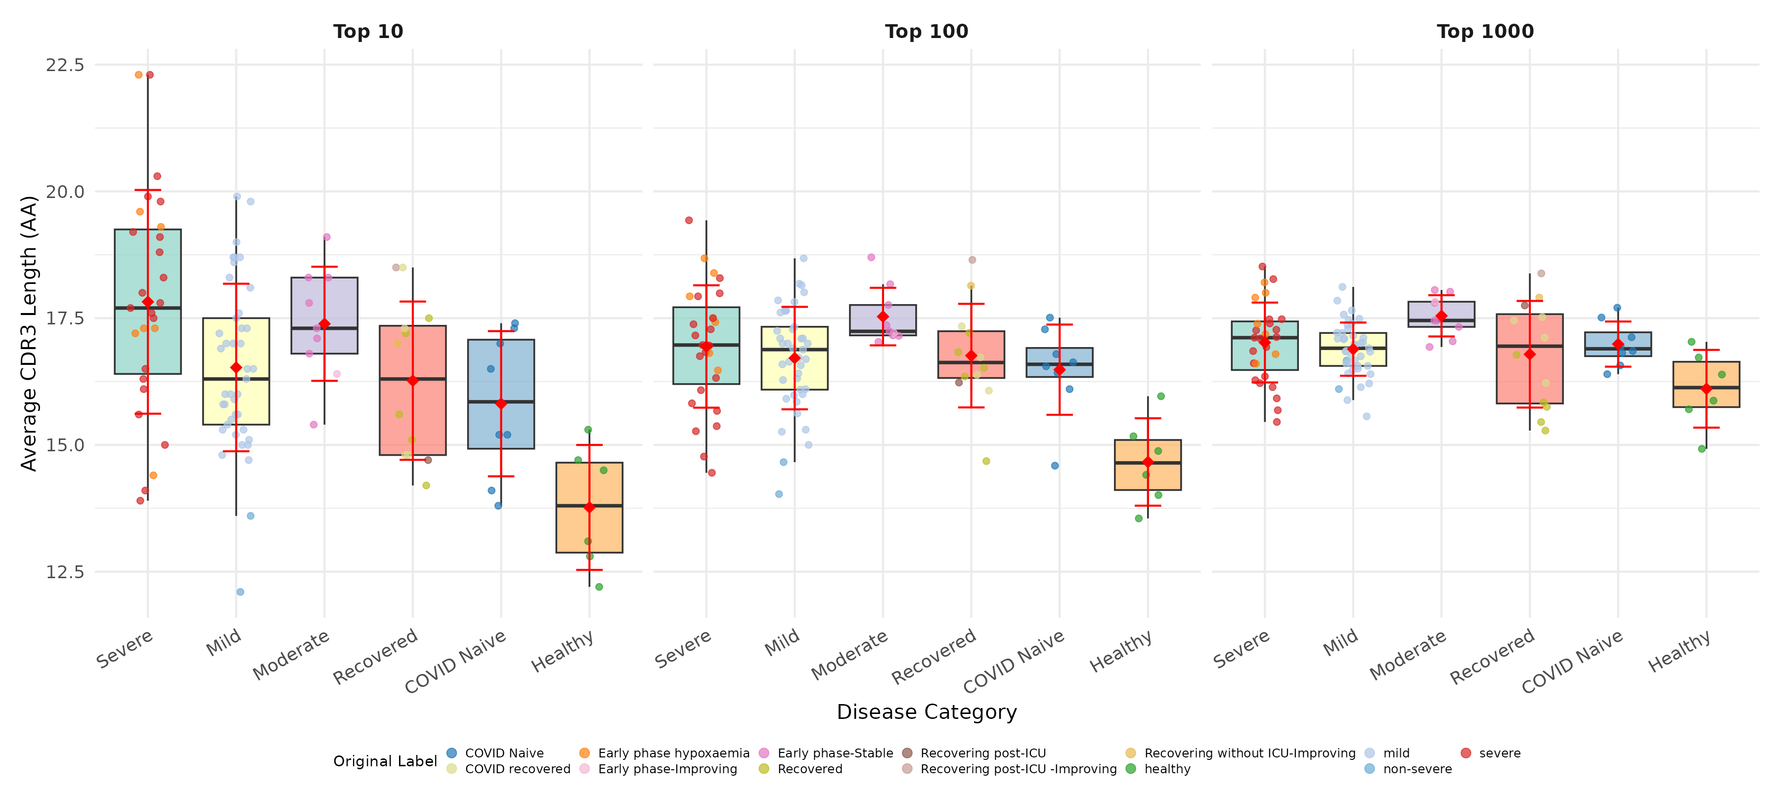
Figure 13. Average CDR3 amino acid length of top expanded clones (Top 10, Top 100, Top 1000), by disease category.

Table 5. Median average CDR3 AA length of top-X clones by disease category.
Disease Category | n | Top 10 (AA) | Top 100 (AA) | Top 1000 (AA)
Severe | 27 | 17.7 | 17.0 | 17.1
Mild | 41 | 16.3 | 16.9 | 16.9
Moderate | 9 | 17.3 | 17.2 | 17.4
Recovered | 12 | 16.3 | 16.6 | 17.0
COVID Naive | 8 | 15.8 | 16.6 | 16.9
Healthy | 6 | 13.8 | 14.6 | 16.1

4.2 CDR3 Length by Age and Disease
Figure 14 shows CDR3 AA length distributions stratified by age group within each disease category.
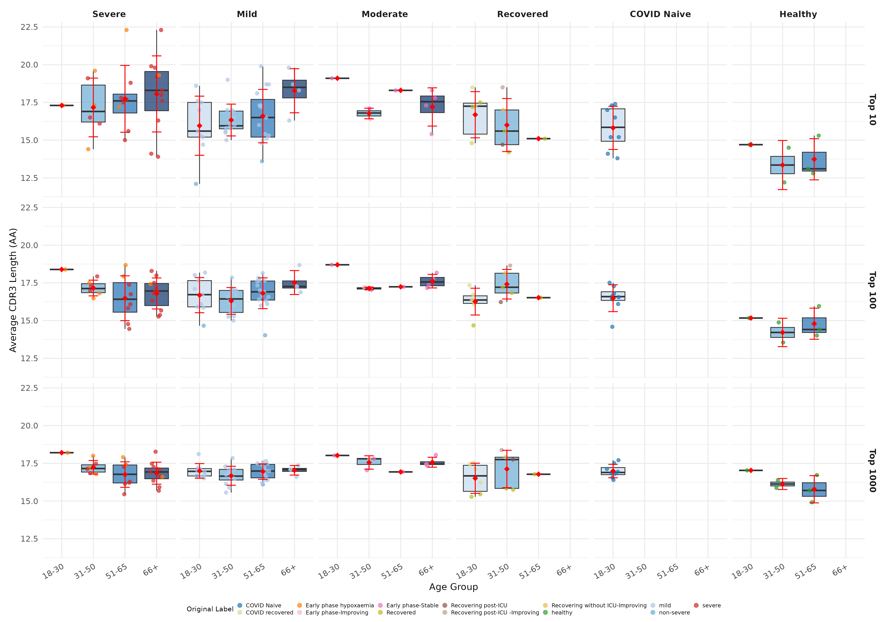
Figure 14. Average CDR3 AA length by age group, faceted by disease category and top-X tier.

4.3 CDR3 Length by Sex and Disease
Figure 15 presents CDR3 AA length distributions by sex within each disease category.
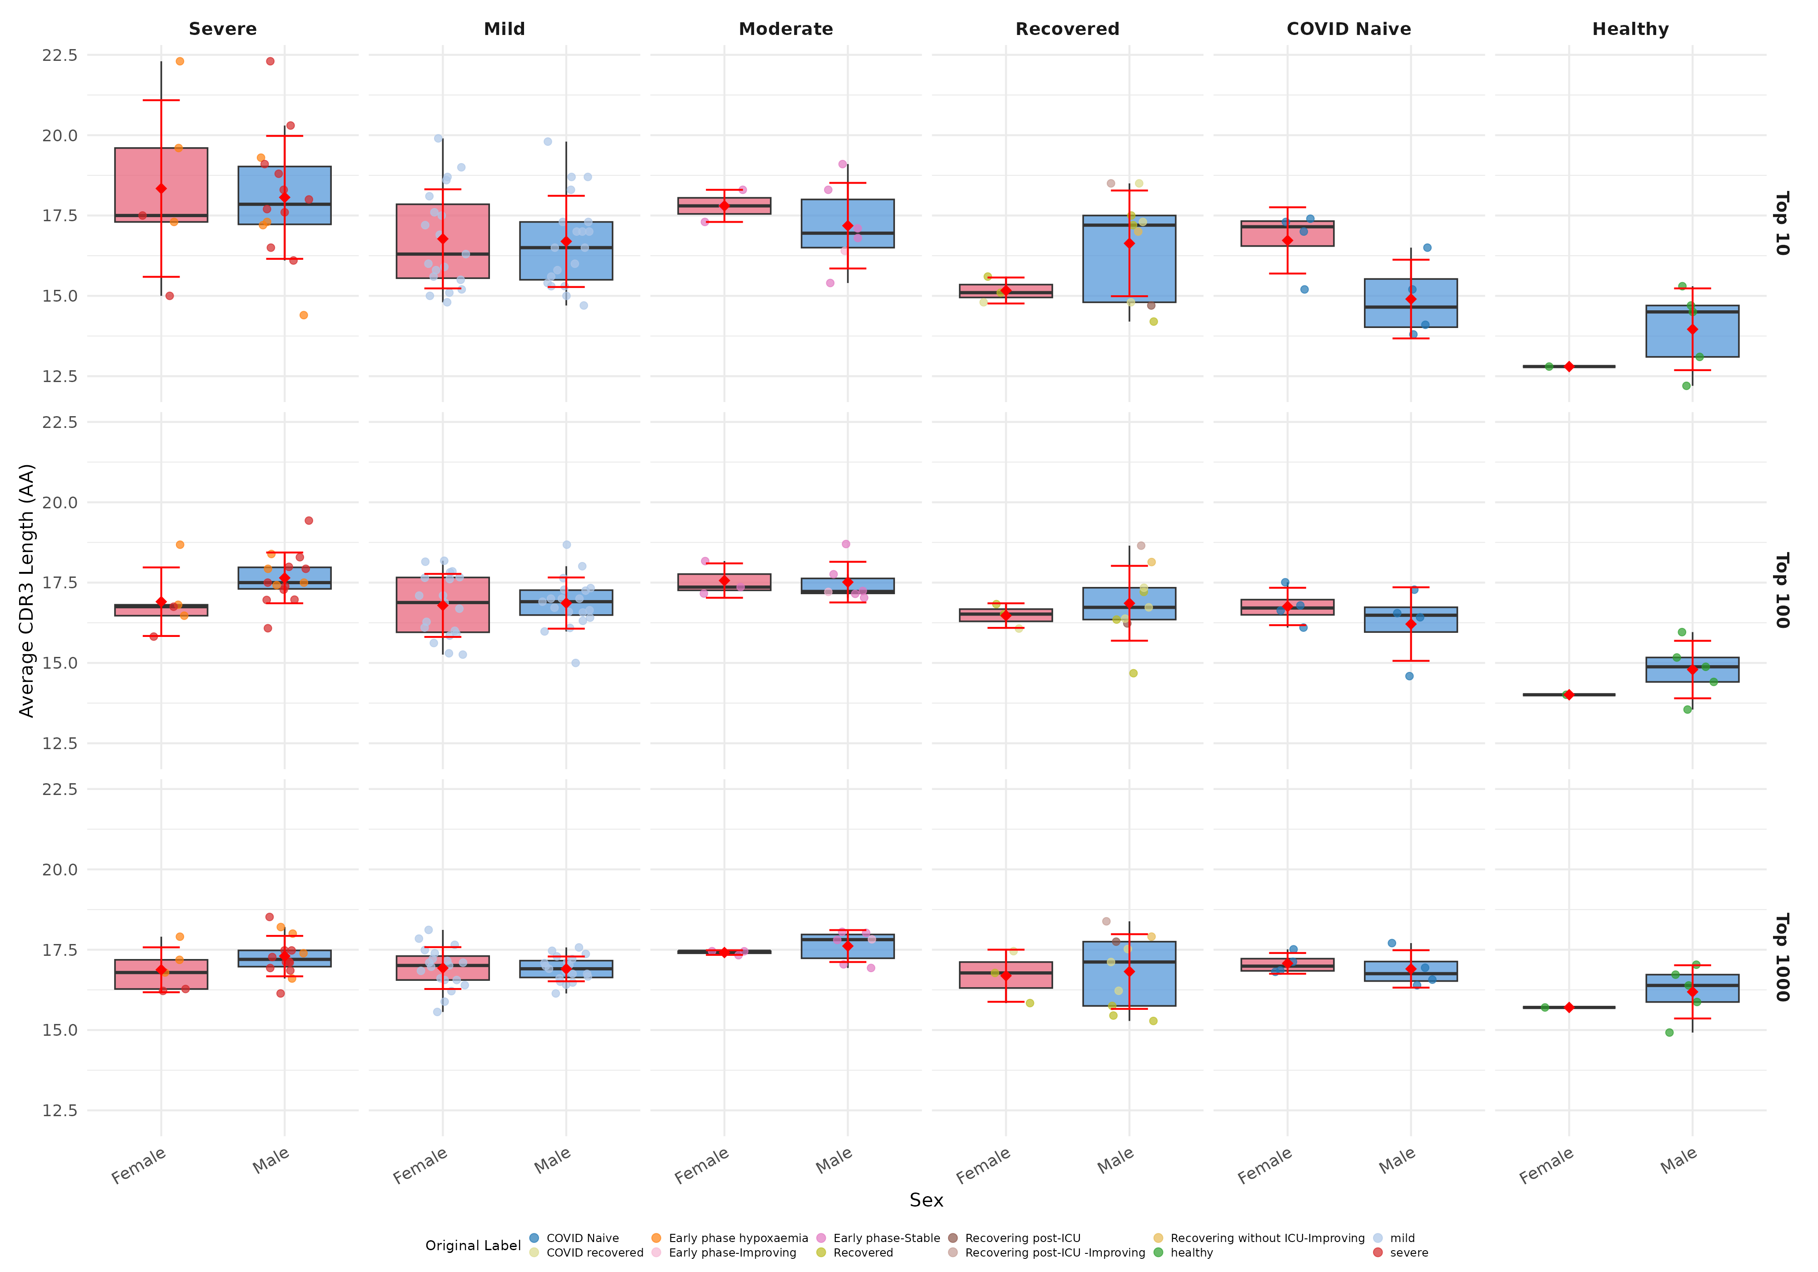
Figure 15. Average CDR3 AA length by sex, faceted by disease category and top-X tier.

Table 6. Median CDR3 AA length by disease category and sex.
Disease Category | Sex | n | Top 10 (AA) | Top 100 (AA)
Severe | Female | 5 | 17.5 | 16.8
Severe | Male | 14 | 17.8 | 17.5
Mild | Female | 19 | 16.3 | 16.9
Mild | Male | 19 | 16.5 | 16.9
Moderate | Female | 3 | 17.8 | 17.4
Moderate | Male | 6 | 17.0 | 17.2
Recovered | Female | 3 | 15.1 | 16.5
Recovered | Male | 9 | 17.2 | 16.7
COVID Naive | Female | 4 | 17.2 | 16.7
COVID Naive | Male | 4 | 14.6 | 16.5
Healthy | Female | 1 | 12.8 | 14.0
Healthy | Male | 5 | 14.5 | 14.9

