Materials and Methods
The iReceptor Statistics API (IS-API, v0.3.0) was developed based on ImmuneDB databases [REF]. The databases were built from raw AIRR-seq BCR sequences and their associated metadata, annotated and stored along with BCR-specific annotations such as germline and clone assignment, somatic hypermutation counts, and pre-calculated statistical measures. Each database holds data from a different study or experiment. A schematic view explaining the process prior to IS-API is shown in Figure 1.
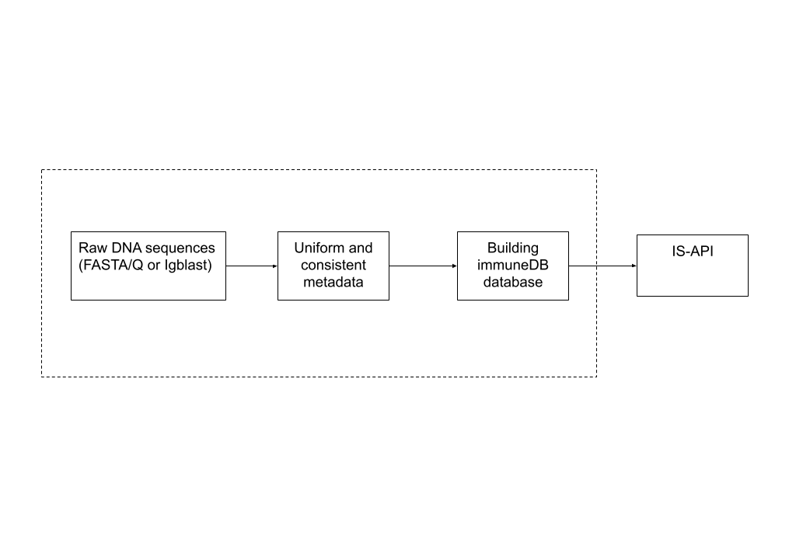
Figure 1. Pipeline from raw sequences to IS-API.

Collecting the Data and Creating the Databases
Data were collected for healthy and diseased individuals from 7 published studies containing raw DNA AIRR BCR sequences. The collected data included diverse immune-response contexts: COVID-19 with different levels of disease severity, recovered, vaccinated, COVID-naive, and healthy individuals. Two additional databases (SD1 and FL1) were excluded from the current analysis as they contain unpublished data. The transplant dataset (GT1, sykesIgblast2020; PMID: 38014202) was also excluded as it falls outside the COVID-19 disease scope of this study. For study details, subject identifiers, and all other relevant metadata, see Supplementary Table S1.
To ensure a uniform metadata framework for cross-study analysis, we built a standardized metadata template that enforces compliance with the AIRR-seq data commons [REF] while providing flexibility to include study-specific fields. The IS-API uses a metadata fingerprint grouping mechanism that identifies unique combinations of metadata fields across subjects and samples, enabling consistent cross-database comparisons despite heterogeneous metadata schemas.

Subject Selection and Exclusion Criteria
From an initial pool of 126 subjects across all databases, the following exclusion criteria were applied to arrive at a final cohort of 103 subjects:
- Tissue filter: Only peripheral blood samples were retained (tissue labels: "blood", "PBL", "Peripheral blood"). The HC1 (lp16_Igblast) study uses bone marrow (BM) samples and was retained as the sole healthy control cohort.
- Non-biological controls: Two entries from CVX2 (covid_vaccine_new) were removed: Fb (fibroblast control) and Water (negative control).
- Insufficient data: Three subjects from HC1 (lp16_Igblast) were excluded due to insufficient sequence data: D159, D154, and Hu-1.
- Healthy controls from COVID studies: Three healthy subjects from CD3 (covid19) were excluded (H3, H4, H8), as their disease context differs from the dedicated healthy cohort (HC1).
- Non-COVID datasets: The GT1 (sykesIgblast2020) transplant dataset (16 subjects) was excluded as it falls outside the COVID-19 scope.
- Unpublished datasets: SD1 and FL1 databases were excluded as they contain unpublished data.
The final cohort comprised 103 subjects across 7 studies (CD1: n=51, CD2: n=19, CD3: n=10, CVX1: n=12, CVX2: n=5, HC1: n=6).

Disease Harmonization
The 103 subjects were originally labeled with 13 distinct disease stage descriptors across the 7 studies. To enable meaningful cross-study comparisons, a rule-based harmonization was applied to map these labels into 6 standardized disease categories:
Harmonized Category | Original Labels (Source Study)
Severe (n=27) | "severe" (CD1, CD3), "Early phase hypoxaemia" (CD2)
Mild (n=41) | "mild", "non-severe" (CD1, CD3), "Early phase-Stable", "Early phase-Improving", "Recovering without ICU-Improving" (CD2)
Moderate (n=9) | "Recovering post-ICU", "Recovering post-ICU -Improving" (CD2)
Recovered (n=12) | "Recovered" (CVX2), "COVID recovered" (CVX1)
COVID Naive (n=8) | "COVID Naive" (CVX1)
Healthy (n=6) | "healthy" (HC1)

This harmonization was guided by clinical severity: CD2 subjects with hypoxaemia were classified as Severe, those with stable or improving early-phase disease as Mild, and those recovering post-ICU as Moderate, reflecting an intermediate severity between acute illness and recovery.

Computer Hardware and Software Requirements
IS-API is written in Node.js [REF] using the Express framework [REF], which provides a flexible yet robust development environment that enables connecting to multiple ImmuneDB instances with relatively short response time. The API queries ImmuneDB databases that may be located on different servers across the internet, regardless of location, as long as their addresses are configured (Figure 2). Code, software, and library requirements can be found on GitHub [REF] in a public repository.
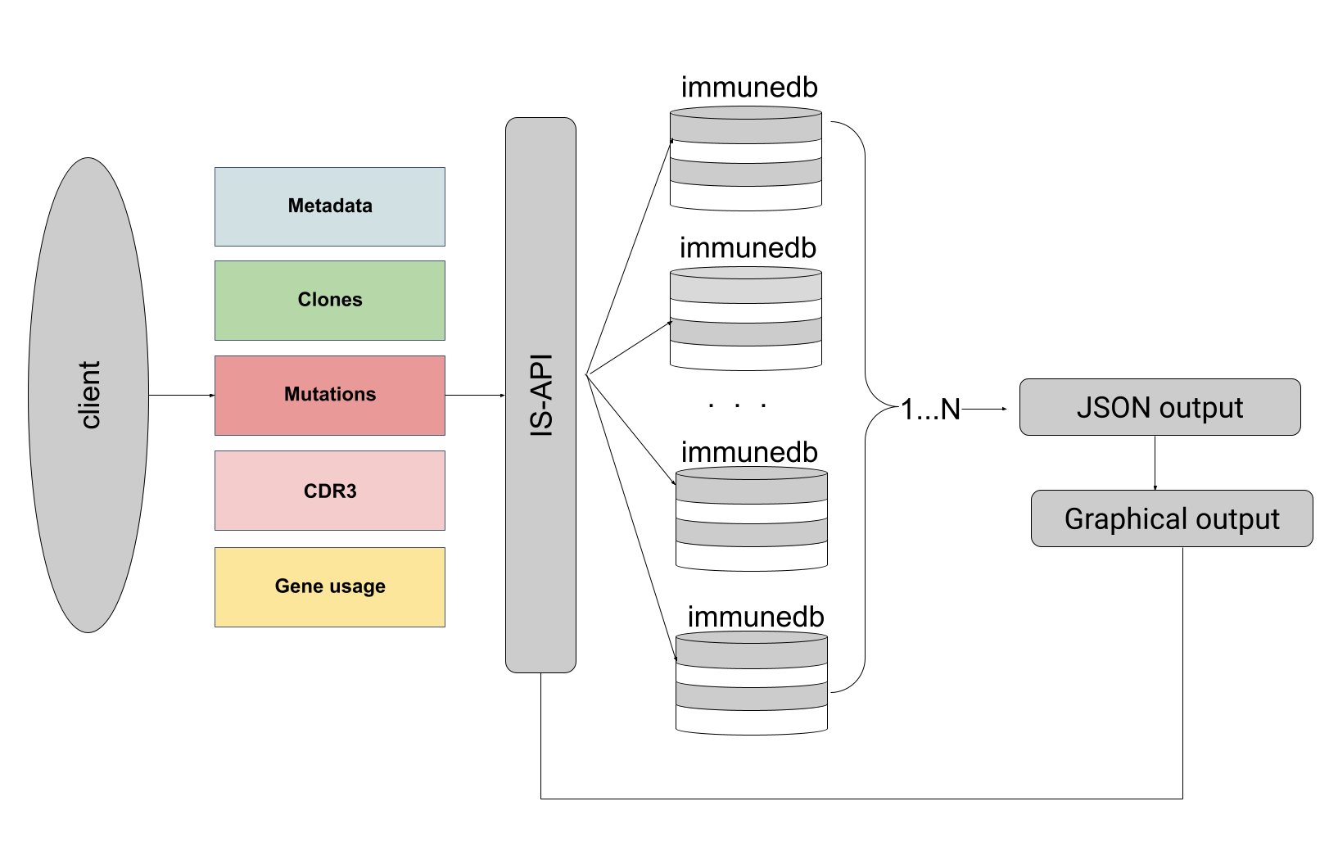
Figure 2. IS-API architecture: client queries across multiple ImmuneDB databases.

Building the Endpoints
The questions that a researcher can ask using IS-API can be grouped into two levels: (1) metadata questions and (2) biological/research questions. Both levels, their endpoints, and example questions are listed in Supplementary Table S2 and Supplementary Table S3, respectively. A conceptual hierarchy of the analytical layers is shown in Figure 3.
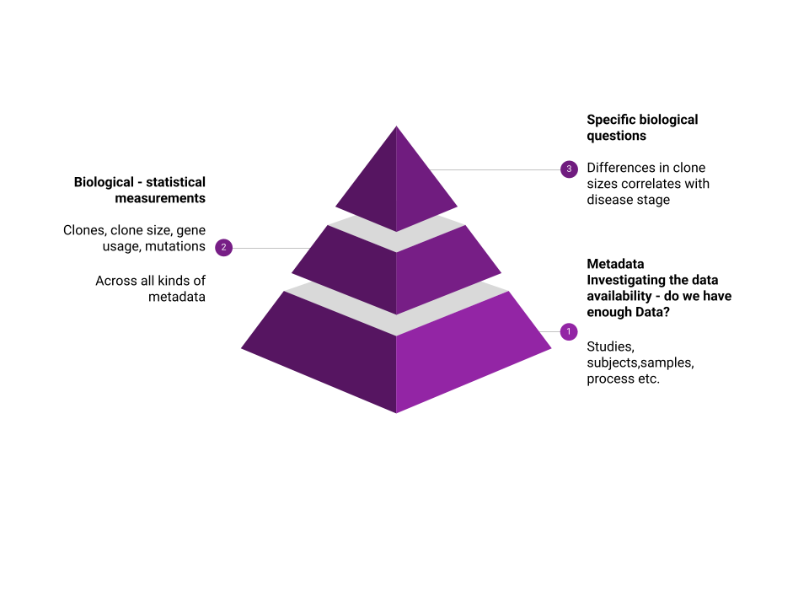
Figure 3. Three-tier analytical hierarchy: metadata, biological measures, and specific questions.

Specifying a Set of Biological Statistical Questions
Each repertoire was characterized using the following measures:
- Clone size (expanded clones): The total number of unique sequences per clone across all samples in a subject. A clone was defined as "highly expanded" if it contained more than 100 copies. For each disease category, we reported the median clone size, the number and percentage of highly expanded clones, and the proportion of subjects with at least one expanded clone.
- Clone count: The number of distinct clones per subject per sample.
- Top-X clone ratio: The total sequence copies in the largest 10, 100, or 1,000 clones per subject, expressed as a proportion of total copies. This captures repertoire dominance by a small number of expanded clones.
- CDR3 length: The average length (in amino acids) of the CDR3 region in the top 10, 100, or 1,000 largest clones per individual.
- Mutation level: The average number of total unique somatic mutations per clone in the top 10, 100, or 1,000 largest clones per individual.
- Mutation by region: The average number of mutations broken down by immunoglobulin framework (FW1, FW2, FW3) and complementarity-determining (CDR1, CDR2) regions for the top 10, 100, or 1,000 clones.
- Replacement-to-Silent (R/S) mutation ratio: The ratio of replacement (non-synonymous) to silent (synonymous) mutations in each region (CDR1, CDR2, FW1, FW2, FW3), computed for the top 10, 100, or 1,000 clones per subject. This ratio reflects the degree of antigen-driven selection pressure on different parts of the antibody.

Input and Output Structure
All endpoints are designed as POST requests that enable sending data to and receiving data from the server. The request body is in JSON format and contains two objects:
- Repertoire: Holds information about the metadata of interest (e.g., tissue type, sample identifier).
- Statistics: Holds information about the statistical question of interest (e.g., clone size, mutation level).
The following is an example of a POST request (input) to the clone endpoint, querying for clone size in tissue "Lung" for a specific sample:
{
"repertoires": [{
"repertoire": {
"meta_key": "tissue",
"meta_value": "Lung",
"sample_id": "1"
}
}],
"statistics": ["Clone_size"]
}
The response (output) is also in JSON format and includes two fields:
- Info: Information about the project (name, release version, contacts).
- Result: Contains the repertoire and statistics objects with the result values.

Visualization
JSON format outputs were imported and parsed using R (v4.x). Graphs were generated using ggplot2 [REF] with a standardized theme (theme_bw, base size 26pt, axis titles 22pt bold, axis text 20pt) at 400 DPI resolution. Boxplots were overlaid with individual data points (jittered), and mean values with standard deviation error bars were displayed as red diamonds. All visualization code and library requirements can be found on GitHub [REF].

Supplementary Tables
Supplementary Table S1. Healthy and diseased subjects included in the analysis and their metadata (n=103).
# | Subject | Study | Publication | Disease Stage | Harmonized | Age | Sex | Tissue
1 | Cov1 | CD1 | PMID: 37153628 | mild | Mild | NA | NA | blood
2 | Cov2 | CD1 | PMID: 37153628 | mild | Mild | 23 | F | blood
3 | Cov4 | CD1 | PMID: 37153628 | mild | Mild | 58 | M | blood
4 | Cov5 | CD1 | PMID: 37153628 | mild | Mild | 45 | M | blood
5 | Cov6 | CD1 | PMID: 37153628 | mild | Mild | 55 | M | blood
6 | Cov7 | CD1 | PMID: 37153628 | severe | Severe | NA | M | blood
7 | Cov13 | CD1 | PMID: 37153628 | mild | Mild | 39 | M | blood
8 | Cov14 | CD1 | PMID: 37153628 | mild | Mild | 31 | F | blood
9 | Cov15 | CD1 | PMID: 37153628 | mild | Mild | 44 | F | blood
10 | Cov16 | CD1 | PMID: 37153628 | mild | Mild | 43 | F | blood
11 | Cov18 | CD1 | PMID: 37153628 | mild | Mild | 30 | F | blood
12 | Cov19 | CD1 | PMID: 37153628 | mild | Mild | 59 | F | blood
13 | Cov20 | CD1 | PMID: 37153628 | mild | Mild | 58 | M | blood
14 | Cov21 | CD1 | PMID: 37153628 | mild | Mild | 68 | M | blood
15 | Cov22 | CD1 | PMID: 37153628 | severe | Severe | 75 | M | blood
16 | Cov24 | CD1 | PMID: 37153628 | mild | Mild | 61 | F | blood
17 | Cov25 | CD1 | PMID: 37153628 | mild | Mild | 78 | M | blood
18 | Cov26 | CD1 | PMID: 37153628 | mild | Mild | 61 | M | blood
19 | Cov27 | CD1 | PMID: 37153628 | mild | Mild | 69 | F | blood
20 | Cov28 | CD1 | PMID: 37153628 | severe | Severe | 49 | M | blood
21 | Cov29 | CD1 | PMID: 37153628 | severe | Severe | 52 | M | blood
22 | Cov30 | CD1 | PMID: 37153628 | mild | Mild | 57 | M | blood
23 | Cov31 | CD1 | PMID: 37153628 | severe | Severe | 62 | F | blood
24 | Cov32 | CD1 | PMID: 37153628 | severe | Severe | 86 | M | blood
25 | Cov33 | CD1 | PMID: 37153628 | mild | Mild | 65 | M | blood
26 | Cov34 | CD1 | PMID: 37153628 | severe | Severe | 69 | M | blood
27 | Cov38 | CD1 | PMID: 37153628 | mild | Mild | 42 | F | blood
28 | Cov39 | CD1 | PMID: 37153628 | mild | Mild | 18 | M | blood
29 | Cov40 | CD1 | PMID: 37153628 | mild | Mild | 19 | F | blood
30 | Cov43 | CD1 | PMID: 37153628 | severe | Severe | 53 | F | blood
31 | Cov45 | CD1 | PMID: 37153628 | mild | Mild | 55 | F | blood
32 | Cov49 | CD1 | PMID: 37153628 | mild | Mild | 49 | F | blood
33 | Cov50 | CD1 | PMID: 37153628 | mild | Mild | 28 | M | blood
34 | Cov51 | CD1 | PMID: 37153628 | mild | Mild | 47 | F | blood
35 | Cov53 | CD1 | PMID: 37153628 | severe | Severe | 43 | M | blood
36 | Cov56 | CD1 | PMID: 37153628 | mild | Mild | 48 | F | blood
37 | Cov57 | CD1 | PMID: 37153628 | mild | Mild | 61 | F | blood
38 | Cov58 | CD1 | PMID: 37153628 | mild | Mild | 26 | F | blood
39 | Cov59 | CD1 | PMID: 37153628 | mild | Mild | 37 | M | blood
40 | Cov60 | CD1 | PMID: 37153628 | mild | Mild | 51 | M | blood
41 | Cov61 | CD1 | PMID: 37153628 | mild | Mild | 61 | M | blood
42 | Cov62 | CD1 | PMID: 37153628 | severe | Severe | 34 | M | blood
43 | Cov63 | CD1 | PMID: 37153628 | severe | Severe | 61 | M | blood
44 | Cov64 | CD1 | PMID: 37153628 | mild | Mild | 58 | F | blood
45 | Cov65 | CD1 | PMID: 37153628 | mild | Mild | 36 | M | blood
46 | Cov66 | CD1 | PMID: 37153628 | mild | Mild | 27 | M | blood
47 | Cov67 | CD1 | PMID: 37153628 | mild | Mild | 28 | F | blood
48 | Cov68 | CD1 | PMID: 37153628 | mild | Mild | 55 | F | blood
49 | Cov69 | CD1 | PMID: 37153628 | mild | Mild | 85 | M | blood
50 | Cov70 | CD1 | PMID: 37153628 | mild | Mild | 34 | M | blood
51 | Cov71 | CD1 | PMID: 37153628 | severe | Severe | 72 | M | blood
52 | AT0008_0001 | CD2 | PMID: 33384691 | Early phase hypoxaemia | Severe | 32.7 | F | Peripheral blood
53 | AT0008_0002 | CD2 | PMID: 33384691 | Early phase-Stable | Mild | 39.6 | M | Peripheral blood
54 | AT0008_0003 | CD2 | PMID: 33384691 | Early phase hypoxaemia | Severe | 54.6 | M | Peripheral blood
55 | AT0008_0004 | CD2 | PMID: 33384691 | Early phase-Stable | Mild | 78.5 | M | Peripheral blood
56 | AT0008_0005 | CD2 | PMID: 33384691 | Early phase-Stable | Mild | 70.5 | F | Peripheral blood
57 | AT0008_0006 | CD2 | PMID: 33384691 | Recovering without ICU-Improving | Mild | 39 | M | Peripheral blood
58 | AT0008_0007 | CD2 | PMID: 33384691 | Early phase-Improving | Mild | 35.8 | M | Peripheral blood
59 | AT0008_0008 | CD2 | PMID: 33384691 | Early phase-Stable | Mild | 51.7 | M | Peripheral blood
60 | AT0008_0009 | CD2 | PMID: 33384691 | Early phase hypoxaemia | Severe | 76.3 | M | Peripheral blood
61 | AT0008_0010 | CD2 | PMID: 33384691 | Early phase-Stable | Mild | 70.9 | F | Peripheral blood
62 | AT0008_0011 | CD2 | PMID: 33384691 | Early phase hypoxaemia | Severe | 25.6 | M | Peripheral blood
63 | AT0008_0012 | CD2 | PMID: 33384691 | Early phase-Stable | Mild | 87.4 | F | Peripheral blood
64 | AT0008_0013 | CD2 | PMID: 33384691 | Early phase-Stable | Mild | 29.1 | M | Peripheral blood
65 | AT0008_0014 | CD2 | PMID: 33384691 | Early phase-Stable | Mild | 49.4 | M | Peripheral blood
66 | AT0008_0015 | CD2 | PMID: 33384691 | Early phase hypoxaemia | Severe | 35 | M | Peripheral blood
67 | AT0008_0016 | CD2 | PMID: 33384691 | Early phase hypoxaemia | Severe | 58.6 | F | Peripheral blood
68 | AT0008_0017 | CD2 | PMID: 33384691 | Early phase hypoxaemia | Severe | 42.3 | F | Peripheral blood
69 | AT0008_0018 | CD2 | PMID: 33384691 | Recovering post-ICU | Moderate | 37.2 | M | Peripheral blood
70 | AT0008_0019 | CD2 | PMID: 33384691 | Recovering post-ICU -Improving | Moderate | 40.1 | M | Peripheral blood
71 | M5 | CD3 | PMID: 32669287 | non-severe | Mild | 25 | NA | blood
72 | M6 | CD3 | PMID: 32669287 | non-severe | Mild | 61 | NA | blood
73 | M7 | CD3 | PMID: 32669287 | severe | Severe | 76 | NA | blood
74 | S20 | CD3 | PMID: 32669287 | severe | Severe | 71 | NA | blood
75 | S21 | CD3 | PMID: 32669287 | severe | Severe | 71 | NA | blood
76 | S22 | CD3 | PMID: 32669287 | severe | Severe | 76 | NA | blood
77 | S23 | CD3 | PMID: 32669287 | severe | Severe | 81 | NA | blood
78 | S24 | CD3 | PMID: 32669287 | severe | Severe | 51 | NA | blood
79 | S25 | CD3 | PMID: 32669287 | severe | Severe | 61 | NA | blood
80 | S26 | CD3 | PMID: 32669287 | severe | Severe | 71 | NA | blood
81 | N1 | CVX1 | PMID: 34648302 | COVID Naive | COVID Naive | 20 | M | Peripheral blood
82 | N2 | CVX1 | PMID: 34648302 | COVID Naive | COVID Naive | 30 | M | Peripheral blood
83 | N3 | CVX1 | PMID: 34648302 | COVID Naive | COVID Naive | 30 | F | Peripheral blood
84 | N4 | CVX1 | PMID: 34648302 | COVID Naive | COVID Naive | 30 | F | Peripheral blood
85 | N5 | CVX1 | PMID: 34648302 | COVID Naive | COVID Naive | 20 | F | Peripheral blood
86 | N6 | CVX1 | PMID: 34648302 | COVID Naive | COVID Naive | 20 | M | Peripheral blood
87 | N7 | CVX1 | PMID: 34648302 | COVID Naive | COVID Naive | 20 | F | Peripheral blood
88 | N8 | CVX1 | PMID: 34648302 | COVID Naive | COVID Naive | 20 | M | Peripheral blood
89 | R1 | CVX1 | PMID: 34648302 | COVID recovered | Recovered | 20 | M | Peripheral blood
90 | R2 | CVX1 | PMID: 34648302 | COVID recovered | Recovered | 20 | M | Peripheral blood
91 | R3 | CVX1 | PMID: 34648302 | COVID recovered | Recovered | 30 | F | Peripheral blood
92 | R4 | CVX1 | PMID: 34648302 | COVID recovered | Recovered | 30 | M | Peripheral blood
93 | IHCV2020-005 | CVX2 | PMID: 33858945 | Recovered | Recovered | 31 | M | PBL
94 | IHCV2020-019 | CVX2 | PMID: 33858945 | Recovered | Recovered | 23 | M | PBL
95 | IHCV2020-020 | CVX2 | PMID: 33858945 | Recovered | Recovered | 53 | F | PBL
96 | IHCV2020-022 | CVX2 | PMID: 33858945 | Recovered | Recovered | 43 | F | PBL
97 | IHCV2020-029 | CVX2 | PMID: 33858945 | Recovered | Recovered | 24 | M | PBL
98 | D145 | HC1 | PMID: 28829438 | healthy | Healthy | 58 | M | BM
99 | D149 | HC1 | PMID: 28829438 | healthy | Healthy | 55 | M | BM
100 | D168 | HC1 | PMID: 28829438 | healthy | Healthy | 56 | F | BM
101 | D181 | HC1 | PMID: 28829438 | healthy | Healthy | 46 | M | BM
102 | D182 | HC1 | PMID: 28829438 | healthy | Healthy | 46 | M | BM
103 | D207 | HC1 | PMID: 28829438 | healthy | Healthy | 23 | M | BM

Supplementary Table S2. Endpoints for metadata questions.
Metadata Question | Related Endpoint
How many studies? And which? | POST /irplus/v1/stats/meta/metadata
How many healthy/COVID/non-COVID subjects?
What is the age of subjects?
What is the sex of subjects?
Subjects with disease / disease stage?
How many samples in each subject?
How many samples per gender/age/disease?
Which cell subset?
Which cell phenotype?
Which sequencing platform?
Which alignment method?
What diseases in the data?
What disease stages?

Supplementary Table S3. Endpoints for biological/experimental questions.
Category | Biological Question | Related Endpoint
Clones | How many clones in a subject/sample/repertoire? | POST /irplus/v1/stats/clone/count/
 | What is the clone size distribution by disease?
 | What is the ratio of top 10/100/1000 clones?
Mutations | Mutation level in expanded clones by disease? | POST /irplus/v1/stats/clone/mutation
 | Total unique mutations per clone in top X clones?
 | Mutations per region (CDR1, CDR2, FW1, FW2, FW3)? | POST /irplus/v1/stats/clone/mutation_by_region
 | Replacement-to-Silent ratio per region? | POST /irplus/v1/stats/clone/rs_ratio
CDR3 | Distribution of CDR3 length (AA) in top X clones? | POST /irplus/v1/stats/clone/CDR3_length

