**SBACCOUNT RESULT**

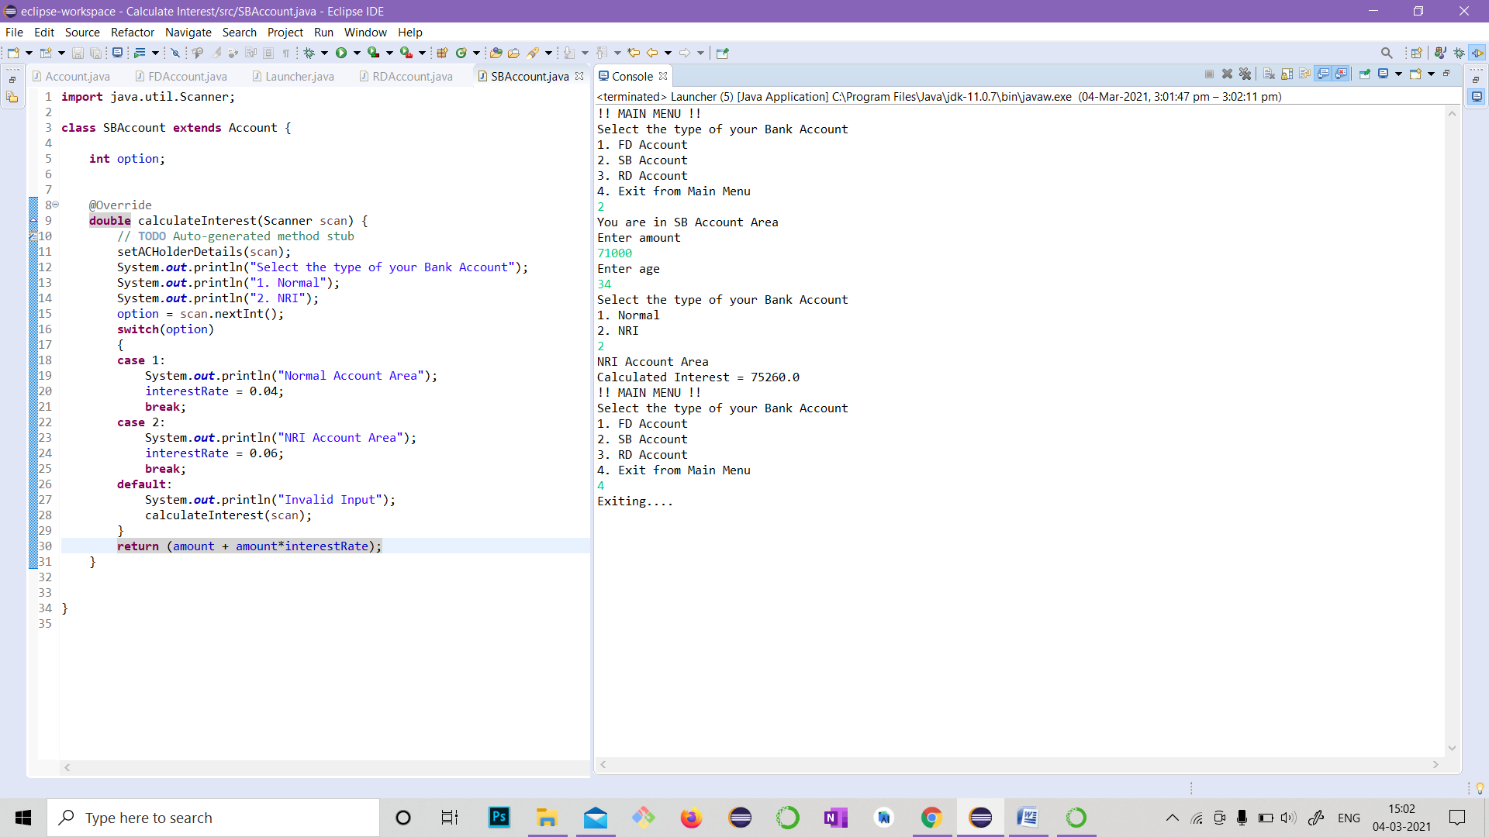

**RDACCOUNT RESULT**

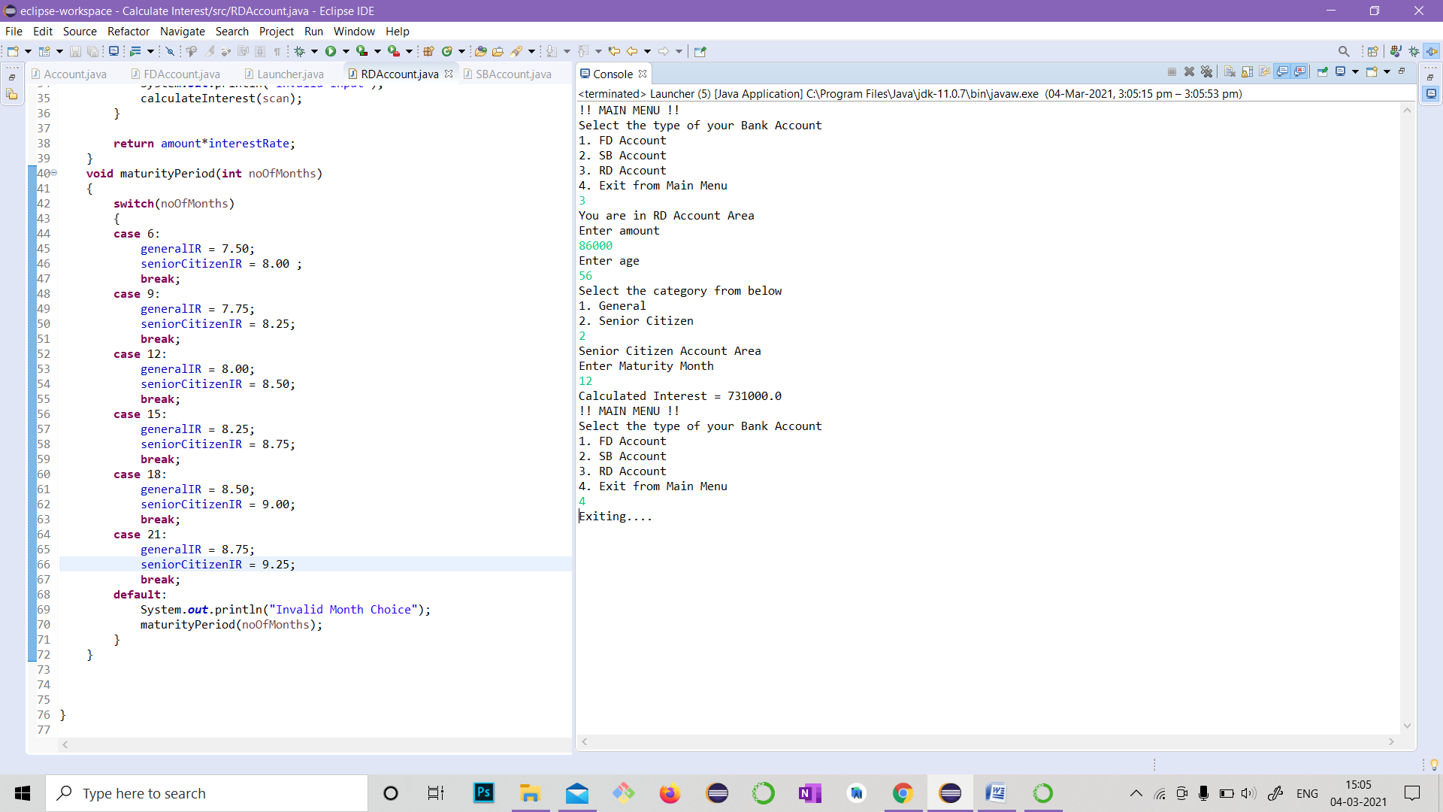

**FDACCOUNT RESULT**

