**OWNER FUNCTIONALITIES**

**Case 1 Add video**

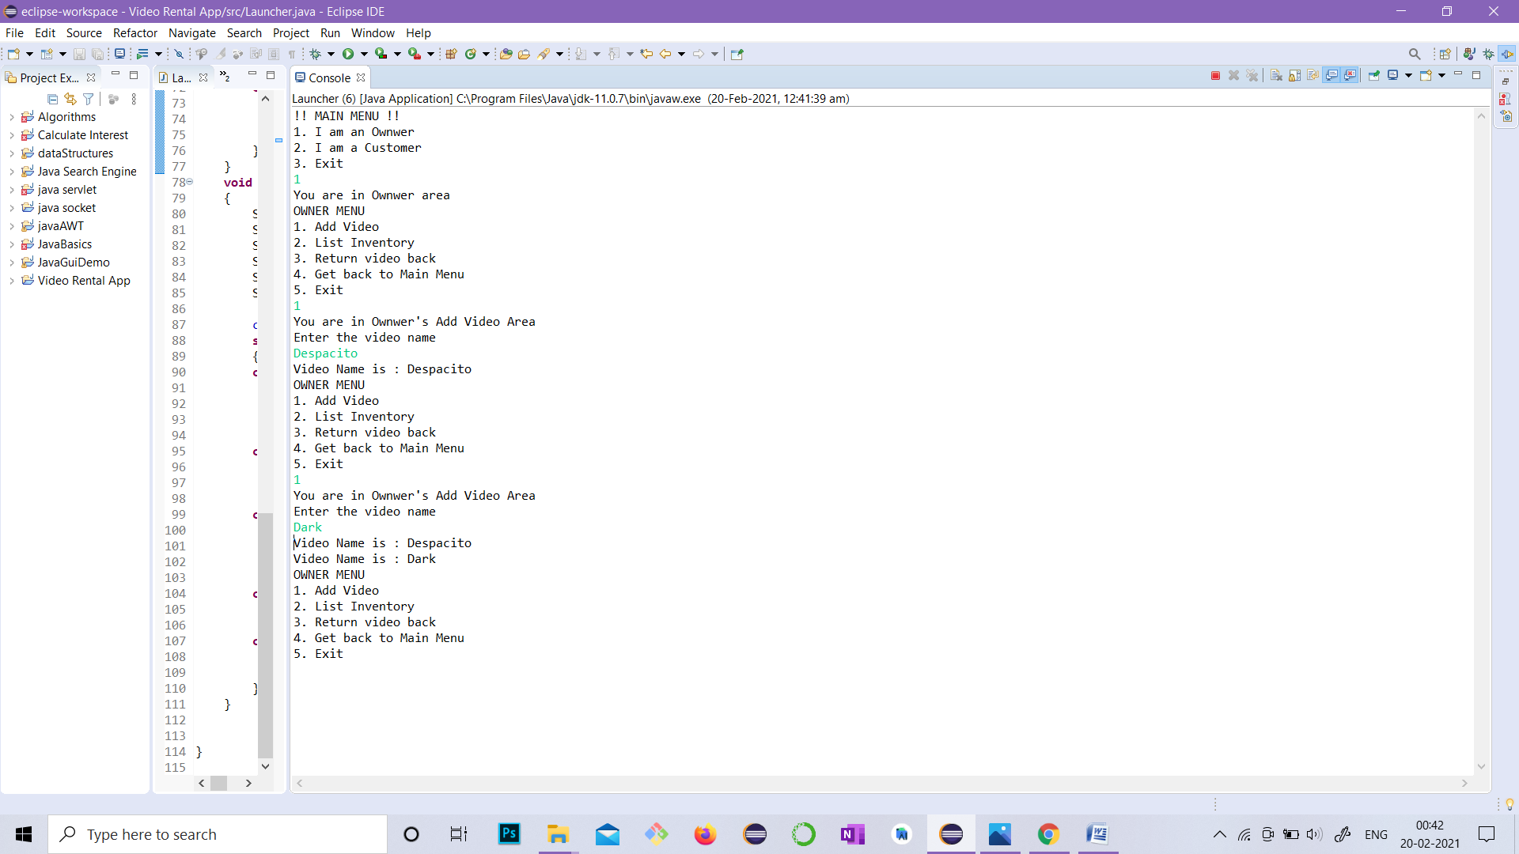

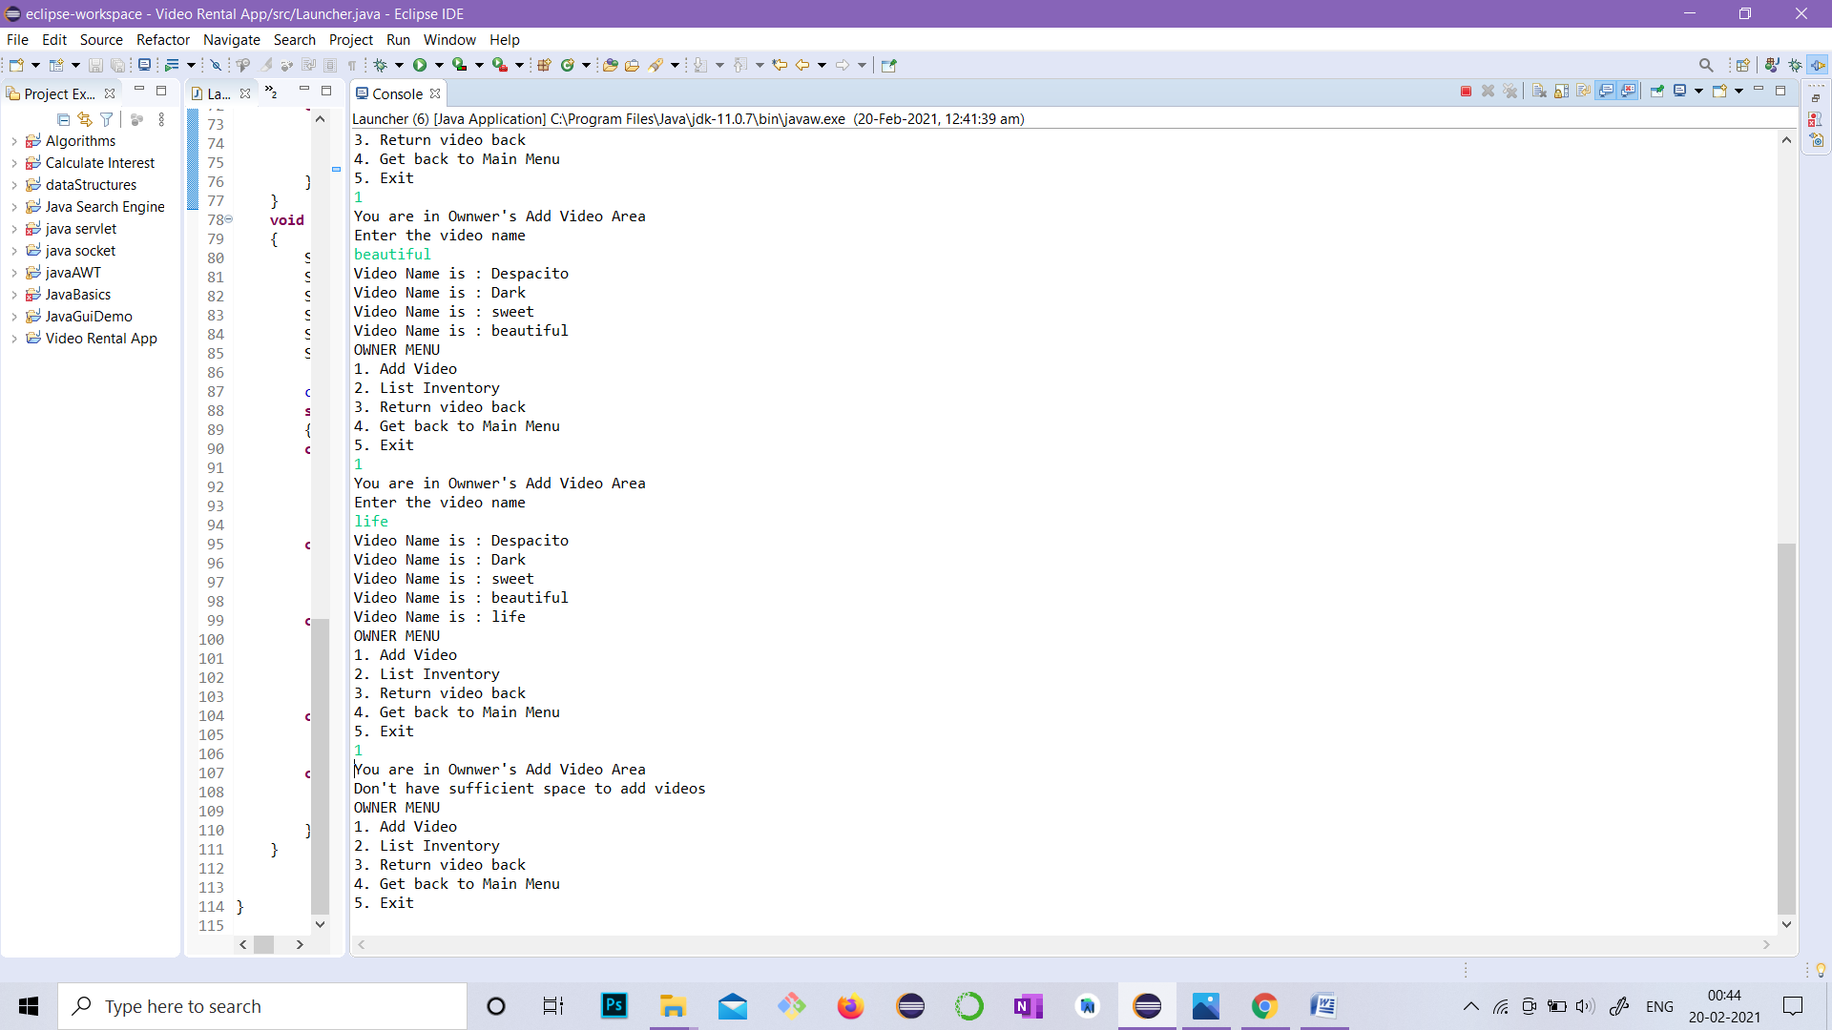

**Case 2 List Inventory**

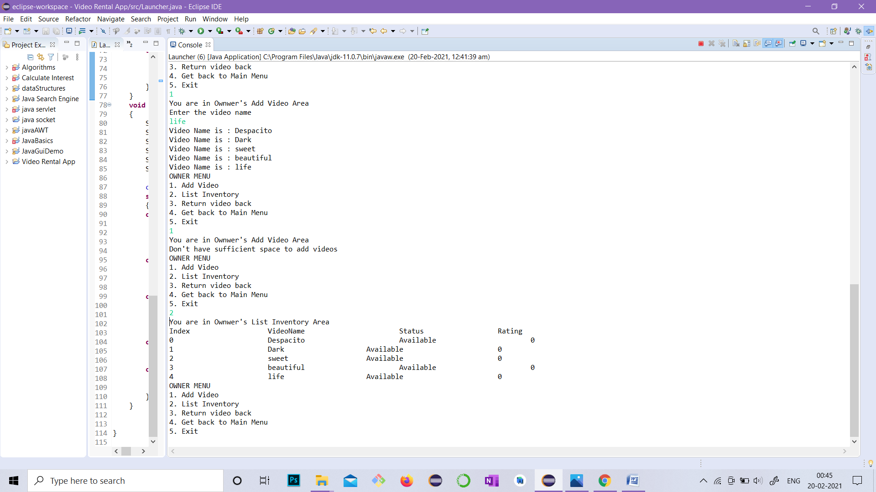

**Case 3 Return video**

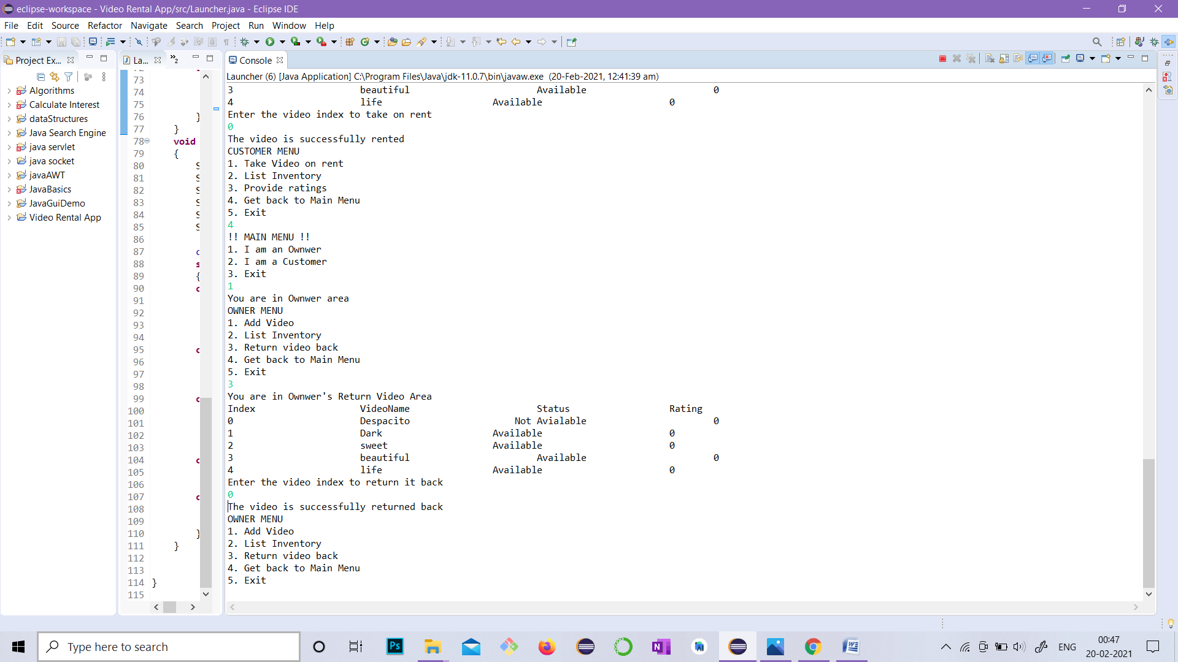

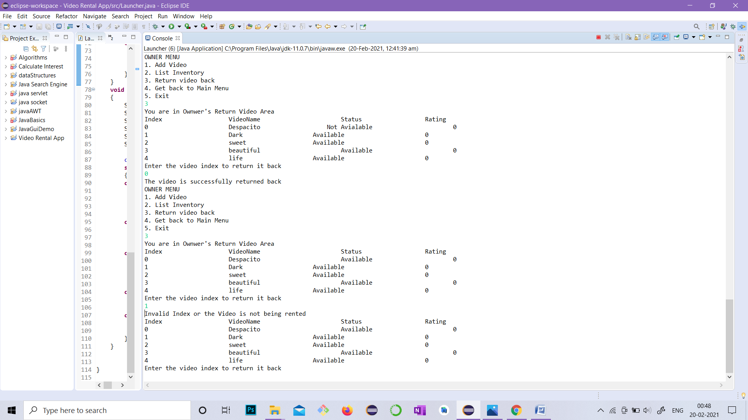

**CUSTOMER FUNCTIONALITIES**

**Case 1 Take video**

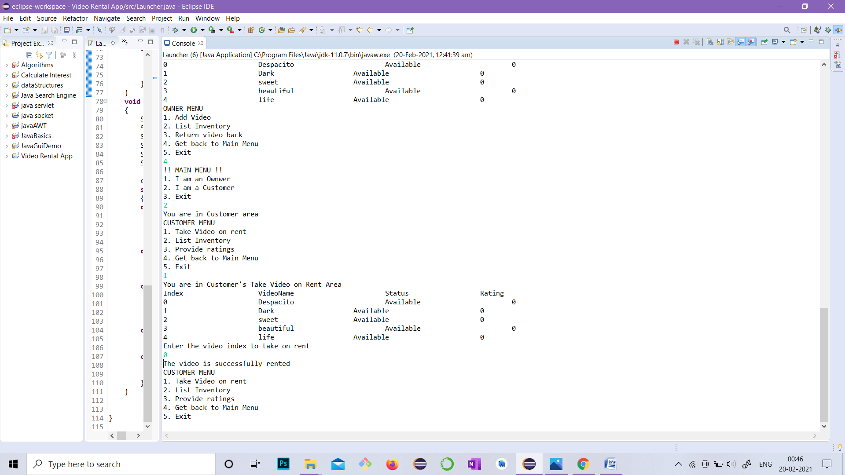

**Case 2 List Inventory**

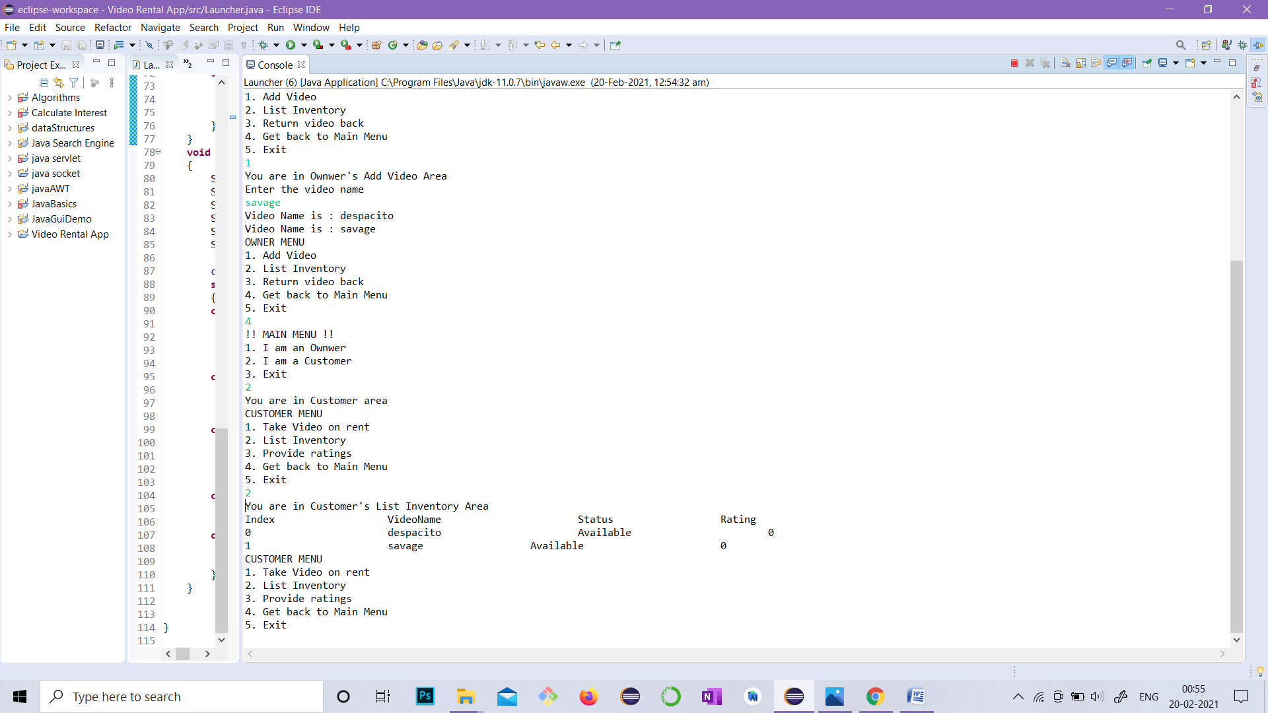

**Case 3 Provide Ratings**

