**Name:**

**ERP:**

**QUIZ 5 - VERSION 5.3**

Q: Which of the following is not an example of a runtime exception error?

1. Arithmetic Exception
2. Null pointer Exception
3. Missing a comma or a quotation mark Exception
4. Divide by zero Exception

Q: Which block is used to handle the exception?

1. Try
2. Catch
3. Finally

Q: The built-in base class in Java, which is used to handle all exceptions is:

1. Raise
2. Exception
3. Error
4. Throwable

Q: Which of the following are checked exceptions? (Choose all that apply)

* 1. Exception
  2. IllegalArgumentException
  3. IOException
  4. NullPointerException
  5. NumberFormatException
  6. StackOverflowError

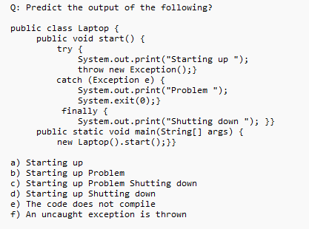

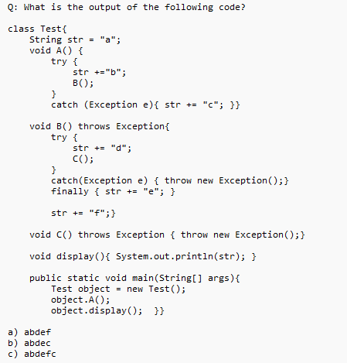

Q: Which exception may be thrown if the given code is executed?

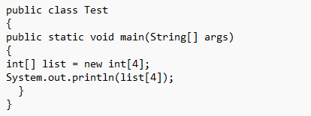

Q: What is the super or base class of all exceptions in Java?

Q: What are the types of exceptions in Java? (List and explain in bullets)