Areesha Sohail
DHC-4496

Digital marketing campaign
PHASE 2

Introduction
This report presents the Phase 2 digital marketing campaign executed for Turkish Rahat Pizza, a newly launched restaurant located at Girja Road, Near Bank of Punjab, Rawalpindi Cantt. Building on the foundation established in Phase 1, this phase focused on scaling efforts, optimizing content, and implementing advanced marketing strategies across TikTok, Facebook, and WhatsApp to achieve higher reach, engagement, and conversions. The campaign covered Week 4 (Advanced Marketing & Campaign Expansion) and Week 5 (Data Analysis & Community Building), with the goal of strengthening brand presence.

Week 4 – Deliverables

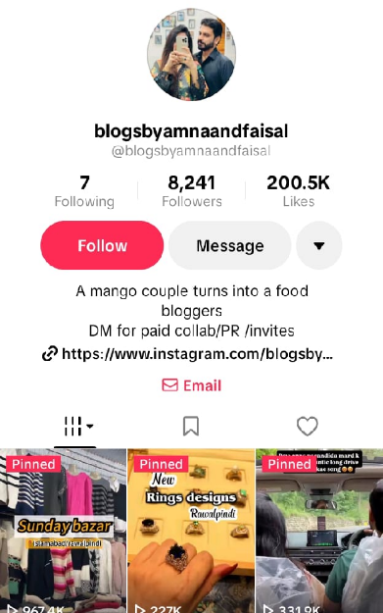
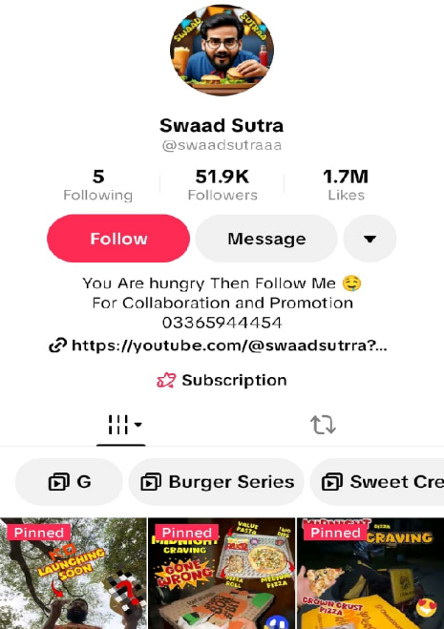
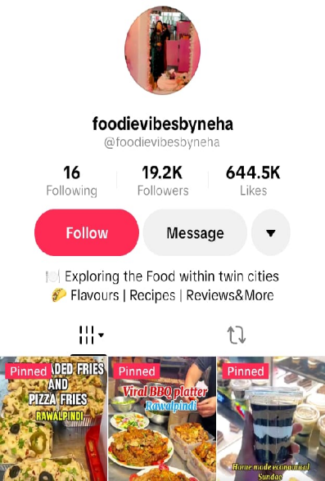
INFLUENCER IDENTIFIED

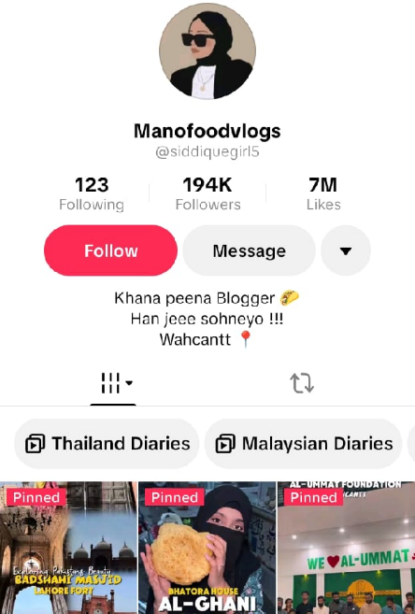
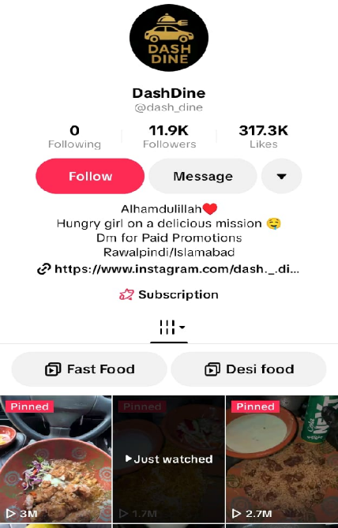

OUTREACH MESSAGE
As all of them are food vloggers so I drafted one common message for all.
Assalamualaikum [Name],
I came across your content and really enjoyed it. Your videos are quite engaging!
I'm a social media intern working with Turkish Rahat Pizza, Rawalpindi Cantt, and we'd love to collaborate with you. We'd like to offer you one of our special pizzas, complimentary, in exchange for a social media review or promotion. As a thank you, you'll also receive a 20% discount on your next three orders. If you're interested, please let us know. We'd love to hear from you!

Search Engine Marketing (SEM)
Keywords: Pizza Rawalpindi, Pizza deals Rawalpindi, Food deals Rawalpindi, Best pizza near me, Turkish pizza Rawalpindi, Affordable pizza Rawalpindi

Ad Variation 1 :

Weekend Deal
Headline: Weekend Ka Plan? Turkish Rahat Pizza, Rawalpindi!
Description: What's your friend doing this weekend? Bring them here and enjoy our exclusive weekend deal. Good food, great company!

Ad Variation 2:

New Item Launch
Headline: New Launch Alert Tortilla Mexican Wrap!
Description: Want something spicy, different and full of flavour? We got your taste buds! Try our newly added Tortilla Mexican Wrap

Ad Variation 3:

Affordable Deal
Headline: Best Pizza Deals in Rawalpindi $$ Budget Friendly!
Description: High economy and down mood? We got you covered! Hook yourself up with our affordable deals at Turkish Rahat Pizza.

ENGAGEMENT POSTS

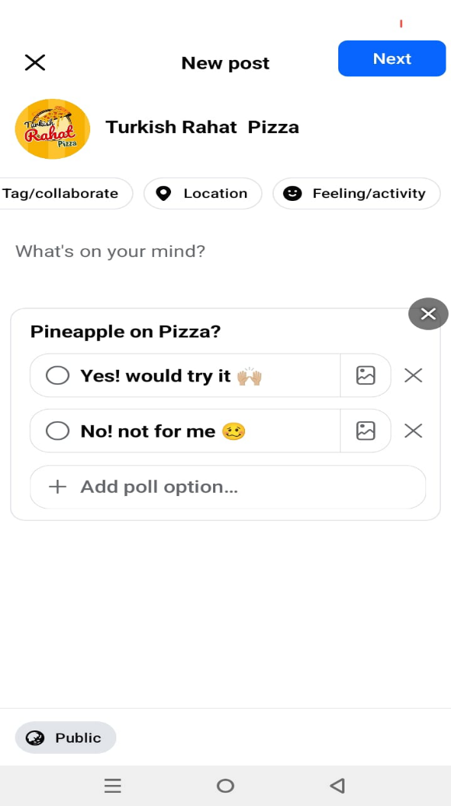
Fb poll

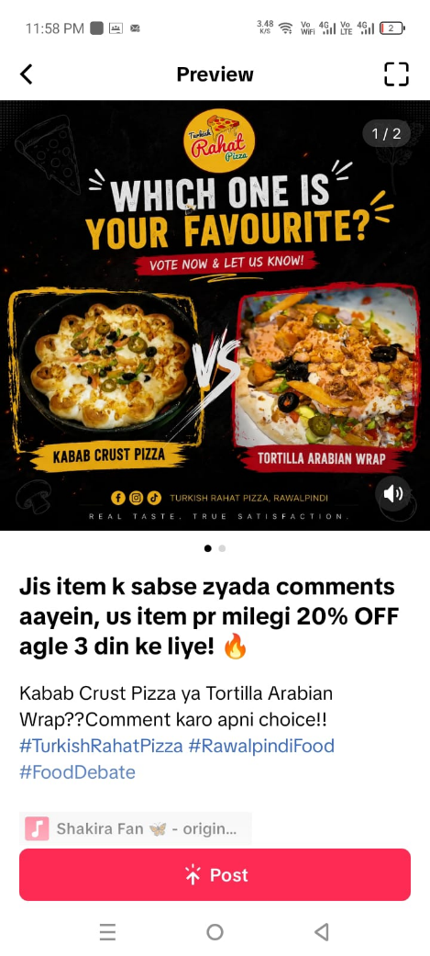
Tiktok Contest post

RETARGETING ADS

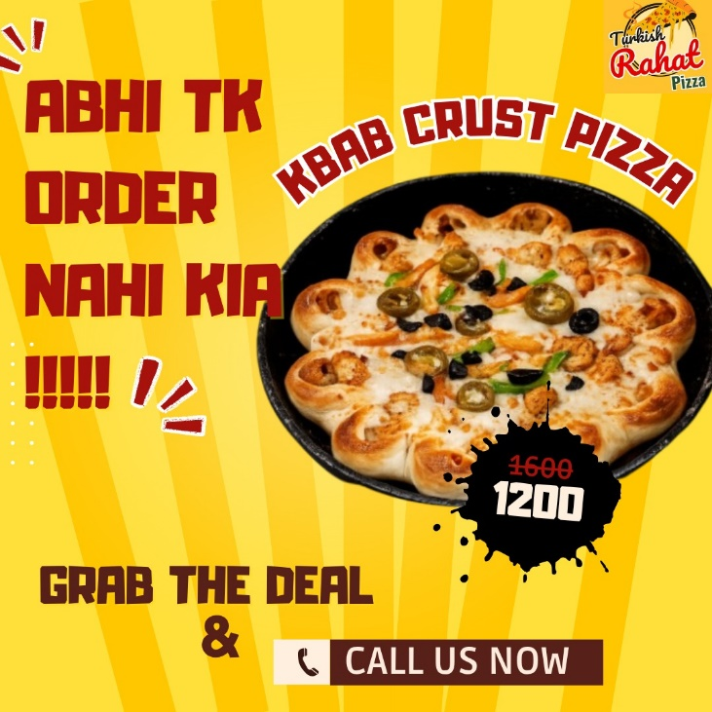
Ad Graphic

Targeting Criteria:
Platform: Facebook & Instagram
Target: Users who visited page or engaged with posts in last 30 days
Objective: Conversions
CTA: Order Now
Budget: Rs. 300/day

CONTENT DISTRIBUTION
Cross-platform distribution strategy planned for future growth. Currently focusing on TikTok and Facebook to build strong audience base first before expanding to other platforms.

Week 5 – Deliverables

ANALYTICS REPORT

TikTok
Post Views: 14.9K ↑273%
Profile Views: 216 ↑300%
Likes: 718 | Comments: 195 ↑306% | Shares: 15
Traffic: 79.6% For You Page

Facebook
Total Views: 12K ↑100%
Engagement: 320 ↑100%
Followers: 26 | Viewers: 8.8K

WhatsApp Channel:
Followers: 38 | Posts: 6

Key Insights:
- TikTok organic reach proved to be strong by attracting 79.6% FYP traffic.
- Comments increased by 306% indicate active engagement
- Peak: June 22 — 4K views in one day

COMMUNITY BUILDING

Mock Q&A Plan
Platform: Facebook Live
Duration: 30 minutes

Questions:
1. Can we do takeaway or only dine-in?
2. Any deals for students or families?
3. Discount if we bring 3-4 new customers?
4. Is dessert available? Is it free?
5. Benefits of membership card besides 20% discount?
6. Perks of being a regular customer?
7. Free delivery if order is above 2k even outside range?

EMAIL DRIP CAMPAIGN

Email 1
Subject: Welcome to Turkish Rahat Pizza!
Body: Assalamualaikum! Turkish Rahat Pizza ab aapki community mein aa gaya hai! Visit karein Girja Road, Near Bank of Punjab, Rawalpindi. Membership card se pao 20% discount on every order!

Email 2
Subject: Aaj Ka Special Deal Sirf Aaj Ke Liye!
Body: Assalamualaikum! XL Kabab Crust Pizza + 1 Zinger + 2L Drink Ab Rs. 2600 ki jagah sirf Rs. 2200! Order karo abhi!

Email 3
Subject: Last Chance! Deal Ab Aur Bhi Sasti!
Body: Assalamualaikum! Same deal ab sirf Rs. 2000! Yeh last chance hai. Abhi order karo!

A/B TESTING
Test: Same graphic style, different deal names
Platform: TikTok
Regular Deals Views: 363
Family Deals Views: 53
Regular Deals performed best. Family Deals underperformed possibly due to different audio, posting time, or "Family" word not resonating with TikTok's young audience. Recommendation: Use trending audio and post during peak hours 7-9 PM.

