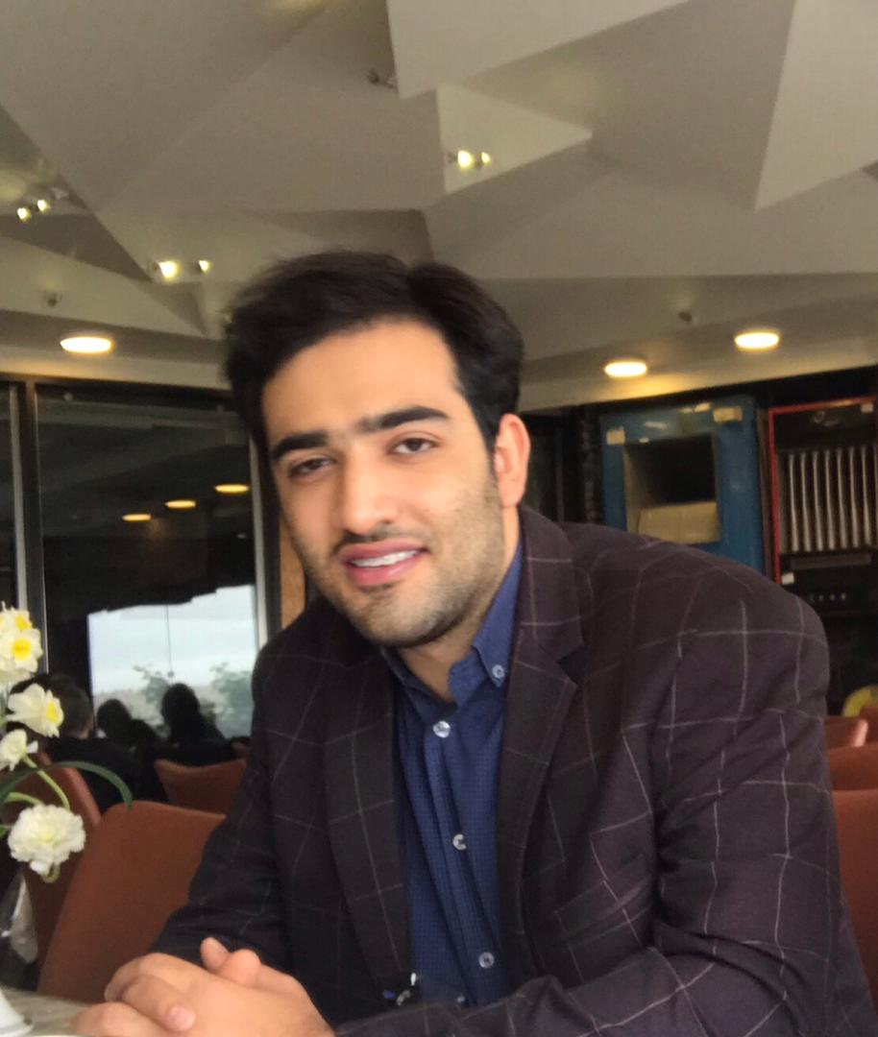 | Seyed Aref Sajjadi
 | Mobile  E-Mail | +98 933 532 94 18  primary:  arefsajjadi80@gmail.com | Website  Address | http://www.arefsajjadi.ir  No. 243, 186 street, Tehran, Iran, Postal Code:  6516931319
Note: some of the organizations and media, also wrote ‘Sajjadi’ as ‘Sajadi’ / ‘Aref’ as ‘Rf’ / ‘..dAref’ as ‘..d Aref’ which is also accepted.

Professional Profile
An international competitor, national champion and undergraduate of computer engineering with professional experience in software development and team management. Seriously eager to learn, enjoy artistic problem solving and overcoming challenges with a view of achieving academic and scientific experience and certification. Fully energetic in working in teams and highly skilled in fundamental knowledge and skills of software engineering.

Education
Hamedan University  HUT. BioMedical Engineering  March 2017 – July 2021 | Final Project:  Implementation of a Web and Trend-Shopping Services. / https://www.pergas.io/
Azarmi High School  Diploma and College  March 2013 – August 2017 | Major:  Mathematics and Physics  Note: This major is the main choice to carry on higher education in engineering

Professional Experience
Back-end Developer | Homsa | / https://www.homsa.net/
Full-stack Developer | Bsuperior Ltd | / https://bsuperiorsystem.com/
Founder and Director | Pergas | / https://www.pergas.io/
Project Manager | Iran Medical Services | / https://www.imeds.ir/
Senior Developer | AmlakGharb | Implementation of GPS back-end, web and google-API, front-end (2019 to 2020) / https://www.amlakgharb.ir/
Freelance Developer | Self-employed | - Web Design and Development (since 2019)  - Mobile Applications Programming (since 2018 until 2019)

Volunteer Experience
Founder, Director, and Editor in Cheif | Iran Pergas | Pergas is a bidding market that aims for the lowest price of anything. This is not just a bidding website but a marketplace for sellers looking for a real buyer. / http://www.pergas.io/

Honors and Awards
Music Awards | - 2nd, Fajr Festival, with ritard Band, Hamedan (2019)  - 1st, Javan Festival, Tehran (2015)

Skills
Programming Languages | C++, PHP, Ruby, Scala
Web Technologies | Bootsratp, HTML5, Laravel (Advanced), microservice, RPC, CDC, Redis
Desktop Technologies | Windows Forms Applications, Windows Presentation Forms
Mobile Technologies | Java (basic)
Database Systems | MySQL
NoSQL Database Systems | MongoDB (basic), Redis, Elasticsearch
Analyzing and Designing Software Solutions | - Considering all possible options and deriving the best solution based on sound analytical judgment and the client’s best interests  - Using system analysis and design methodologies (such as Unified Modelling Language (UML), software framework, and Design Patterns)  - Build data warehouse and required for business intelligence/ executive dashboard  - Proper interface and layering for mobile solution.  - Use Case modelling and analysis (such as Use Case Diagram, Use Case Description, Actor Description, Use Case Package)  - Structural modelling and analysis (such as Object, Class, Domain Class Diagram)  - Dynamic modelling and analysis (such as Sequence Diagram, Collaboration Diagram, State Diagram, Activity Diagram)  - Data modelling tools and techniques (such as Entity Relationship Diagram, Normalization, Data Dictionary)  - Object design and package  - Relational or object database design and data flow diagrams  - Human-computer interface design/user experience  - Security and controls design  - Multi-tier application design
Enterprise Software Development | - Accurate and Consistent Version Control (with tools such as Git)  - Using Microsoft TFS project management tool  - Using system development methodologies such as object-oriented design  - Considering normal and abnormal scenarios, and exception handling  - Following standards: Style Guide, Code Convention, Human Interface Design (UI), Managing Directories and Files  - Code Refactoring and Analysis  - Evaluate and integrate appropriate libraries and frameworks into a software solution
Version Control | Git, Microsoft TFS,
Server Administration | Linux, Windows Server

Languages
Persian | Native proficiency
English | Full professional proficiency

Soft Skills
Work Organization and Management | - Principles of productive team work  - Design a proper flow of the system that is designed and provide proper notification when needed  - Applying company standards into system  - Planing each day’s production schedule according to available time and take into account time limitations and deadlines  - Applying research techniques and skills to keep up-to-date with the latest industry guidelines  - Reviewing own performance against the expectations and needs of the client and organization  - Preparing a good system documentation on how to use, install and run the system
Communication and Interpersonal Skills | - Confirm that the created application meets the original specifications and obtain user sign-off for completed system  - Collaborate with others to develop the required outcomes  - Work well in group problem solving  - Prioritizing and scheduling tasks  - Allocate resources to tasks
Problem solving, innovation, and creativity | Knowing and understanding:  - The common types of problem and requirements which may occur within software development  - Diagnostic approaches and suitable system or software to problem solving  - Trends and developments in the industry including new platforms, languages, conventions, and technical skills  - The use of latest technology to be applied in software scenario which requires the ability to demonstrate and provide an over-arching business solution to a problem  - How to set-up, develop, and integrate into designed solution the latest technology and hardware that will drive a better business solution.  Able to:  - Research encountered problems independently  - Identify and resolve problems in a timely manner  - Gather and analyse information skilfully  - Develop alternatives using the latest technology to support better business solution.

Hobbies
Music | - Violin soloist at “National Symphony Orchestra” (since 2015 to 2017)
Artificial intelligence | - Certified junior collegian, IS-Baba singularity University intern ship (since 2021)

