Falak Al Balushi

∗ 98796181∗ falak.aijaz@hotmail.com
Career Objective | 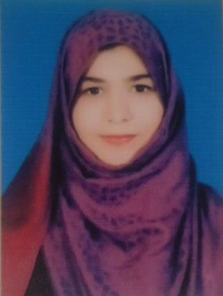  An enthusiastic graduate with high dedication and motivation and an outstanding academic record is looking for training in a reputed company. Has developed excellent problem-solving skills while working in the billing department and studying a full range of Finance modules. Have good organizational skills and capable of working and handling pressure in any situation. Have the ability to learn fast.
Core Competencies
  - Fostering Teamwork  - Trustworthiness and Ethics | - Quick learner  - Motivated and Ambitious
Professional Experience | Lama Polyclinic  Billing Department, January 2017  - Responsible for all corporate receivables, medical billing, invoices and preparing reports.  - Assisted in insurance claims processing and analyzing insurance receivables.  - Ensures all insurance and corporate related duties are completed in timely and accurate manner.  - Worked with department staff to research, identify and provide solutions to patients, corporate and insurance company inquiries.  - Practiced professional telephone etiquette and customer service while making claim inquires.  - Demonstrated strong attention to detail and ability to multitask.  - Researched and solved claim and billing issues.  - Prepared reports, credit notes and invoices.
Education  Qualifications | Majan University College  B.A (HONS) Finance, 2016  - GPA: 3.3/4  A levels (Accounting, Business Studies, Economic). 2013  O levels (Commerce), 2011  Skill Development Centre, Pakistan  Specialisation in Banking, 2013
Additional Skills  Languages | - Proficient in Microsoft Office and Tally.  - Confident when working individually or in groups, been the team leader during college assignments.  - Strong interpersonal skills.  - Communication skills, both verbal and written.  - Analytical and research skills.  - Preparation and analysis of financial statements like P&L, Cash flow and Balance Sheet.  - Knowledge of IAS/IFRS standards.  - Calculation of Taxable income and tax to be paid.  - Been active in participation in International School Educational Olympiad.  - Participated in MSM Financial Analyst Challenge.  - English- Speak, read and write fluently  - Urdu - Speak, read and write fluently  - Balushi- Native  - Arabic- Basic Knowledge

