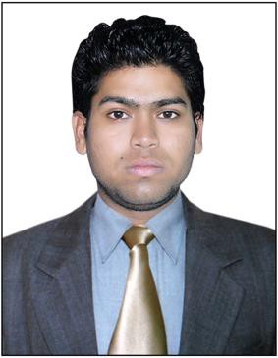

[***Curriculum vitae***](http://www.google.co.in/url?sa=t&amp;rct=j&amp;q&amp;esrc=s&amp;source=web&amp;cd=2&amp;ved=0CD8QFjAB&amp;url=http%3A%2F%2Fen.wikipedia.org%2Fwiki%2FCurriculum_vitae&amp;ei=A5PVUJziEZGJrAfpi4D4CA&amp;usg=AFQjCNGUeo8hB8NVitVOREZc5LDdTZE32Q&amp;bvm=bv.1355534169%2Cd.bmk)

AKSHAY

# 297/2, Multan Nagar, Meerut. Mob: +91-9760510773

**Email:** [**animatorakshay@gmail.com**](mailto:animatorakshay@gmail.com) **Passport No. L6335493**

**OBJECTIVE**

To work in an organization that offer challenging opportunities,

Responsibilities and a chance for personal development and a vision to achieve and exceed.

# EDUCATION

**ACADEMIC QUALIFICATION**

* 10th from UP BOARD year 2006-2007
* 12th from UP BOARD year 2008-2009

# PROFESSIONAL QUALIFICATION

* Diploma in animation (AG pro) 3D, 2D & from Animaster.
* B.Sc. Multimedia from Punjab Technical University.

# EXPERIENCE

* Four year experience in **Elite Consultant** for **3D Modeling**.

# SKILLS, ABILITIES & KNOWLEDGE

* Specialized in high-poly and low-poly organic & inorganic Modeling, Texturing, Lighting, Rigging & Rendering. (Autodesk Maya)
* Interior and exteriors visualization. (3ds Max)
* Next gen characters development. (Maya, Photoshop)
* Image based modeling. (3D Urban Modeller)
* Work on point cloud data.(Scene, Recap Pro)
* Specialized in 3D modeling crowed area with dimensions.

1



# AREA OF INTEREST

* Interior & Exterior Architecture designing.
* 3D development & arts.
* Rigging (Autodesk Maya).
* Architecture Modeling.

# SOFTWARE KNOWN

* Adobe Photoshop
* Adobe Flash
* Adobe Premier
* Autodesk Maya
* Autodesk 3ds Max
* Autodesk Stitcher
* Autodesk Recap 360
* Google SketchUp
* Autodesk Image Modeler
* Esri Cityengine
* Agisoft Photo Scan
* Faro Scene
* GeoCV 3D Urban Modeller

# PERSONAL SKILLS

* Interacting with people.
* Travelling.
* Playing video games.

# Personal Details:

* **Name :** Akshay
* **Father’s Name :** Amarnath Sharma
* **Date of Birth :** 5th Nov 1992
* **Sex :** Male
* **Marital Status :** Single
* **Languages Known :** Hindi
* **Nationality :** Indian
* **Email Id :** [animatorakshay@gmail.com](mailto:animatorakshay@gmail.com)

2