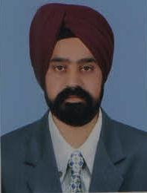**CURRICULUM VITAE**

**NAME: MR. HARTAJ SINGH**

**FATHER’S NAME: S. BACHITTAR SINGH**

**D.O.B: 05-02-1979**

**ADDRESS: V.P.O-Bharakh, Near Kalakh Gurudwara, Teshil-Pouni & District- Reasi-185203, State-J&K**

**CONTACT NO.: +91-9596376182/7889955305**

**E-mail:** [**harttajsingh32@gmail.com**](mailto:harttajsingh32@gmail.com)

**RELIGION: SIKH**

**NATIONALITY: INDIAN**

* **EDUCATION QUALIFICATION: GRADUATE/B.E. (AUTOMOBILE ENGINEERING) FROM GULBARGA UNIVERSITY, KARNATAKA SECURED SECOND CLASS WITH 59.56 % MARKS.**

**EXPERIENCE: 12 YEARS**

**LICENCE DETAILS: HOLDING BOTH HEAVY AND LIGHT LICENCE, INDIA**

**NUMBER: JK-02 2010 0058132**

**DATE OF ISSUE: 10-03-2010**

**DATE OF EXPIRY: 04-10-2029 & HEAVY (Trans.) 16-01-2021**

**PASSPORT DETAILS:-**

**NUMBER: P8554984**

**DATE OF ISSUE: 10-10-2017**

**DATE OF EXPIRY: 09-10-2027**

**DECLARATION: I hereby declare that all the above given information are true and correct to the best of my knowledge and belief.**

**NAME: Mr. HARTAJ SINGH**

**PLACE: REASI**