**CURRICULUM VITAE**

***MITHLESH KUMAR*** 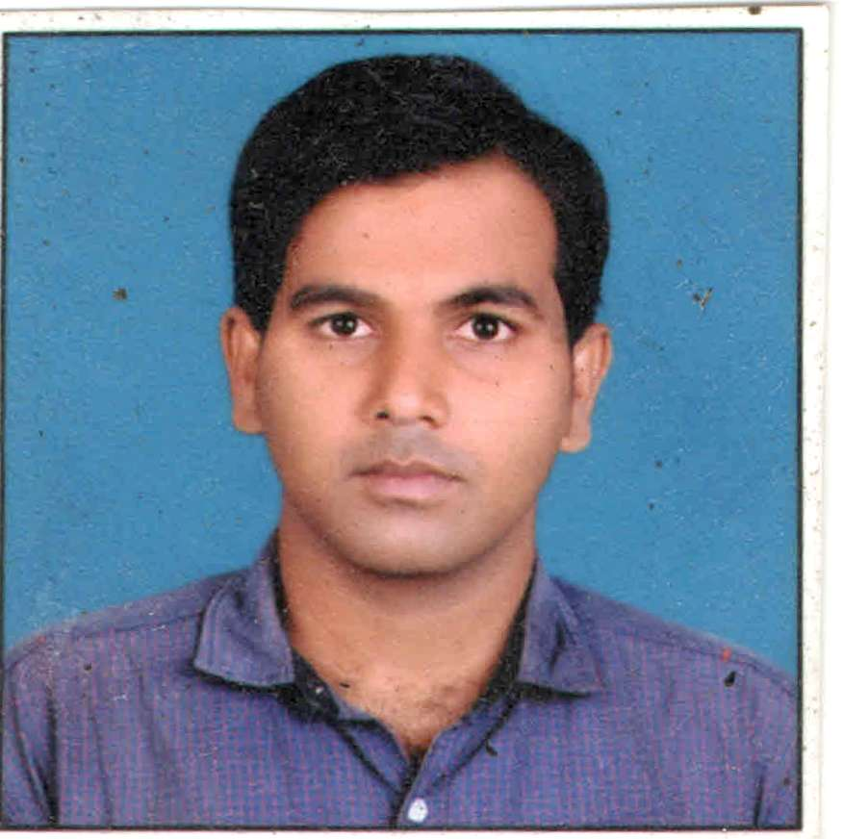

**Ambuja Colony ,Dabourji.Distt-Rupnagar(Punjab) 140113**

**Cell Nos: Current: +91 7503327631,+91 8837597801**

**E-Mail ID:** [**freshmm1991@gmail.com**](mailto:freshmm1991@gmail.com)**, mithleshnb18@rediffmail.com**

**­_____________________________________________________________________________________________________**

**POST APPLIED FOR:-**

**Piping Supervisior**

**CAREER OBJECTIVE:**

* To attain a challenging job in Mechanical works, Project Construction and Management in an organization

That allows Professional plus personal growth and adds valuable experience to my career.

**PROFESSIONAL QUALIFICATION:**

* Diploma in Mechanical Engineering for Punjab State Board of Technical Education & Industrial training, Chandigarh.**.**

**Institute:-** GGS Polytechnic College Kharar Punjab (2011)

* **Metric (10th level):-** Board :- Bihar State Education Board in Patna (Bihar) 2007

**COMPUTER LITERACY:**

* 1 Year Course In DCA (Diploma In Computer Application)
* Efficient in MS Office 2007 & MS Project 2007. Data entry skills.
* Record preparation, preservation and record keeping skills.
* Internet browsing, uploading & downloading skills.
* I Have professional blogger and create at 3 websites .www.naukre.online,www.freeejobalert.in, technologye24reviews.ooo**,**

**PROFESSIONAL AFFILIATION:**

* Life time membership with NGO at Acharya welfare society Deoria up

.

**WORK EXPERIENCE:**

**Total experience :- 6.4 Years**

* I have more than **6.4 Years** of experience as a  **PIPING SUPERVISIOR** Covering various activities,

Ranging from Mechanical Construction, Erection, Fabrication & QA/QC Inspection of Equipments, Process

Piping, & Steel Structure in **Oil & Gas Industries & Oil Refineries.**

**EMPLOYMENT HISTORY:**

* **Designation: PIPING SUPERVISIOR (Mechanical)**

**Employer: RAVI ENGINEERING (Engineers-Fabricators-Contractors)**

**JAMNAGAR-GUJARAT.**

**CLIENT:- RELIANCE INDUSTRIES LTD**

**Period: 10 March 2012 TO 05 October 2018**

* **Designation: PLANING ENGINEER (Mechanical)**

**Employer: Ambuj Construction Company**

**JAMNAGAR-GUJARAT**

**CLIENT:- RELIANCE INDUSTRIES LTD**

**Period: 20 OCT TO TILL DATE**

**JOB RESPONSIBILITIES:**

* Checking & Issue of Isometrics (P&ID Check, Line Routing, Support Check ,

Special Pipe Supports,Site suitability modifications etc.)

* Selection of Pipe Supports, Special Support & Spring Hangers.

Excellent control over loop clearance.

* Ensuring mechanical clearance for hydro Testing.
* Overall Supervision of including such as:HSE, piping fabrication including pipe supports, piping erections, spool pieces control, check and monitor tools, equipment and welding consumables, check and monitor preservation, pipe internal cleaning (Flushing)for small bore and large bore.

Schedule monitoring for manpower mobilization. Consult Engineering problems.Check work front and coordinate with other disciplines.

* Ensure work permits (confined space, hot work, cold work, work at height etc).

Follow Up of punch work.

* Prepare daily and weekly reports (DPR- Inch-dia, Inch-meter, supports etc).

**INDUSTRIAL TRAININGS/TECHNICAL VISITS:**

* Period: 7ND June 2010 to 7ND June 2010

Company: AMBUJA CEMENT LTD

Rupnagar.Punjab

* Period: 10TH AUG 2010 to 10TH DEC 2010

Company: : AMBUJA CEMENT LTD

Rupnagar.Punjab..

**PERSONAL DETAILS:**

Fathers Name KAMESHWAR SINGH

Date of Birth 30 December, 1991

Nationality Indian

Religion Hindu

Marital Status Un Married

Languages English, Hindi & Bhojpuri

Passport Number L7670023

Passport Issued 03 March 2014

Passport Expired 03 April 2024

**DECLARATION:**

I here by declare that the information furnished above is correct to best of my knowledge.

DATE

PLACE :- Rupnagar Mithlesh kumar