**RESUME**

**Birendra kumar** 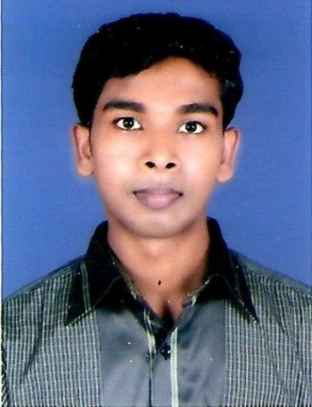

**Contact:** +919506183797

**E-Mail:** Kumar.birendra238@gmail.com

## 

**Career Objective:**

Work with excellence in order to secure a challenging position where I can deliver my hard work and

Skills for the growth of your company as well as for my own personal growth.

**Acadamic Qualifications:**

|  |  |  |  |  |
| --- | --- | --- | --- | --- |
| Examination | Discipline/  Specialization | School/college | Board/University | Year of Passing |
| High school | Science | S.S Inter Collage Varanasi | U.P. BOARD | 2007 |
| Intermediate | Commerce | S.S Inter Collage Varanasi | U.P. BOARD | 2009 |
| Graduation | Psychology, sociology | Suryanath Maha  Vidalaya | M.G.K.V.P Varanasi | 2015 |

**Computer Qualifications:**

|  |  |  |  |  |
| --- | --- | --- | --- | --- |
| **DIPLOMA** | **Discipline/ Specialization** | **College/institution** | **Board/university** | **Year of**  **Passing** |
| **6 Month** | Computer Operator & Data Entry Operator | Rajkiye Mahila polytechnic | Techinical Education Board U.P | 2011 |
| **1 Year** | Diploma in Computer Hardware With Networking | Navodaya Institute Of Technology | U.P Gov. Recognized | 2012 |
| **3 Month** | Hardware | Jetking | DUDA | 2016 |

**Working Exprience :**

* **Relince Petrolium Varanasi :** Manager ( 6 month )
* **Computeer Technician :**  Field Work ( 1 year )

**Personal Profile:**

**Name**   **:** Birendra Kumar

**Father’s Name** **:** Rambilash Mahato

**Mother’s Name**  **:** Usha Devi

**Date of Birth**  **:** 14 June1992

**Hobbies**  **:** Trying new Technologies and innovations.

**Permanent Address** **:** N-12/342 R-1-M Shivratanpur , Bazerdiha, Varanasi U.P – 221109

**Declaration:**

I hereby declare that the above-mentioned information is correct up to my knowledge and I bear the responsibility

for the correctness of the above-mentioned particulars.

**Place: Varanasi**

**Date:**

Birendra kumar

Signature