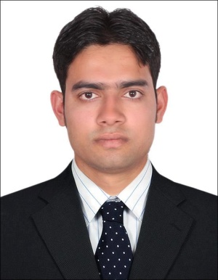

**Objective:**

Seeking a quality environment where my knowledge and experience can be shared and enriched. Looking for the opportunity where I can improve my quality and management skills.

To become a successful professional in field of site ELECTRICIAN in electrical field and get in to and innovative and competitive world.

Electrical field and get in to and innovative and competitive world in India overall **8** years in electrical field.

**CARRIER HIGHLIGHTS:-**

**PRESENTLY WORKING WITH:**

**M/s Emirates Technical Associates (ETA)**

M & E / FMD Division, (ETA/ASCON Group of Companies), Abu Dhabi, UAE **since 14 May 2012 to 10 august 2014**

Presently I am working on **“Mafraq Hospital” (Under Universal Voltas llc) since 8 September to till date**

EXPERIENCE IN INDIA:

1. Worked as an electrician from 2007 to 2008 in Praveen Electrical.

In Mumbai.

2. Worked as an electrician from 2008 to 2010 in SHOBHA Projects& Trade Pvt. Ltd. In Mysore.

3. Worked as an electrician from 2010 to 2012 in Sterling & Wilson Pvt. Ltd. Chennai.

**EDUCATION QULIFICATION:-**

* 10th passed from UP board, Up, India

**PROFESSIONAL QULIFICATION:-**

* **2** years I.T.I in Electrical from Govt.(National Industrial Training Institute) Digha ghat, Patna, India

**JOB PROFILE:-**

Erection, Testing, Commissioning, Operation and maintenance of the following terms.

* Handling the day to day complaints.
* Up to dating daily reading and ppm report in PDA machine
* Attending the trouble shooting star delta starter and DOL starter.
* Can able to do trouble shooting of all type of breakers like a (MCB,MCCB,ACB,ELCB,RCCB,ISOLATER)
* Installation and commissioning FDB,SMDB, DB dressing
* All kinds of Electrical Bus Bars MCC Panels, MDB's UPS, SMDB's DB's Cables pulling.
* Termination, Panels Glanding & termination.
* Power and Lighting systems (LCP) and dimming system.
* Laying GI tray and Tranking from MCC's to Motor of Mechanical Equipment's like chiller's AHU's chiller water pumps etc.

**NAME: - TARIQ ANWER** CALL: -

(+971) 50 5936392 (IN UAE)

(+91) 9534696877 (IN INDIA)

**Email ID:-**

[tariqanwer45@gmail.com](mailto:tariqanwer45@gmail.com)

**Skype ID: tariqanwer4**

**PERSONAL DATA:-**

Date of Birth : 02/06/1989

Sex : Male

Marital Status : Single

Nationality : Indian

Language: English, Urdu & Hindi

**PASSPORT DETAILS: -**

Passport No. : K1332843

Place of Issue : PATNA

Date of Issue : 31/10/2011

Date of Expiry : 30/10/2021

**PERMANENT ADDRESS**

V.Shakhi Chakia Po. Bara Chakia

Dist. East Champaram (Motihari)

Bihar-845412

**LOW CURRENT SYSTEM:-**

* Fire Alarm system's
* Emergency Lighting system's (maintained and non maintained)

Declaration:-

I consider myself familiar with your concern. I am also confident of any ability to work in a team.

I hereby declare that the information furnished above is true it the best of my knowledge.

Yours Sincerely

(TARIQ ANWER)