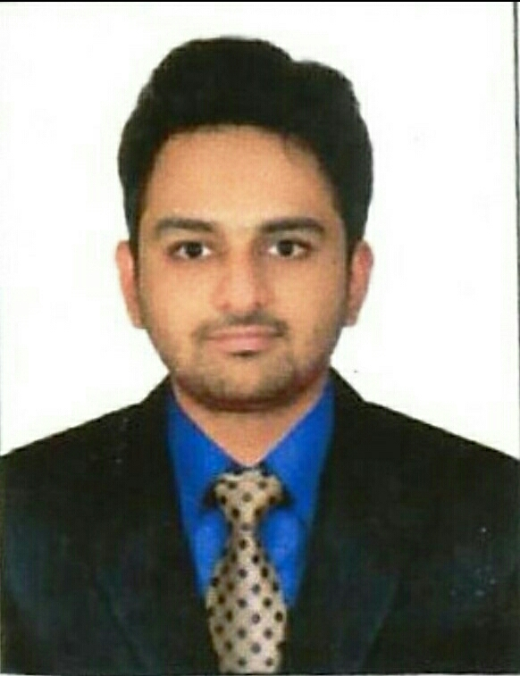

|  |  |  |  |  |
| --- | --- | --- | --- | --- |
|  | |  | | |
| **Sameer Ahmed**  **Quick Snapshot**  **Total Experience** : **5 years**  **Last Company** : **Omega Tech Solutions Private Limited**  **Last Position** : **Sr. CCTV and Electronic Low Voltage engineer.**  **Email : [smrhmd50@gmail.com](mailto:smrhmd50@gmail.com), sameer_ahmed003@Skype.com**  **Nationality : Indian.**  **Visa Status : Visit Visa( Expires on 20 Jan).**  **Mobile : 0503360158.** | | | | |
| : | | | | |
| **Job Objective**  Looking to work in an environment where I can get an opportunity to apply my skills and expertise in it, specifically looking for an organization where I can get an opportunity to grow, learn and innovate.  **Professional Summary**     * Design, installation, configuration, testing and Maintenance of CCTV and Access Control and other Security Systems. * Establishment of relationships with vendors and contractors pertaining to CCTV Systems. * Configuration of DVR after the complete setup of CCTV cameras. * Conduct customer site surveys and provide sales engineering support, including collecting and recording detailed operational, functional and technical requirements, developing project scopes, and providing overall system costing for Access Control & CCTV projects. * Understanding plans and specifications to identify the types and grades of materials and equipment needed to ensure compliance with project requirements. * Prepare, monitor and report on all planned preventative maintenance (PPMs) for all security systems CCTV, Access Control and Fire Alarm Systems.   **Organizational Experience**  **Duration:** Aug 2012 to Sep, 2017.  **Role:** Senior Low Voltage Engineer/ CCTV and Security Engineer..  **Duties & Responsibilities**   * Installing the video & audio CCTV surveillance system according to the premises and customer’s need. * Participation in training and development in order to maintain an awareness of latest technologies related to CCTV cameras and systems. * Worked on CP plus, Samsung, Panasonic, Axis and other Indian brands of CCTV cameras. * Sending enquiries to other companies & comparing the products & prices to select best product & price. * Attend customer sites and undertake periodic maintenance of security systems and carry out necessary fault finding on client sites. * Participate in team briefings, operator working groups and the Employee Development and Performance Management Schemes to work more closely with management and other agencies in the development and administration of the service * Responsible for follow up with different projects status on the sites according to the projects plans. * Installation of Biometric system (Products of R.C.G Company) * Assembling DVR, NVR and configuring, customizing the embedded Linux software for the first time use. * Supervising and effectively managing team members for installation and laying of different cables like RG59, RG6, Fiber Optic cable, Cat 5 & Cat 6. * Installation of patch panels of LAN & doing punching of key stone jacks. * Doing clamping, crimping and applying relief boots to RG45 cable. * Making of patch cords for LAN e.g. straight cables & cross cables. * Testing & troubleshooting of different cables used for installing through a digital multimeter. * Installation of cameras based on diagrams done through designing tool. * Designing, installation and commissioning of complete Access control systems, Biometric Devices & time attendance system. * Configuration, integration and testing of installed systems, applications & software. * Using safe systems of work when working with all plant and equipment and ensure the same with the department and among sub-contractors and third parties. * Participate in project work including refurbishment of existing building equipment/systems and/or new installations. * Assist in monitoring utility consumption, collation of consumption figures, and update records as required. * Manage the requisition of tools, spare parts and consumables. * Conduct regular tests on the equipment to determine operating reliability and efficiently.   **Technical Skills**   * Operating Systems: Windows 2000/XP/7. * CCTV, Access control (Biometric and door locking system). * Knowledge on LAN, Routers, Firewall and IP networks. * Trained on Employability and time management skills by GMM institute (Govt of India).   **Academic Background**   * Masters degree in (VLSI & ES) From Azad Engineering College Affiliated to JNT University. * Bachelor’s degee in (Electronics and communication) From Royal Institute of Technology and Science affiliated to JNT University. | | | | |
| **Personal Details**   * Father's name : Nazeer Ahmed. * Date of Birth : 8th June 1989. * Linguistic proficiency : English and Hindi. * Passport Number & Expiry : J3905905(Expires on 21/03/2021).   **Declaration**  The Following information mentioned above is true and my documents are verified & attested by the Ministry of Foreign Affairs India, Embassy of United Arab Emirates India.  **References** Reference will be furnished on demand. | | | |
|  | |  | |
|  |  | | | |
|  |  | |  | |
|  |  | |  | |
|  |  | |  | |
|  |  | | | |