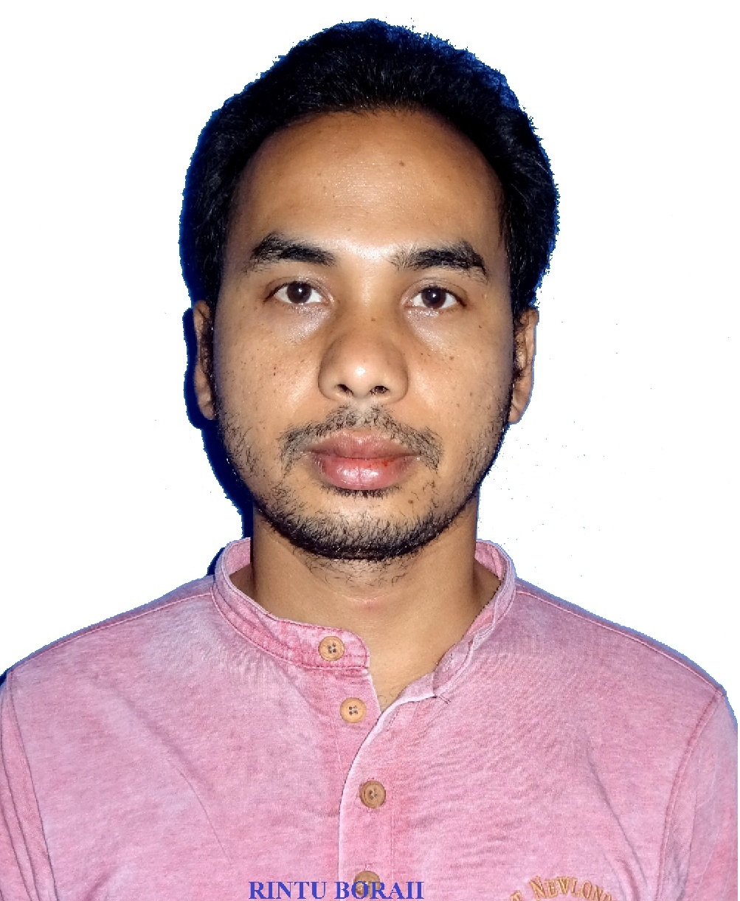 **RINTU BORAH**



**National Informatics Centre,**

**C/O-DC Office, P.O.-Tezu**

District-Lohit, State**:** Arunachal Pradesh,

Pin Code**:** 792001

Contact No.**: +919863751802, +917423800465.**

**E-mail Id:** [**rintu_borah@yahoo.com**](mailto:rintu_borah@yahoo.com)

***Objective***

To secure a position in growing organization that will utilize my talents, challenge my skills and offer me opportunities to grow both personally and professionally.

***Educational Qualifications***

B Tech. In Electronics & Communication from Guru Gobind Singh College of Engg. & Technology Talwandi Sabo (Bathinda) Punjab.

|  |  |  |  |  |
| --- | --- | --- | --- | --- |
| **Examination**  **Passed** | **Institution** | **Board/University** | **Year Of**  **Passed** | **Percentage** |
| B.Tech.  (In Electronics & Communication Engineering) | Guru Gobind Singh College Of Engg. & Technology,  Talwandi Sabo, Bathinda (Punjab) | Punjab Technical University, Jalandhar (Punjab). | 2009 | 70% |
| Diploma  (In Electronics &  Telecommunication Engineering) | H.R.H. The Prince Of Wales Institute Of Engg. & Technology | Assam State Technical Education Council, Assam. | 2004 | 75.6% |
| HSLC | Cinnamara High School | Secondary Board Of Education, Assam | 1998 | 53.5% |

***Training:***

**1. FUTURONIX AUTOMATION PVT. LIMITAD, NEW DELHI (INDIA)**

**Futuronix Automation Pvt. Ltd.** Is a masterpiece in various PLC, SCADA individual industry Project‘s in India.

* **June to August, 2007.**
* **June to December, 2008.**

**Job profile:**

1. Programming in various **PLC ( Twido, Allen Bradelly, Modicon, Mitsubishi)**.
2. Controlling of **AC Drives** & **DC Drives.**
3. **How to Control of projects in SCADA Software.**

**2. ASSAM ELECTRONICS HOUSE, GUWAHATI, ASSAM. (INDIA)**

**Assam Electronics House** is a house of Manufacturing, assembling and repairing electronics items.

* **February to August 2005** **.**

**Job Profile:**

Supervise the assembling and repairing of inverter &Ups.

***Work Experience:***

**1. ERICSSON , JORHAT, ASSAM (INDIA)**

**Position: Engineer from October, 2010 to March 2011.**

**Job Profile:**

**i)** Responsible for Monitoring of Aircel BSC & MSC.

ii) Responsible for Maintenances of Project Sites

**2.AUROBINDO CHAUDHURY MEMORIAL GREAT INDIAN DREM FOUNDATION**

**Position: Faculty from April, 2011 to November 2011.**

**Job Profile**

Responsible for Special “**SGSY Skill Development Programmed**” on Electronics Trade at District Tinsukia, Kakapathar in Assam to BPL family.

**3. WIPRO LIMITED**

**Position: As a Networking Engineer from 4th November, 2013 to till date.**

**Job Profile:**

**Responsible as Router, Modem, Switch configuration, Windows Server 2003/8/12 & SQL Server & Computer Hardware, Data Entry and its peripheral maintenance in the National Informatics Centre, DC Office Tezu site, Arunachal Pradesh.**

***Other Qualification***

Bachelor Of Preparatory Program in commerce from “**Indira Gandhi National Open University”**

From **C.K.B. Commerce College, Jorhat, Assam, India.**

***Personal Details***

**Name**  Rintu Borah**.**

**Father Name** Chidananda Borah.

**Mother Name**  Soonali Borah.

**Date Of Birth**  01 June, 1982.

**Sex** Male.

**Marital Status** Married.

**Religion** Hinduism.

**Nationality** Indian.

Passport Number Z4336438. and File No. GU6060948340417

**Permanent Address** Cinnamara F.C.I. Gate (Near: O.N.G.C.) ,**P.O.:** Cinnamara,

**Dist.:** Jorhat, **State:** Assam, **Pin Code: 785008**

**Language Known**  Assamese, Hindi, English.

***Declaration***

I do hereby declare that the information furnished above is true to the best of my knowledge.

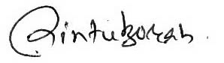 Date: 28/03/2018 **Rintu Borah**