**Curriculum Vitae**

# **Objective: Looking for a Job of Project Manager/Engineer MEP/Electrical. Having experience of more than 24 years (12 Years in Gulf) in MEP / Electrical in multistoried residential / commercial buildings.**

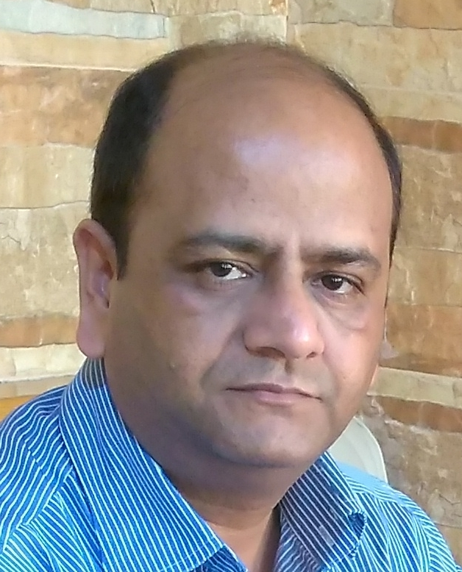

Name : **Dilip Chatterjee**

Father’s Name : Late shri J. Chatterjee

# Date of birth : 27-07-1971

Present Address : New Delhi

**Mobile** : **0091- 7289997706**

E-mail : **dilip_satna@yahoo.com**

Matrimonial Status : Married

## Educational qualification : -

|  |  |  |  |  |  |
| --- | --- | --- | --- | --- | --- |
| **Sl.** | **Examination** | **Year of Passing** | **Board or university** | **Subject(s)** | **Div. with %** |
| 1 | Metric (Class 10th ) | 1986 | M. P. Board | All | I with 67% |
| 2 | Hr. Sec. (Class 12th ) | 1988 | M.P. Board | Mathematics | I with 68% |
| 3 | **3-Years** Engineering **Diploma** | 1991 | M.P. Board | **Electrical Engineering** | II with 62% |
| 4 | **AMIE**  **(Equivalent to B.E.)** | 1997 | *Institution Of Engineers India* | **Electrical Engineering** | With 66% |
| 5 | **Bachelor of Engineering** | 2004 | ***N****ational* ***I****nstitute of* ***E****ngineering and* ***T****echnology, New Delhi.* | **Electrical Engineering** | With 68% |

## Professional Experience:-

**Last Activity**: (From October 2015 to May 2016) Worked in **Airmech** LLC, Bahrain as Sr. Project Manager MEP. Company was expecting some big contracts but, it didn't come. Therefore, I came back to home, spent some time at home for small renovation / construction work of family house &

**Presently, looking for a suitable job.**

**(1)** (From 11-04-2014 to 30-08-2015) Worked with ***Larsen & Toubro Limited*** (***L&T***) at Gurgaon, Hariyana, India **in DLF’s “The Crest” project** as MEP Head.

**Company Profile** : Larsen & Toubro is a major technology, engineering, construction, manufacturing and financial services conglomerate, with global operations. L&T Construction, India's largest construction organization and ranked among the world's top 30 contractors, has been over the past seven decades transforming cityscapes and landscapes with structures of immense size and grandeur. The company's capabilities span the entire gamut of construction - civil, mechanical, electrical and instrumentation engineering - and its services extend to all core sector industries and infrastructure projects.

Several of the country's prized landmarks - edifices, structures, airports, industrial projects, flyovers, viaducts, water and power infrastructure projects carry L&T's signature of excellence in construction. Today, more and more structures beyond India's boundaries are standing tall, thanks to L&T Construction.

**Reason of leaving**: It was a fixed term contract employment.

(2) (From 13-11-2010 to 31-03-2014) :- Worked in “*VOLTAS LIMITED*”, (New Delhi) as Assistant General Manager Projects (MEP) for AIIMS Hospitals projects in India. I was attached to **AIIMS Bhopal**. It is a 960 bed hospital with full scale medical collage.

## Company Profile: *VOLTAS* is India's largest air conditioning company, and one of the world's premier engineering solutions providers and project specialists. Founded in India in 1954, *VOLTAS* Limited offers engineering solutions for a wide spectrum of industries in areas such as heating, ventilation and air conditioning, refrigeration, electro-mechanical projects, textile machinery, mining and construction equipment, water management & treatment, cold chain solutions, building management systems, and indoor air quality.

**Reason of leaving**: Betterment.

(3)(From 17-05-2008 to 30-09-2010) Worked in Shapoorji Pallonji Mideast LLC, Dubai as Manager MEP Services at Park Towers, DIFC, **Dubai**, UAE.

**Nature of Job/responsibilities :**

**** Installation of following electrical & Mechanical services for *DAMAC* Park Towers (3Basements+7Podiums+**42Floors, Twin towers**) at DIFC, Dubai :-

# Medium voltage services including switchgear, Generators, Transformers, and Cabling.

# Low Voltage system including, Main panels, Power Distribution, Small power and lighting.

# Emergency lighting systems.

# Fire detection systems.

# Security Systems.

# Building Management Systems.

# Telephone Systems.

# MATV Systems

# PA System

# Plumbing and Drainage system

# Fire Protection System

# HVAC System (Including Chilled water pipe work, Ductwork & airside equipments)

# LPG System

 Follow up with works and allocation of resources in terms of material, manpower, tools and plants.

 Obtain approval and inspection of consultants and local regularity bodies.

 Studying the design intent of the project and ensuring compliance.

 Studying shop drawings, taking care of material submission - including orders.

 Highlighting the issues relating to the claims or technical inconsistencies.

 Attending meetings with project director, clients, consultants and civil contractors.

 Assisting project director in management and implementation of QA/QC systems with safety procedures.

 Responsible for closeout issues viz., O&M manuals, as built drawings, testing and commissioning.

(4)(from 28-12-2006 to 10-05-2008)Worked in Construction Development Company, as Senior Electrical Engineer (Projects), in Al-Fardan Towers, (30Fl, 40Fl twin towers) Doha, Qatar.

**Company overview :-**

Established in 1982 and, today CDC is a registered grade "A" construction and development company inevitably involved in the contemporary progress of Qatar. Fully specialized in project solutions in areas like civil engineering, construction, oil & gas development, infrastructure development, RI and telecommunications, the company is recognized among its many clients in Qatar and abroad as a prompt and reliable deliverer of successful results. Being the leader in constructing, CDC's name is related to most of Doha's major landmarks such as Al-fardan Commercial Center, BMW showroom, Al Bustan and Al Jasmine residential complexes, Commercial Bank of Qatar, Qatar Industrial Manufacturing Company (QIMCO) Headquarters etc. At the present moment the company is again involved in several strategic projects

Nature of Job/responsibilities : As mentioned above.

Reason of leaving the job : Company refused to give family status (accommodation, air ticket, visa, medical etc).

(5) (*22-05-2002* to 20-12-2006) Worked in "Thermo L.L.C." as Project engineer Electrical, in **Dubai International Airport Project, in Dubai. UAE.**

Company overview :-

A leader in the field of Mechanical, Electrical and Plumbing engineering and contracting with an experience of 28 years, Thermo L.L.C. offers comprehensive services as a single or multi-service engineering contractor for both small and large projects. Headquartered in Dubai, Thermo L.L.C. maintains offices in Abu Dhabi, Sharjah, Al Ain and Doha, Qatar.

**Nature of Job/responsibilities :**

Installation of all electrical services for Terminal-3 of international airport, Dubai, UAE”.

# Medium voltage services including switchgear, Generators, Transformers, and Cabling.

# Low Voltage system including, Main panels, Power Distribution, Small power and lighting.

# Emergency lighting systems.

# Fire detection systems.

# Security Systems.

# Building Management Systems.

# Telephone Systems.

# MATV Systems

# PA System

Reason of leaving the job : Un-avoidable family responsibility.

(6) *(27-1-1998 to* 18-05-2002 )Worked in **Shipra Estate Limited** as Project Engineer Electrical, at *Shipra Sun City* , Ghaziabad, UP, INDIA.

**Company Overview :**

Shipra Group is a leading name in Real Estate and Hospitality with a turnover of Rs.100 crores. The entry of the group into real estate was in 1995 with Shipra Apartments, Kaushambi, a magnificent 10 storied residential tower of 110 flats.

In 1996, the group joint ventured with GDA to build Shipra Riviera, Indirapuram with 1300 flats and commercial units as well In 1998, the group once again joint ventured with GDA to come up with a complete mini township known as Shipra Sun City in Indirapuram, spread over 200 acres.

Besides Real Estate , the group is also into hospitality industry with its expanding chain of Shipra Hotels in Noida, Delhi, Mussorie, Ghaziabad and Dehradun.It is also developing its own North India's largest Mall, Multiplex, 5 Star Hotel with Asia's largest convention cum banqueting facility, and a theme water park. The group has also partnered to come up with the Centre stage Mall, in sector 18, Noida.

**Nature of Job/responsibilities:**

 Responsible for electrical, plumbing, fire fighting, electrical panel, lifts, DG sets, substations and other electrical/mechanical infrastructures which are installed, being installed and which are to be installed in on going projects of G+3, G+8, G+11, G+13, G+19 buildings.

 Ensuring quality and systematic installation of the site according to design & layout with the help of SLD, schematics, power, lighting, lightning and grounding layouts substations and switchyards, confirming to specifications (IS, IE & ISO ), technical bid and consultant’s drawing.

 Responsible for cable sizing, transformer sizing and lighting calculations.

 Ensuring the quality upkeep of site, random calibration/testing of electrical power/Kwh meters, earth resistance testing, grounding etc.

Responsible for inventory management.

 Ensuring quit and calm functioning of electrical/mechanical systems/services provided to residents in above stated high-rise buildings.

 The job is of techno-administrative nature.

Reason of leaving the job: I got the chance to work abroad.

(7) *(29-01-1994 to 28-10-1997)* completed apprenticeship training of one year and worked as shift engineer at **universal Cables Limited**, in Electrical maintenance department and DG power house.

Nature of Job/responsibilities :

 Troubleshooting of electrical /mechanical problems in plant equipments.

 Preventive maintenance/breakdown maintenance.

 Machine repair condition monitoring and other maintenance systems.

 Operation of DG power house with three 750 KW and six 310 KW Kirloskar engines.

Reason of leaving the job: Betterment.

Nature of job preferred : Real Estate / Engineering Projects/ Facility management / Utility management related jobs.

Type of industry preferred : Large Engineering projects/Facility/utility providing units.

Location preferred : Anywhere on the globe.

_____________________