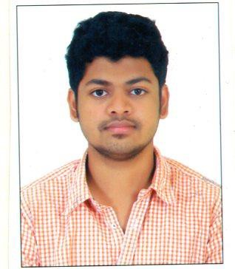

**ABDUL BASITH S.J**

**+91 9840732853**

[**basithsj8@gmail.com**](mailto:basithsj8@gmail.com)

# OBJECTIVE

Looking for a job and want to associate with an organization to enhance my skills. Hardworking and eager to get opportunities to improve myself professionally and contribute to the growth of the organisation with quality services

# Experience

Employer Name : Casa Grande Pvt Ltd Designation : Junior QA/QC engineer Experience : Oct 14 2015 – Till date

# Key responsibilities handled

* Preparing quality plan and executing everything with respect to it.
* Preparing method statements regarding works for execution
* Incoming material inspection
* Issuing Non-Conformity report
* Checking Pre-pour, During pour, Post-pour in concreting.
* Drawing co-ordination with Architect.
* Conducting tool box talk before every activity
* Ensuring that QA related problems are solved in an efficient way and economically.
* Having sound knowledge in Finishing works in Residential
* Sound knowledge in taking Handing over snags
* Coordinating with the CRM department to hand over the Flats to the clients.
* Handling clients/customer in diplomatic way

# Educational Qualification

* First class in Bachelor of Civil Engineer from SRM Valliammai Engineering college affiliated to Anna university in 2015
* HSC passed from Santhome Higher school in year 2011 with 72 %
* SSC passed from Santhome Higher school in year 2009 with 88 %

# Key Skills

* Auto CAD
* Good knowledge of Basic computers, MS office and Internet
* Good problem solving skills

# Achievement

* Won Best quality performer of the month twice
* Handed over 148 residential units to client with Zero snags
* Actively participated and organized many college events

# PERSONAL DETAILS

**Date of Birth and Age :** 17/02/1994 23 Yrs.

**Gender :** Male

**Father**’**s Name :** Mr. S.M .Jamal Mohideen

**Nationality :** Indian

**Languages :** English (Expert) ,Tamil(Expert),Hindi(Beginner)

**Passport no :** M6439659