**CURRICULUM VITAE**

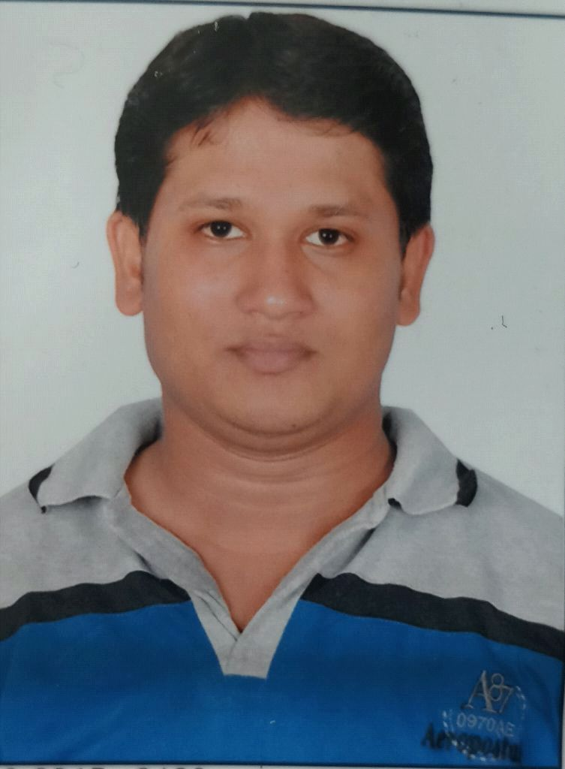

**Mohammed Hasan**

eliance Tower,

Basu(B.K.)-385526Cell: +919537936559

GujaratEmail:magichasan123@gmail.com

**CAREER OBJECTIVES**

To have a challenging position in an organization for utilizing my knowledge, talent and abilities for the growth of the organization. Also to acquire knowledge, experience and to satisfy my short term and long term goals through my chosen organization and work field.

**EDUCATIONAL QUALIFICATION**

|  |  |  |  |  |
| --- | --- | --- | --- | --- |
| **COURSE** | **INSTITUTION** | **UNIVERSITY**  **/BOARD** | **YEAR OF PASSING** | **AGGREGATE** |
| **Diploma in**  **Chemical Engineering** | **Sirbhavsinhji institute bhavnagar** | **gujarat technological university** | **2014** | **7.86** |
| **sSC** | **jafary english school kanoar** | gshse | **2009** | **69.73** |

**Technical Qualification:**

* Obtained **P**ost **G**raduate **D**iploma in **I**ndustrial **A**utomation **(PGDIA)** from Technocrat Automation Pvt Limited (IAO Accredited) Chennai, with 6 months **hands on practical experience** in Industrial Automation Tools specializing in **PLC, DCS, SCADA and VFD.**
* **ADVANCED DIPLOMA IN PROCESS AUTOMATION**

**EXPERIENCE**

* **Currently working in SRF LTD IN MNC chemical plant As a Junior Production engineer in DCS plant.**
* **2 year of experience in ADANI HAZIRA PORT in chemical liquid terminal unit as a automation engineer and DCS and SCADA operator.**
* **1 Year Experience in Dyes&Intermidiates at GOPINATH CHEM TECH Ltd in 2014 to 2015.**
* **6Month Experience in HPLC (High Performance Liquid Chromatography)**

**Roles and Responsibilities**

* **Plant in charge in production unit and in LAB and HPLC in charge.**

**Technical Skills:**

* Advance Analytical Research and Training Institute in GC &HPLC
* **PLC** (Programmable Logic Controllers) & **DCS** (Distributed Control System) - Programming languages such as **LD** (Ladder Diagram) & **FBD** (Functional Block **D**iagram) **exposure**  in brands as **Siemens**, **AB** (Allen Bradley), **ABB** (Asea Brown Boveri), **Honeywell**
* **Hands on Practical exposure in Schneider,** **GE-Fanuc, Keyence, Omron, Messung**, **Mitsubishi,** and **Delta**
* **SCADA** (Supervisory Control & Data Acquisition) – Screen designing, PLC interface, Data collection & storage
* **HMI** (Human Machine Interface) - Screen designing, PLC interface, DCS interface
* **VFD** (Variable Frequency Drive) – Commissioning and Troubleshooting
* **Pneumatics & Field Instruments** ( Control Valve, Sensors, Level Transmitters, Flow Transmitters, Temperature Transmitters, Pressure Switches)
* Knowledge in **PID** (ProportionalIntegralDerivative)
* **Troubleshooting**  – PLC & DCS programming

**ADVANCED DIPLOMA IN PROCESS AUTOMATION**

DCS Plant Operation & Malfunction handling of below mentioned Process Models:

* Distillation column
* Steam generator
* Pump
* Heat exchange
* Gas turbine
* Furnace
* Evaporator
* CSTR
* Plug flow reactor
* Fixed bed reactor
* Cogeneration boiler

**PROJECT REPORT**

* Phosphoric acid
* On Contribution Personality Development

**TRAINING**

* Advance Analytical Research and Training Institute in GC &HPLC
* Gopinath Chem Tech LTD Chattral.
* Safety Innovation School tranning at L&T.
* TRIVEDI & ASSOCIATES TECKNICAL SERVICES (P) LTD.(Tranning for building safety culture in industries)

**ACHIEVEMENT**

* Won 1st prize in race competition.

**PERSONAL INFORMATION**

* Father's Name : Ismail bhai
* Date of Birth : 29-04-1992
* Gender : Male
* Religion : Muslim
* Marital Status : Bachelor
* Languages Known : English, Hindi & Gujarati
* Nationality : Indian

**PERMANENT ADDRESS**

* Area : Beside Reliance Tower
* Village : Basu
* Post Office : Basu
* District : Banaskantha
* State : Gujarat
* Pin Code : 385526
* Mobile No. : +919925856792

**DECLARATION**

I hereby declare that the information I have provided in this curriculum vitae is true and correct to the best of my knowledge and belief.

Date:

Place: Basu (**MOHAMMED HASAN**)