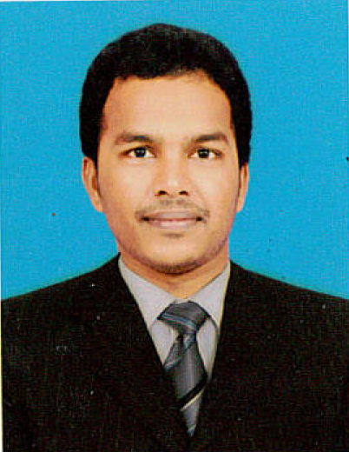

**RESUME**

**Shabiya 10,**

**Near Alam Super market ,**

**Building Number 10,**

**Abudhabi- UAE.**

**Name :** S. Arockia Nivas

**Email Id** : [nivasraj91@gmail.com](mailto:nivasraj91@gmail.com)

**Mobile N**o: +971558474033

**OBJECTIVE**

To work in a globally competitive environment on challenging assignments that shall yield the twin benefits of the job satisfaction and a steady-paced professional growth.

**PROFESSIONAL SUMMARY**

* Bachelor of Mechanical Engineer (7.4/10 CGPA) in Shanmuganathan Engineering College (2008-2012), Anna University Chennai India.
* Focused experience in MES (Manufacturing Execution System) and Fire and Safety sector.
* AutoCAD 2D certified professional from CADD center.
* NDT (Non-Destructive Testing) certified from Genius Technical Institute
* Working as a Site Engineer at Global Alarms Safety and Security Equipment LLC.
* Worked in Production Planning Engineer in SICOR Engineering India Pvt Ltd for the client KONE ELEVATORS INDIA PVT LTD.
* Worked in HINDUJA Foundries Ltd (HINDUJA GROUP ) as a GET (Graduate Engineer Trainee).

KEY SKILLS AND SOFTWARE PROFICIENCY

M.S Office (Word, Excel), Automobile, Elevator, Fire Alarm and Fire fighting, Quality Management, Cost Control, Manpower Allocation.

**CARIEER EXPERIENCE- 5 YEARS 2 MONTHS**

Global Alarms Safety and Security Equipment LLC

Designation : Engineer

Duration : January 2016–Till date

Client : ETIHAD AIRWAYS, 5PL, NCTH, AL RAHA INTERNATIONAL

Responsibilities:

* Provided fire alarm and fire fighting technical support to facility staff and management.
* Performed regular evaluations of all facility fire systems.
* Conducted corrective and preventive maintenance checks on fire alarm and fire fighting equipments.
* Working Knowledge of FACP- Simplex, Cooper, Notifier, Morely IAS, Zent Vigilon
* Working Knowledge of fire suppression systems FM200, Foam systems.
* Preparing the schedule of maintenance and fault rectification works to employees.
* To ensure that all the fire and safety policies are being followed.
* Organizing training program for the staff and the new joiner.
* Making the plans in emergency case to make sure for their implementation.
* Working on fire regarding complaints and for their solutions.

Sicor Engineering India Pvt Ltd

Designation : Engineer – Production Planning and Quality

Duration : July 2014–October 2015

Client : KONE ELEVATORS

Responsibilities:

* Oversaw testing and replacement of damaged elevator components and parts.
* Used third-party automation software to perform preventive equipment maintenance tests.
* Prevented malfunctions on public elevators by making adjustments and parts replacement.
* Maintained repair logs for specific clients for submission to management.
* Handled overtime requests and approvals.
* Preparing MIS reports like Planning, MR12 Gear box machine, Plan Vs RFD output and delivery report.
* Conducted preventive maintenance and troubleshooting.
* Oversaw all mechanical and electrical elevator work.
* Submitted repair budget allocation requests to management.
* Make necessary arrangements during break-downs, process failures, deviations in all the process activities to meet target.
* Apply SPC quality tools in the various manufacturing processes & take corrective actions whenever deviation occurred
* Creating awareness programs in EMS, Industrial Safety, Housekeeping, 5 s Implementation, On-job Training etc., to the worker

Hinduja Foundries Ltd

Designation : Graduate Engineer - Production & Quality

Duration : June 2012– June 2014

Client : SIMPSON & CO Ltd , Mahindra & Mahindra , CUMMINS, TAFE

Responsibilities :

* Monitoring & recording the process parameters in fettling operation.
* SAP exp: Store reservations, Material purchase request creation
* Analyze the casting defects and to make Root-Cause Analysis for the various defects.
* Penetrate and Magnetic yoke test in defect castings.
* Apply SPC quality tools in the various manufacturing processes & take corrective actions whenever deviation occurred.
* Analyze the defects in various fettling processes to reduce the overall core scrap level.

**ONAL DETAILS**

PERSONNEL DETAILS

Name : S. Arockia Nivas

Father's Name : M.G. Sahayaraj

Date of Birth : 14.01.1991

Gender : Male

Nationality : India

Marital status : Single

Languages : English, Tamil, Malayalam, Hindi

Passport No : K1673307

Date of Expiry : 26/11/2022

**DECLARATION**

I hereby declare that the above information is true to the best of my knowledge.

AROCKIA NIVAS .S