**CURRICULUM VITAE**

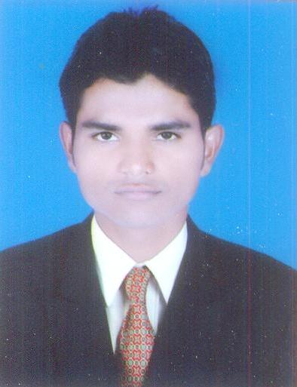

**MUHAMMAD IMRAN**

H. No. C-74A, Raju Park

Devli Road, Khanpur

New Delhi-110062

Mob: 9934000285

Email :- hussainmdimran494@gmail.com

**OBJECTIVE:**

Seeking a carrier in an organization where I can utilize skills & ability to grow & help in growth of organization by my hard work & determination towards the company.

**EDUCATIONAL QUALIFICATION:**

* 10th Passed from U.P. Board in 2009.
* 12th Passed from U.P. Board in 2011.
* B.A. Passed from DDU, Gorakhpur in 2014.

**TECHNICAL QUALIFICATION:**

* DIT- (Diploma in Information Technology) in 2013.

**EXPERIENCE:**

* 1 year & 6 months experience in Salesman.
* 1 year & 2 months experience in E-corp Info System as a Web Designer.

**PERSONAL DETAILS:**

Father’s Name : Mr. Anwar Husain

Date of Birth : 02-07-1993

Marital Status : Unmarried

Gender : Male

Nationality : Indian

Language Known : English, Hindi & Urdu

**DECLARATION:**

I hold the above information to be true and if any information is found to be false or incorrect the organization has the right to take necessary action.

**Date:27/06/2016**

**Place: New Delhi (MUHAMMAD IMRAN)**