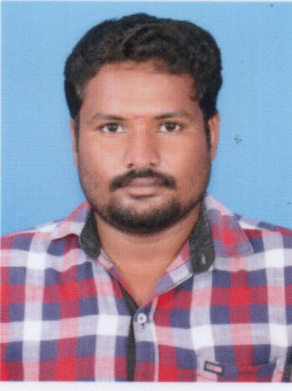**MUTHU.S**

**B.E., CIVIL ENGINEERING**

**S.MUTHU**

No.1599/B, Seenivasan Nagar, Email:s.muthusaha2212@gmail.com

Thondi Road, Contact No : 91-9566814169

Sivagangai-630561.

9566814169

**CAREER OBJECTIVE**

Seeking a position to apply my skill, knowledge and hard work to provide quality service to your company.

**EDUCATION QUALIFICATION**

|  |  |  |  |  |
| --- | --- | --- | --- | --- |
| **STUDIES** | **BOARD / UNIVERSITY** | **INSTITUTE** | **YEAR OF PASSING** | **PER**  **CENTAGE** |
| B.E., CIVIL ENGINEERING | ANNA UNIVERSITY | SRI RAAJA RAAJAN COLLEGE OF ENGINEERING AND TECHNOLOGY | 2017 | 73 CGPA |
| DIPLOMA IN CIVIL ENGINEERING | DEPARTMENT OF TECHNICAL EDUCATION | SELKALATHUR KAMATCHI AMMAN POLYTECHNIC COLLEGE MANAMADURAI | 2013 | 78 |
| SSLC | STATE BOARD | RAJAH’S HIGHER SECONDARY SCHOOL, SIVAGANGAI | 2008 | 65 |

**CIVIL SOFTWARE PROFICIENCY**

* Revit Architecture
* Auto CAD
* MS Office

**PROJECT PROFILE**

* Real Life Project PWD – Assessment of Holiday resort building
* Main project in – Quarry dust as partial replacement for sand in concrete

**SKILLS RELEVANT TO THE JOB**

* A Committed person, responsible for my duties given trust
* Good verbal and written skills
* Good in taking timely decision
* Eager to work as a team for the betterment of the Company.
* Leadership Quality

**OTHER SKILLS**

* Good in drawings in Software
* Good in both computer and internet

**PERSONAL PROFILE**

|  |  |  |
| --- | --- | --- |
| Name | : | Muthu Sekar |
| Father Name | : | Sekar. K |
| Mother Name | : | Gomathi. S |
| Interest / Hobbies | : | Reading and Movies |
| Languages Known | : | English, Tamil |

Yours Truly,

(Muthu Sekar)