|  |
| --- |
|  |

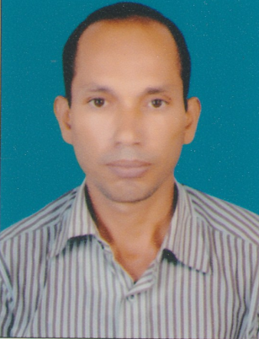**RESUME**

MOHD. SHAKIL ANWAR

***🖁9123220145/7631751523***

*🖂* shakilanwaramir@gmail.com,[*Qamarhadisiddiqui52@gmail.com*](mailto:Qamarhadisiddiqui52@gmail.com)

# CAREER OBJECTIVE

A highly motivated person with good attitude strong analytical and development skills wanted to become part of a leading organization and fulfill the desire of acquiring Knowledge and Pleasure in working with the most competent professionals.

**QUALIFICATION**

|  |  |  |  |  |
| --- | --- | --- | --- | --- |
| **EDUCATION** | **COLLEGE/**  **UNIVERSITY** | **BOARD** | **YEAR** | **Class** |
| **Intermediate Science** | Millat College Laheriasarai Darbhanga | Bihar Intermediate Education Council | 1996 | 2nd |
| **High School** | Shafi muslim high school | Bihar School Examination Board | 1994 | 2nd |
| **Industrial Trade Certificate** | RITI | NCVT | 1998 | 1st |

**JOB EXPERIENCE: 7.5 Years of GCC Experience in Maintenance and Project**

* Worked with **ARABIAN BEMCO CONTRACTING CO.LTD.** At Saudi Arabia as a Post of “Electrician with effect from 19-12-2015 to 16-03-2017 till work.
* Worked with **M/S SALIMABDUL ALSAVA** in Saudi Arabia as an ELECTRICIAN for 6 years from 16-07-2007 to 05-02-2013.
* Worked in **INDIA AS ELECTRICIAN** for 6 years from 01-11-2001 to 10-11-2006.

**Job responsibilities:**

* DB. Dressing, Pipe fitting, power Lighting Wiring, Cable Tray Trunking , Cable Glanding and Cable Termination, panel board Internal Wiring,
* Maintain daily activities and reporting.
* Good Knowledge of maintenance of Electrical like PPM of SMDB, DB.
* Good Knowledge of Electrical Wiring, Fault Tracing, and Repairing.
* All type of Project work related to Electrical
* All Electrical equipment’s installment work
* Good knowledge about all types of equipment

**PERSONAL DETAILS**

Father’s Name : Md. Mumtaz Alam

Date of Birth : 07 August 1978

Marital Status : Married

Religion : Islam

Nationality : Indian

Languages known : English, Urdu, Hindi.

Address : VILL P.O-MILKICHAK  
 P.S-LAHERIASARAI STAE- BIHAR  
 Dist. Darbhanga (846004)

**PASSPORT DETAILS**

Passport No. : G 9321599

Place of Issue : Riyadh

Date of Issue : 01/12/2008

Date of Expiry : 31/11/2018

**DECLARATION**

I would like assure that if you will give me a chance to server in organization. I will prove my self as an asset for your organization.

PLACE…

DATE: ***(Shakil Anwar)***