**Curriculum Vitae**

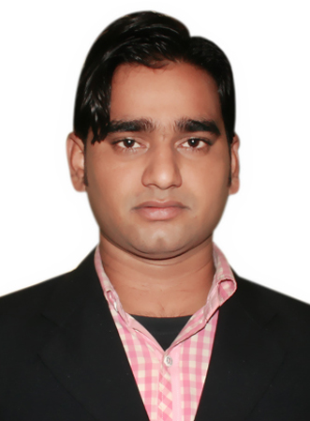

# Name : MINHAJ SARWER

**Address** : S/o- ABU SALEH ANWER

Vill-PHULWARI,PO-ALTA

HAT, DIST-KISHANGANJ

Bihar, Pin– 855107

**Mobile : +917549240462,**

**+917503101481**

**E-mail :** [minhajsarwer@***gmail.com***](mailto:minhajsarwer@gmail.com)

**Career Objective**

Intend to build a career with leading corporate of hi-tech environment with committed and dedicated people, which will help me to explore myself fully and realize my potentials.

**Professional Qualification**

**B.Tech** in **Mechanical Engineering** from “Bengal Institute of Technology & Management”, Santiniketan (West Bengal)

**Academic Qualification**

|  |  |  |  |  |  |
| --- | --- | --- | --- | --- | --- |
| **Degree / Certificate** | Qualification | **Institute** | Board/University | **Year of Passing** | **Aggregate % / DGPA** |
| Graduation | B.Tech  (Mech. Engg.) | Bengal Institute of Technology& Management Santiniketan (West Bengal) | W.B.U.T | 2014 | 7.13  (On scale of 10) |
| 12th | H.S. | **DR. Zakir Hussain+2 H/S,Patna City** | B.S.E.B  PATNA | 2010 | 60.0% |
| 10th | Matriculation | **High School Sontha** | B.S.E.B  PATNA | 2008 | 65.4% |

Quality Engineer in injection molding in Machino Plastics Ltd, Manesar Gurgaon (Haryana)

Professional Experience (2 Years)

* Experience in Injection molding machine **(**JSW, UBE, TOSHIBA, CLF, Super master, L&T… Injection molding Machine**)** in MACHINO PLASTICS Ltd (Sector 8, Plat No 128,129 MANESAR,) 11 Jun 2014 to till date
* **ERA INFARA Engg.Ltd, Noida-in Execution department since july 2015.**
* **Project Name-D.M.R.C.(Dehli Metro Rail corporation)**
* **Project Details- Desin and construction of Tunnel by shield TBM and Metro Stations by cut and cover method between jama Masjid and kashmere gat for underground works.**
* **Job Responsibilities- working as an assistant Engineer of steel structure works, waler strut erection at Lal quila sit,fabrication and erection of plunge colume for top to bottom construction slab.Erection of O.T.E ducts at Lal Quila site.**
* **Vocational Training**
* Two week Vocational Training under the NTPC From 17/06/2013 to 02/07/2013

**Computer Proficiency**

* AutoCAD.
* Microsoft Office
* Operating System: Windows xp / 7

**Final Year Project**

* Project on Home Cooling by & Air Conditioner.

**Hobbies**

* **Playing cricket**
* **Biking**
* **Net surfing**

**Personal Profile**

Father’s Name : LATE ABU SALEH ANWER

Date of birth : 23-03-1993

Gender : Male

Marital status : Single

Nationality : Indian

Language Known : Hindi, English and Urdu

PASSPORT status : OK (Valid up to 2024)

**Declaration**

I do hereby declare that all the statements made in this application are true, complete and correct to the best of my knowledge and belief.

**Date :**

**Signature**

**Place:**  **Name**