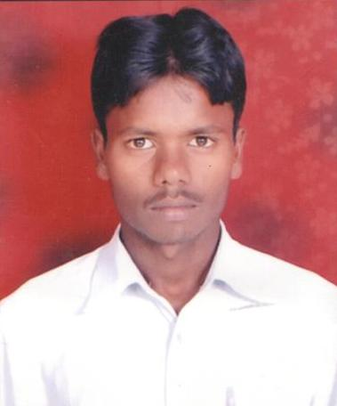**R E S U M E Manish Kumar Rawat**

**Persent Address:-**

**VPO - Kapashera**

**Distt- South West Kapashera**

**State –New Delhi**

**Contact No.+91-7827377384**

**Email Id: sudhir.local@gmail.com**

**CAREER OBJECTIVE:-**

* ***To Build my career with the dynamic and professionally managed organization that will provides me opportunity to grow professionally and where I can put my knowledge and skills for achieving, organizational as well as personal goals.***

**ACADEMIC QUALIFICATION:-**

***Metriculation******Passed******Form Bihar Board Patna In 2010 High School Bangardhi Laxmipur Of Bihar*.**

***Intermaditate I. OF Arts Passed Form Bihar Board Patna In 2013 Sarswati Acklav Collage Jamui OF Bihar****.*

***Undergraducate B.A. PART Secound Years Appring Geography HONS paper Form Jodhpur National University Jodhpur Rajastan (india) With Neptune Institute of Management & Technlogy New Delhi.***

**Professinal Computer QUALIFICATION:-**

***One year D.C.A.Trade (Diploma In Computer Application ) From Govt of NCT Of Delhi In 2012 To 2013 WITH – A- Grade NIACT (National Institute Advanced For Computer Technology Manesar, Gurgaon(Haryana).***

**Softwere Skills :-**

***Goods Computer Professional Skill Window Xp & MicroSoft Office:- 2003 & 2007.***

***Mozilla FireFox / Opera And Lanuch Internet Explorer Browser****,* ***Goods Computer******Typing Speed Fourty, Fundanentals.***

**Computer Operating System Maintance :-**

***Computer Window XP & MicroSoftOffice 2003 & 2007 Installantion & Service & Hardware Handling Connection Maint*ance**.

WORKING EXPERIENCE **:-**

***One Year Front Office Exective Working Experience form A Tata Enterprises Gingerhotels IMT Manesar ,Gurgaon Haryana India.***

### 1. Handling domestic & national calls. 2. Coordinates with internal staff and the directors. 3. Handling Customers and Guest at the Reception. 4. Fixing Appointments for the directors and internal staff. 5. Keeping records and cheques of vendors bills and payments. 6. Directing the guest to the concerned person properly. 7. Handling the whole reception & Night Auditing Reports Maintance.

**Other Basic Accounting Knowledge:-**

***I.C.A One Year (The Institute OF Computer Accountant)Finance Accounts & Manual******Accouts Professsionaly In Manesar Passed 2012 From NIACT(the National Institute Advacnced Of computer Technology)In Manesar, Gurgaon (Haryana).***

***Computer Accounting Professional Tally 7.2 & ERP 9.0.***

***Manual Accounts With Tally***

***VAT (Value Added Tax ) CST (Central Sales Tax ) EPF (Empolyee Provident Funds) ESIC (Empolyee Stats Insurance Corporation) Service Taxes, From, Returns, Bills OF document.***

***Finance Accounts With Tally***

***For the Balance Sheet Flow.***

***Making the Attandance Sheet Flow****.*

***PERSONAL STRENGTH:-***

* ***Able to work efficiently in a team as well as individually.***

***Smart Working, Confident, Responsible & Every time want to gain something****.*

**HOBBIES:-**

* ***Playing Cricket & Football.***
* ***Reading Books*** *&* ***Music*** *.*

**PERSONAL DETAILS:-**

**Father’s Name : Sh. Shankar Rawat**

**Mother’s Name : Smt. Shardha Devi**

**Date of Birth : 06/04/1995**

**Martial Status : Unmarried**

**Nationality : Indian**

**Languages Known : Hindi & English**

**DECLARATION**

* ***I hereby declare that the above particulars are true to the best of my knowledge and belief.***

**Date:**

**Place:** **(SIGNATURE)**