**SREERAJ V. P.**

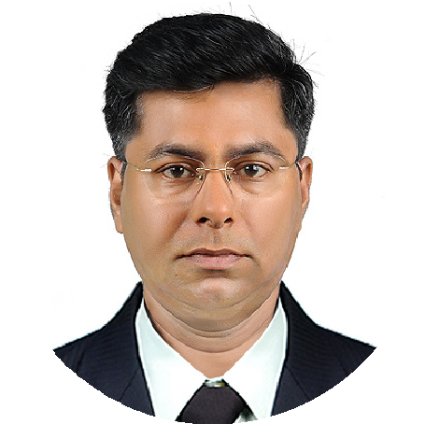

**WORK EXPERIANCE**

**CURRICULUM VI TAE**

**ABOUT ME**

Resultoriented, Hardworkingwithinnovative ideas and problem solving ability. Who has been in the industry for more than 10 years. Detail- and results-oriented individual with above-average critical thinking skills, time management skills, and organizational skills. Who communicates well with clients, co- workers, and supervisors alike. Interested in getting results and ensuring a great customer experience for each client.

Highly motivated self-starter who maintains high team morale during difficult times.

Take charge manager who resolves difficult situations under adverse conditions.

## +91 7558853337

O

+91 9400043334

m

[vpsreeraj@gmail.com](mailto:vpsreeraj@gmail.com)

edathoot house, kannikulangara p. o., thrissur kerala, india - 680682

,

No. S 5008925 Exp.11/07/2028



**LANGUAGES**

ENGLISH

HINDI MALAYALAM

**PROFICIENCY**

SAP BUSINESS ONE MS SQL SERVER CRYSTAL REPORT WINDOWS SERVER WI NDOWS CLIENT

LINUX ORACLE DB

TALLY INDESIGN PHOTOSHOP CORELDRAW

# Manager (IT and Surveillance)

Feb. 2014 - Till Date Entesos Enterprise Solutions (P) Ltd., Kochi Domain : Retail, Distribution, Service, Software Development and implimentation Software Domains worked : Hospital, Retail



* Finalise the software design and architecture for the software products.
* Co-ordinate with the marketing, design, development and implementation.
* Finalising the development cost and determine the price for products.
* Finalise the recruitment process of the department.
* Control the day to day financial activities of the company.
* Formulate the financial plans and budgets of the company.
* Coordinate with the auditors and accountants to prepare the final accounts.
* Formulate business plan for the Surveillance and Software Division.
* Monitor the sales, installation and service divisions
* Make the purchase as per the market trends and orders.
* Make marketing plans, sales schemes for dealers and incentive plans for FOS.

# Manager (Systems & IT)

### Feb 2011 – Jan. 2014 Lens and Frames Opticians., Kochi



Domain : Retail

* Managing the day to day activities of IT Infrastructure like servers, firewall, etc. for the head office and 23+ branches spread accross the states.
* Design the ERP software as per the requirement of the organisation.
* Co-ordinate with the development company for the development and implementation.
* Identify the system requirements for the new implementation and fill the gaps with new or upgraded hardware and software
* Generate the MIS reports as per requirement of the management using SQL.

# Functional Consultant ERP

### Nov. 2010 – Jan. 2011 Maverick Infotec (P) Ltd., Mysore



Domain : Accounts

* Design add-on for providing sub ledger accounting and other client requirement on SAP Business One, test and implement it.

# Functional Consultant ERP

### Jul. 2009 – Nov. 2010 Nortech Infonet (P) Ltd., Kochi



Domain : Retail

* Conduct Business Study in Organizations and Prepare Business Understanding and Blueprint for Implementation of ERP.
* Provide guidance to Technical Consultants for customization and addons.
* Testing of add-ons, customizations and reports.
* Data migration from legasy system to SAP Business one.
* Provide pre and post implementation Support.
* Provide SAP Business One Training for clients.
* Provide Presales consulting for SAP Business One.

# Unit Manager

### Feb. 2008 – Mar 2009 ICICI Prudential LIC Ltd., Kochi



Domain : Insurance

* Recruiting Financial Advisors from the age group of 18 to 60.
* Manage, motivate, and train them for achieving the desired target.
* Conduct meetings, give sales presentations, etc.



**PROFICIENCY**

C# VB PHP JAVA HTML CSS JS

DREAMWEAVER

MSWORD MS EXCEL

MS POWER POINT

MS ACCESS

**PERSONAL**

DOB 27 NOV 1977 RELEGION HINDU

FAMILY STATUS MARRIED

# Team Manager – PL

### Jan. 2005 – Feb. 2008 Swiss Capital Kochi

(DST of Standard Chartered Bank)

Domain : Personal Loan

* + Managing team of FOS and TME in the Personal Loan Division.
  + Recruiting the team for PL Division.
  + Fixing up of Monthly target, motivate them to achieve the target, helping them in closing the Sales.
  + Verifying and Processing the applications for logins
  + Follow-ups of the logins, and making the Executives to rectify the defects if any.

# Team Leader

### July 2002 – Jan. 2005 Waves Communications Cherthala

(AirTel Connect)

Domain : Mobile

* + Coordinate the sales and activation team.
  + Implementing the marketing techniques prescribed by the airtel.
  + Recruiting the marketing team.

# Sales Representative

### July 2000 – Nov. 2000 Eureka Forbes Ltd. Kochi

(DST of Standard Chartered Bank)

Domain : Sales

* + Marketing the Aqua guard water purifier.

**EDUCATION**

B.Com. - Bachelor of Commerce with Commerce Main.

University of Kerala. 2000

**HONOR**

ICWAI - Completed Course for Intermediate.

Institute of Cost and Works Accounts of India.

MCP on Windows Server and Client.

Microsoft Corporation.