**CURICULUM VITAE**

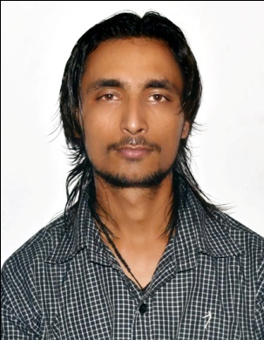

## JITENDRA SINGH

**H.NO.199, NEAR POST OFFICE,**

**VPO-MOTHROWALA,**

**DEHRADUN, UTTARAKHAND, INDIA,**

**PIN/ZIP: 248115.**

**CONTECT NO: +917409270631, +919927270407.**

**Email ID –Jitu.loveu2006@Gmail.Com,jitu143986@yahoo.com.**

**CAREER OBJECTIVE:­**

* I am seeking a job where I could have opportunity to always learn something new and where I could contribute to my fullest of ability and capacity.

**PROFESSIONAL QUALIFICATION:­**

* **Diploma** (in **MACHNICAL PRODUCTION**) from **ALPINE COLLEGE OF MANAGEMENT & TECHOLOGY, NANDA KI CHOWKI,PREM NAGAR,DEHRA DUN.in year 2013**
* **I.T.I.**(in **MACHINIST**) from govt. **I.T.I. Majra, Niranjanpur Dehradun**, **in year 2008**.
* Basic knowlege of computer applications and working in Ms office, Ms word, Ms excel, Ms powerpoint,

**EDUCATIONAL QUALIFICATION:­**

**.**

* High school passed from U.A. Board in the year 2004.
* Intermediate passed from U.P. Board in the year2011.

**WORK EXPERIANCE**

* In Current/Persent working as a **instructor (Faculty)** with **Devi Bhoomi Groups of Institution** in **mechanical department.**
* **One year** apprenticeship from **DEAL DRDO, Raipur road, Dehradun, Uttarakhand, INDIA.**
* Four **month** work experience in **Tata Motors Ltd, Pant Nagar, UTTARAKHAND ,INDIA** as a Temporary Operator.
* Four **weeks** V.T. From M.B.ll, Dharashu (Bharethi), Uttarakashi, Uttarakhand.
* Six month work experience as **Service Supervisor** in **BM TVS** **Dehradun, Uttarakhand, INDIA.**
* **Two year** (**self working**) experience to **Maintenances,repairment and service** of twowheelers moter bike’s.

**TECHNICAL SKILLS (ROLE):­**

**MECHNICAL SKILLS (ROLE):­**

* **Operate and maintenance all kind of machine such as :- *Lathe machine, shaper machine, milling machine, wooden lathe, surface grinder machine, power hexsaw machnie,*** [***engraving* machine**](https://www.google.co.in/search?q=engraving+machine&spell=1&sa=X&ved=0ahUKEwikwISIsP_OAhUJN48KHfu8A0sQvwUIGigA)***, punching machine* and also basic knowledge of operating *CNC & VMC machine*, and good knowledge of *automobile field*.**
* **Assembling and Disassembling the all kind of manual machine in machine shop.**
* **Maintenances,repairment and service of all kind two wheelers**.

**HOBBIES:**

* **Bike Riding.**

**STRENGTH:**

* Quick Learner.
* Think Positive**.**

**PERSONAL DETAILS:­**

* Name : Jitendra Singh
* Father’s Name : Late Gorakh Bhadur
* Date of Birth : 7thoct 1989
* Nationality : Indian
* Marital Status : Unmarried
* Languages Know : Hindi &English
* Gender : Male

# Declaration:

I hereby declare that the above information is true and correct to the best of my Knowledge.

**Date: . . . . . . . . . .**

## (JITENDRA SINGH)

## Place: . . . . . . . . .

## 