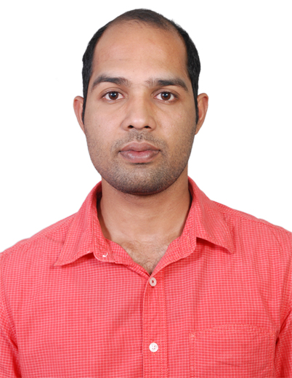**CURRICULUM VITAE**

**SOUJAL NK**

**NADUVILE KUNHITHAYYIL**

**KATALUR PO**

**KOZHIKODE**

**Contact No: 00919061315148**

**E-Mail: soujal@gmail.com**

**OBJECTIVE**

* Seeking a position of Health and safety professional in industrial work field with an oppurtunity for advancement of career based on skill and job perfomance. The career objective is mainly to be distinguished as an expert in the field of health and safety by providing effective efforts in order to as certain positive safety culture across the organization.

**PROFESSIONAL QUALIFICATION:**

* ***International General Certificate in Occupational Health & Safety(NEBOSH)***
* ***Safety Management (IOSH)***
* ***HABC level-1 in fire safety (Highfield U K)***
* ***Diploma in Fire and Safety engineering (N I F E)***
* ***MEDIC First Aid USA***
* ***Certificate in basic security guard training ( NSI ABU DHABI)***

**EDUCATIONAL QUALIFICATION**

* Plus Two ***(Board of Higher Secondary Examination, Kerala)***
* S.S.L.C***. (Board of Public Examination, Kerala State***)

**COMPUTER KNOWLEDGE**

* Ms Office
* Data processing
* Internet and mail communication

|  |
| --- |
| **LANGUAGES KNOWN** |

* English
* Arabic
* Hindi
* Malayalam

**SKILLS**

* Communication skill in English and Arabic
* Quick learning curve and ability to work hard
* Effective leadership qualities
* pleasant personality

**EXPERIENCE SUMMARY**

* Worked as a **security guard** in United Security Group Abu Dhabi   
  (2010 Jan to 2013 Nov).
* **Al ain Hospital**
* **K.M Hypermarket Al ain**
* **Worked as a Safety Supervisor in Al-waha General Construction Company,Kuwait(2014 May to 2016 March)**

**WORK EXPERIENCE:**

* Applying standard safety procedures with in the organizations,
* Maintianing high level of safety standards at all work places
* Asessing the risk areas and categorizing and selection of safety signs accoundingly
* Supervising a team of fire fighters and safety assistants
* Doing risk assesment of various activities.
* Giving trainging to all the technical staff to handle the emergency situation.
* Report writing of any abnormality in plant, Equipments, Mechinary and Persons.
* Co-ordination with all other departments regarding safety issues.
* Handling and checking the work permits and tagging the work area accordingly.
* Maintaing records of PTW’s to be available for auditing as required by company standards.

**PERSONAL DETAILS**  
Name : Soujal NK

Date of Birth : 22/10/1983

Sex : Male

Nationality : Indian

Marital Status : Married

**Passport Details**

Passport No. : P 2194018

Date of issue : 11-08-2016

Date of expiry : 10-08-2026

|  |
| --- |
| **Declaration** |

I hereby declare that the above statement is true and correct to the best of my knowledge and belief.

SOUJAL **NK**