**DEEPU ANIRUDHAN**

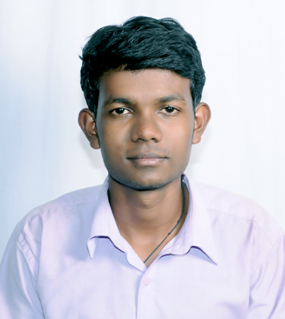

**TEL** : +91 9747120619

**E-MAIL** : [deepuanirudhan@gmail.com](mailto:deepuanirudhan@gmail.com)

**CAREER OBJECTIVE:**

To have a growth oriented and challenging career, where I can contribute my knowledge and skills to the organization and enhance my experience through continuous learning and teamwork.

**ACADEMIC DETAILS:**

|  |  |  |  |  |
| --- | --- | --- | --- | --- |
| **COURSE** | **INSTITUTION** | **UNIVERSITY** | **BATCH** | **PERCENTAGE** |
| **Bachelor of Engineering**  **(Mechanical)** | BGS Institution of Technology  B G Nagar | Visvesvaraya Technological, University. | 2011 - 2015 | 69.7% |
| **Higher Secondary (PCMB)** | Govt GHSS,  Kunnam. | Kerala Secondary, Examination Board. | 2009-2011 | 81.2 % |
| **Secondary School leaving Certificate** | MSS Seminary,  Thazhakkara. | Kerala Secondary, Examination Board. | 2008-2009 | 87 % |

|  |  |  |  |  |  |  |  |  |
| --- | --- | --- | --- | --- | --- | --- | --- | --- |
| **SEMESTER** | **1** | **2** | **3** | **4** | **5** | **6** | **7** | **8** |
| **PERCENTAGE** | 74.45% | 73.81% | 66 % | 64.33% | 71.11% | 64.11 % | 61.5% | 80.9% |

**TECHNICAL SKILLS:**

* Catia v5 R20, BGSIT,Mandya,2013
* Autocad,BGSIT,Mandya,2013
* Strength of materials

**AREAS OF STRENGTH:**

* Ability to cope up with different situations
* Ability to rapidly build relationship and set up trust
* Personality type “ENTJ”

**ACCOMPLISHMENTS:**

* Participated in National Service Scheme, Alappuzha, 2011.
* Participated in U-16 District(cricket) competition, Alappuzha, 2010

**HOBBIES:**

* Watching cricket
* Travelling
* Social activities

**PERSONAL INFORMATION:**

**DOB :** 2nd september 1992

**Sex :** Male

**Father’s Name :** P V Anirudhan

**Mother’s Name :** Ambujam

**Languages Known :** English , Malayalam , Hindi

**Permanent Address :**  Deepthy Bhavan

Kunnam(P.O) Mavelikara

Alappuzha(DIST) Kerala

PIN : 690108

I hereby declare that all the information given above is true to the best of my knowledge.

(DEEPU ANIRUDHAN)