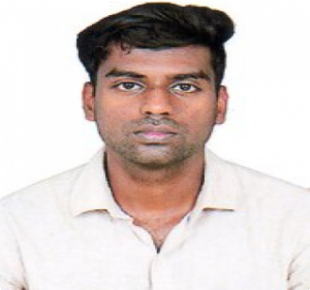**Agin sathiya**

**OBJECTIVE**

**Chennai India.**

**E-mail:** [**aginsathiya@gmail.com**](mailto:aginsathiya@gmail.com)

**Phone: 8300101546**

**9486081914**

**To pursue a challenging and an exciting career where I can use my skills to grow along with the company while being flexible,resourceful and can play a key role in a team**

**SUMMARY Over 2 Years of Experience in Mechanical Industry**

**Identified and addressed technical issues in a timely and efficient manner Facilitated plant operations during plant manager's absence.**

**Evaluate equipment and machine operation for repair needs**

**Identified and addressed technical issues in a timely and efficient manner Facilitated plant operations during plant manager's absence .**

**WORK EXPERIENCE**

# **AAM Group India May 2018 — Present**

## **Production Engineer**

**Executed technical inspections in the production process in the context of the authorization of manufacturer operation**

**Supported troubleshooting and participated in Quality survey requests Maintained all necessary quality records and documents**

**Perform In process inspections first piece article and final audit inspections Tested pre-production materials to determine quality prior to production processes Preformed production studies and machine analysis to identify quality and process problems**

**Developed and maintained an excellent working relationship with well tenders in the field**

**Safely operated equipment and tools to complete projects**

# **Hinduja Foundries Limited May 2016 — April 2018**

## **Quality inspector**

**Failure Investigations Supplier Quality Assurance**

**Corrective Action Boards Hardware Nonconformance Dispositions Improved supplier quality by coordinating corrective actions**

**Rate suppliers based on quality performance and work with suppliers on quality issues**

**Implementing and maintaining a Quality system.**

**Collaborate with customers to satisfy new part introduction requirements and resolve quality issues.**

**Issue and resolve Corrective Action Reports**

**Dropped low performing suppliers and fixed qualified suppliers as a team member Addressing customer concerns by documenting the corrective action Implementing and maintaining a Quality system**

**Utilize power and hand tools as needed while maintaining safety standards Can build strong interpersonal relationships**

**PERSONAL**

**SKILLS Good team player and have excellent interaction skills to coordinate with team Well determined in delivering output in less time without losing efficiency Ability to work under tight deadlines and pressure as part of a team**

**Able to manage multiple tasks.**

**Able to work to an agreed time scale. The ability to work under pressure Problem-solving skills**

**Disciplined**

**Smart Worker and Self Motivator Project Management**

**STRENGTHS**

**Good team player and have excellent interaction skills to coordinate and work within a team effectively**

**Well determined in delivering output in less time without losing efficiency**

# **EDUCATION Diploma in Mechanical Engineering 2013 — 2016**

## **Anna University**

**Secondary School SSLC 2012 — 2013**

**Tamilnadu Matriculation Board**

**CERTIFICATION**

**Completed Auto Desk Designing Course 2017**

**REFERENCES**

**Date of Birth : 14-08-1996 Fathers Name : Sathiya Dhas Nationality : Indian**

**Language Known : English,Tamil,Malayalam Passport Number : R5345780**

**Passport Expiry : 29-10-2027**

**DECLARATION**

**I, hereby declare that the information given above is true to the best of my knowledge**

**Agin sathiya**