

#  EDUCATION

### BHSBIET LEHRAGAGA / PTU

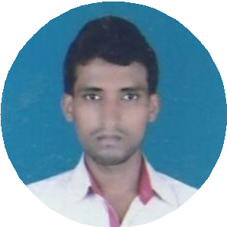

Mechanical Engineering 73.53%

2017

### MJK College Bettiah

Intermediate(ISc Math) 70%

2013

### Adarsh High School Machhargawa

Matric 78.6%

2011

#  EXPERIENCE

### BHSBIET Campus Training/Workshop Training

*May 2014 - July 2014*

Fresher

### SHREE MANGAL MOTORS MOTIHARI

Mahindra & Mahindra Tractor Summer Training

*June 2015 - August 2015*

Under Workshop Incharge

### MIC Chandigarh & Shivam Tech Inst. Zirakpur

Industrial & Software Training

*Dec 2016 - May 2017*

Supervisor at MIC Chandigarh

### RSPL Plant Gujrat

Constructional Work *June 2017 - August 2018* Site Incharge

#  PROJECTS

### Workshop Minor Project

*28 days*

In Institute Workshop a minor project is done at Lathe Machine assembling of a steel rod.

### Major Project : Automobile Differential

*42 days*

Automobile Differential as a major project is done from out of Institute under project incharge of my institute.

**MD ABDUL LAISH ALAM**

 [ariy](mailto:ariyanabdul5196@gmail.com)[anabdul5196@gmail.com](mailto:anabdul5196@gmail.com)

 8709113532

 PANDEY TOLA NAUTAN DUBEY

WARD NO. 16 PO+PS: NAUTAN DUBEY

WEST CHAMPARAN BIHAR 845438

 **TECHNICAL SKILLS**

Planning & Performance Help Desk/Technical support

%

%

Networking/Web development

%

##  INTERESTS

Automobile Production Maintanance



 **ACHIEVEMENTS & AWARDS**

Tech Fest in college campus Runner of mini marathon

 **ACTIVITIES**

Known of basic Computer Ms Word & Excell creating

 **PERSONAL PROFILE**

Date of Birth

: 05/01/1996

Marital Status : Married

Nationality

: Indian

Known

Languages

: Hindi & English

Hobby

: Walking, Running, Travelling, Cricket

Passport

Organising

: Passport No. R6523825