## POST APPLIED FOR : Electrical engineering.

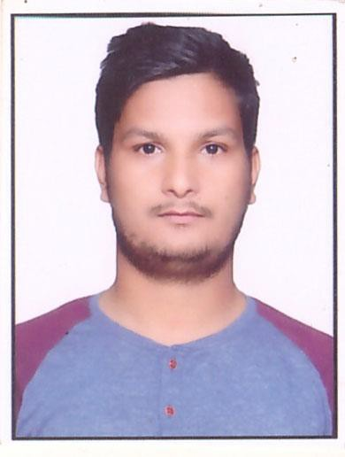

**Objective:**

Seeking a challenging role in a reputable organization, interested in demonstrating my skills and knowledge to ensure that the company achieves its financial objective.

# NASEEM ISRAQUE

### ELECTRICAL ENGINNER

**VITALS**

New Delhi India 70

+91 9993591978

[israque.naseem@gmail.com](mailto:Israque.naseem@gmail.com)

**TECHNICAL SKILLS:**

.Basic Knowledge Of Electrical Generation And Principal Working Of Xmer Generator And Alternator.

.BASIC KNOWLEDGE OF POWER FACTOR, DEMAND FACTOR AND LOAD FACTOR..KNOWLEDGE OF POWER DISTRIBUTION AND TRANSMISSION SUPPLY FROM ONE SUBSTATION TO ANOTHER.

.BASIC KNOWLEDGE OF ELECTRICAL INSTRUNMENT LIKE AMMETER,VOLTMETER AND AUTOTRANSFORMER.

.KNOWLEDGE OF MS OFFICE (POWER POINT WORD EXCEL).

SKILLS

Adaptability, Loyality, Accepting Challenge, Dynamism Honesty, Punctuality And Smart Working Are My Assets.

# Experience:

## SERVOTECH ELECTRICAL PVT LTD NEW DELHI.

July 2017- Today

Installation of bus bar from control panel board to building tower. Preparation of daily reports and also monthly reports of electrical works. Quality of materials that are used in electrical works.

Implementation and monitoring of power distribution.

# Training /Internship:

Dec16 – May17

6 months internship from Suvidha Engineering pvt Ltd . On the Installation of DG Machine and undergrounding of cables from control panel to building. Hotel hyatt regency Aerocity New delhi.

Oct16 -Nov16

1 month internship from the state govt co. MPMKVVCL(Madhya Pradesh Madhya kshetrya vidyut viatran co. ltd ) on power sector and working of power distribution.

Aug16 -Sep16

1 months internship MEC INDIA PVT LTD . installation of distribution board and MCB three phase in high voltage AC supply .Candor Gurgaon office parks at Sector-48, Subhash Chowk, Gurgaon.

2

Education

B.E(2017)

Electrical Engg.

Rajiv Gandhi Proudyogiki

Vishwavidyalaya Bhopal.

12 (2013)

Govt Coed Sr. Secondary School.

10(2011)

Kathuria Public School N.DELHI.

NASEEM ISRAQUE

ELECTRICAL ENGINNER