**CURRICULUM VITAE**

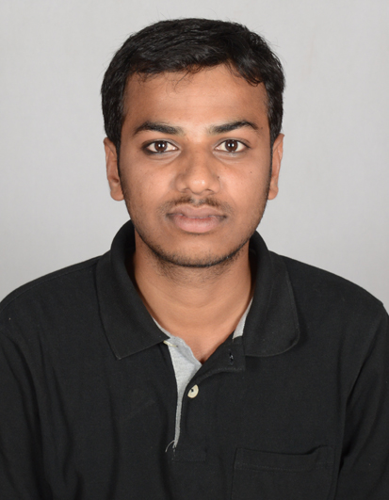

**SOHIL AHMED NADAF**

**Communication Address**

H.no-#254/1

2nd cross

Narasaraj pet

Davangere-577001

Karnataka State India

**+91-7795212517**

Email: sohilahmed666[@gmail.com](mailto:zafarahmed058@gmail.com)

I am a Graduate in Civil engineering having **experience** in **high rise building construction,** worked in fast track projects in well reputed company. My resume as follows...

**Objective:**

To obtain a position as a Project engineer in an organization which gives me an opportunity to work & utilize all my skills & show my hard work for the company’s growth.

**EDUCATION:**

|  |  |  |  |  |  |
| --- | --- | --- | --- | --- | --- |
| **S.No** | **Degree / Course** | **Institution** | **University** | **Period** | **Percentage** |
| 1 | B.E Civil Engineering | S.J.M Institute of Technology, Chitradurga. | VTU | 2010-2014 | First class  with  64.00% |
| 2 | XII | Trishul PU Science College, Davangere | Dept. Of Pre- University Education, Karnataka | 2010 | 68.5% |
| 3 | S S L C | Montessori High School, Davangere | Karnataka Secondary Education Examination Board | 2008 | 72.16% |

**SOFTWARE SKILLS:**

* Auto Cad
* MS-Office Packages ( MS-Excel, MS-Word, MS-Power point)

PRESENT EMPLOYER:

|  |  |  |  |  |  |  |  |
| --- | --- | --- | --- | --- | --- | --- | --- |
| **Sl.No** | **Employer** | **Project** | **Role** | **Period from** | | **Other Details** | |
| 1 | **Worked Under P.W.D Class I Contractor** | Convention hall construction | **Site Engineer** | From Aug-14 To June-15- | **10 months** | Government Projects | |
| 2 | **Synergy Property Development Services Pvt Ltd.**  **Bangalore** | L1 Block Commercial Building  Project,  Manyata Embassy Tech Park,  Bangalore,  Karnataka | **Asst. Engineer- Site Engineer** | From  Aug-15  To  Present | **1 year**  **7 months** | Client | Embassy Groups,  Bangalore. |
| Architect | M/s RSP |
| Structural Consultant | Innotech Engineering Consult Pvt. Ltd |
| 3 | **Synergy Property Development Services Pvt Ltd.**  **Bangalore** | L2 Block Commercial Building  Project,  Manyata Embassy Tech Park,  Bangalore,  Karnataka | **Asst. Engineer- Site Engineer** | From  Aug-15  To  Present | **1 year**  **7 months** | Client | Embassy Groups,  Bangalore. |
| Architect | M/s RSP |
| Structural Consultant | Innotech Engineering Consult Pvt. Ltd |

**Role:**

Represents the client's interest. Develops strategy for delivery of the projects from concept to completion stage. Ensures effective communication between clients and project team members.

**Responsibilities:**

* To Implement Master Schedule/Micro Schedule including Resource Planning, Pour Schedule & Tracking logs for various activities
* To cross-check ongoing job execution at site with drawings.
* To follow up with contractors’ staff at site for daily activities.
* To engage in meetings with Contractors and handle Contractors to avoid delay.
* To manage daily meeting at site with staff to discuss progress of work.
* Review Safety Procedures and support Manager Quality & Safety in his work
* To do Value Engineering and provide comments on drawings and raise RFIs.
* Inspection of work quality and material delivered at site.
* To ensure sufficient manpower at site with contractor’s representatives.
* To Overview and review Cost of the Project on regular basis.
* Taking care of daily progress work & comparing the quantities planned to be executed.
* Coordinate closely with the Project Heads/ Coordinators of decisions that require to taken in the interest of the Project.

**STRENGTHS:**

* Ability to easily acquire and learn new technology and modern construction techniques.
* Self-Confident having positive attitudes.
* Hard working capacity, Flexibility with colleagues and working schedules.
* Dynamic and self-motivated person.
* Time management & working with full Efficiency in working hours.

**SOFT SKILLS:**

* Project Management.
* Quantity Surveying.
* Estimation.
* Technical Skills.
* Communication Skills.
* Critical Thinking.

**AREA OF INTEREST**

* Building Planning and Drawing
* Quantity surveying and Billing
* Interested in mobile OS (symbian and android).
* Listening music and reading books.
* Playing cricket and football.

**PASSPORT DETAILS:**

Passport No. : L8995307

Date of expiry : 22/04/2024

**PERSONAL DETAILS:**

Name : SOHIL AHMED NADAF

Age : 25 Yrs

Sex : Male

Relationship : Single

Father’s Name : MOHAMED ATHAULLA NADAF T

Date of Birth : 05th  March 1992  
Languages Known : English and Hindi & Kannada (to speak, write and read*)*

**Declaration:**

I hereby declare that all the details furnished above is correct & true to the best of my knowledge. And also I assure that if given an opportunity to join in your esteemed organization, I will discharge my duties with sincerity & honesty to the satisfaction of my superiors & will try my best to be an asset to the organization.

Place: Bangalore

Date: SOHIL AHMED NADAF