***CURRICULAM VITAE***

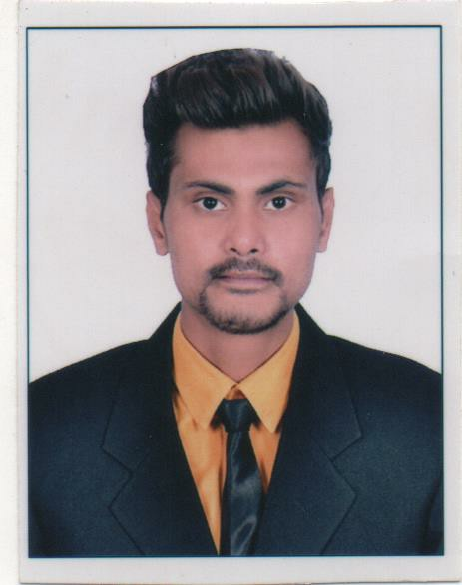

***MOHD BILAL***

***Civil Engineer with India Experience***

*D.O.B.: 21-Dec-1997*

*Nationality :. Indian*

*Location:. Rampur Uttar Pradesh , India Mobile:. +91 9997201572 / +91 8433046100*

*Email:.* [*mohdbilal1572@gmail.com*](mailto:mohdbilal1572@gmail.com)

# *PROFESSIONAL PROFILE*

*My Name is an accomplished Civil Engineer/supervisor 1 year of experience as Site Engineer. I proven* success in organizing tasks, increasing and multiplying business from limited material and resources is searching for a hospitality industry where my experience and skills would be put in use.

# *OBJECTIVE*

*Applying 1 year of Indian Site supervisor experience combined with proven expertise in managing a high-* end Site work.

# *EDUCATION*

## *High School Passed (July 2013) From N.I.O.S Board Rampur India 244901*

* + - *3 Years Regular Diploma In civil engineering (December 2016) From Teerthanker Mahaveer University Moradabad India 244001*

***LANGUAGES***

***English –*** *Excellent reading, writing and speaking* ***Hindi --*** *Mother language*

***SPECIALIZED SKILLS***

* + - *Excellent interpersonal and communication skills*
    - *Multi-tasking abilities with proficiency in organizing and managing different tasks*
    - *Executing Technical Rounds and reporting any technical issues;*
    - *Follow established safety rules and regulations and maintain a safe and clean environment;*
    - *Proficient in assigning duties and scheduling shifts*
    - *Ability of recruiting, training and supervising staff*
    - *Maintain & painting of building interiors and exterio*

# *PROFESSIONAL EXPERIENCE*

* ***M/s Jaina Construction pvt. Ltd, Rampur Uttar Pradesh India*** *(April 2017-till Date as dutie)*
* ***Deep ji Construction Company pvt. Ltd. Rudrapur India****(January To March 2017)*
* ***IL&FS Engineering & Construction Company Ltd, T.M.U Moradabad 244001****(10 june 2015 - 10 July 2015)*

# *Responsibilities and Role details:*

* + *Meet with the General Contractor to keep the project on time and on budget.*
  + *Direct construction, operations, and maintenance activities at project site*
  + *Estimate quantities and cost of materials, equipment, or labor to determine project feasibility.*
  + *Recruiting, training and motivating staff & labour*
  + *I come Provide technical advice regarding design, construction, or program modifications and structural repairs to industrial and managerial personnel.*

***Relevant skills***

* + *Complete Diploma in* ***Auto CAD 2D*** *, Rampur 244901 India*
  + *Final Year project* ***Crumb Rubber*** *as replacement over aggregate in concrete*
  + *Participate* ***Auto CAD seminars*** *T.M.U Moradabad*
* *Excellent knowledge* ***Ms office , Ms word , Ms power point , Ms Excel***

***OTHER INTERESTS***

* + *Learn new things of civil engineering, Bike Riding, watching YouTube videos, playing cricket*

***THANKS***

# *Personal profile*

* ***Father 's name - Mr. shakeel Ahmad***
* ***Language known - English , Hindi , Urdu***
* ***Date of birth. - 21 December, 1997***
* ***Nationality. - Indian***
* ***Driving license- Indian***
* ***Passport no. - R7386416***
* ***Marital status - Unmarried***
* ***Permanent address - Ghair saifuddin khan Domehla Road Rampur India***

***Declaration***

*I hareby Declare that all the Particulars Mentioned Above are True the best of my Knowledge and belief,*

*Er. Mohd Bilal*