**RESUME**

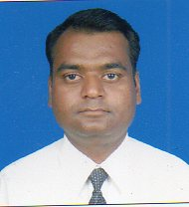

**Post Applied For - ADMINISTRATION OFFICER**

Name - Deshmukh Santosh Kumar

Date of Birth - 09 Sep 1977

Next of Kin - Mrs Sushma S Deshmukh (Wife)

Language known - English, Hindi, Marathi

Designation in Indian Navy - Petty Officer, Radio (Tactical)

Computer Knowledge - MS Word,MS Excel, Power Point and basic hardware & networking

**Contact no. - +91 9284998983**

E-mail ID - santoshkumardeshmukh777@gmail.com

**Address:**  - Deshmukh Santosh Kumar

S.No 18/2, Sambhaji Nagar, Runwal Park

Dighi, Pune – 411 015

**Professional Qualifications**:

|  |  |  |
| --- | --- | --- |
| Senior Team Leader | Feb 2017 | Ambrey Risk |
| Maritime Security Team Leader | Feb 2015 | Ambrey Risk |
| Deputy Team Leader | Feb 2014 | Ambrey Risk |
| Petty Officer |  | Indian Navy |

Additional Qualifications:-

|  |  |  |  |
| --- | --- | --- | --- |
| Anti Piracy Course |  | Jul 2013 | Ambrey Risk UK |
| City & Guilds Course |  | Feb 2014 | MANIPAL |
| 2nd Officer (NCV) Coastal |  | Jan 2012 | LBS CAMSAR |
| Fire and safety Officer | Certificate No. FFA/3281/027/17 | Jun 2017 | Indian Navy |
| Advanced medical and trauma courses | Certificate No. MFA/0292/021/17 | Jun 2017 | NAMAC |
| SSO | SSOC/0385/025/12 | Jun 2012 | NAMAC |
| GMDSS(Radio Officer) | GMDSS(GOC)/MUMBAI/MUM/R/1599 | Jun 2012 | NAMAC |
| ROSC(Radar simulator) | Certificate No. ROSC/0292/021/11 | Oct 2011 | NAMAC |
| ARPA(Automatic Radar) | Certificate No. ARPA/0289/022/11 | Nov 2011 | NAMAC |

**Seafarer’s Documents**:

|  |  |  |  |  |
| --- | --- | --- | --- | --- |
| **Documents** | **Number** | **Date of Issue** | **Place of Issue** | **Date of Expiry** |
| PASSPORT(Indian) | Z3943736 | 04-01-2017 | Pune | 03-01-2027 |
| CDC (Indian) | MUM 194892 | 27-01-2017 | Mumbai | 26-01-2027 |
| PCC | SB/VERI/R/49549/2016 | 24-01-2017 | Pune | 23-01-2018 |
| Yellow Fever | C-01575 | 08-07-2013 | Mumbai | 18-07-2023 |
| Seafarer Medical |  | 08-06-2017 | Mumbai | 07-06-2019 |

**Educational Qualification**:

|  |  |  |
| --- | --- | --- |
| NAME OF EXAMS | UNIVERSITY | YEAR |
| Degree Equivalent  Diploma in General communication  Diploma in Information Technology  SSC | INDIAN NAVY  Cochin University of Science & Technology  Om Computer Institute, Mumbai  CBSE Board | 2011  2006  2011  1994 |

**WORK EXPERIENCE IN INDIAN/MERCHANT NAVY**

|  |  |  |  |  |  |
| --- | --- | --- | --- | --- | --- |
| **Date** | **Company** | **Position** | **Role & Responsibilities** | **Number of Transits** | **Number of Sea Days** |
| 15 Feb 2017 – Till date | Ambrey Risk(Apex) | Senior Team Leader | Working as Senior Team Leader, supporting vessels across HRA | 07 | 200+ |
| 21 Sep 2013 – 14/02/17 | Ambrey Risk(IPM) | Maritime Security Team Leader | Worked as an Team leader, supporting vessels across HRA | 42 | 800+ |
| 04/08/12 – 08/02/13 | Timeline Ship mgt | Jr Off/ Radio Off | Carried out duties of 2nd Off and Radio Officer | -- | 186 |
| 31/07/1996 – 31/07/2011 | Indian Navy | Petty Officer | Worked as department head in various Naval establishments. | 15 Years | -- |

**Pen Picture:** 15 Years of extensive experience onboard various Naval vessels and Naval establishments. Worked in highly disciplined, challenging, highly sensitive environments and operations of time bound nature. Experienced in skillfully handling and solving various queries/complaints in highly demanding situations.

An astute and result oriented professional with over 15 years of varied experience in Indian Navy and various mercantile vessels transiting through High Risk Area. Some of the achievements are highlighted below :-

* **Presently working as Senior Indian Team Leader with Ambrey Risk, (United Kingdom). First Indian to be selected by the company for this post. Successfully completed 50 transits (1000 + days) through UKMTO designated High Risk Area. Incharge of Maritime security teams of personnel of different nationalities.**
* **Primarily responsible for conduct of the teams, assessment of the organization, compiling various reports for onward submission to the company. Writing personnel assessment of team members for the company.**
* **Have experience of over four years working for a British Company. Possessing high level of English language knowledge. Have experience of working with people of various nationalities.**
* **As a Senior Team Leader, highly experienced in maintain records, taking care of company equipment, Conduct of the team members, preparing various reports.**
* **Responsible for day to day training of team members.**
* **Excellent feedback from clients have resulted in boosting company’s client base. No negative report from over 50 clients (vessels) have resulted in out of turn promotions.**
* **Responsible for maintaining highest standard of client satisfaction.**
* **Responsible for liasoning with different authorities of various countries for smooth operations.**
* **Responsible for prompt solving and reporting of queries and complaints.**
* **Have worked in highly tense and stressful situations and environments.**
* **Organisational skills have been highly appreciated at company and client levels.**
* **Worked as department incharge of the Indian Naval Organisation in various Naval establishments.**
* **Selected for Deputy Team Leader course conducted by Ambrey Risk (UK) in just three months. Got out of turn promotions on two occasions for exemplary professional standards.**
* **Undergone City & Guilds course conducted by Ambrey Risk(UK) through Manipal university**
* **Having knowledge of 2nd Off and Radio Off has helped in carrying out duties of STL/MSTL/MSO , excellent assessment reports post transit and performing exceptionally well in all the security related courses conducted by the company.**
* **Experienced in conducting various briefs such as Masters brief, Crew brief and drills onboard.**
* **Experienced in conducting Risk Assessment and threat management onboard ships in HRA.**
* **Experienced in compiling post incident and Post Transit Reports, Returns, Inventory of Arms and equipment and compiling MSO/ personnel assessment.**
* **Full understanding of company’s SOP’s and legal requirements.**
* **Good Computer working experience including accessing internet**
* **Responsible for discipline and welfare of colleagues/co workers.**
* **Qualified Fire and Security Officer.**
* **Performed observation and reporting task of Organisational requirement. Maintenance and preparation of Vehicles, and control of team equipment in the Naval service.**
* **Has an experience in management of 24 persons in their welfare management as in charge of my department on various naval establishments and Ships.**

Date: 28 Nov 17 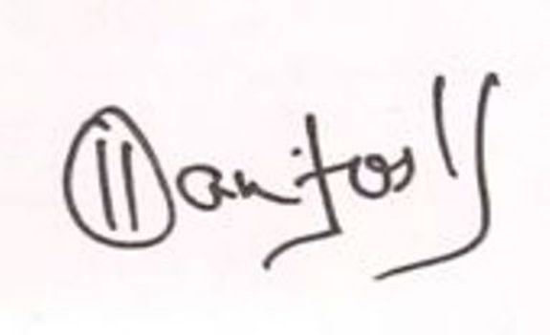

Place: Pune (Santosh K Deshmukh)