CURRICULUM VITAE

# CAREER OBJECTIVE

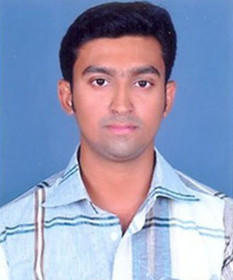

**VIJO VARGHESE** MENACHERRY (H) KARUMALLOOR P.O MANAKAPPADY NORTH PARAVUR PIN:683511

**E-mail** [vijovarghese89@gmail.com](mailto:vijovarghese89@gmail.com) **Phone:**0484 2672370 **Mobile:+91**9747235252

## Personal Information

**Father’s Name** Mr.M.K Varghese **Mother’s Name** Mrs.Jessy Varghese **Date Of Birth**

15-11-1989

**Religion** Christian **Caste** R.C.S.C

## Sex

Male **Nationality** Indian

To be a part of your successive organization in which I can contribute my knowledge, skills for the progress of any carrier and development of my abilities, potentials and work to acquire fulfillment in the field I have chosen

# EDUCATIONAL DETAILS

## DIPLOMA

Course : DIPLOMA IN ENGINEERING

: ELECTRONICS & COMMUNICATION

College : Govt Polytechnic College Perumbavoor Year : 2010-2013

Marks scored : 78.31%

## ITI

Trade : ELECTRONIC MECHANIC

Institute : Govt. ITI Kalamassery

Year : 2007-2009

Marks scored : 77.71%

## HIGHER SECONDARY

Board : State Board

School : Govt. H S S Chendamangalam Year : 2005-2007

Marks scored : 60.5%

## SECONDARY

10th : State Board

School : F.M.C.T.H.S Karumalloor

Year : 2005

Marks scored : 66.31%

# TECHNICAL SKILLS

* Participated in the training program CTV&HT Demo basics conducted at c.s Training Academy- south from 10/09/2009 to 12/09/2009
* UPS & Inverter Servicing

**Marital Status** Single **Blood Group** : A+ **Hobbies**

Travelling, Listening Music Reading Books **Linguistic Abilities** English

Hindi Malayalam

## Passport No: L 6063564

**ACADEMIC PROJECT AND SEMINAR**

* **Project:** GSM Based Smart Parking System
* **Seminar:** Retinal Scan Display (Virtual Retinal Display)

# EXPERIENCE:

* LG Service Center
* IGA-Tech Industrial Electronics Pvt.Ltd (Still continue)

# PERSONAL SKILLS:

* Problem solving abilities
* Ability to deal with people
* Willingness to learn
* Hard worker
* Helping mentality
* Mathematical knowledge.

# DECLARATION:

I hereby declare solemnly declare that all the above-furnished details are true to the best of my knowledge.

## Driving License No:42/1091/2008

Yours faithfully,

PLACE: N.Paravoor Vijo Varghese