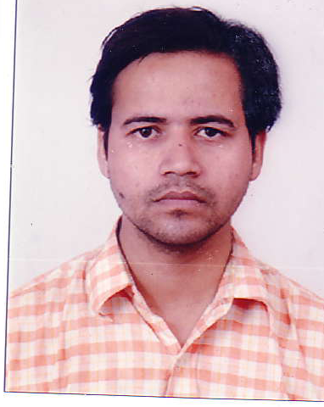RESUME

#### AKSHAYA RAI

367/492

Attarsuiya,Allahabad-211003

Uttar Pradesh

INDIA

E-mail: akshaya_rai13@yahoo.co.in

Contact number: 09632209683

# Professional Objective –

To build a long term promising career with a reputed firm and apply innovative ideas to the industry.

## Personal Details-

***DATE OF BIRTH*** – 13-JULY-1984

***FATHER’S NAME*** – Mr. AJAY KUMAR RAI

***RELIGION***- HINDU

***MARITAL STATUS***  -MARRIED

***NATIONALITY-*** INDIAN

***Languages Known***

1 English

2 Hindi

***Preffered Location***-Any were in ***GLOBE.***

## Educational Qualification

* B.Tech with 56% in **Electrical and Electronics** from United College of Engineering and Research (affiliated to U.P.T.U.), NAINI, Allahabad in 2006.
* Higher Secondary with *57%* from Shivcharandas Kanhaiyalal Inter College (U.P. Board), Allahabad in 2000.
* Matriculation with *56%* from Shivcharandas Kanhaiyalal Inter College (U.P.Board), Allahabad in 1998.

***Experience Details***

* July 2006 to may 2008 in different control panel companies in the production of MCC,PCC,APFC,Bus coupler and synchronizing panels.

1-VENUS CONTROL & SWITCHGEAR 2-SHIVALIC POWER & CONTROL

3-KRYPTON POWER

* June 08 to Oct10 in Jaiprakash Associates Limited, Korcham Wangtoo Hydro Electric Project(1000MW) in construction of Hydro Electric Power plant HIMACHAL.
* Nov10 to Aug 11 in Jaiprakash Associates Limited Thermal Power Project (3300MW) in construction ALLAHABAD.

. Aug11 to Nov 12 in ISOLUX CORSAN as a Site Engineer IN construction project.

March 13 to Dec 13 in Surendra Electrical as a Site engineer in 33/11KV PROJECT LOCATED AT BITS PILANI.

Jan 14 to April 15 in Manu Electrical P Ltd as a Site Engineer in HIGH RISE BUILDING PROJECT,13 FLOOR BUILDING,ALL TYPE OF ELECTRICALWORK.

May 2015 to Sep 2015 Infinity switchgear p ltd Bangalore

1 OCT 2015 to till now in MJ INFRASTRUCTURE P LIMITED IN HIGH RISE BUILDING PROJECT,PROJECT NAME-AMADEUS,BANGALORE.16 FLOOR BUILDING.

***Job Profile***

Maintenance of machinery use in construction.Maintenance of Batching plant and Crusher plant.Earthing of power house,substation,DG sets,Substation etc.Maintenance of Control Panels-MCC,PCC,APFC,VFD,.HT work up to 33kv in transmission and distribution.Erection Comission and Operation of 33/11 kv ,132/33kv substation.LT work etc,Power transformer up to 3MVA,switch gear,its control and power circuit testing etc.Maintenance of Motors,Switchgear etc.manpower Handling etc.Installation of DB,Ladder type cable tray,control panel installation,manpower handling etc.Insure EHS at site,Material management at site,

EXPERIENCE As An Electrical Engineer in Construction Industry.Purchase of electrical items with the help of BOQ.Tie up with vendors and client.

***Doing liasning work like Land Clearing,meeting govt officials,etc.***

***Salary***

**Expected :-** Negotiable

**DECLARATION**

I hereby declare that the particulars of information and facts stated above are true and complete to the best of my knowledge.

Signature

Date: AKSHAYA RAI