# MOHAMMAD AFLAH J

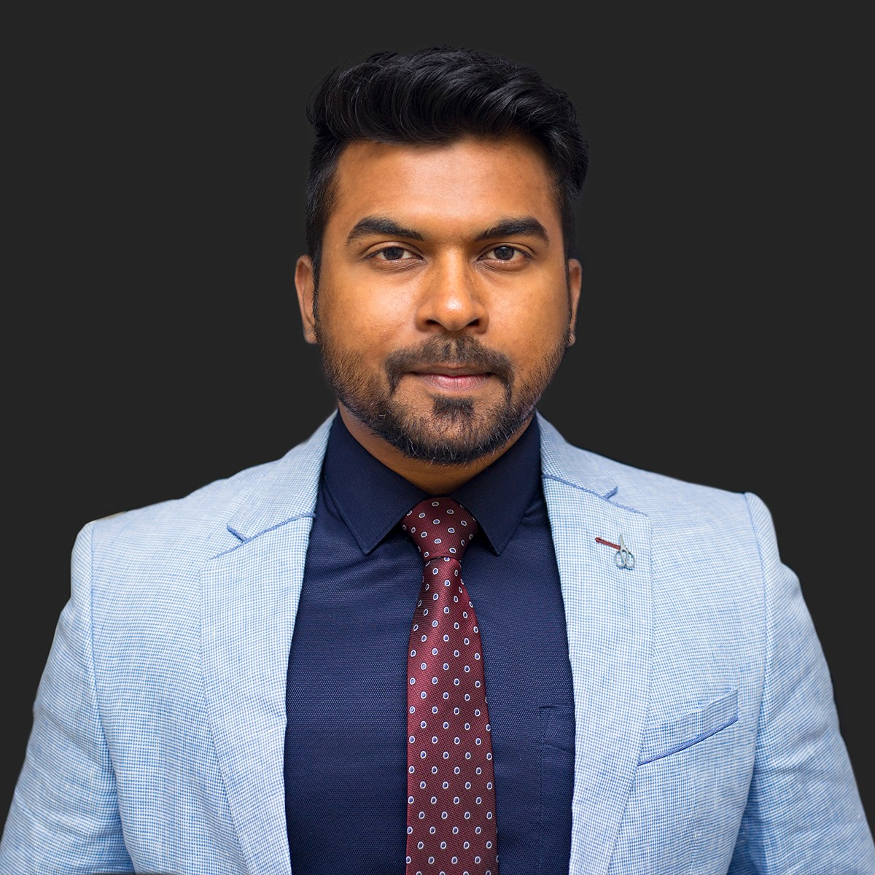

Versatile, high-energy professional to work in a team environment to design and develop **Building construction projects** successful in achieving business growth objectives within turnaround & rapidly changing environment; targeting senior-level assignment in **Mechanical Engineering** with an organization of repute, preferably in UAE.

## [mohd.aflah3@gmail.com](mailto:mohd.aflah3@gmail.com) +971528892603

 Key Skills  Profile Summary

 A Multi-faceted professional with **5 years** of experience in **Building construction (MEP)**.

|  |
| --- |
| Design & Site Supervision |
| MEP Coordination |
| Technical support & Application |
| Solar Design & Installation |
| HVAC, HSE & Fire Fighting |
| Testing & Commissioning |
| Safety Measures |
| Quality Assurance & Quality Control |
| Team Building & Leadership |

 Key Experience in **Project Engineering, Design & Site Supervision,**

## Installation, Testing & Commissioning.

 Worked in UAE as following positions **Senior Technical Support Engineer, Technical Coordinator, Junior Mechanical Engineer.**

 Worked in projects of Commercial, Residential towers, Infrastructural, Villas, Hospitals, Hotels etc.

 Experienced in managing complete project operations entailing resource utilization, procurement, manpower management, design and application, technical support, performance estimation, and so on.

 Hands-on experience in Designing, Installation, Supervising services and Commissioning of Systems.

 Steered the creation of conceptual & schematic designs including plans/layout and interfaced with clients for approval of the same

 Possess sound knowledge of **AutoCAD, Solid Works, MS Office, PRO-E,**

and **Excel.**

 Familiar With **HVAC, Water supply, Solar Hot Water System,**

## Firefighting, Fabrication and so on.

 Interface with clients, Reviewing **technical submittals**, perform technical studies of feasibility reports and **perform load calculations, energy simulation and equipment selections** .

Skills Career Timeline



Communicator

Innovator

Thinker

Team Player & Fast Learner

Education

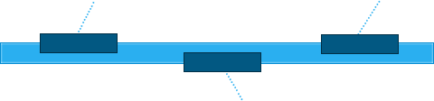

**Synergy Vector Electromechanical Works L.L.C, Dubai, UAE as Senior Technical Support Engineer**

Feb'16-Dec‘17

April’14-Jan'16

**Kerala Automobiles Ltd, India as Junior Mechanical Engineer**

Nov'12 –Mar‘14

**DULSCO Dubai, UAE as Technical Coordinator**

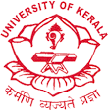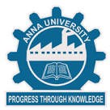B.E. Mechanical Engineering from PET, Anna University, Tamil Nadu in 2012.

12th from Sabarigiri HSS Kerala in 2006

# Work Experience



**February 2016- December 2017 with Synergy Vector Electromechanical L.L.C, Dubai, UAE As Senior Technical Support Engineer.**

## Key Result Areas:

 Performing activities such as regulating projects using engineering principles & techniques, liaising with Consultant, Client & Sub-contractors, arranging manpower, Safety features ,material, tools & machinery as per project requirement, and so on

 Provide direction and technical training to teams in design, development and system integration and served as a technical mentor

 Scheduled projects and managed resources

 Keeping a track record of Material submittals and fulfilling site/stock requisition

 Negotiating with the suppliers, administering drafting and engineering design staff and rendering technical support to other staff as necessary

 Performing Site work inspections, Material inspections and get it approved by consultant.  Implementing and following all required safety measures in work site.

 Interacting & coordinating with site staff to complete the project as per target program & in budgeted cost to ensure smooth running of projects

 Made presentations on project status, presented monthly and annual reports to senior management

 Directing material labor output and utilization of site resources, assuring safety & quality as per the company standards

 Planning, estimating, tracking & implementing project plans within budgets and deadlines

 Managing process of development from designing, validation of design, trials production to design output

 Monitoring product quality & impact of design modifications on product features while emphasizing on cost reduction during detailed engineering

 Understanding client requirements and recommending design modifications based on client requirements and implementing the same

## Highlights:

Hands-on in Hot Water Solution Installation & Design (Thermosiphon, Forced Circulation, Calorifiers, Boilers, Heat Pumps

 Hands –on in Equipment selection of Hot water systems ( Fully drain back systems, Thermo siphon systems, Solar

with Boiler back up ,solar with heat pump back up, solar with electric element backup)

 Experienced in civil & electrical work as well as in HVAC , Water Supply, Solar, Fire Fighting and so on

 Expertise in Solar from Design, Installation, Testing & Commissioning, Operation and Maintenance activities

 Exposure in preparing process, layout & Shop drawings, Material Submittals, specifications, decision of controls, selection of hydraulic components by managing a team size

 Achieved cost reduction and material reduction in Previous projects

 Ensured standardization of system and module

## Key Projects:

 Damac- Akoya Oxygen (1800 Villas) Dubai, UAE

 Fujairah National Construction- (G+4+R) Dubai, UAE

 Al Shirawi Electrical and Mechanical- (G+4+R) Dubai, UAE

 Tiger Construction- (G+4+R) Dubai, UAE

 Mediclinic Hospitals- Dubai, UAE

 FIFA Medical Centre of Excellence, Dubai, UAE

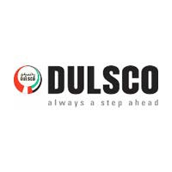

**April 2014 – January 2016 with DULSCO L.L.C., Dubai, UAE As Technical Support Coordinator**

## Key Result Areas:

 Reviewed Shop Drawings of MEP Systems, recommended solutions for improvement, liaised with commissioning team and contractor to solve the installation, operational and design problems

 Supervised MEP Systems with building automation systems and troubleshoot operational problems

 Understood expectation of the client before deployment and conducted predeployment site inspection and submitted necessary reports

 Prepared & maintained detailed and accurate project records including data, documentation and progress reports  Formulated & presented system details and balancing reports to consultant for final witness & approval

## Highlights:

 Experienced in MEP systems by working on different projects in UAE

 Familiar with resource management such as materials, tools, equipments and manpower

 Familiar in briefing and coordinating with CNC and lathe technicians to ensure best output

 Familiar with safety features implemented in different site locations and got several safety trainings

## Key Projects:

 Halliburton, Dubai, UAE

 Legnano Techno Electric, Dubai, UAE

 Nestle, Dubai, UAE  Alumco, Dubai, UAE  Aggreko, Dubai, UAE

 Concordia, Dubai, UAE  Edrafor, Dubai, UAE

 World Trade Center, Dubai, UAE

 Al Shirawi Facilities Management, Dubai, UAE

 Aujan Industries, UAE

## November*’*2012*–* March*’*2014 with Kerala Automobiles, India as Junior Mechanical Enginee

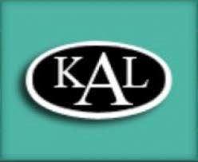

**r**

**Key Result Areas**

 Conducted inspections, supervised and inspected the installation of mechanical systems  Managed operations relationship with distributed network of suppliers

 Preparing reports for submitting with higher authorities

 Maintained mechanical systems of vehicles on a regular basis

 Investigated mechanical failures or unexpected maintenance problems

# Technical Skills

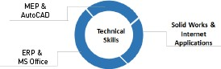

**Personal Details**

**Date of Birth:** 1st June1989

**Languages Known:** English, Arabic, Hindi, Malayalam & Tamil

**Nationality:** Indian

**Marital Status:** Married

**Driving License:** Valid UAE Driving License

**Visa Status:** Visit Visa