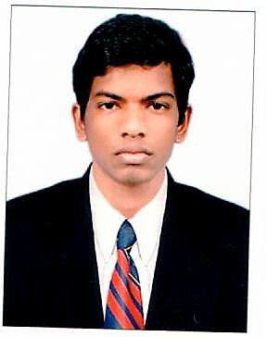**CURRICULUM VITAE**

**JAGATHEESAN**

Mobile: + 971 525477678,0557258894

Email: [jagadeesanbalu47@gmail.com](mailto:jagadeesanbalu47@gmail.com)

|  |
| --- |
|  |
| **Summary**    Safety-conscious HVAC and refrigeration Technician who effectively manages a large volume of work orders for both commercial and residential properties. Focused on delivering quality work and exceptional customer service. Strong work ethic and flexible schedule. |
| **Highlights**   * In depth knowledge of Ventilation and air conditioning. * Preventive maintenance * Operation Expert * Leak checks * Excellent problem solver * Adaptable * Analytical thinker |
| **Experience** |
| HVAC Technician March 10-2015 to current  National project and maintenance company, LLC- UAE   * Installation, Repair, and maintain the air-conditioning systems. * Comply with engineering standards and practices all times. * Complete preventive maintenance of air-conditioning system.   **HVAC Technician**    Voltas A/c Dealers Coimbatore-India July 2012 to March 2015    Examine heating, and air-conditioning systems for signs of defects or malfunction.   * Installed air conditioning and refrigeration equipment and tested them for proper operation. |
| * Troubleshot and repaired HVAC refrigeration equipment.   HVAC Technical Assistant August 2011 to July 2012.  Fortel hotel Chennai-India 4star |
|  |

* Complete preventive maintenance of Refrigerant and air conditioning system.
* Attending guest requests and update the daily log.

**Education**

ITI in Refrigerant and air conditioning passed in 2011 from Thiruvarur Aroran poly technic-Tamilnadu

Secondary school certificate Board of Tamil Nadu- 2009

**Personal Details**

|  |  |
| --- | --- |
| **Date of Birth** | **July 15, 1995** |
| **Father’s Name** | **Mr. Balu** |
| **Gender** | **Male.** |
| **Religion** | **Hindu** |
| **Nationality** | **Indian** |
| **Marital Status** | **Single** |
| **Languages Known** | **English, Tamil, Hindi,** |
|  |  |
| **Passport Number** | **L 4660137** |
| **Date of Issue** | **SEP 20 , 2013** |
| **Date of expiry** | **SEP 19, 2023** |
|  |  |
|  |  |

**I hereby declare that the above-mentioned information is correct up to my knowledge and I bear the responsibility for the correctness of the above-mentioned particulars.**

**Place: Date:**

**JAGADEESAN**