* 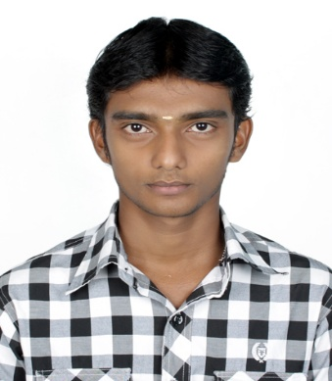

**SREERAM .M**

Mobile no: +919840328327 ADDRESS: 2/441, Singaravelan 2nd street,

[Mail ID: sreemech5@gmail.com](mailto:Mail%20ID:%20sreemech5@gmail.com) Chinna neelankarai,

Chennai-600041

**EmPLoyment Objective**

* To enhance my professional skills in a dynamic and fast paced workplace and also to contribute effectively to the company’s reputed success and to bring about remarkable growth of the company.

**PROFESSIONAL EXPERIENCE**

* **QH Talbros India Pvt Ltd, Chennai -** [May 2015– July 2017]

**Supply Quality Assurance** – [Automobile Industry]

**ROLES AND RESPONSIBILITIES**

* Checking the Supplier Materials As Per Customer drawing Standards
* After checking and verifying the documents from supplier, MRR will be Authorize in the Oracle Software
* Preparing The PPAP for the New Project and Knowledge in Autocad software.
* Monitoring The Monthly PPM and Reduce the Rejection From Supplier parts
* Following The ECN and ECI
* Strong knowledge in Rockwell Hardness Machine, Universal Testing Machine, Brinell Hardness Machine, Vickers Hardness.
* Having strong work experiences in MS Office, Excel, Word.
* Interaction with suppliers to clear the problems from their end.

**Educational Qualification**

B.E. Mechanical Engineering from Chennai Institute of Technology. Affiliated to Anna University and secured an aggregate of 76.3% (2011-2015)

XII from Brother Hood Matriculation Higher Secondary School, Chennai (State Board) and secured an aggregate of 77.08% (2010-2011)

X from Brother Hood Matriculation Higher Secondary School, Chennai and secured an aggregate of

77.4 % (2008-2009)

**AREA OF INTEREST**

* Quality control and Quality assurance
* Autocad
* Procurement
* Supply Chain Management

**INPLANT TRAINING**

* Training on “**OIL AND GAS**” at “**PETROFAC INDIA PVT LTD, CHENNAI**” from **5/03/2014** to **25/03/2014**.
* Training on **“PRODUCTION & TOOLING”** at **“MK AUTO COMPONENTS INDIA PVT. LTD., Chennai”** during **January 2012** to **April 2012.**
* Training on **“STEERING MANUFACTURING”** at **“RANE TRW. Chennai”.**
* Training on **“MANUFACTURING SIDE MIRROR FOR CARS”** at **“SMR Industries, Chennai”.**

**EXTRA-CURRICULAR ACHIEVEMENTS**

* Zone level player in **“VOLLEY** **BALL”** – Runner.
* Participated in several inter college “**VOLLEY BALL”** matches and got prizes.

**Personal Profile**

* Date of Birth : 20th March 1993
* Father’s Name : Murugan.J
* Sex : Male
* Marital Status : Single
* Hobbies : Playing Volleyball and Football
* Languages Known : Tamil and English
* Age : 24
* Nationality : Indian

**Declaration**

I hereby declare that the information furnished above is absolutely true to the best of my knowledge and test of my understanding.

Place: Chennai

Date: Sreeram.M