**Application** 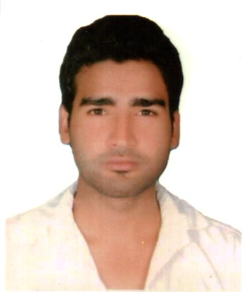

R/Sir,

Currently, I am working in M/s Arvind Mill Ahmedabad as a knitting Manufacturing manager. Where my responsibilities includes to Production Operation with quality parameter against customer requirement, but I would like to change my job in order to gain additional experience as to my general preparedness. My resume has been enclosed herewith for your kind consideration.

I hope you will provide me this opportunity to prove my worth and efficiency.

Thanking you

Sumit Thakur

**RESUME**

**SUMIT THAKUR**

Vaibhavi infrastructure D-401 Vishvas city -9 NR Simandhar status VILL: gota (gseb) tal: daskori distt:Ahmedabad 380001.

E-mail ID: [samthakur1991786@gmail.com](mailto:samthakur1991786@gmail.com)

MOB.NO--+918263945440,+917016624374

***Career Objective-***

To work in an environment, where I can put my ideas to actual implementation & one that allows growth and is equally rewarding with a versatile job profile

Encompassing areas like Production and Maintenance.

***EDUCATIONAL QUALIFICATION***

|  |  |  |  |  |  |
| --- | --- | --- | --- | --- | --- |
| **Qualification** | **Board/University** | **Name of** | **Year of Passing** | **%age** |  |
|  |  | **Institution** |  |  |  |
|  |  |  |  |  |  |
|  |  |  |  |  |  |
| B. Tech | HIMTU | J.N.G.E.C , SUNDERNAGAR | May,2015 | 65.4 |  |
|  |  |  |  |  |  |
|  |  |  |  |  |  |
|  |  |  |  |  |  |
| XIIth | H.P BOARD | BLUE STAR Sen Sec. | 2010 | 61 |  |
|  |  | School,HAMIRPUR |  |  |  |
|  |  |  |  |  |  |
|  |  |  |  |  |  |
| Xth | H.P BOARD | ADARSH SHISHU Sen. | 2008 | 68 |  |
|  |  | Sec. School,HAMIRPUR |  |  |  |
|  |  |  |  |  |  |
|  |  |  |  |  |  |

***Work Experience-***

Total Experience 3 year in textile platform.

Currently Working in**M/s. Arvind Mill** as a Knitting Manufacturing M**anager s**ince Aug 2015 to till date)

Previously Worked in M/s. Fashion gauge knitwear Industries . as a Production and quality control Dept (knitting division) .

***Jobs title history. Profile & Responsibility-***

* Get production plan from PPC Dept and review the plan according to knit m/c assignment, yarn availability and no. of day to knit the fabric.
* Review m/c setting and m/c availability according required quality.
* Prepare the manpower availability in running the planed m/c.
* Review Plan for m/c efficiency and productivity and over time hours according to delivery date.
* Handling outsourcing
* Making MIS report & reporting to MIS dept.
* Holding profit, loss meeting with the seniors in month of last.
* Conducting supervisors meeting for improvement of production efficiency with quality.
* Maintaining m/c Maintenance schedule and machine setting.
* Follow up IMS audit activity with documentation and presentation.
* Keeping Co-ordination with P.P.C.Dept. for timely delivery of product.
* Follow up fabric complaint received from our process house & taking necessary action for trouble shooting.
* Monitoring fabric quality , Maintains activity and product development as per costumer
* Shade Matching of Dyed fabric & yarn dyed & mélange yarn with approved shade Cutting & give approval for proceeding.
* Problematic fabrics inspect & give final grade for dispatch.
* Preparing all report and reporting to Higher Authority
* We subscribe to the knitting of the needles ,sinkers,cylinder Groz beckert.

***Strengths-***

Achievement oriented, with technical skills and an ability to manage the situation with

Ease, working in organization as team to achieve its objectives.

***Technical Proficiency***

Technical proficiency in knitting**.**

*General knowledge of knitting socks machine, flat bed, Maintenance or Spinning, & finishing*

Basic knowledge in computer

**Extra achievement-------- 1. Socks knitting machine Designing course completed**

2. IMS internal auditor course completed

***Personal Details***

Father's Name : Mr. Rattan Chand

Date of Birth : 30.04.1991

Sex : Male

Marital Status : Unmarried

Languages known : Hindi, English, Punjabi,Gujrati

Hobbies : To achieving extra ordinary task

Herewith I declare that the above furnished information is true from

The best of my knowledge.

Date:

Place: Ahmedabad Sumit Thakur