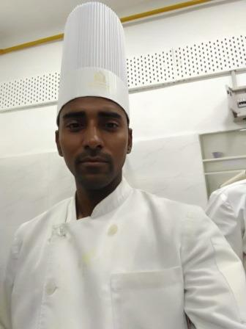

**Mohammad Afzal**

**Mb# +919453870434**

**Email#**chefafzal.raynee@gmail.com

[linkedin.com/in/mohammad-afzal-27b876114](https://www.linkedin.com/in/mohammad-afzal-27b876114)

**Skype I’d=> chefafzal.raynee**

## ***Career Objective:***

Aspiring for a challenging position as Chef in a global hotel industry to utilize my professional and personal skills and to grow consistently in this competitive world.

## ***Working Area’s***

* Indian Kitchen & Tandoor

## ***Experience:***

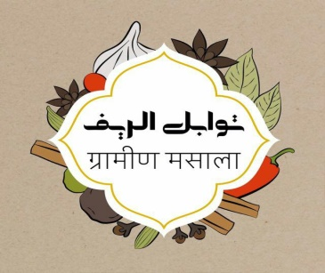

**January 2017- February 2018**

Designation : Tandoor Chef

Organization : Tawabel Al-Reef Restaurant

Location : Sector Al-Farooq, Royal Commission

Area, Jubail Industrial City, Dammam,

Saudi Arabia

Participating actively and providing useful input in menu design and food costing.  
Managing portion control and minimization of food waste   
Reporting Kitchen Manger about stern disciplinary concerns if any  
I was also handled Indian Curry, Biryani, Shawarma and Butchery Section.

Cooked different varieties of curries and dishes from Tandoor as listed in Restaurant Menu.

**November 2016- December 2016**



Designation : Commis 1st Chef

Organization : Noor Us Sabah Palace

Location : V. I. P. Road, Koh-E-Fiza, Bhopal

Madhya Pradesh, India- 462001

Prepared all the prep work for Sauces, Salads and Entrees etc.  
Prepared and cook food in keeping with recipes, quality and

Presentation standards.

Test food to verify if they have been cooked adequately.

Stored all food items in appropriate storage area.

Proficient in Indian hospitality and sustainable practices followed in Indian cuisine.

**December 2015- September 2016**

Designation : Commis 1st Chef

Organization : Silver Salt Indian Cuisine

Location : Sufi Chamber, Banjara Hills, Road No- 1,

Hyderabad, Telangana , India- 500034

Maintained the cleanliness and hygiene Kitchen.  
Quality control of the food, garnishing and portion size.  
Provided assistance for preparing stock purchase list as needed.

Helped Chef to make and frame the Menu.  
Maintained the standards of the kitchen and the food.

**January 2015- October 2015**



Designation : Commis 2nd Chef

Organization : Lukshmi Villas Palace

Location : J. N. Marg, Vadodara, Gujarat, India

Responsible for receiving, storing, and rotating produce, dairy,

Meat, Fish, poultry.  
Ensured a clean and organized work station while preparing food items for service.

Properly prepped and executed recipes as assigned by the Head Chef.  
Responsible for straining, cooling, and storing stocks in a timely manner.  
Accompanied the offsite events team on special events to assist in preparation, plating, and service of hors d'oeuvres, salad, Sauce, Kebab, Naan, Paratha's etc.

**February 2014- December 2014**



Designation : Commis 3rd Chef

Organization : Lukshmi Villas Palace

Location : J. N. Marg, Vadodara, Gujarat, India

Ensured apt portions, chopping and storage of ingredients as needed for preparation of food items.  
Cleaned, peeled and plated fresh fruits and vegetables and fish, chicken, mutton etc.  
Prepared ingredients with right weigh, measure and mix.  
Followed recipes meticulously to cook food keeping up with quality standards and presentation instructions.  
Used efficiently kitchen equipment’s including ovens, grills, fryers, stoves and microwaves.  
Inspected food preparations for quality and quantity.

## ***Role & Responsibilities:-***

* Assure conformance to all food production standards and specifications set by the Executive Chef or the Sous Chef.
* Control usage and eliminate wastage with a view to minimizing food costs.
* Maintain a high standard of cleanliness in stations.
* Make out daily requisitions for the supplies needed with the approval of the Executive Chef or the Sous Chef.
* Work with all other sections and maintain harmony in the main kitchen.
* Ensure that employees in the department conform to house rules and policies of the hotel.
* Proper Co-operate with Chef, Sous Chef, Executive Chef and all F & B staffs.

## ***Academic Qualification:-***

Graduation (B.com) from Kanpur University

Intermediate from UP Board Allahabad

High school from UP Board Allahabad

## ***Computer Skills:-***

MS Office, Internet, Tally

Expert in computer related operations Windows XP, Vista,

Windows 7, Windows 8, Windows 10

## ***Language Known:-***

Hindi, English, Arabic, Urdu.

## ***Personal Information:-***

Father’s Name : Mohammad Zaki

Date of Birth : 14 August 1987

Gender : Male

Religion : Islam

Marital Status : Single

Nationality : Indian

Permanent Address : Rayeen General Store, Near Old Petrol Pump,

Unchahar, Raebareli( U.P.) India 229404

## ***Passport Details:-***

Passport Number : N 7004894

Date of Issue : 19th January 2016

Date of Expiry : 18th January 2026

Place of Issue : Lucknow, Uttar Pradesh, India

**Reference:** Reference can be given on the request.

**Date…………..**

**Place………… (Mohammad Afzal)**