**CURRICULUM-VITAE**

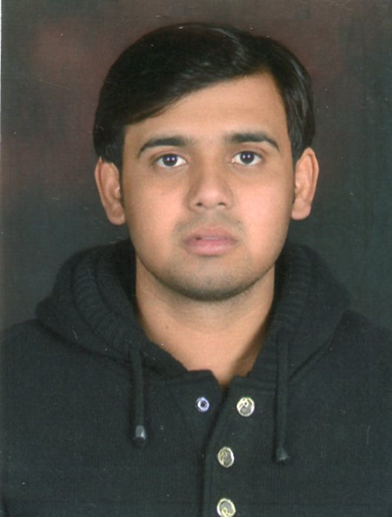

**Ankit Saini**

728/6 Neta Ji Nagar PAC Mod Shyam Nagar

Pin 208013

M- 8052885544,9455066218

E-mail ankitajnara48.as@gmail.com

passport number-p0341970

**Post applied for**- Site Engineer (civil)

|  |
| --- |
| **CARRER OBJECTIVE** |

* To work cumulatively and effectively for the responsibilities offered by the organization and to apply innovative techniques in field of civil construction

|  |
| --- |
| **EDUCATION QUALIFICATION** |

* Completed Intermediate from U.P. Board in year 2009.
* Completed High School from U.P. Board in year 2007.

|  |
| --- |
| **PROFESSIONAL QUALIFICATION** |

* Three year Diploma in Civil engineering from UPBTE in 2012
* Basic computer knowledge

|  |
| --- |
| **WORK EXPERIENCE** |

* One Month Training in **PWD Department** at Kanpur Nagar.
* Worked in **Ajnara India Ltd.** Ghaziabad as a J.E. from 1-June- 2012 to

7-April- 2014.

* Worked in **Vansh Infrasolution Pvt.Ltd.** (kaushambi) Gaziabad as a site engineer project of Indian railway undertaking structure work (culvert) from 15-April-2014 to 30-Nov-2014.
* Worked in **Five Roses** as a Junior Engineer from 01-Nov-2014 to 26-May-2016.
* Working in **Nagarjuna Construction Company Lmt.** (Hyderabad) as Junior Engineer from 06-Jun-2016 to till now.

|  |
| --- |
| **PROFESSIONAL SKILLS** |

* **Interpersonal Skill:** The ability to work with range of people from diverse background and culture.
* **Flexibility :** Ability to handle frequent changes.

|  |
| --- |
| **Present Status** |

* Presently working with nagarjune construction company lmt.
* Construction Residential Building till date as a Eng Civil.

|  |
| --- |
| **Personal Skills** |

Father’s Name Mr. Jagdish Kumar Saini

Marital Status Unmarried

Gender Male

Date of Birth 31/10/1992

Strengths Positive attitude and Sincerity

Language Hindi & English

**DECLARATION**

I hereby declare that all the information furnished above is true and complete to the best of my knowledge and belief.

**Date:**

**Place: ( ANKIT SAINI )**